**Problem Statement:-**

In today’s Era, Knowledge of stock market is very important for most of the peoples of the society. Stock Market has the potential to ensure the worthy source of the second income for most of the people. Like Everything has pros and cons, stock market is subject to market fluctuation risk. Before investing in stock, it’s very important to see the performance of the stock in past for minimize the risks, and for common people it’s difficult for keeping track of the fluctuating prices of the stock. So, here we built the model for Analysis of stock prices which shows the opening and closing price history of the stock in which user is interested.

**Library Include:-**

1. Numpy:- NumPy is a Python library used for working with arrays
2. Pandas:- Pandas is a Python library. Pandas is used to analyze data.
3. Matplotlib:- Matplotlib is a low level graph plotting library in python that serves as a visualization utility.
4. Keras:- Keras is an open-source high-level Neural Network library, which is written in Python is capable enough to run on Theano, TensorFlow, or CNTK.

**Framework Used:-**

1. Streamlit:- Streamlit’s open-source app framework is the easiest way for data scientists and machine learning engineers to create beautiful, performant apps in only a few hours! All in pure Python. All for free.

**Important Function:-**

1. Pyplot:-Most of the Matplotlib utilities lies under the pyplot submodule, and are usually imported under the plt alias.

**Graph:-**

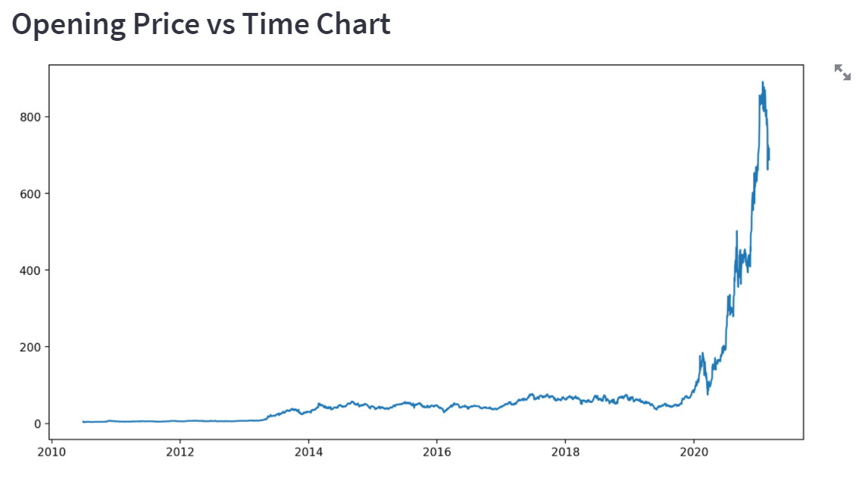

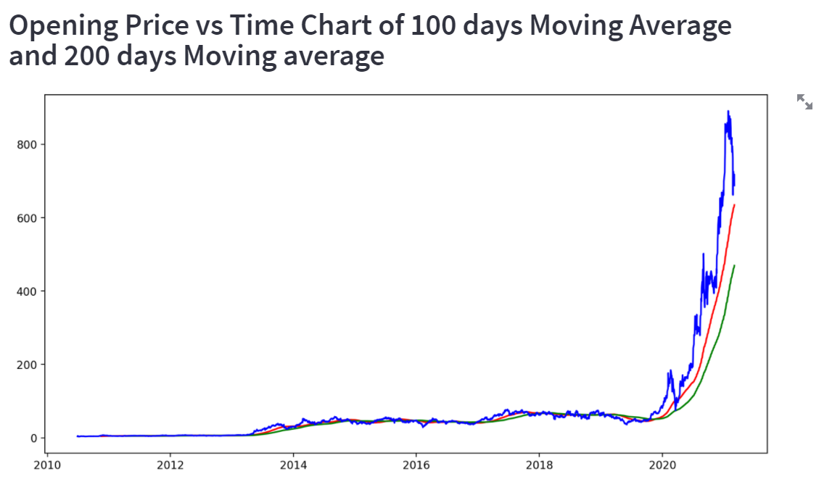

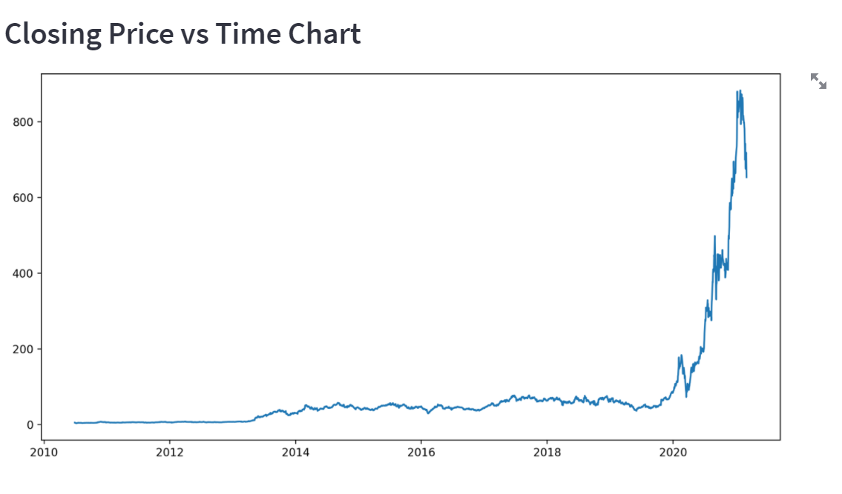

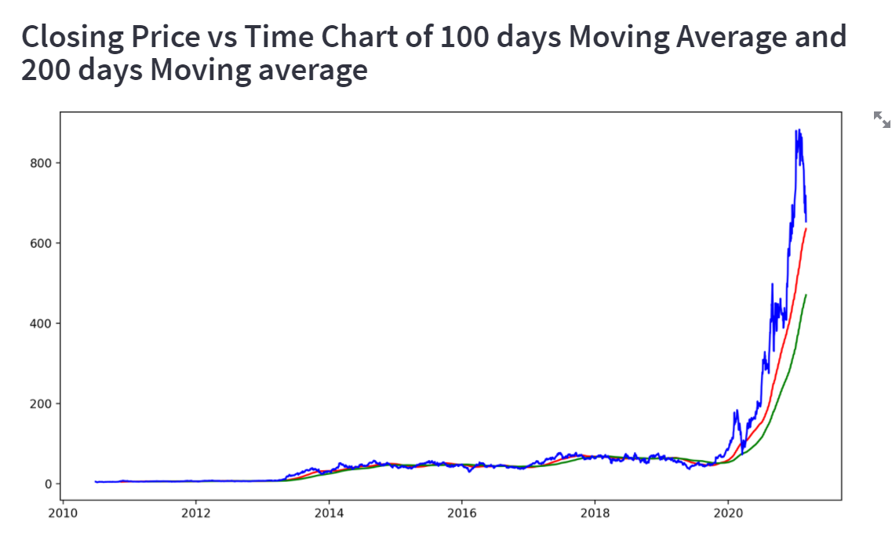

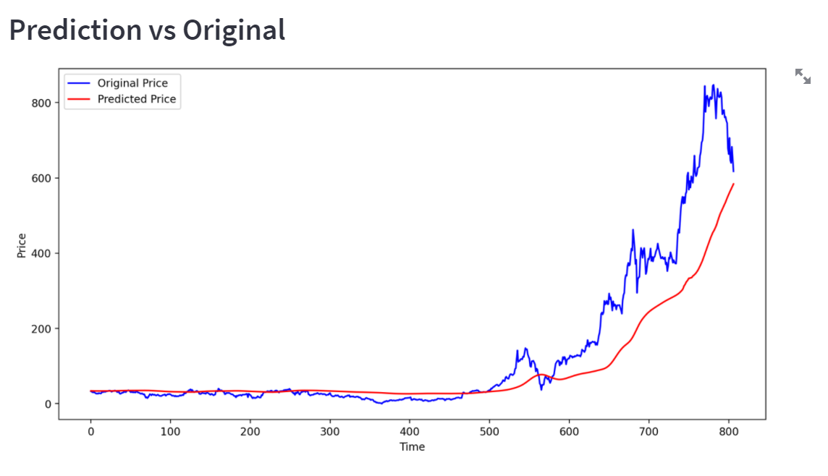

**Conclusion:-**

Predicting the stock market was a time-consuming and laborious procedure a few years or even a decade ago.

However, with analysing stock market data of previous 10 years by interactive graph, it became too easy for common people to choose profitable stocks.

The Opening Value of the stock, the Highest and Lowest values of that stock on the same days, as well as the Closing Value at the end of the day, are all indicated for each date. Furthermore, the total volume of the stocks in the market is provided in project. With this information, we can save a lot of time & also make a lot of money investing in stocks or trading in the stock market.