Academic Honesty

Any kind of copying, sharing code with others, and malpractices attract high penalties to the extent

of referring to the Institute Level Disciplinary committee. To this end, your submission must

include a signed self declaration in the following format.

Declaration of Academic Honesty

I declare that i) the assignment here submitted is original except for source material explicitly

acknowledged in the readme file; ii) I have not distributed or shared the assignment either wholly

or partly to the fellow students of the course - Compiler Design; iii) I have not copied the assignment

either partly or wholly from the fellow students of the course.

I am aware that I will be held responsible and liable to disciplinary actions if I am

found guilty.

Full Name: Keshav Kumar Manjhi

Roll No: CS21B027

Date: 04/08/23

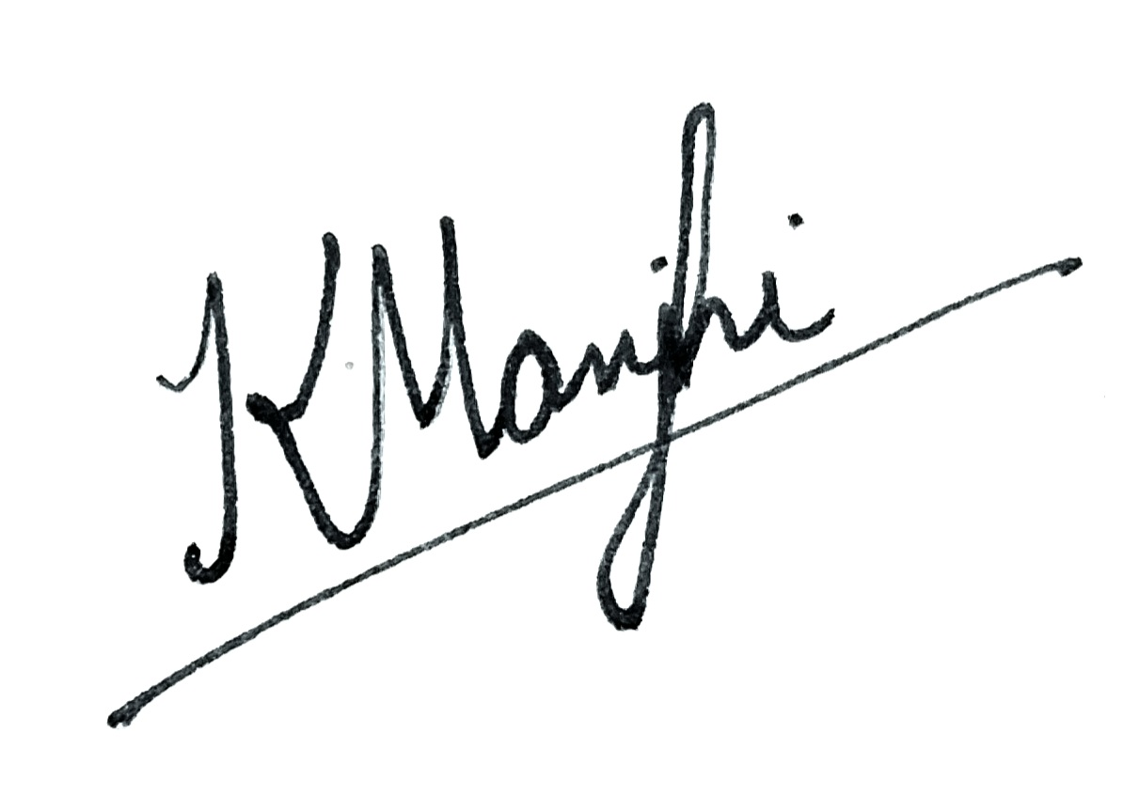

Signature of the student