

UE23CS352B - Object Oriented Analysis & Design

Mini Project Report

Smart Campus Event Management System: A Role-Based Web Application for University Event Automation

Submitted by:Keshav Vithal Sangonda

Team Members
NAME | SRN
Keshav Vithal Sangonda | PES1UG23CS300
Pushkar P | PES1UG24CS822
Jeevan A N | PES1UG23CS266
Kasa Guruvi Reddy | PES1UG23CS289

6TH Semester - “E” Section

Prof.Vinay Joshi
January - May 2026

DEPARTMENT OF COMPUTER SCIENCE AND ENGINEERING
FACULTY OF ENGINEERING

PES UNIVERSITY
(Established under Karnataka Act No. 16 of 2013) 100ft Ring Road, Bengaluru – 560 085, Karnataka, India

Problem Statement: Smart Campus Event Management System
Key Features:
1. Comprehensive Role-Based Access Control (RBAC):
- Implemented distinct dashboards and secure access levels for four primary actor roles: Student, Organizer, Faculty, and Admin.
- Each role is restricted to its specific workflows (e.g., Admins manage users/payments, Faculty review events, Organizers host events, Students register).

2. Complete Event Lifecycle Management:
- Creation & Proposal: Organizers can draft and propose new campus events with specific details, dates, and media.
- Faculty Approval System: Implemented a robust approval workflow where Faculty members must review, approve, or reject proposed events before they are visible to students.
- Date Restriction Logic: Implemented dynamic date validation to ensure events are created with logical, future timelines.
- Modification/Deletion: Organizers retain control to edit event details or delete events depending on their current approval status.

3. Advanced Smart Registration & Eligibility Filtering:
- Developed a smart registration engine that evaluates students' profiles against event prerequisites.
- Automatically filters out and denies registration to students who do not meet specific CGPA or Age limits set by the organizer.

4. Integrated Payment-to-Certificate Workflow:
- Built a streamlined process for paid events. The system tracks the financial transaction, updating the student's status upon successful payment, and links this directly to their eligibility for final event certification.

5. Dedicated Attendance Tracking System:
- Provided organizers with a dedicated interface to verify and mark the physical or virtual attendance of registered students on the day of the event.

6. Automated PDF Certificate Generation:
- Implemented a system that automatically designs and generates custom PDF certificates upon event completion.
- Strict validation ensures that certificates are generated only for students who were explicitly marked as "Attended" by the organizer.

7. Secure Authentication & Account Recovery:
- Implemented secure user login and session management.
- Integrated an automated Password Recovery Workflow via Gmail SMTP, allowing users to securely reset forgotten passwords via email verification.

8. Professional & Dynamic User Interface:
- Built a responsive, aesthetically pleasing frontend using modern web development standards.
- Included support for dynamic background styling, event image uploads, and visual flair to emulate a premium, real-world application.
- Included static informational architecture such as About Us and Privacy Policy pages to make the application legally and professionally complete.

9. Application of Software Design Patterns:
- Structured the backend utilizing industry-standard Object-Oriented Analysis and Design (OOAD) principles.
- Specifically implemented the Singleton Pattern and Builder Pattern to construct robust, scalable, and maintainable Java code.

Models:
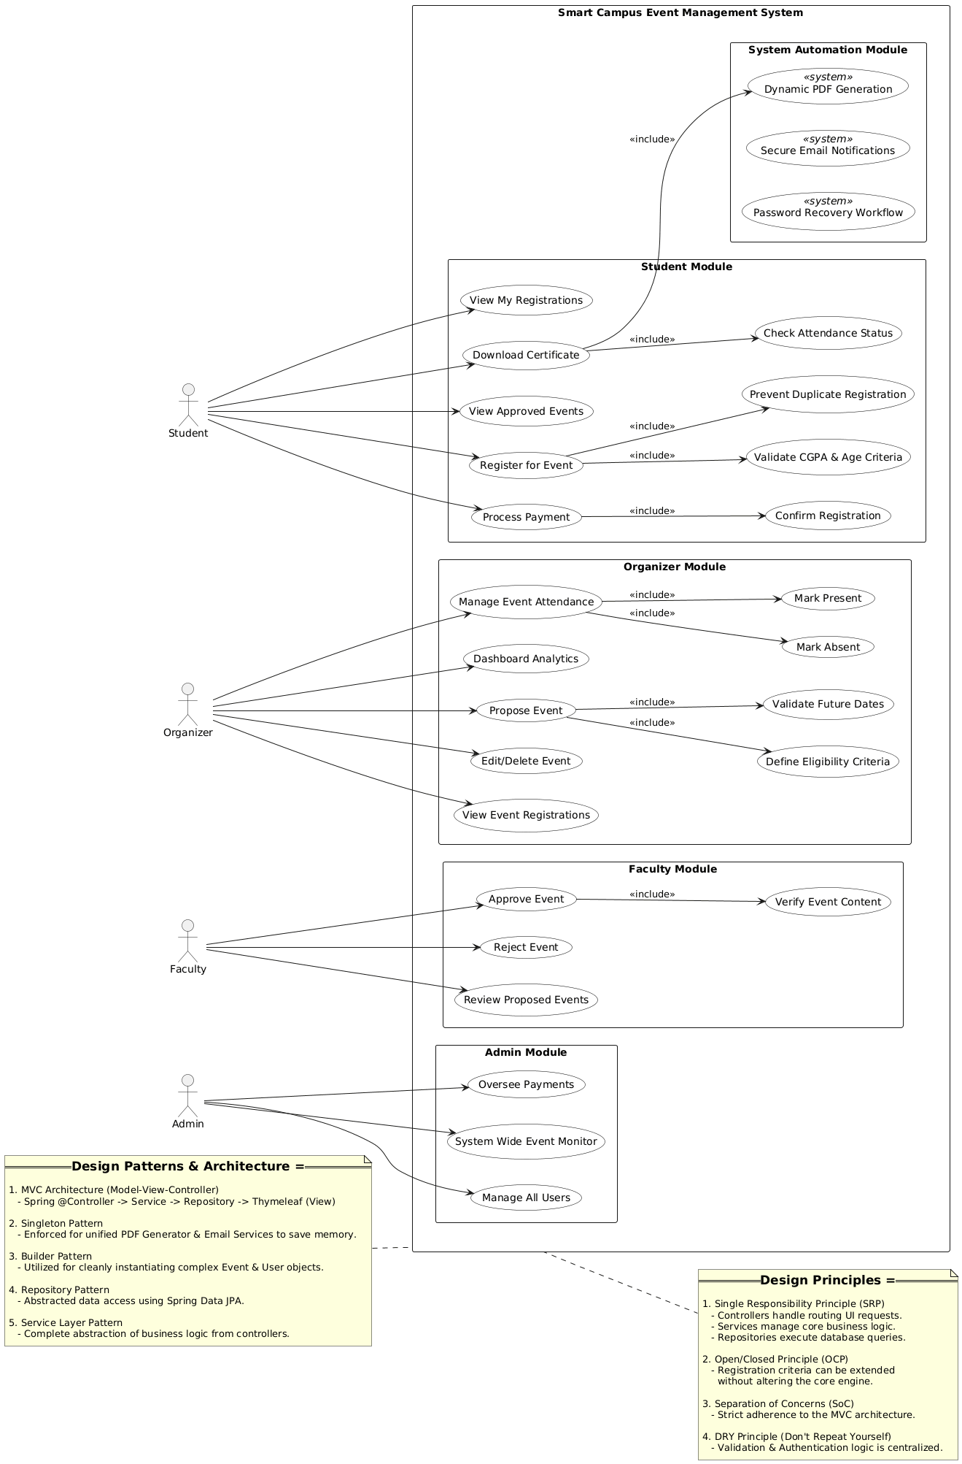
Use Case Diagram:

Class Diagram:

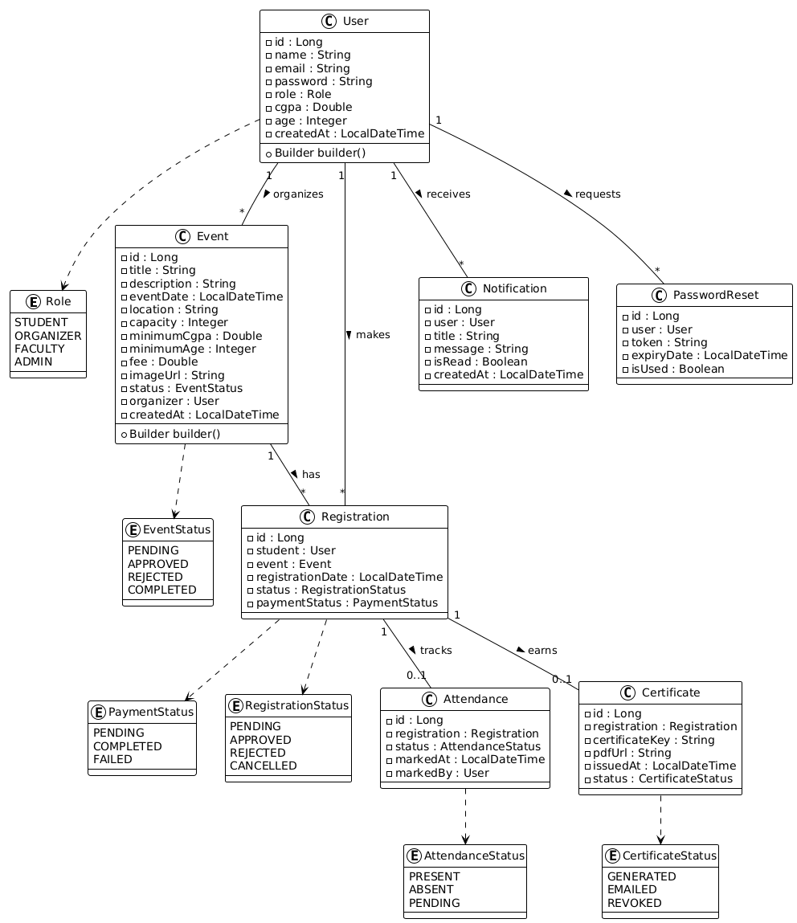

State Diagram:

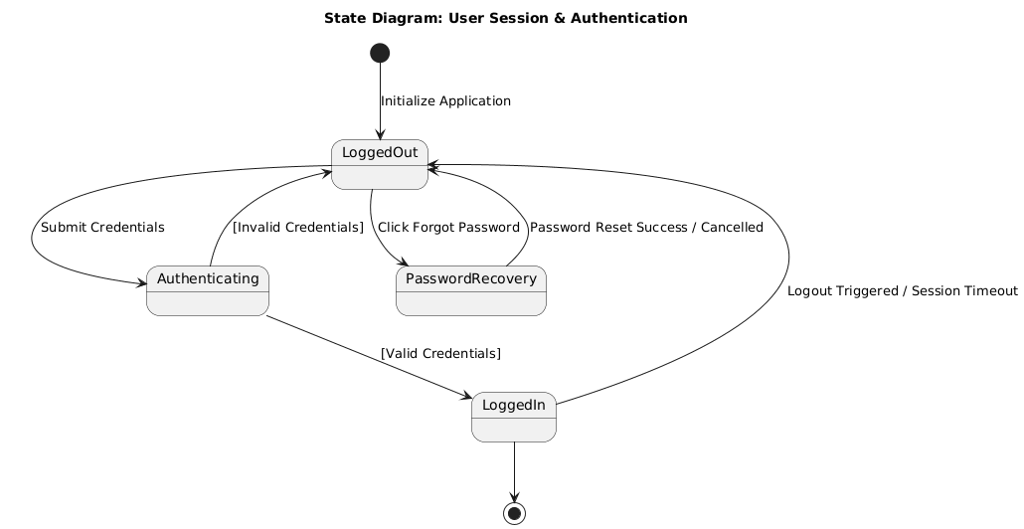

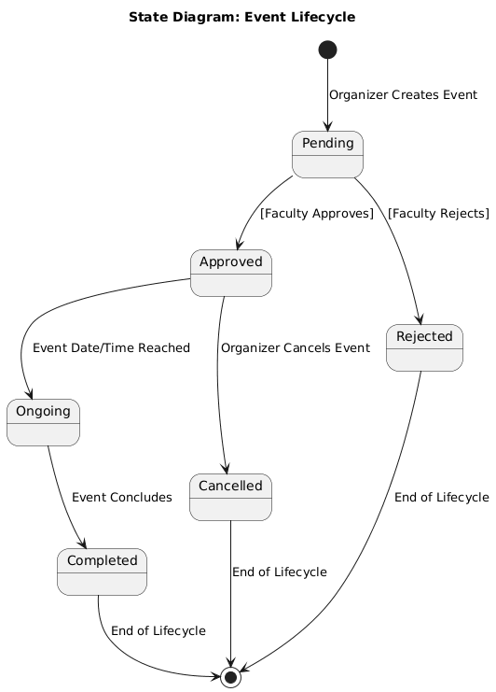

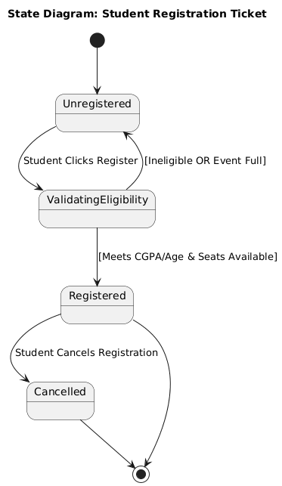

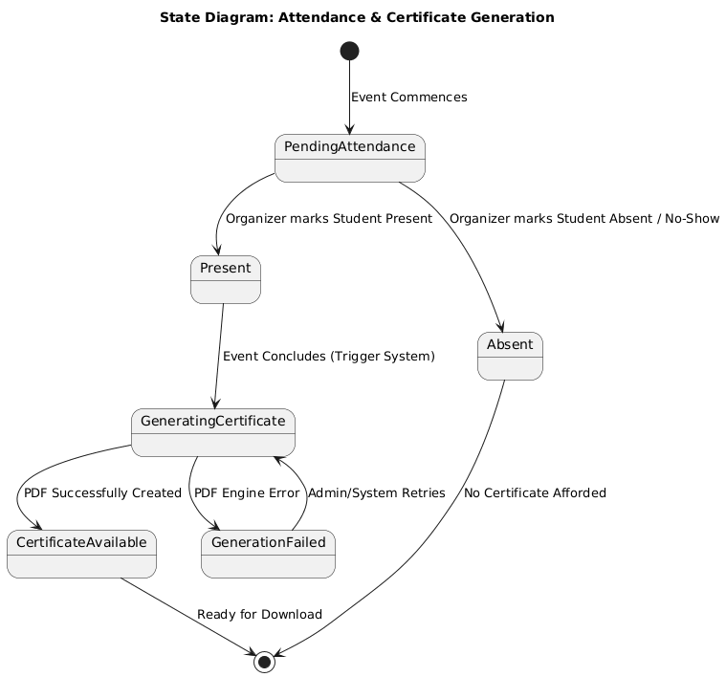

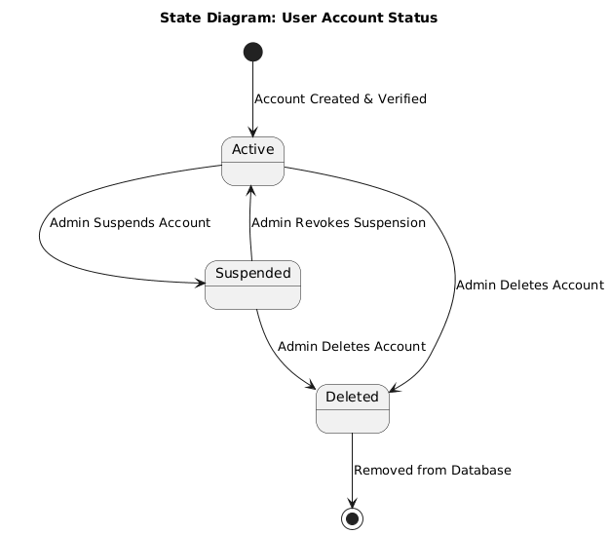

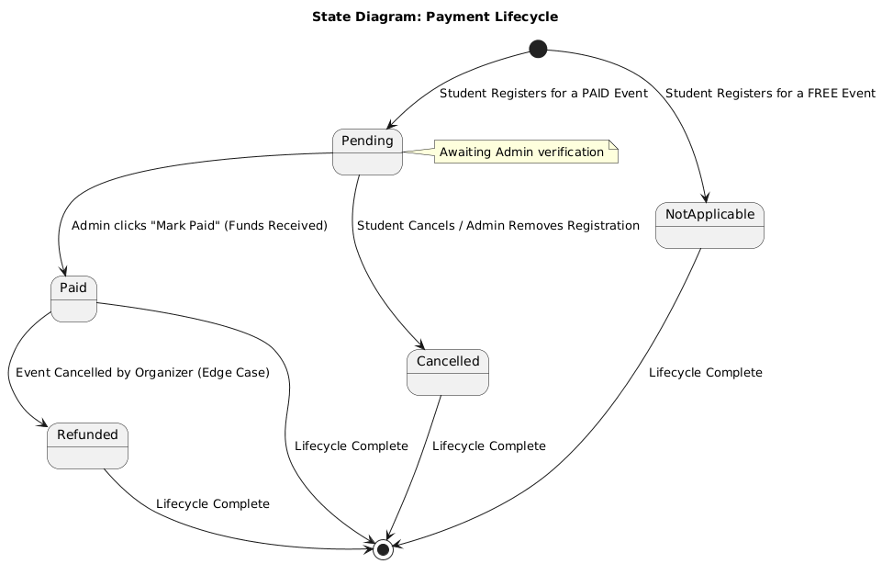

Activity Diagrams:

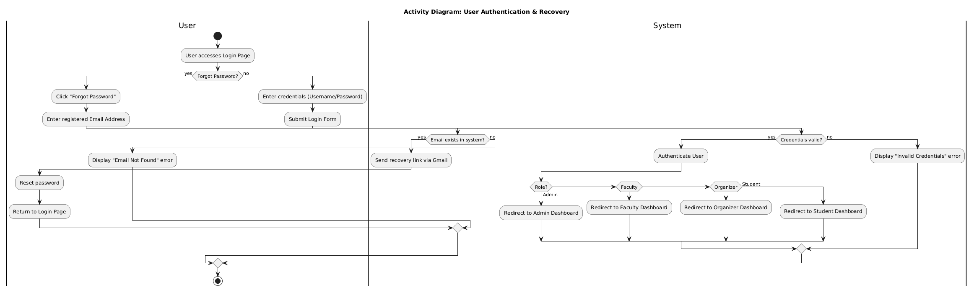

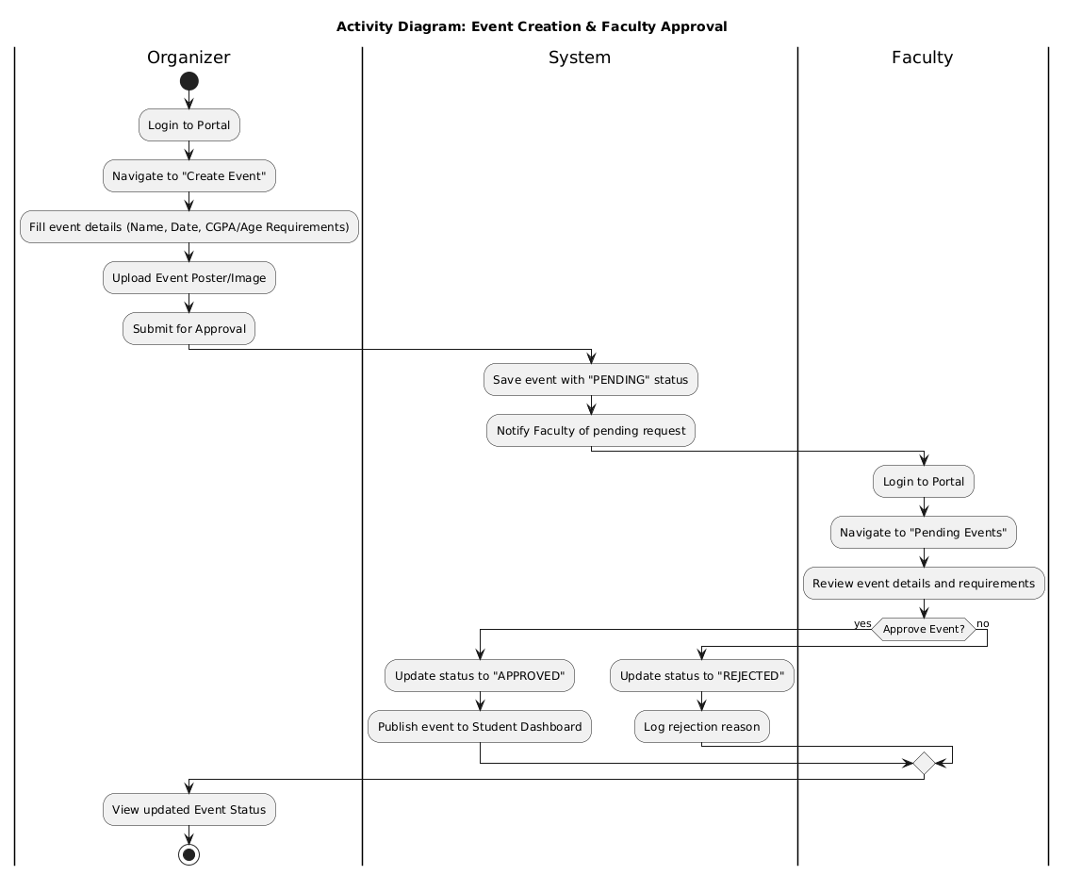

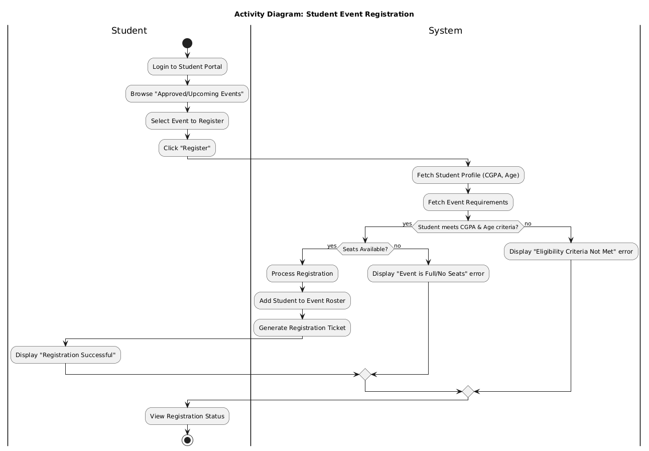

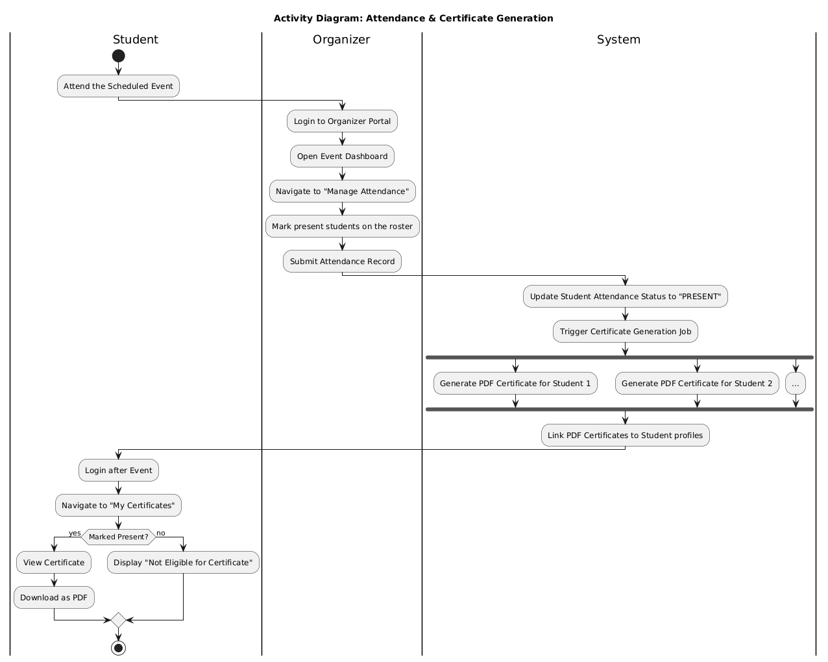

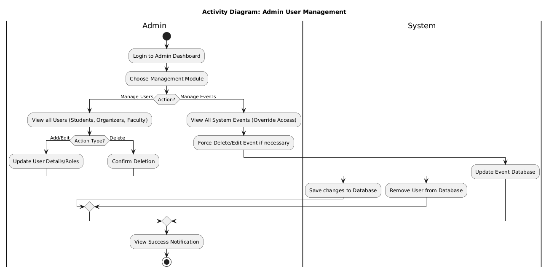

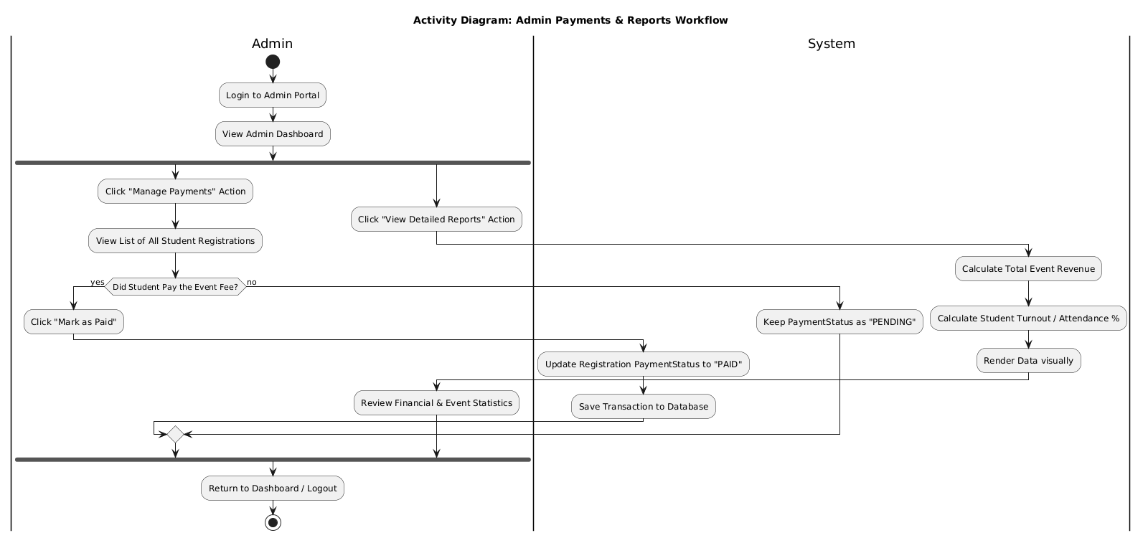
Design Principles, and Design Patterns

MVC Architecture used? Yes

The project is built upon the Model-View-Controller (MVC) architectural pattern using the Spring Boot framework. This pattern divides the application into three interconnected components, ensuring a clear separation of internal representations of information from the ways that information is presented to, and accepted from, the user.

Model (Data & Logic layer): Represents the data and the core business logic of the application. In this project, the Model is implemented using JPA Entity classes (such as User, Event, and Registration). These classes map directly to the backend database tables. The Model also encompasses the Service layer (UserService, RegistrationService), which enforces business rules like checking student eligibility (CGPA and age) before allowing database updates.

View (Presentation layer): Responsible for the user interface and displaying the data provided by the model. The project utilizes Thymeleaf HTML templates (e.g., layout.html, dashboard.html, register.html) as the View layer. It dynamically renders the data to the browser, displaying tailored dashboards based on the logged-in user's role (Admin, Faculty, Organizer, or Student).

Controller (Routing & Request layer): Acts as an interface between the Model and the View. The Controllers (such as StudentController or HomeController) intercept incoming HTTP requests from the user's browser, process user inputs, invoke the necessary business logic from the Service layer, and return the appropriate Thymeleaf View populated with the required data object.

Design Principles:

Single Responsibility Principle (SRP): The project architecture strictly separates concerns into distinct layers. `Controllers` (e.g., `StudentController`) handle only HTTP requests and routing, `Services` (e.g., `RegistrationService`) encapsulate core business logic, and `Repositories` manage database interactions. This ensures each class has only one reason to change.

Dependency Inversion Principle (DIP): Through Spring Boot’s Inversion of Control (IoC) and Dependency Injection, high-level modules like Controllers do not depend on low-level concrete implementations. Instead, dependencies are injected via constructors or `@Autowired`, making the system loosely coupled and easier to test.

Don't Repeat Yourself (DRY): Common, reusable logic—such as user authentication checks, role-based authorization, and student eligibility filtering (CGPA and age)—is centralized within dedicated service methods rather than being duplicated across multiple controller endpoints.

Design Patterns:

Model-View-Controller (MVC) Pattern: This is the core architectural pattern of the application. The Model represents the data structures (Entities like `User`, `Event`, `Registration`), the View defines the frontend presentation (Thymeleaf HTML templates like `attendance.html`), and the Controller manages the data flow between them.

Singleton Pattern: Managed implicitly by the Spring framework. Service classes (like `UserService`) and DAO Repositories are registered as Spring Beans with a default singleton scope. This ensures that only one instance of these classes exists system-wide, optimizing memory consumption and standardizing state.

Builder Pattern: Utilized extensively for complex object creation. It is implemented specifically in `CertificateBuilder.java` to step-by-step construct and generate dynamic PDF certificates. It is also used across entity classes (via Lombok's `@Builder` annotation) to instantiate records cleanly without cumbersome constructors.

Repository / DAO Pattern: Implemented using Spring Data JPA (`JpaRepository`). This pattern abstracts the underlying database interactions, allowing the application to perform CRUD (Create, Read, Update, Delete) operations using domain objects rather than raw, hard-coded SQL queries.

Github link to the Codebase:
https://github.com/Keshavvs123/smart-campus-event-management-system

Screenshots

UI:

Organizer:

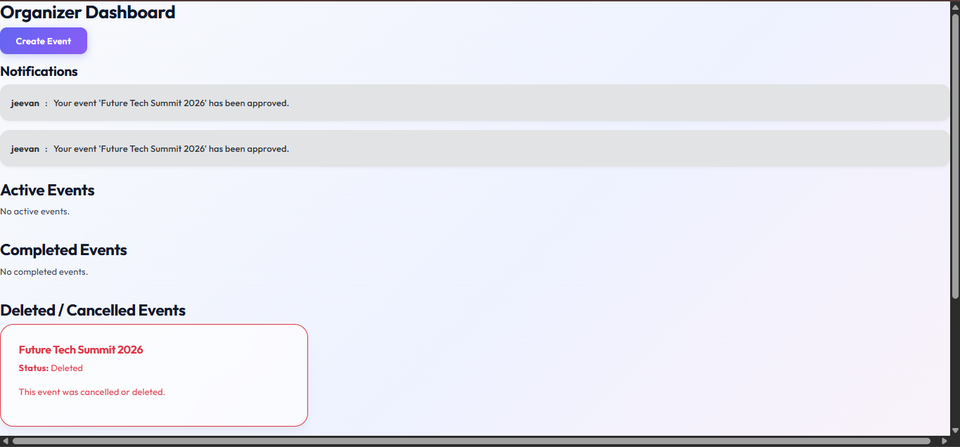

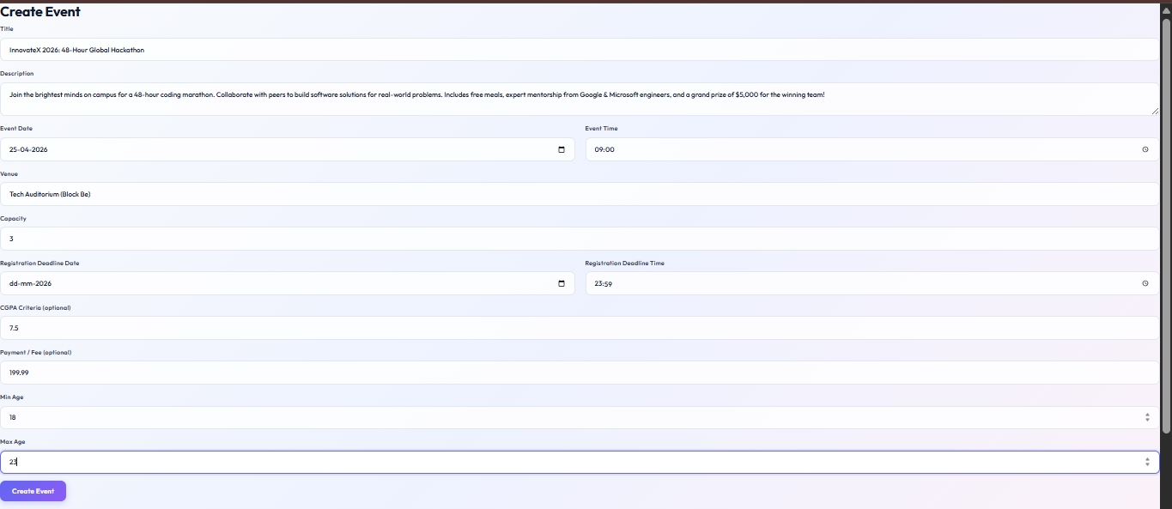

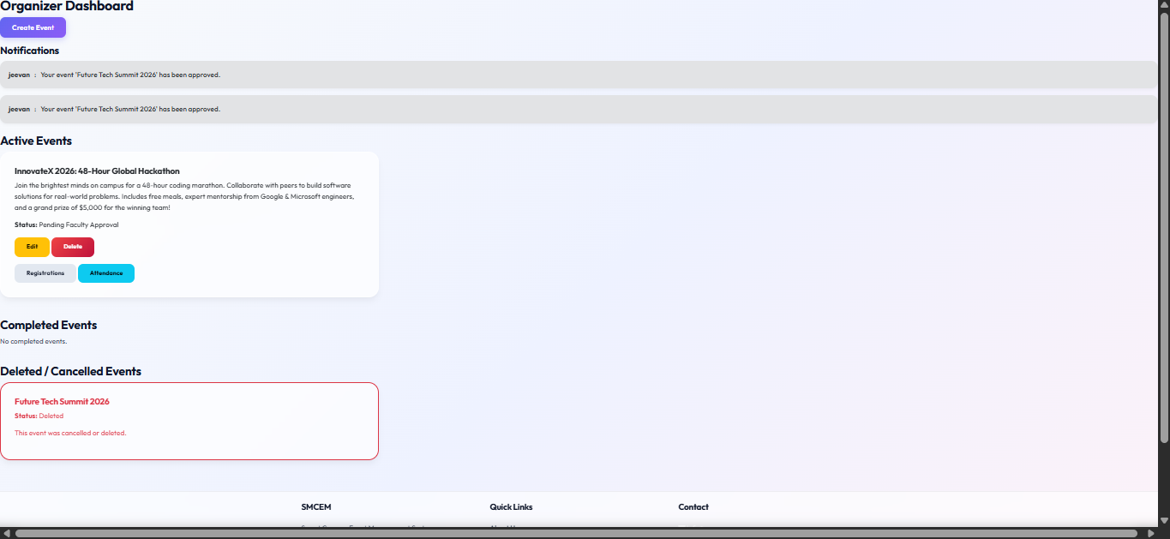

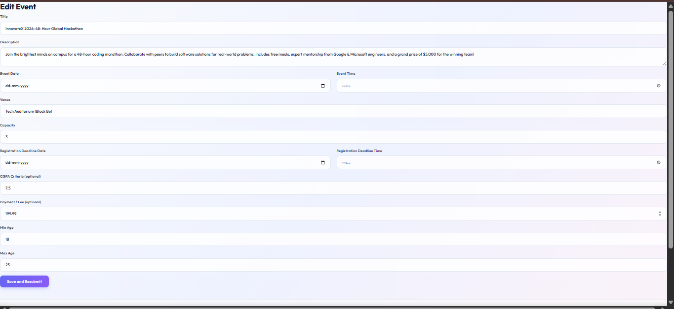

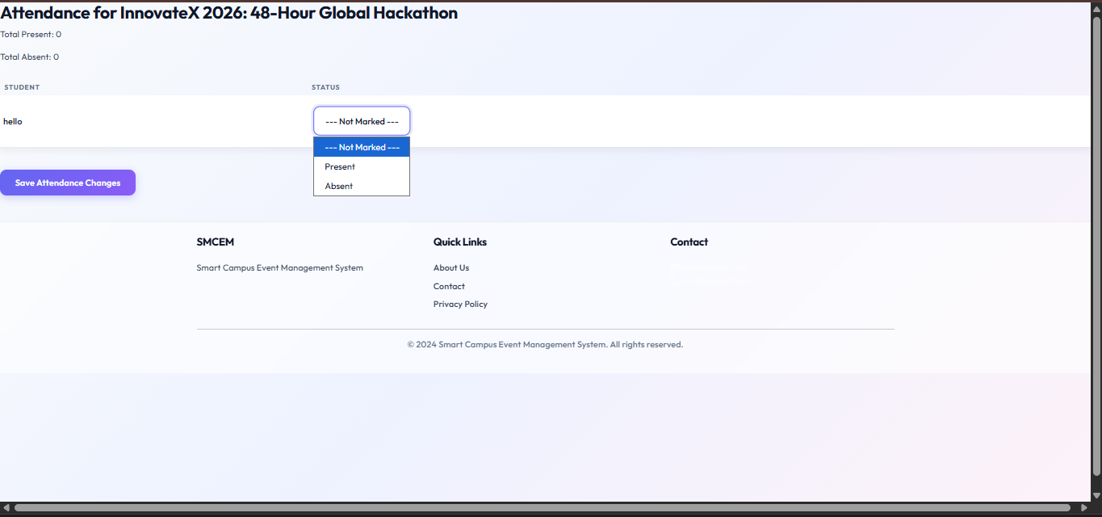

Faculty:

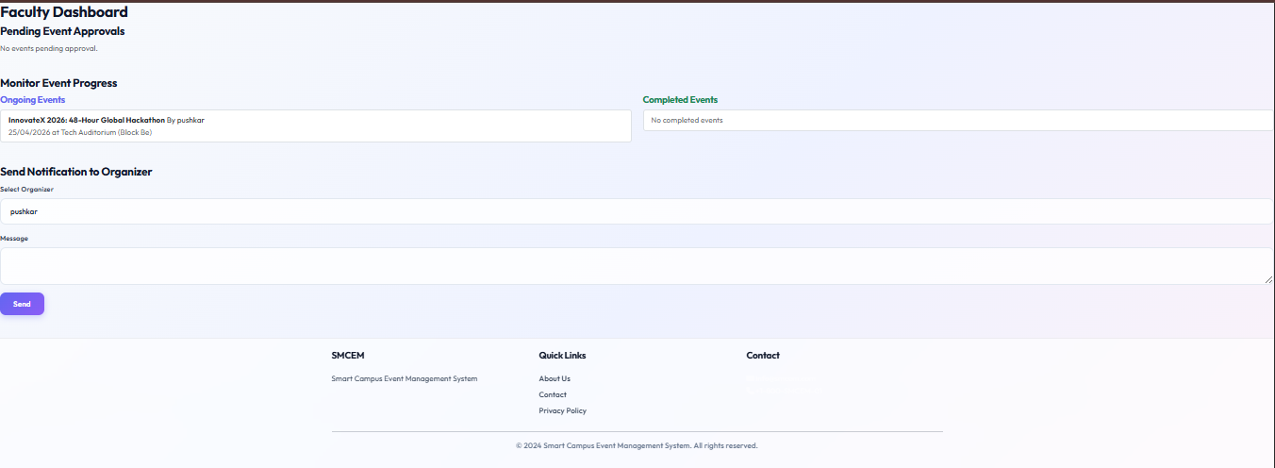

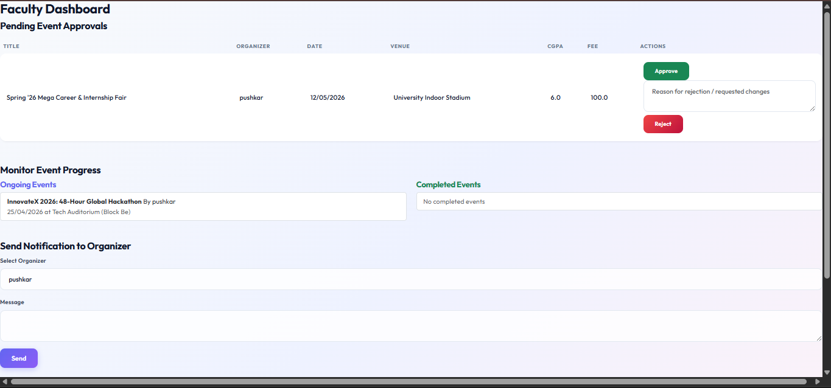

Admin:

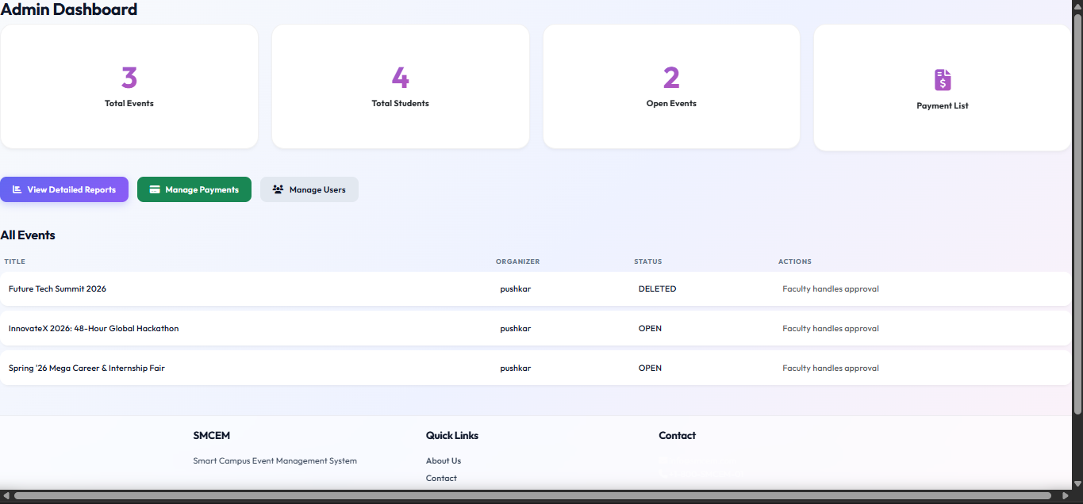

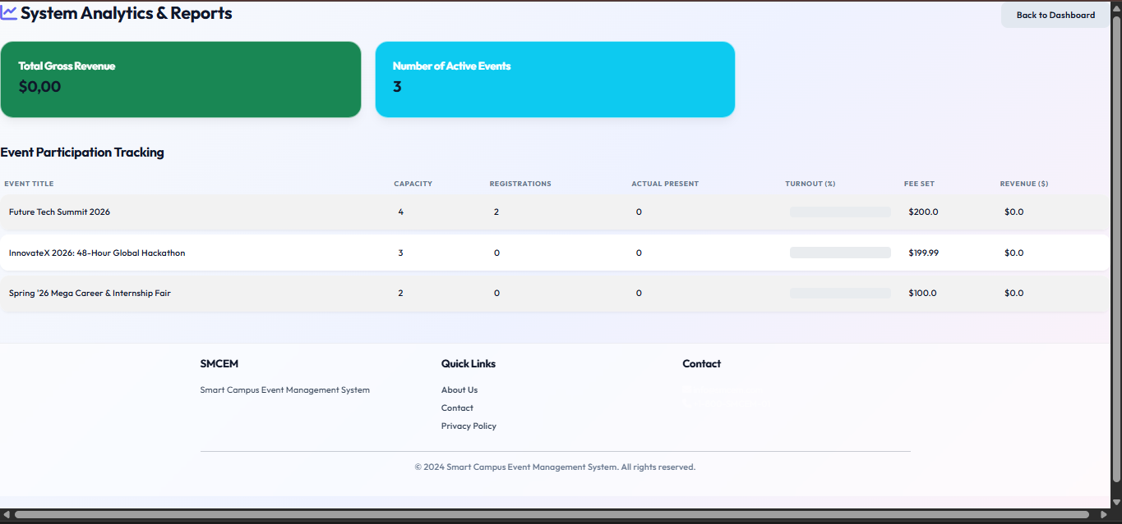

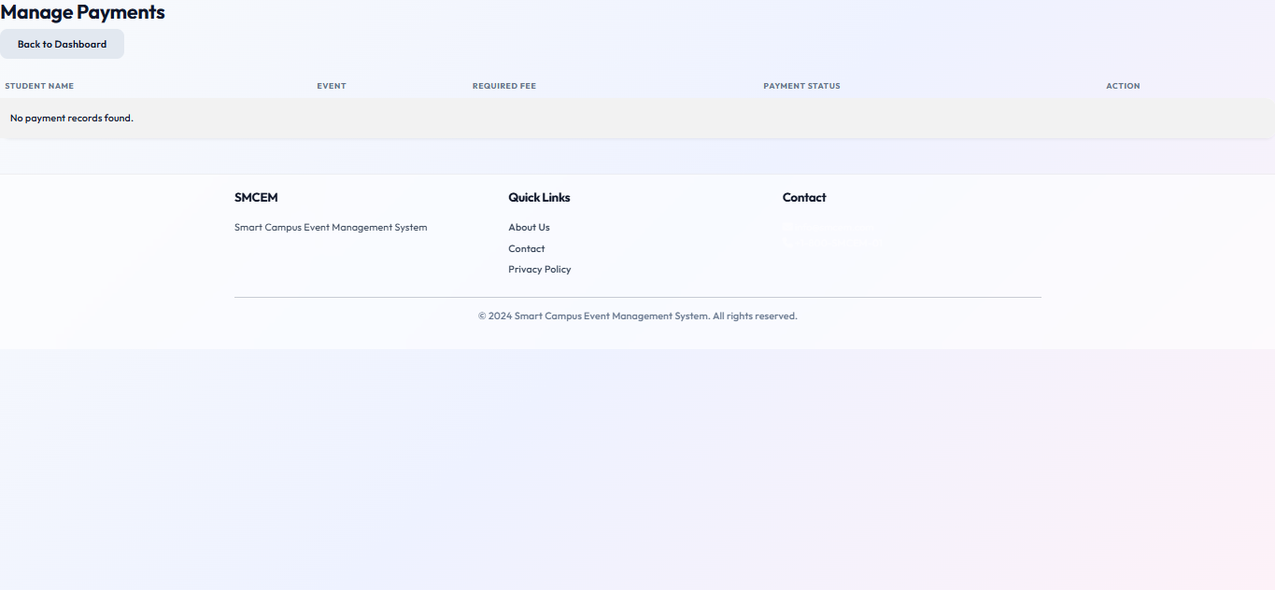

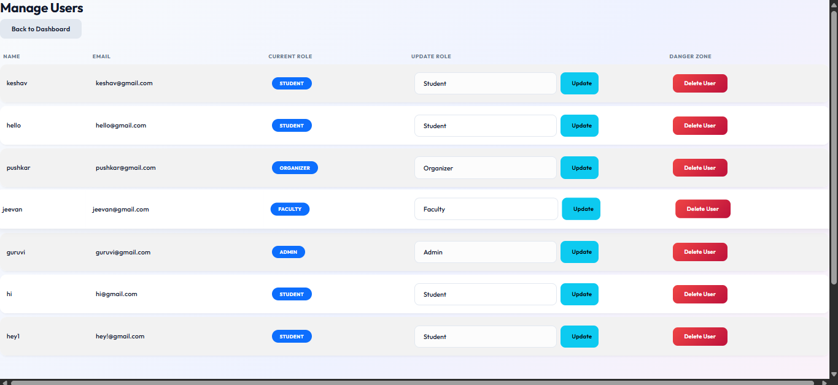

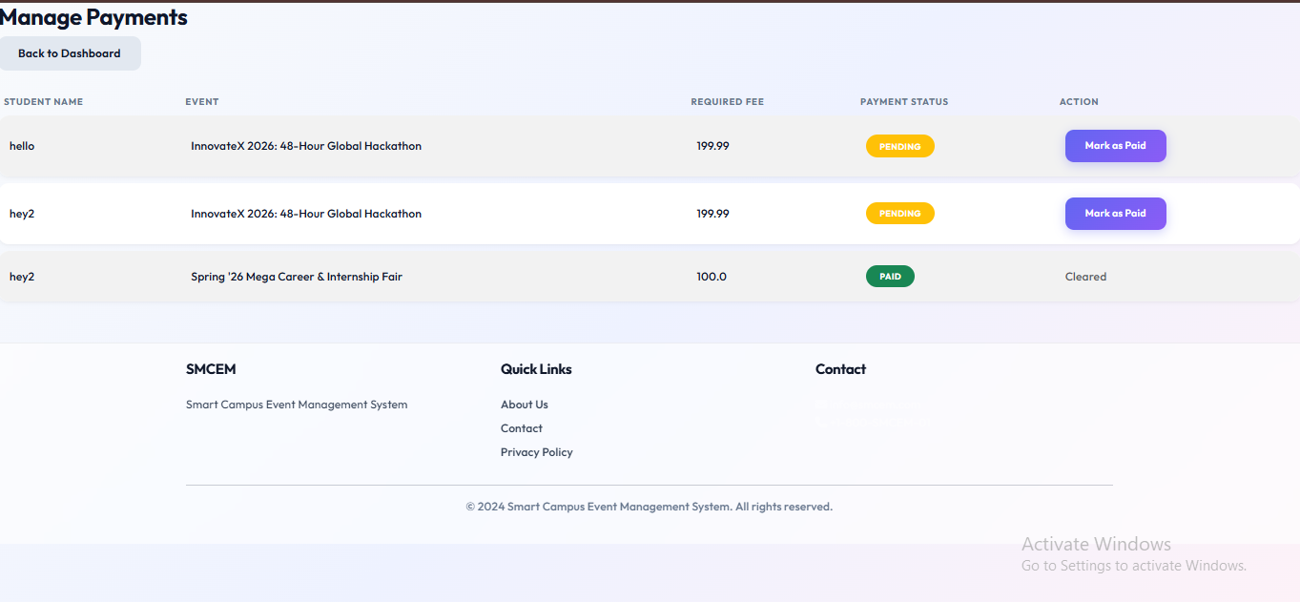

Student:

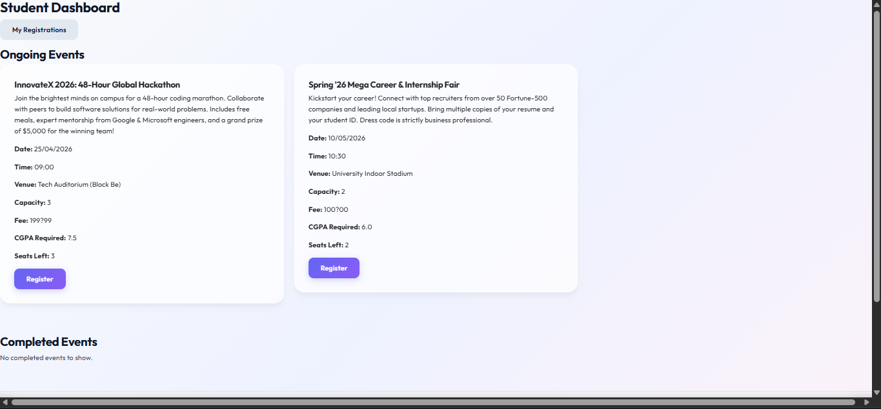

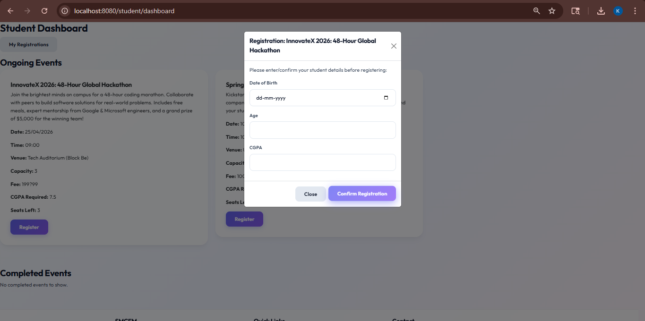

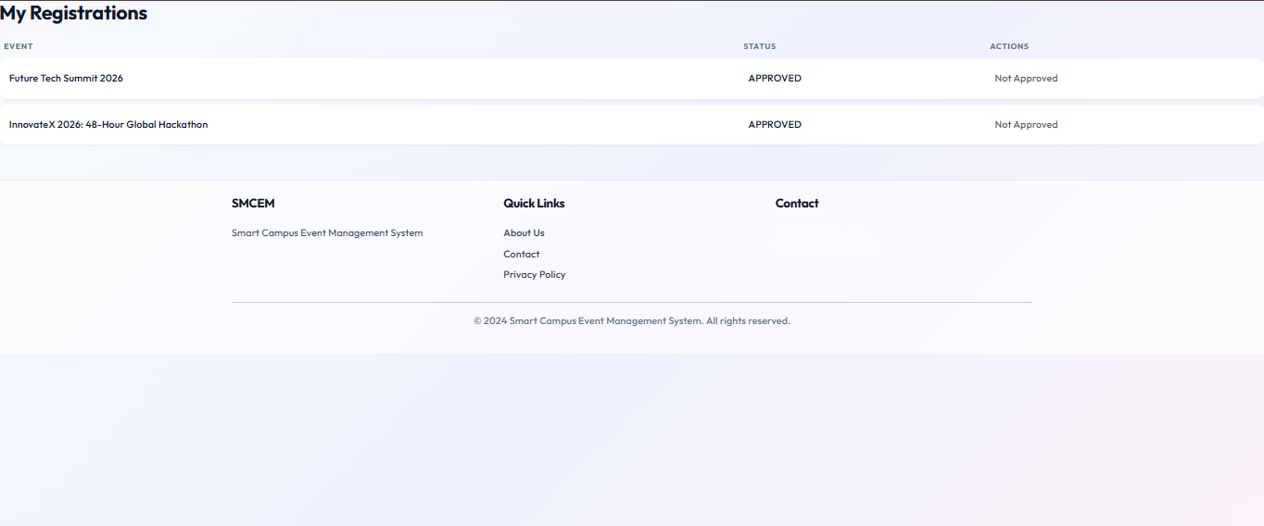

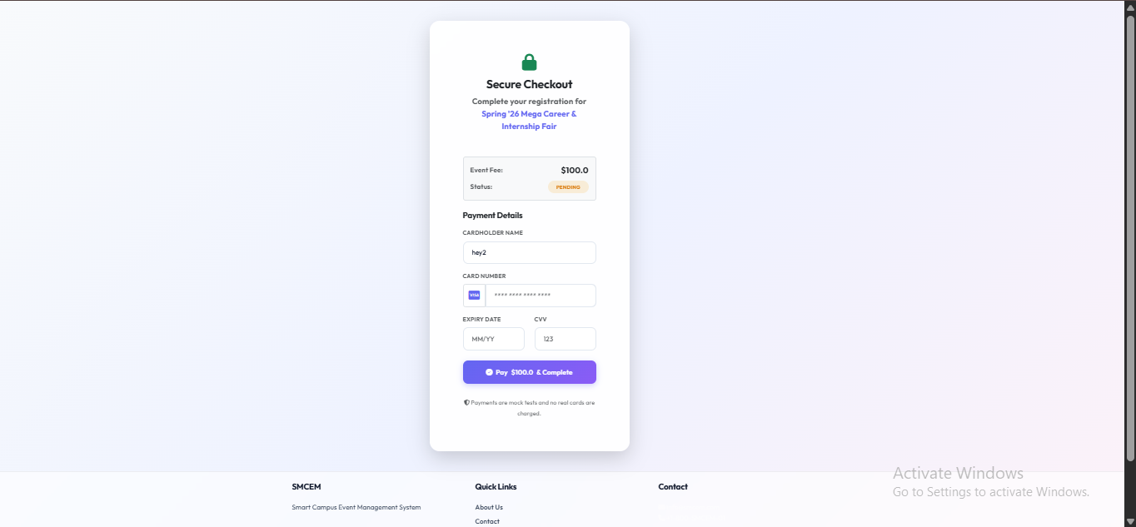

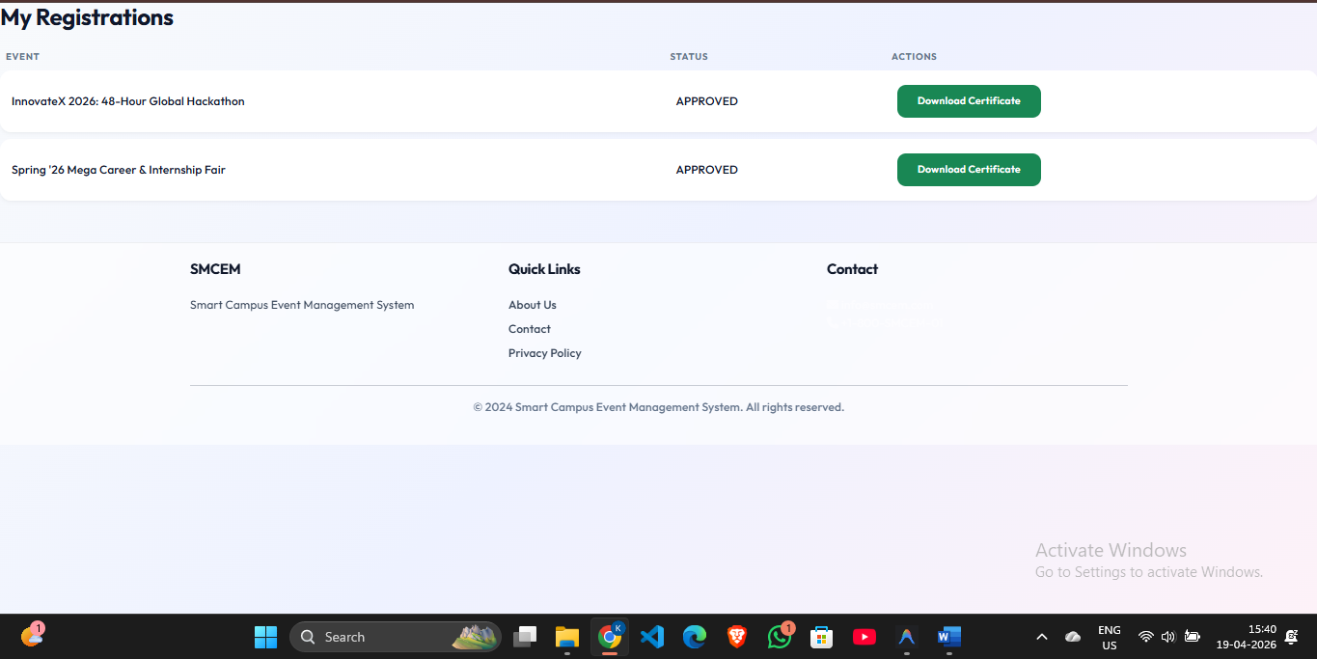

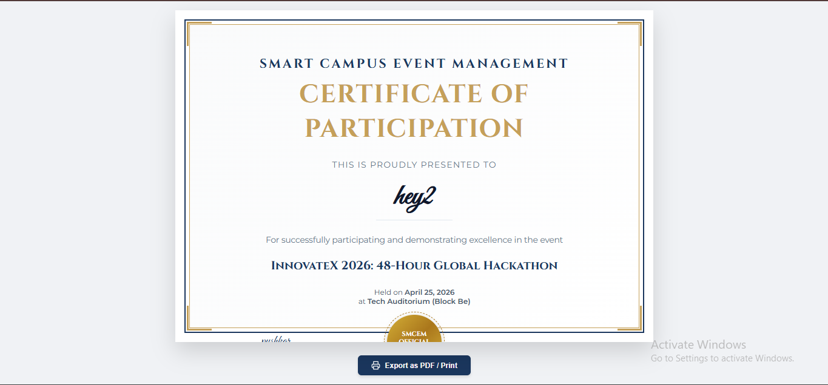

Login Page:

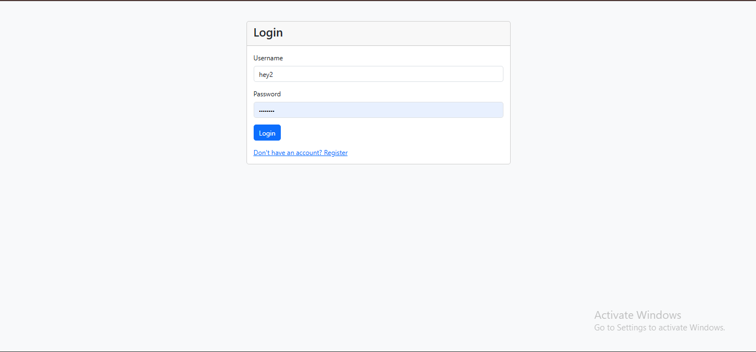

Registration Page:

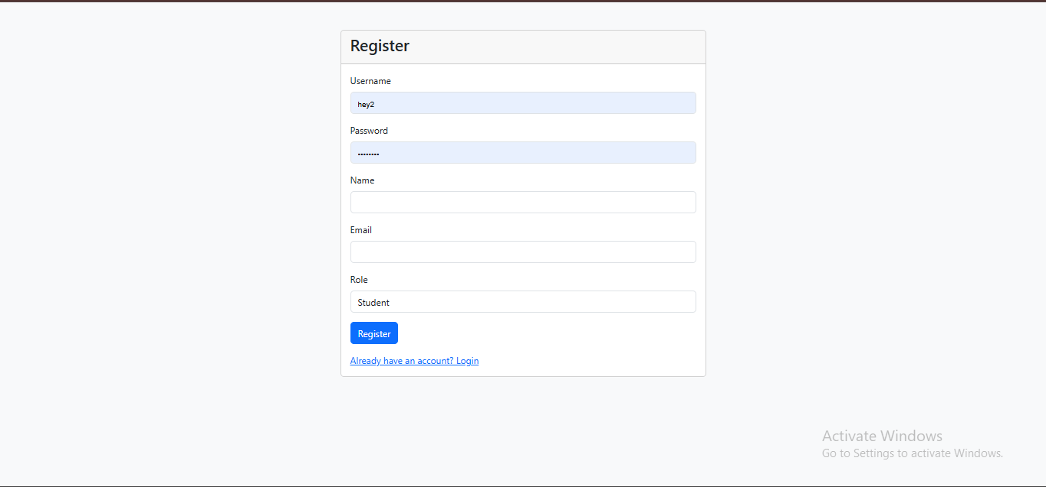

Individual contributions of the team members:

Name | Module worked on
Keshav Vithal Sangonda | Student & Core Workflow Module: Implemented the Student dashboard, intelligent event filtering (Age/CGPA constraints), automated registration workflows, the secure mock payment gateway, and dynamic Certificate of Participation generation.
Pushkar P | Organizer & Event Management Module: Developed the Organizer dashboard, the complete event creation lifecycle (including UI for image uploading), seat capacity logic, and the real-time student attendance tracking system.
Jeevan A N | Faculty Review & Feedback Module: Designed the Faculty dashboard and the event approval ecosystem. Engineered the feedback loop allowing faculty to reject events and append required change messages directly to the Organizer.
Kasa Guruvi Reddy | Admin & Security Infrastructure: Built the core Spring Security authentication (including role-based access control and BCrypt hashing), the Admin overview dashboard with live statistics, global user management, and system reporting logic.

