# /Volumes/MS/All Staff/Branding/Branding - Australias Global University/Logo 2016/Templates/Bands and Tagline/A4_portrait Sydney.png

UNSW

School of Computer Science and Engineering  
Information Systems and   
Technology Management

# 

GROUP ASSIGNMENT COVER SHEET

Group (No./Name): \_\_\_\_\_\_\_\_\_\_\_\_\_\_\_\_\_\_\_\_\_\_\_\_\_\_\_\_\_\_\_\_

Course: \_\_\_\_\_\_\_\_\_\_\_\_COMP9322\_\_\_\_\_\_\_\_\_\_

Tutorial time: \_\_\_\_\_\_\_\_\_\_\_\_\_\_\_\_\_\_\_\_\_\_\_\_\_\_\_\_\_\_\_\_

Assignment Title: \_\_\_\_\_\_\_\_\_\_\_\_\_\_\_\_\_\_\_\_\_\_\_\_\_\_\_\_\_\_\_\_

Due Date: Friday 6th May 2018

We declare that this assessment item is our own work, except where acknowledged, and has not been submitted for academic credit elsewhere, and acknowledge that the assessor of this item may, for the purpose of assessing this item:

* Reproduce this assessment item and provide a copy to another member of the University; and/or,
* Communicate a copy of this assessment item to a plagiarism checking service (which may then retain a copy of the assessment item on its database for the purpose of future plagiarism checking).

We certify that we have read and understood the University Rules in respect of Student Academic

Misconduct.

|  |  |  |  |
| --- | --- | --- | --- |
| zID | Name | Signed | Date |
| \_\_\_\_\_\_\_\_\_\_\_\_\_\_ | \_\_\_\_\_\_\_\_\_\_\_\_\_\_\_\_\_ | \_\_\_\_\_\_\_\_\_\_\_\_\_\_\_\_ | \_\_\_\_\_\_\_\_\_\_\_\_\_\_ |
| \_\_\_\_\_\_\_\_\_\_\_\_\_\_ | \_\_\_\_\_\_\_\_\_\_\_\_\_\_\_\_\_ | \_\_\_\_\_\_\_\_\_\_\_\_\_\_\_\_ | \_\_\_\_\_\_\_\_\_\_\_\_\_\_ |
| \_\_\_\_\_\_\_\_\_\_\_\_\_\_ | \_\_\_\_\_\_\_\_\_\_\_\_\_\_\_\_\_ | \_\_\_\_\_\_\_\_\_\_\_\_\_\_\_\_ | \_\_\_\_\_\_\_\_\_\_\_\_\_\_ |
| \_\_\_\_\_\_\_\_\_\_\_\_\_\_ | \_\_\_\_\_\_\_\_\_\_\_\_\_\_\_\_\_ | \_\_\_\_\_\_\_\_\_\_\_\_\_\_\_\_ | \_\_\_\_\_\_\_\_\_\_\_\_\_\_ |
| \_\_\_\_\_\_\_\_\_\_\_\_\_\_ | \_\_\_\_\_\_\_\_\_\_\_\_\_\_\_\_\_ | \_\_\_\_\_\_\_\_\_\_\_\_\_\_\_\_ | \_\_\_\_\_\_\_\_\_\_\_\_\_\_ |

*This assignment cover sheet is* ***valid only with your signature (not typed)****. The cover sheet is to be provided with any print or digital submission of the assignment. Failure to include a signed cover sheet will lead to a 10% penalty of the total marks available for the assignment. No marks will be released until a signed cover sheet is received.*

**Introduction**

This report aims to help the readers understand the model our group has built more clearly. As is required in the second assignment, there are two models that we have specified, the services model and the information model.

The overall structure could be visualized as the following graph:

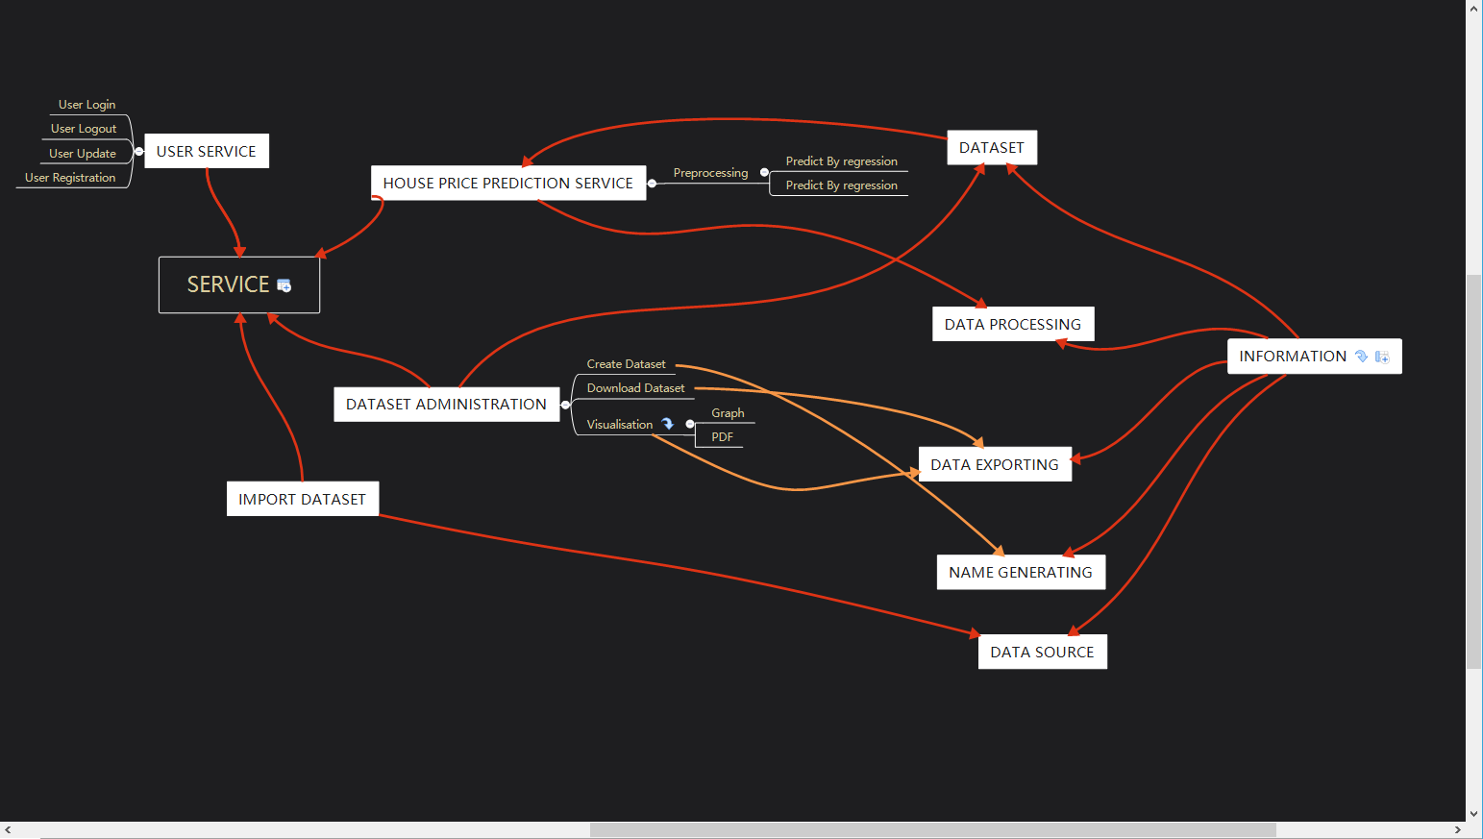

**Information model**

As in the case study, the information part comes first so this paragraph would explain the information section. The concepts in the information modelling are modified from the demo.

In the program aspect, the house price prediction has programs for various functions.

In the data exporting program, we would export data in the format of the user’s choice. And there is a function for the name of the output data when exported as PDF file or graph, it would generate the name of data in the system to prevent the same file name from the similar requests from users, which is related to the name generating program.

In the data processing program, it needs the parameters for the algorithms, which would be extracted from the system for users to choose in the instance. Then, as in the instances, the program would preprocess the data in the first step, the following step could be prediction in regression or prediction in neural network.

In the dataset parts, the creation date and the name of the dataset are saved as attributes. Then we have some instances, such as the dataset storing the raw data gained from the Domain website, the dataset with the output of the predicted house price and the dataset used for the clean type of the house price.

The data source is the domain website as is specified in the assignment and the result is calculated through the data processing program with its unique format. Then the user’s information is in the User parts in the programs.

There is also the house place’s information in the model. When the users are looking for the place, the location of the house or the level and room of the office could be gained.

**Services model**

The second model is related to the service aspect, where the model could be built under the Digital Interactions module. Because the assignment only introduce the functions that could be used by the users in the operational system.

First of all, when the service is related to the online users, it is essential for the system to have the ability handling the users information. In this case, the basic functions for the users’ behaviors, which could include the registration, login, logout and the information update, are created for both new users and existing users. If a user comes to the website for the first time, the new account for this user could be registered that the information, which are the birth date, email address, name, password and user id, would be posted to the database. Then the information of the account could be accessed when the user login, meanwhile a session for the login would created and would be deleted while logout. In the period of activated session, user could modify the information of the account and update it to the database.

After the functions for user’s account, the functions of importing datasets are taken into consideration. From the description in the assignment, downloading data from the Domain.com.au and creating a new dataset related to the downloaded data are necessary functions. This is implemented by “Import Dataset” and “Create Dataset”.

Then, when the data is imported, it should be preprocessed and the user have the choice of methods, which have the links to the regression program or neural network program, to do the prediction and return the result.

In the last step, users also have two options for them. Therefore, we assign the DownloadDataset and VisualizeDataset to output the PDF file or a graph. In the download function “DownloadDataset”, the dataset would be transformed from the type”house prices prediction”. While in the visualizing function, the graph would be created.

**Interface Model**

After the previous two models have been defined, the following model is to make the interface that help users interact with the services using the information objects.

In the house price prediction application for the users, there is the main page for the users to navigate to the other functional parts such as user register page or login page. Then after the login, the user would return to the main page with the user update or logout bar. Meanwhile, the main page would show the users the page to import the dataset with the user’s selection and input parameters. With the dataset created by the user’s choice, it would be preprocessed first and user could select the different methods in the execute model page. The result page would be shown to the user after the prediction is done by the selected program. At this time, the bars of methods to export the data, which are downloading the data as PDF file or visualizing the data as graph, would be in this page for the user selection. Finally, the different page would pop out related to the selection. When it is to download the dataset, the needed data could be selected for output. When the visualization is chosen, there is also a choice of needed dataset and the format of the graph could be determined.

**Process Instance**

This process instance is related to the previous interface model. For the user section, which includes the registration, login, logout and update, the relationship is shown in the following graph:

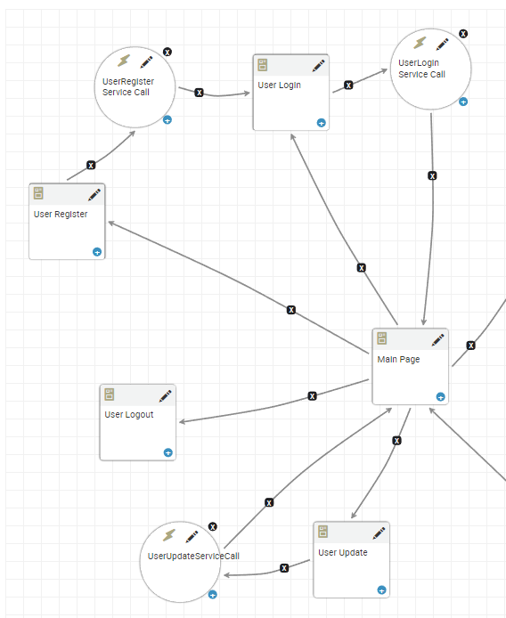

It could been seen that the user section is designed to be linked with the main page, which means the users could operate their own state from the beginning of the application. Then, after a series of user’s operations that are told in the assignment’s requirement, the result would come out and the application would return to the main page for the next query or user’s logout.

