**COMP9444 18s2 Assignment 2 Report**

**Keshi Chen z5142821**

**Chuguan Tian z5145006**

**Description:**

In this project, we aim to implement a RNN neurall network to do sentiment classification on IMDB reviews. This project includes two parts, preprocessing and graph design.

In the preprocessing phase, we firstly removed common and neutral words by measuring the word’s relevance between positive and negative attitude. Then for each article, we only collected the first 40 words. We also removed punctuations.

In the graph design phase, we defined 128 LSTM cells and dropout cell with keeping probability 0.9.

To define the weights, we choose truncated_normal_initializer which values more than two standard deviations from the mean are discarded and re-drawn. This is the recommended initializer for neural network weights and filters. Bias is initialized as 0.

The optimizer we choose to use is Adam optimizer which is popular on NLP problems by its characteristic of maitaining individual adaptive learning rates.

Structure of RNN Network:

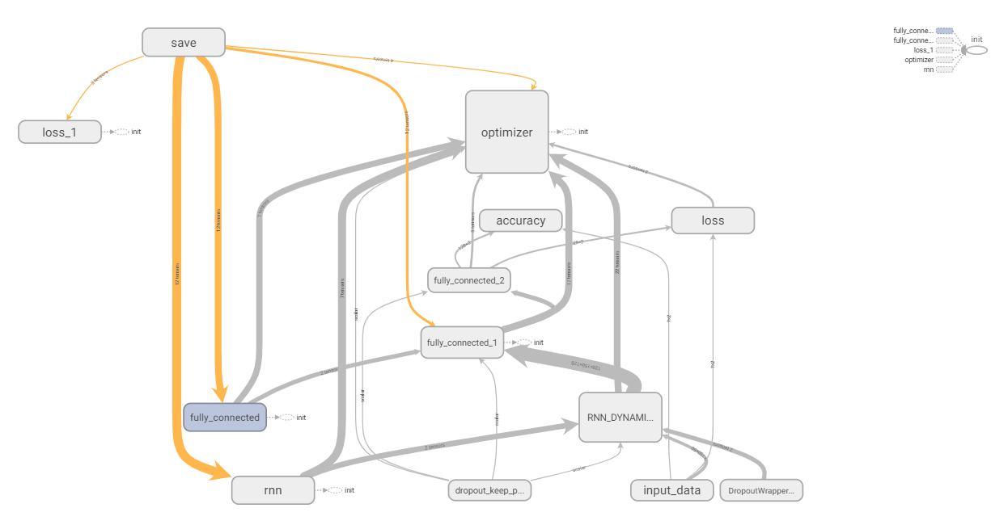

Parameters:  
After several times of trying various of max words in review and batch size, we found the parameter setting that produce the best test-accuracy(about 75%), they are :

BATCH_SIZE = 128

MAX_WORDS_IN_REVIEW = 40