- Utilitza el Packet Tracer per construir la xarxa que us especifica el següent Diagrama de Topologia. Utilitza els routers 1841 i configura'ls per tal que tinguin 2 ports serial.

- Crea la Taula d'Adreçament corresponent a aquest Diagrama de Topologia.
 | Nom del Dispositiu | Interfície (IP + MX) | Gateway
Xarxa 1 (LAN1)  172.16.3.0/24 | PC1 | FastEthernet 0: 172.16.3.2/24 255.255.255.0 | 172.16.3.1
Xarxa 1 (LAN1)  172.16.3.0/24 | Router1 | FastEthernet 0/0: 172.16.3.1/24 255.255.255.0 | Es la Gateway
Xarxa 2 (LAN2)  172.16.1.0/24 | PC2 | FastEthernet 0:  172.16.1.2/24 255.255.255.0 | 172.16.1.1
Xarxa 2 (LAN2)  172.16.1.0/24 | Router2 | FastEthernet 0/0: 172.16.1.1/24 255.255.255.0 | Es la Gateway
Xarxa 3 (LAN3)  192.168.2.0/24 | PC3 | FastEthernet 0:  192.168.2.0/24 255.255.255.0 | 192.168.2.1
Xarxa 3 (LAN3)  192.168.2.0/24 | Router3 | FastEthernet 0/0: 192.168.2.1/24 255.255.255.0 | Es la Gateway
Xarxa 4 (WAN1)  172.16.2.0/24 | Router1 | Serial 0/0/0:  172.16.2.1/24 255.255.255.0 | 172.16.2.2 (Next hop)
Xarxa 4 (WAN1)  172.16.2.0/24 | Router2 | Serial 0/0/0:  172.16.2.2/24 255.255.255.0 | 172.16.2.1 (Next hop)
Xarxa 5 (WAN2)  192.168.1.0/24 | Router3 | Serial 0/0/0:  172.16.1.1/24 255.255.255.0 | 172.16.1.2 (Next hop)
Xarxa 5 (WAN2)  192.168.1.0/24 | Router2 | Serial 0/0/0:  172.16.1.2/24 255.255.255.0 | 172.16.1.1 (Next hop)
- Configureu, per CLI (línia de comandes)
- Les adreces IP dels routers

ROUTER2 FAST ETHERNET 0/0
Router>enable
Router#config terminal
Enter configuration commands, one per line. End with CNTL/Z.
Router(config)#interface fa
Router(config)#interface fastEthernet 0/0
Router(config-if)#ip address 172.16.1.1 255.255.255.0
Router(config-if)#no shutdown
%LINK-5-CHANGED: Interface FastEthernet0/0, changed state to up

%LINEPROTO-5-UPDOWN: Line protocol on Interface FastEthernet0/0, changed state to up
ROUTER1 FAST ETHERNET 0/0
Router>enable
Router#config ter
Router#config terminal
Enter configuration commands, one per line. End with CNTL/Z.
Router(config)#interface fa
Router(config)#interface fastEthernet 0/0
Router(config)#interface fastEthernet 0/0
Router(config-if)#ip address 172.16.3.1 255.255.255.0
Router(config-if)#no shutdown

Router(config-if)#
%LINK-5-CHANGED: Interface FastEthernet0/0, changed state to up

%LINEPROTO-5-UPDOWN: Line protocol on Interface FastEthernet0/0, changed state to up
ROUTER3 FAST ETHERNET 0/0
Router>enable
Router#config
Router#configure ter
Router#configure terminal
Enter configuration commands, one per line. End with CNTL/Z.
Router(config)#inter
Router(config)#interface F
Router(config)#interface FastEthernet 0
Router(config)#interface FastEthernet 0/0
Router(config)#interface FastEthernet 0/0
Router(config-if)#ip add
Router(config-if)#ip address 17
Router(config-if)#ip address 172
Router(config-if)#ip address 192.168.2.1 255.255.255.0
Router(config-if)#no shutdown

Router(config-if)#
%LINK-5-CHANGED: Interface FastEthernet0/0, changed state to up

%LINEPROTO-5-UPDOWN: Line protocol on Interface FastEthernet0/0, changed state to up
ROUTER2 SERIAL 0/0/0
Router>enable
Router#confi
Router#configure ter
Router#configure terminal
Enter configuration commands, one per line. End with CNTL/Z.
Router(config)#inter
Router(config)#interface se
Router(config)#interface serial 0
Router(config)#interface serial 0/0/0
Router(config-if)#ip addre
Router(config-if)#ip address 172.18.2.2 255.255.255.0
Router(config-if)#no shutdown

%LINK-5-CHANGED: Interface Serial0/0/0, changed state to down
Router(config-if)#
ROUTER2 SERIAL 0/0/1
Router(config-if)#exit
Router(config)#inter
Router(config)#interface S
Router(config)#interface Serial 0/0/1
Router(config-if)#ip address 192.168.1.2 255.255.255.0
Router(config-if)#clock rate 56000
Router(config-if)#no shutdown

%LINK-5-CHANGED: Interface Serial0/0/1, changed state to down
ROUTER1 SERIAL 0/0/0
Router#confi
Router#configure ter
Router#configure terminal
Enter configuration commands, one per line. End with CNTL/Z.
Router(config)#fas
Router(config)#fast Eth
Router(config)#inter
Router(config)#interface Se
Router(config)#interface Serial 0/0/0
Router(config-if)#ip address 172.18.2.1 255.255.255.0
Router(config-if)#clock rate 56000
Router(config-if)#no shutdown
Router(config-if)#
%LINK-5-CHANGED: Interface Serial0/0/0, changed state to up

Router(config-if)#
%LINEPROTO-5-UPDOWN: Line protocol on Interface Serial0/0/0, changed
ROUTER3 SERIAL 0/0/0
Router>enable
Router#confi
Router#configure ter
Router#configure terminal
Enter configuration commands, one per line. End with CNTL/Z.
Router(config)#inter
Router(config)#interface Se
Router(config)#interface Serial 0/0/0
Router(config-if)#ip address
Router(config-if)#ip address 192.168.1.1 255.255.255.0
Router(config-if)#no shutdown

Router(config-if)#
%LINK-5-CHANGED: Interface Serial0/0/0, changed state to up

- Les adreces dels PCs, mitjançant DHCP
https://www.cisco.com/c/en/us/td/docs/ios/12_2/ip/configuration/guide/fipr_c/1cfdhcp.html

ROUTER1
Router(config)#service dhcp
Router(config)#ip dhcp pool POOL1
Router(dhcp-config)#network 172.16.3.0 255.255.255.0
Router(dhcp-config)#default-router 172.16.3.1
Router(dhcp-config)#ip dhcp excluded-address 172.16.3.1
Router(dhcp-config)#exit
Router(config)#
PC1
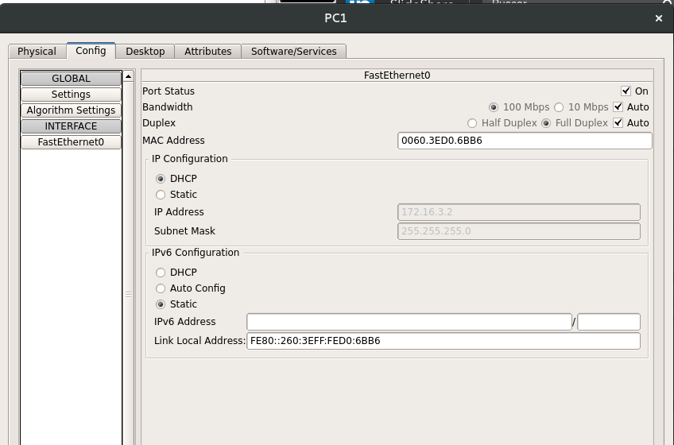
C:\>ipconfig

FastEthernet0 Connection:(default port)

Link-local IPv6 Address.........: FE80::260:3EFF:FED0:6BB6
IP Address......................: 172.16.3.2
Subnet Mask.....................: 255.255.255.0
Default Gateway.................: 172.16.3.1

C:\>
ROUTER2
Router>enable
Router#config
Router#configure ter
Router#configure terminal
Enter configuration commands, one per line. End with CNTL/Z.
Router(config)#service dhcp
Router(config)#ip dhcp pool POOL1
Router(dhcp-config)#network 172.16.1.0 255.255.255.0
Router(dhcp-config)#default-router 172.16.1.1
Router(dhcp-config)#ip dhcp excluded-address 172.16.1.1
Router(config)#exit
Router#
%SYS-5-CONFIG_I: Configured from console by console

Router#
PC2
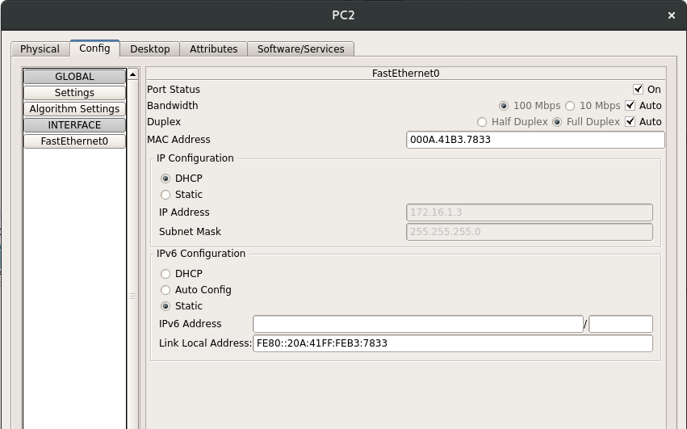
C:\>ipconfig

FastEthernet0 Connection:(default port)

Link-local IPv6 Address.........: FE80::20A:41FF:FEB3:7833
IP Address......................: 172.16.1.3
Subnet Mask.....................: 255.255.255.0
Default Gateway.................: 172.16.1.1

C:\>
ROUTER3
Router>enable
Router#config
Router#configure ter
Router#configure terminal
Enter configuration commands, one per line. End with CNTL/Z.
Router(config)#service dhcp
Router(config)#ip dhcp pool POOL1
Router(dhcp-config)#network 192.168.2.0 255.255.255.0
Router(dhcp-config)#default-router 192.168.2.1
Router(dhcp-config)#ip dhcp excluded-address 192.168.2.1
Router(config)#exit
Router#
%SYS-5-CONFIG_I: Configured from console by console

Router#
PC3
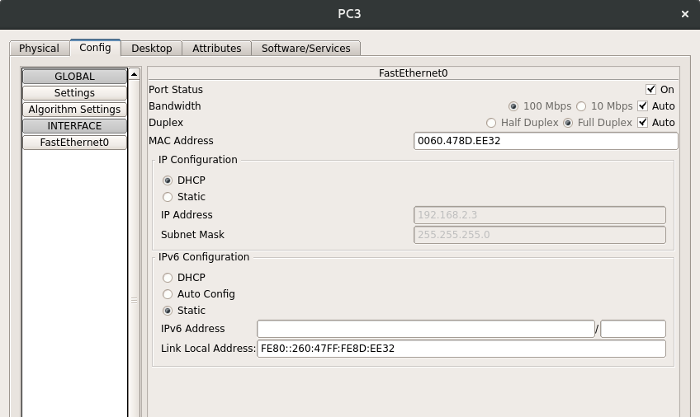
C:\>ipconfig

FastEthernet0 Connection:(default port)

Link-local IPv6 Address.........: FE80::260:47FF:FE8D:EE32
IP Address......................: 192.168.2.3
Subnet Mask.....................: 255.255.255.0
Default Gateway.................: 192.168.2.1

C:\>

- Copia la configuració del running-config a l'startup-config. No t'oblidis d'anar fent aquest pas a mesura que avances en l'exercici.
ROUTER1
Router>enable
Router#copy running-c
Router#copy running-config star
Router#copy running-config startup-config
Destination filename [startup-config]?
Building configuration...
[OK]
Router#
ROUTER2
Router>enable
Router#copy ru
Router#copy running-config sta
Router#copy running-config startup-config
Destination filename [startup-config]?
Building configuration...
[OK]
Router#
ROUTER3
Router>enable
Router#copy ru
Router#copy running-config star
Router#copy running-config startup-config
Destination filename [startup-config]?
Building configuration...
[OK]
Router#

- Visualitza les taules d'enrutament de cada router i comprova que contenen les xarxes connectades directament a cadascun d'ells. Quina comanda utilitzes per veure la taula d'enrutament d'un router? Inclou el resultat.
ROUTER1
Router#show ip route
Codes: C - connected, S - static, I - IGRP, R - RIP, M - mobile, B - BGP
D - EIGRP, EX - EIGRP external, O - OSPF, IA - OSPF inter area
N1 - OSPF NSSA external type 1, N2 - OSPF NSSA external type 2
E1 - OSPF external type 1, E2 - OSPF external type 2, E - EGP
i - IS-IS, L1 - IS-IS level-1, L2 - IS-IS level-2, ia - IS-IS inter area
* - candidate default, U - per-user static route, o - ODR
P - periodic downloaded static route

Gateway of last resort is not set

172.16.0.0/24 is subnetted, 1 subnets
C 172.16.3.0 is directly connected, FastEthernet0/0
172.18.0.0/24 is subnetted, 1 subnets
C 172.18.2.0 is directly connected, Serial0/0/0
ROUTER2
Router>enable
Router#show ip route
Codes: C - connected, S - static, I - IGRP, R - RIP, M - mobile, B - BGP
D - EIGRP, EX - EIGRP external, O - OSPF, IA - OSPF inter area
N1 - OSPF NSSA external type 1, N2 - OSPF NSSA external type 2
E1 - OSPF external type 1, E2 - OSPF external type 2, E - EGP
i - IS-IS, L1 - IS-IS level-1, L2 - IS-IS level-2, ia - IS-IS inter area
* - candidate default, U - per-user static route, o - ODR
P - periodic downloaded static route

Gateway of last resort is not set

172.16.0.0/24 is subnetted, 1 subnets
C 172.16.1.0 is directly connected, FastEthernet0/0
172.18.0.0/24 is subnetted, 1 subnets
C 172.18.2.0 is directly connected, Serial0/0/0
C 192.168.1.0/24 is directly connected, Serial0/0/1
ROUTER3
Router>enable
Router#show ip route
Codes: C - connected, S - static, I - IGRP, R - RIP, M - mobile, B - BGP
D - EIGRP, EX - EIGRP external, O - OSPF, IA - OSPF inter area
N1 - OSPF NSSA external type 1, N2 - OSPF NSSA external type 2
E1 - OSPF external type 1, E2 - OSPF external type 2, E - EGP
i - IS-IS, L1 - IS-IS level-1, L2 - IS-IS level-2, ia - IS-IS inter area
* - candidate default, U - per-user static route, o - ODR
P - periodic downloaded static route

Gateway of last resort is not set

C 192.168.1.0/24 is directly connected, Serial0/0/0
C 192.168.2.0/24 is directly connected, FastEthernet0/0

- Quin grup de comandes has hagut d'executar per configurar la interfície Fa0/0 del Router R1? Indica també, el «mode» en el que s'ha de trobar el router per tal d'executar cadascuna de les comandes (per exemple: R1#).
- Enable
- configure terminal
- interface Fast[TAB] 0/0
- Mode enable per a poder configurar amb permisos privilegiats el Router (R1#). I seguidament en mode «configure terminal».

- Quin grup de comandes has hagut d'executar per configurar el servei DHCP del Router R1 per a la Xarxa 1 (LAN1)? Indica també, el «mode» en el que s'ha de trobar el router per tal d'executar cadascuna de les comandes (per exemple: R1#).
ROUTER1
Router(config)#service dhcp
Router(config)#ip dhcp pool POOL1
Router(dhcp-config)#network 172.16.3.0 255.255.255.0
Router(dhcp-config)#default-router 172.16.3.1
Router(dhcp-config)#ip dhcp excluded-address 172.16.3.1
Router(dhcp-config)#exit
Router(config)#
Está en mode enable, configure terminal i després obrim el servei de DHCP del Router1. Després entra en mode configuració de DHCP-config.

- Activa el «debug» de la taula d'enrutament per als tres routers. És a dir, activa el servei que t'avisa de qualsevol canvi que es produeixi en la taula d'enrutament. Aquest servei s'activa mitjançant la comanda Router#debug ip Routing

Router>enable
Router#debug ip routing
IP routing debugging is on
HO FEM ALS 3 ROUTERS

- Acaba de configurar les taules d'enrutament dels tres routers mitjançant «enrutament estàtic: next-hop» (només rutes per a les LAN). Indica quina comanda has d'executar al router R1 per tal de configurar la ruta estàtica a la xarxa 192.168.2.0/24.

ROUTER1
Router>enable
Router#debug ip routing
IP routing debugging is on
Router#CONF
Router#conf
Router#configure TER
Router#configure TERminal
Enter configuration commands, one per line. End with CNTL/Z.
Router(config)#ip route 172.16.1.0 255.255.255.0 172.18.2.2
Router(config)#RT: SET_LAST_RDB for 172.16.1.0/24

NEW rdb: via 172.18.2.2

RT: add 172.16.1.0/24 via 172.18.2.2, static metric [1/0]

RT: NET-RED 172.16.1.0/24

Router(config)#ip route 192.168.2.0 255.255.255.0 172.18.2.2
Router(config)#RT: SET_LAST_RDB for 192.168.2.0/24

NEW rdb: via 172.18.2.2

RT: add 192.168.2.0/24 via 172.18.2.2, static metric [1/0]

RT: NET-RED 192.168.2.0/24

Router(config)#
Necesitarem la comanda «ip route destí máscara i next hop, en aquest cas: 192.168.2.0 255.255.255.0 172.18.2.2».
ROUTER2
Router>enable
Router#confi
Router#configure ter
Router#configure terminal
Enter configuration commands, one per line. End with CNTL/Z.
Router(config)#ip route 172.16.3.0 255.255.255.0 172.18.2.1
Router(config)#ip route 192.168.2.0 255.255.255.0 192.168.1.1
Router(config)#

ROUTER3
Router>enable
Router#confi
Router#configure ter
Router#configure terminal
Enter configuration commands, one per line. End with CNTL/Z.
Router(config)#ip route 172.16.1.0 255.255.255.0 192.168.1.2
Router(config)#ip route 172.16.3.0 255.255.255.0 192.168.1.2
Router(config)#

- En el mode de simulació del Packet Tracer, envia 3 missatges ping i comprova que tant l'enviament del ping com el retorn de la resposta funcionen.
- El primer ping que vagi del PC1 al PC2
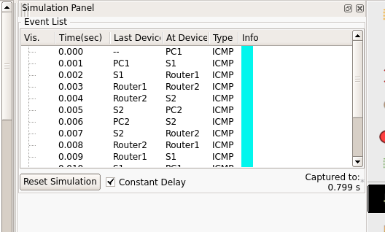

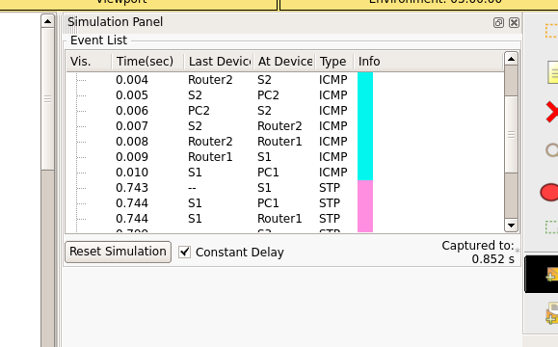
- El segon ping que vagi del PC2 al PC3
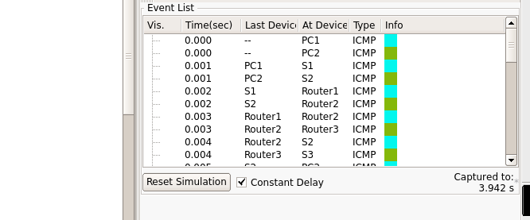

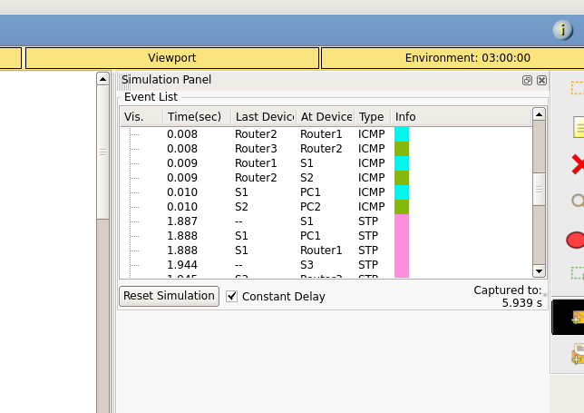
- El tercer ping que vagi del PC3 al PC1
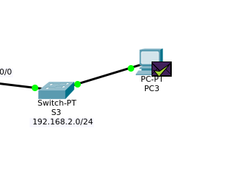
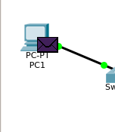

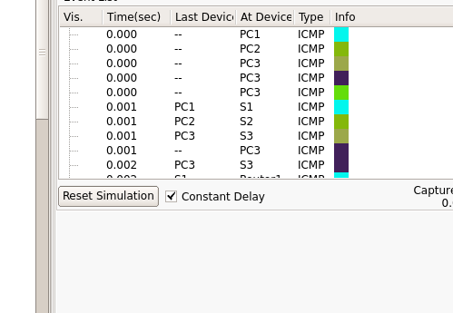

VEIEM QUE TOTS ELS PINGS FUNCIONEN

