Christian Manalo Mañibo - isx9565961
- Utilitza el Packet Tracer per construir la xarxa que us especifica el següent Diagrama de Topologia. Utilitza els routers 1841 i configura'ls per tal que tinguin 2 ports serial.
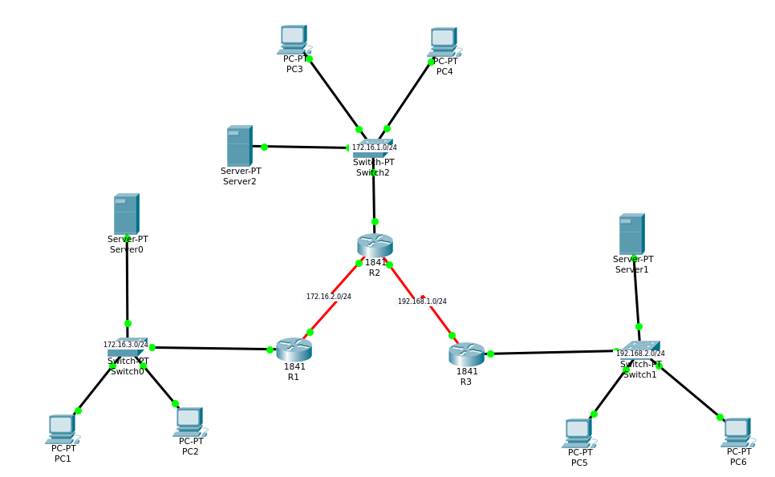

- Crea la Taula d'Adreçament corresponent a aquest Diagrama de Topologia.

 | Nom del Dispositiu | Interfície (IP + MX) | Gateway
Xarxa 1 (LAN1)  172.16.3.0/24 | R1 | 172.16.3.1 255.255.255.0 | 172.16.3.1
Xarxa 1 (LAN1)  172.16.3.0/24 | Servidor DHCP | 172.16.3.2 255.255.255.0 | 172.16.3.1
Xarxa 1 (LAN1)  172.16.3.0/24 | PC1 | Automatic | 172.16.3.1
Xarxa 1 (LAN1)  172.16.3.0/24 | PC2 | Automatic | 172.16.3.1
Xarxa 2 (LAN2)  172.16.1.0/24 | R2 | 172.16.1.1 255.255.255.0 | 172.16.1.1
Xarxa 2 (LAN2)  172.16.1.0/24 | Servidor DHCP | 172.16.1.2 255.255.255.0 | 172.16.1.1
Xarxa 2 (LAN2)  172.16.1.0/24 | PC1 | Automatic | 172.16.1.1
Xarxa 2 (LAN2)  172.16.1.0/24 | PC2 | Automatic | 172.16.1.1
Xarxa 3 (LAN3)  192.168.2.0/24 | R3 | 192.168.2.1 255.255.255.0 | 192.168.2.0
Xarxa 3 (LAN3)  192.168.2.0/24 | Servidor DHCP | 192.168.2.2 255.255.255.0 | 192.168.2.0
Xarxa 3 (LAN3)  192.168.2.0/24 | PC1 | Automatic | 192.168.2.0
Xarxa 3 (LAN3)  192.168.2.0/24 | PC2 | Automatic | 192.168.2.0
Xarxa 4 (WAN1)  172.16.2.0/24 | R1 | 172.16.2.1  255.255.255.0 | 172.16.2.1
Xarxa 4 (WAN1)  172.16.2.0/24 | R2 | 172.16.2.2  255.255.255.0 | 172.16.2.2
Xarxa 5 (WAN2)  192.168.1.0/24 | R2 | 192.168.1.2  255.255.255.0 | 192.168.1.2
Xarxa 5 (WAN2)  192.168.1.0/24 | R3 | 192.168.1.1  255.255.255.0 | 192.168.1.1

- Configureu, per CLI (línia de comandes)
- Les adreces IP dels routers
Router1
Router>enable
Router#configure term
Enter configuration commands, one per line. End with CNTL/Z.
Router(config)#interface fa0/0
Router(config-if)#ip address 172.16.3.1 255.255.255.0
Router(config-if)#no shutdown
Router(config-if)#interface s0/0/0
Router(config-if)#ip address 172.16.2.1 255.255.255.0
Router(config-if)#no shutdown
Router(config-if)#exit
Router 2

Router>enable
Router#configure term
Enter configuration commands, one per line. End with CNTL/Z.
Router(config)#interface fa0/0
Router(config-if)#ip address 172.16.1.1 255.255.255.0
Router(config-if)#no shutdown
Router(config-if)#interface s0/0/0
Router(config-if)#ip address 172.16.2.2 255.255.255.0
Router(config-if)#no shutdown
Router(config-if)#interface s1/0/0
Router(config-if)#ip address 192.168.1.2 255.255.255.0
Router(config-if)#no shutdown
Router(config-if)#exit
Router 3

Router>enable
Router#configure term
Enter configuration commands, one per line. End with CNTL/Z.
Router(config)#interface fa0/0
Router(config-if)#ip address 192.168.2.1 255.255.255.0
Router(config-if)#no shutdown
Router(config-if)#interface s1/0/0
Router(config-if)#ip address 192.168.1.1 255.255.255.0
Router(config-if)#no shutdown
Router(config-if)#exit
- Les adreces dels PCs, mitjançant DHCP
- Copia la configuració del running-config a l'startup-config. No t'oblidis d'anar fent aquest pas a mesura que avances en l'exercici.
Router 1
Router#show running-config
Building configuration...
Current configuration : 854 bytes
!
version 12.4
no service timestamps log datetime msec
no service timestamps debug datetime msec
no service password-encryption
!
hostname Router
!
!
no ip cef
no ipv6 cef
!
!
spanning-tree mode pvst
!
!
interface FastEthernet0/0
ip address 172.16.3.1 255.255.255.0
duplex auto
speed auto
!
interface FastEthernet0/1
no ip address
duplex auto
speed auto
shutdown
!
interface Serial0/0/0
ip address 172.16.2.1 255.255.255.0
clock rate 2000000
!
interface Serial0/0/1
no ip address
clock rate 2000000
shutdown
!
interface Serial0/1/0
no ip address
clock rate 2000000
shutdown
!
interface Serial0/1/1
no ip address
clock rate 2000000
shutdown
!
interface Vlan1
no ip address
shutdown
!
ip classless
!
ip flow-export version 9
!
!
!
line con 0
!
line aux 0
!
line vty 0 4
login
!
!
end

Router 2
Router#copy running-config startup-config
Destination filename [startup-config]?
Building configuration...
[OK]
Router#show running-config
Building configuration...

Current configuration : 847 bytes
!
version 12.4
no service timestamps log datetime msec
no service timestamps debug datetime msec
no service password-encryption
!
hostname Router
!
!
no ip cef
no ipv6 cef
!
!
spanning-tree mode pvst
!
!
interface FastEthernet0/0
ip address 172.16.1.1 255.255.255.0
duplex auto
speed auto
!
interface FastEthernet0/1
no ip address
duplex auto
speed auto
shutdown
!
interface Serial0/0/0
ip address 172.16.2.2 255.255.255.0
!
interface Serial0/0/1
ip address 192.168.1.2 255.255.255.0
clock rate 2000000
!
interface Serial0/1/0
no ip address
clock rate 2000000
shutdown
!
interface Serial0/1/1
no ip address
clock rate 2000000
shutdown
!
interface Vlan1
no ip address
shutdown
!
ip classless
!
ip flow-export version 9
!
line con 0
!
line aux 0
!
line vty 0 4
login
!
end

Router 3
Router#copy running-config startup-config
Destination filename [startup-config]?
Building configuration...
[OK]
Router#show ru
Router#show running-config
Building configuration...
Current configuration : 836 bytes
!
version 12.4
no service timestamps log datetime msec
no service timestamps debug datetime msec
no service password-encryption
!
hostname Router
!
!
no ip cef
no ipv6 cef
!
!
!
spanning-tree mode pvst
!
!
interface FastEthernet0/0
ip address 192.168.2.1 255.255.255.0
duplex auto
speed auto
!
interface FastEthernet0/1
no ip address
duplex auto
speed auto
shutdown
!
interface Serial0/0/0
no ip address
clock rate 2000000
shutdown
!
interface Serial0/0/1
ip address 192.168.1.1 255.255.255.0
!
interface Serial0/1/0
no ip address
clock rate 2000000
shutdown
!
interface Serial0/1/1
no ip address
clock rate 2000000
shutdown
!
interface Vlan1
no ip address
shutdown
!
ip classless
!
ip flow-export version 9
!
!
line con 0
!
line aux 0
!
line vty 0 4
login
!
!
!
end

- Visualitza les taules d'enrutament de cada router i comprova que contenen les xarxes connectades directament a cadascun d'ells. Quina comanda utilitzes per veure la taula d'enrutament d'un router? Inclou el resultat.
R1
Router#show ip route
Codes: C - connected, S - static, I - IGRP, R - RIP, M - mobile, B - BGP
D - EIGRP, EX - EIGRP external, O - OSPF, IA - OSPF inter area
N1 - OSPF NSSA external type 1, N2 - OSPF NSSA external type 2
E1 - OSPF external type 1, E2 - OSPF external type 2, E - EGP
i - IS-IS, L1 - IS-IS level-1, L2 - IS-IS level-2, ia - IS-IS inter area
* - candidate default, U - per-user static route, o - ODR
P - periodic downloaded static route
Gateway of last resort is not set
172.16.0.0/24 is subnetted, 3 subnets
S 172.16.1.0 [1/0] via 172.16.2.2
C 172.16.2.0 is directly connected, Serial0/0/0
C 172.16.3.0 is directly connected, FastEthernet0/0
S 192.168.2.0/24 [1/0] via 172.16.2.2

R2
Router#show ip route
Codes: C - connected, S - static, I - IGRP, R - RIP, M - mobile, B - BGP
D - EIGRP, EX - EIGRP external, O - OSPF, IA - OSPF inter area
N1 - OSPF NSSA external type 1, N2 - OSPF NSSA external type 2
E1 - OSPF external type 1, E2 - OSPF external type 2, E - EGP
i - IS-IS, L1 - IS-IS level-1, L2 - IS-IS level-2, ia - IS-IS inter area
* - candidate default, U - per-user static route, o - ODR
P - periodic downloaded static route
Gateway of last resort is not set
172.16.0.0/24 is subnetted, 3 subnets
C 172.16.1.0 is directly connected, FastEthernet0/0
C 172.16.2.0 is directly connected, Serial0/0/0
S 172.16.3.0 [1/0] via 172.16.2.1
C 192.168.1.0/24 is directly connected, Serial0/0/1
S 192.168.2.0/24 [1/0] via 192.168.1.1

R3
Router#show ip route
Codes: C - connected, S - static, I - IGRP, R - RIP, M - mobile, B - BGP
D - EIGRP, EX - EIGRP external, O - OSPF, IA - OSPF inter area
N1 - OSPF NSSA external type 1, N2 - OSPF NSSA external type 2
E1 - OSPF external type 1, E2 - OSPF external type 2, E - EGP
i - IS-IS, L1 - IS-IS level-1, L2 - IS-IS level-2, ia - IS-IS inter area
* - candidate default, U - per-user static route, o - ODR
P - periodic downloaded static route
Gateway of last resort is not set
172.16.0.0/24 is subnetted, 2 subnets
S 172.16.1.0 [1/0] via 192.168.1.2
S 172.16.3.0 [1/0] via 192.168.1.2
C 192.168.1.0/24 is directly connected, Serial0/0/1
C 192.168.2.0/24 is directly connected, FastEthernet0/0

- Quin grup de comandes has hagut d'executar per configurar la interfície Fa0/0 del Router R1? Indica també, el «mode» en el que s'ha de trobar el router per tal d'executar cadascuna de les comandes (per exemple: R1#).
R1> enable
R1 # config term
R1 (config) # interface fa0/0
R1 (config) # ip address 172.16.3.1 255.255.255.0
R1 (config)# no shutdown
- Quin grup de comandes has hagut d'executar per configurar el servei DHCP del Router R1 per a la Xarxa 1 (LAN1)? Indica també, el «mode» en el que s'ha de trobar el router per tal d'executar cadascuna de les comandes (per exemple: R1#).
Lo he configurat graficament perquè encara no ens han ensenyat en el mode de comandes CLI.

- Activa el «debug» de la taula d'enrutament per als tres routers. És a dir, activa el servei que t'avisa de qualsevol canvi que es produeixi en la taula d'enrutament. Aquest servei s'activa mitjançant la comanda Router#debug ip Routing
Router#debug ip routing
IP routing debugging is on

- Acaba de configurar les taules d'enrutament dels tres routers mitjançant «enrutament estàtic: next-hop» (només rutes per a les LAN). Indica quina comanda has d'executar al router R1 per tal de configurar la ruta estàtica a la xarxa 192.168.2.0/24.

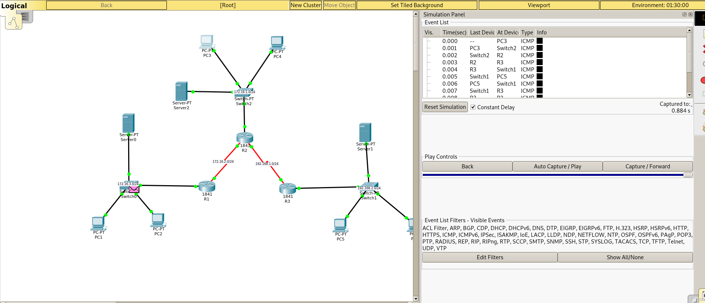
- En el mode de simulació del Packet Tracer, envia 3 missatges ping i comprova que tant l'enviament del ping com el retorn de la resposta funcionen.
- El primer ping que vagi del PC1 al PC2
C:\>ping 172.16.1.4
Pinging 172.16.1.4 with 32 bytes of data:

Reply from 172.16.1.4: bytes=32 time=10ms TTL=126
Reply from 172.16.1.4: bytes=32 time=10ms TTL=126
Reply from 172.16.1.4: bytes=32 time=10ms TTL=126
Reply from 172.16.1.4: bytes=32 time=10ms TTL=126

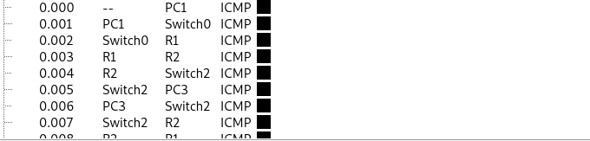

- El segon ping que vagi del PC2 al PC3
C:\>ping 192.168.2.3
Pinging 192.168.2.3 with 32 bytes of data:

Reply from 192.168.2.3: bytes=32 time=10ms TTL=126
Reply from 192.168.2.3: bytes=32 time=10ms TTL=126
Reply from 192.168.2.3: bytes=32 time=10ms TTL=126
Reply from 192.168.2.3: bytes=32 time=10ms TTL=126
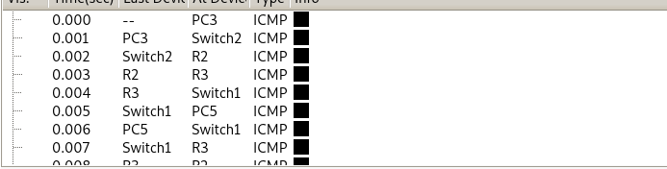

- El tercer pring que vagi del PC3 al PC1
C:\>ping 172.16.1.3
Pinging 172.16.1.3 with 32 bytes of data:

Request timed out.
Reply from 172.16.1.3: bytes=32 time=1ms TTL=126
Reply from 172.16.1.3: bytes=32 time=1ms TTL=126
Reply from 172.16.1.3: bytes=32 time=1ms TTL=126
