**VACON**

**PARAMETER REGISTERS**

| **Signal** | **VACON ID (Reg)** | **Command (Hex frame)** | **Meaning** |
| --- | --- | --- | --- |
| **Motor Current** | 0003h | 01 03 00 03 00 01 85 DB | Read 1 register at 0003h |
| **Output Frequency** | 0001h | 01 03 00 01 00 01 84 0A | Read 1 register at 0001h |
| **Frequency Reference** | 0019h (25 dec) | 01 03 00 19 00 01 25 C8 | Read 1 register at 0019h |
| **Motor Voltage** | 0006h | 01 03 00 06 00 01 85 D8 | Read 1 register at 0006h |
| **Motor Power** | 0005h | 01 03 00 05 00 01 54 09 | Read 1 register at 0005h |
| **Motor Torque** | 0004h | 01 03 00 04 00 01 C5 D9 | Read 1 register at 0004h |

**WIRING**

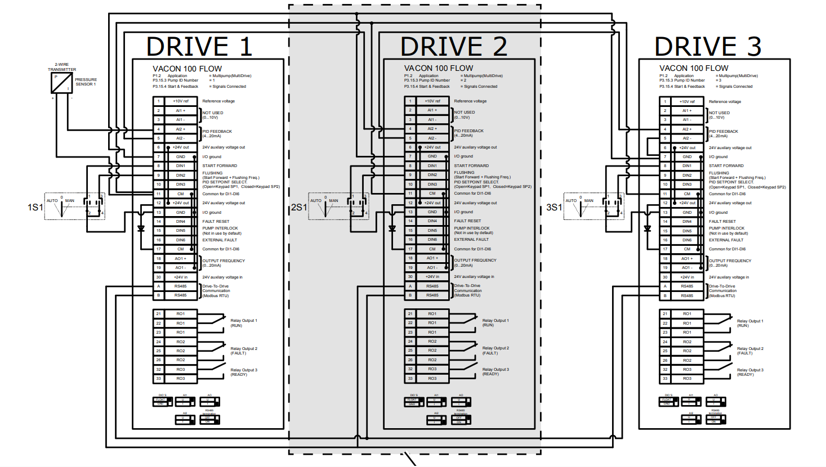RS485-A and RS485-B manual didn’t suggest external terminating resistor it has ha switch for terminating resistor

**TERMINATION WIRING AND TERMINATING DIP SWITCH** 