**TECO**

Based on the provided **TECO A510s Series Inverter Manual**, here is the information you requested regarding **Modbus communication**, **parameter addresses**, and **RS485 wiring**.

### 🔧 RS485 Wiring for A510s Inverter

The A510s inverter supports **Modbus RTU** over RS485. The communication terminals are:

| Terminal | Signal | Description |

|----------|--------|-------------|

| `S(+)` | Data+ | RS485 positive data line |

| `S(-)` | Data- | RS485 negative data line |

| `E` or `G` | Ground | Shield ground terminal |

**Wiring Recommendations:**

- Use **shielded twisted-pair cable**.

- Connect `S(+)` to `D+` and `S(-)` to `D-` of your Modbus master device.

- Ground the shield at the inverter end only.

- For multi-drop networks, enable the termination resistor (via internal switch or parameter) on the last inverter.

### 📊 Modbus Parameter Address Table (Holding Registers)

The following parameters can be read via Modbus using **Function Code 0x03** (Read Holding Registers). All addresses are in **decimal** (Modbus register address = parameter address + 1).

| Parameter | Modbus Register Address (Dec) | Data Type | Units | Scaling |

|---------------------|--------------------------------|-----------|-------|---------|

| Output Current | 12289 (0x2527) | U16 | 0.1 A | Value × 0.1 |

| Output Frequency | 12290 (0x2524) | U16 | 0.01 Hz| Value × 0.01 |

| Frequency Reference | 12291 (0x2523) | U16 | 0.01 Hz| Value × 0.01 |

| Output Voltage | 12292 (0x2526) | U16 | 0.1 V | Value × 0.1 |

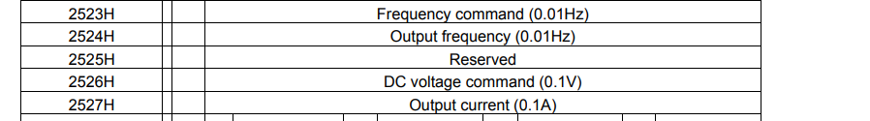

> 🔍 Note: These addresses are based on **Section 4.6.3** of the manual. All values are read-only.

---

### 📨 Example Modbus RTU Command to Read Output Current

Suppose:

- Slave ID = 1

- Register Address = 12289 (Output Current)

- Number of registers = 1

**Request (Hex):**

```

01 03 30 01 00 01 45 C9

```

- `01`: Slave Address

- `03`: Function Code (Read Holding Registers)

- `30 01`: Starting Address High/Low (12289 = 0x3001)

- `00 01`: Number of Registers

- `45 C9`: CRC16 (calculated)

**Response (Hex):**

```

01 03 02 00 64 B8 44

```

- `01`: Slave Address

- `03`: Function Code

- `02`: Byte Count

- `00 64`: Data (100 decimal → 100 × 0.1 = 10.0 A)

- `B8 44`: CRC16

---

### 📘 Additional Notes

- All values are **16-bit unsigned integers**.

- Scaling must be applied as shown in the table.

- Refer to **Section 4.6** of the manual for full Modbus protocol details, including data format and error codes.

- Use a tool like **Modbus Poll** or **CAS Modbus Scanner** for testing.

