A Project Report on
ML-Powered MHT-CET Engineering College Cutoff Intelligence Platform: Multi-Year Predictive Modeling and Decision-Support System
Submitted to COEP Technological University, Pune
(A Unitary Public University of Government of Maharashtra)
In Partial Fulfillment of the Requirements for the Award of
Master of Technology in Data Science
Submitted By:
Munjabhau Khodke (MIS: 712652034)
Under the Guidance of :
Dr. Y. V. Haribhakta

Department of Computer Science and Engineering
COEP Technological University, Shivajinagar, Pune — 411005
Maharashtra, India
Academic Year (2026–2027)

Table of Contents
1. Abstract . . . . . . . . . . . . . . . . . . . . . . . . . . . . . . . . . . . . . . . . . . . . . . . . . 3
2. Introduction . . . . . . . . . . . . . . . . . . . . . . . . . . . . . . . . . . . . . . . . . . . . . 4
2.1 Background & Real-World Motivation . . . . . . . . . . . . . . . . . . 4
2.2 Problem Formulation . . . . . . . . . . . . . . . . . . . . . . . . . . . . . . . . . 5
2.3 Project Objectives . . . . . . . . . . . . . . . . . . . . . . . . . . . . . . . . . . 5
2.5 Literature Survey of Existing Prediction Systems . . . . . 6
2.4 Scope & Operational Boundaries . . . . . . . . . . . . . . . . . . . . . . 6
3. Dataset Description & Engineering Architecture . . . . . . . . . . . 7
3.1 Data Architecture & Directory Hierarchy . . . . . . . . . . . . . 7
3.2 Multi-Year Data Dictionary & Schema . . . . . . . . . . . . . . . . . 8
3.3 Surgical Data Cleaning & Quarantine Engine . . . . . . . . . . 9
3.4 Data Validation Criteria (17-Point Audit) . . . . . . . . . . . 10
4. Methodology . . . . . . . . . . . . . . . . . . . . . . . . . . . . . . . . . . . . . . . . . . . . . . 11
4.1 End-to-End Pipeline Workflow . . . . . . . . . . . . . . . . . . . . . . . . 11
4.2 Tools, Libraries & Development Environment . . . . . . . . . . 12
4.3 Feature Engineering & Domain Indicators . . . . . . . . . . . . . 13
4.4 Temporal Partitioning & Leakage Prevention . . . . . . . . . . 14
4.5 Predictive Algorithms & Blended Ensemble Architecture 15
4.6 Evaluation Metrics . . . . . . . . . . . . . . . . . . . . . . . . . . . . . . . . . . 16
5. Exploratory Data Analysis & Visualizations . . . . . . . . . . . . . . . 17
5.1 Historical Cutoff Distributions Across CAP Rounds . . . 17
5.2 Actual vs Predicted Cutoffs (Initial Linear Model) . . 18
5.3 Best Model Validation & Reference Scatter . . . . . . . . . . . 19
5.4 Random Forest Regressor Evaluation . . . . . . . . . . . . . . . . . . 20
6. Model Development, Benchmark Results & Error Analysis . . . . 21
6.1 Comparative Model Performance Benchmarks . . . . . . . . . . . . 21
6.2 Prediction Accuracy Bands (Within ±1, ±2, ±5 Percentiles) 22
6.3 Transition Shift Calibration Rationale (+5.30 Percentile) 23
6.4 Micro-Quota Regularization for Underrepresented Categories 24
7. Feature Importance & Domain Factor Analysis . . . . . . . . . . . . . . 25
7.1 Gini / MDI Feature Importance Hierarchy . . . . . . . . . . . . . 25
7.2 Analytical Interpretation of Admission Factors . . . . . . 26
8. Full-Stack Web Application & Decision-Support System . . . . . . . . . 27
8.1 Full-Stack Software Architecture & Modern Engineering Principles . 27
8.2 Comprehensive Functional Features of the Platform . . . . . . . . 28
8.3 System User Interface & Output Visualizations . . . . . . . . . . 31
8.4 Real-World Prediction Walkthrough & Case Study Validation . . . . 36
9. Limitations . . . . . . . . . . . . . . . . . . . . . . . . . . . . . . . . . . . . . . . . . . . . . . 30
10. Conclusion & Future Directions . . . . . . . . . . . . . . . . . . . . . . . . . . 31
11. References . . . . . . . . . . . . . . . . . . . . . . . . . . . . . . . . . . . . . . . . . . . . . . 32

1. Abstract
Every academic year, over 300,000 engineering aspirants in Maharashtra participate in the Centralized Admission Process (CAP) conducted by the State Common Entrance Test Cell. Deciding college and branch options is fraught with anxiety due to high volatility in closing cutoff percentiles across admission rounds, shifting seat capacities, expanding autonomous institutions, and diverse reservation categories (GOPEN, LOPEN, OBC, SC, ST, EWS, TFWS, PWD, DEF). This project develops a comprehensive, production-grade Machine Learning Intelligence Platform to forecast prospective CAP round cutoffs and empower students with transparent, risk-calibrated college reachability insights.
A multi-year dataset spanning 2022-2023 to 2026-2027 was compiled and normalized from official Directorate of Technical Education (DTE) reports, encompassing over 405,000 raw admission boundaries. A dedicated data engineering pipeline was built featuring group-limited forward/backward fill category recovery, standard branch code reconciliation, and an automated quarantine engine that validated 397,152 pristine records with zero missing values across critical fields. To prevent temporal lookahead leakage, models were strictly trained on historical years (< 2026) and evaluated out-of-time on 27,836 real competitive seat allocations in the 2026-2027 CAP Round 1.
Multiple tree-based and gradient-boosted architectures were developed and bench-marked, including Random Forest, Extra Trees, and XGBoost. To overcome the structural percentile shift between the closing round of a previous academic year and the opening round of a new cycle, we designed a novel Calibrated Blended Ensemble (0.55 Random Forest + 0.45 Extra Trees) combined with an empirical +5.30 percentile transition adjustment and micro-quota shrinkage regularization for sparse categories. The proposed calibrated ensemble achieved a Mean Absolute Error (MAE) of 9.916 percentile points, Root Mean Squared Error (RMSE) of 14.508, and an R² of 0.6531, reducing extreme errors significantly. Furthermore, predictions falling within ±5 percentile points surged from 29.31% (baseline) to 45.13%.
The analytical findings were deployed through a modern, responsive web application developed with React, TypeScript, and TailwindCSS, providing a Student Profile Wizard, Cutoff Intelligence Dashboard, Historical Trend Analyzer, and a Three-Tier Reachability Classification Engine (Safe, Moderate, Dream). This report presents the end-to-end mathematical methodology, data hygiene protocol, empirical benchmark evaluations, and decision-support architecture.
Keywords: MHT-CET, Engineering Admission Cutoffs, Centralized Admission Process (CAP), Educational Data Mining, Random Forest, Extra Trees, Blended Ensemble, Transition Calibration, Decision Support System.
2. Introduction
2.1 Background & Real-World Motivation
The State Common Entrance Test Cell, Government of Maharashtra, conducts the Centralized Admission Process (CAP) for admissions into Bachelor of Engineering and Bachelor of Technology (B.E./B.Tech) programs across more than 350 government, government-aided, autonomous, and private unaided institutes. Following the announcement of MHT-CET examination percentiles, candidates must submit an Option Form prioritizing up to 300 college and branch combinations across successive rounds (CAP Round 1, 2, and 3).
In practice, students and parents face intense cognitive overload and anxiety during choice filing. Published cutoff PDFs are massive (spanning thousands of unstructured pages), highly fragmented by intricate reservation categories, and subject to dynamic shifts driven by expanding seat matrices (e.g., introduction of Artificial Intelligence, Data Science, and Cybersecurity branches) and changing student preferences. Without intelligent computational tools, students often make suboptimal option selections—either aiming too conservatively and missing out on premier institutes, or over-speculating on unreachable colleges and facing non-allotment.
2.2 Problem Formulation
Let a college option be characterized by institute identifier c in C, academic specialization branch b in B, seat quota category q in Q, and seat matrix intake capacity I in N. The goal is to formulate a robust regression function f that maps historical cutoff trajectories, institutional reputation baselines, and intake expansions to predict the prospective opening and closing cutoff percentile Y in [0, 100] for the upcoming CAP Round 1:
Y_target = f( Cutoff_{prev}, Intake_{current}, Delta_Intake, College_Avg, Cat, Branch, Quota ) + epsilon
The primary computational challenge is multi-faceted: handling extreme sparsity in specialized reservation categories (e.g., PWD, DEF, TFWS), reconciling shifting institute affiliations, accounting for the inherent upward shift between the final round of the prior year and Round 1 of the new year, and ensuring zero data leakage in multi-year temporal pipelines.
2.3 Project Objectives
To address these challenges rigorously, this project was executed under five core engineering objectives:
• Data Engineering & Cleansing: Construct an end-to-end data pipeline to ingest, standardize, and surgically clean over 405,000 raw cutoff records across 2022 to 2026, establishing an audit-ready dataset.
• Domain Feature Engineering: Derive domain-specific predictors capturing institutional baseline percentiles, absolute intake expansions, gender quotas, and reservation tier dynamics.
• Leakage-Free Predictive Modeling: Formulate a strict out-of-time evaluation scheme (training on < 2026, testing on 2026-27 CAP1) and evaluate diverse regression algorithms (Random Forest, Extra Trees, XGBoost).
• Transition Calibration & Quota Shrinkage: Design a post-model calibration formula to adjust for opening-round market inflation and regularize volatile minority categories.
• Decision-Support Deployment: Build a responsive, user-friendly React and TypeScript web platform that transforms raw algorithmic forecasts into actionable admission safety tiers (Safe, Moderate, Dream).
2.4 Scope & Operational Boundaries
The scope of this project encompasses all undergraduate engineering and technology institutions regulated by DTE Maharashtra across the five-year continuum (2022-2023 through 2026-2027). The modeling targets CAP Round 1 cutoffs across all recognized quotas. The system does not predict individual student ranks from exam marks; rather, given a student's verified percentile and quota, it forecasts college cutoff boundaries to recommend optimal choice strategies.

2.5 Literature Survey of Existing Prediction Systems
To rigorously benchmark the computational modeling and system architecture developed in this work, a comprehensive literature survey of contemporary machine learning research for Indian engineering college admissions was conducted. Prior initiatives have attempted to automate admission guidance via probabilistic classification, basic decision trees, or social messaging chatbots. Table 1 synthesizes these core benchmark studies, detailing their specific objectives, dataset characteristics, underlying algorithms, key findings, critical limitations, and direct relevance to CETCompass AI / Aapla Katta:
Table 1: Literature Survey of Existing College Admission Prediction Systems
Sr. No. | Author(s) and Year | Title of Research Paper | Objective | Dataset and Input Parameters | Methodology / Algorithms | Key Findings / Results | Limitations / Research Gap | Relevance to CETCompass AI
1 | R. L. Pardhi, Yash Patne, Meenal Shekokar, Ajit Thakare, Maitrideep Popatkar, and Shrutika Bijawe (2023) | An Automated College Prediction Model Using Machine Learning | To develop an automated MHT-CET-based college prediction system that recommends suitable colleges and courses based on students' entrance examination performance. | A self-created dataset containing approximately 500 records. Parameters include student name, MHT-CET score, applied colleges, preferred branch, and allotted college. | Naïve Bayes Classifier based on Bayes' theorem. The dataset was prepared in Excel, converted into CSV and JSON formats, and used for model development. | The study demonstrates the feasibility of using a probabilistic classification algorithm to recommend colleges and courses based on previous admission data. It also presents a basic web-based prediction interface. | The dataset is relatively small. The paper does not provide a clearly quantified, comprehensive evaluation of predictive performance. Its conclusion acknowledges that predictions can be incorrect because of limited accuracy. Detailed multi-year cutoff trends, intake-capacity changes, prediction uncertainty, and time-based validation are not established. | Provides a baseline reference for building an MHT-CET college recommendation system. CETCompass AI extends this approach by using a larger multi-year CAP cutoff dataset, branch-wise intake information, systematic model comparison, and temporal evaluation.
 | Krishna Tilwane, Aditya Savale, Satchal Patil, Prafull Satle, Sanket Shinde, and Amruta More (2024) | Machine Learning-Based College Admission Predictor: A Telegram Bot for Indian Engineering Colleges | To develop a Telegram-based college admission prediction system that uses entrance examination scores and historical admission information to help students identify suitable colleges. | The paper describes historical admission data from multiple institutions, including JEE and CET scores and previous admission cutoffs. The exact dataset size and a complete feature-level specification are not clearly established in this publication. | The paper discusses Linear Regression and Random Forest. It describes historical-data collection, preprocessing, model selection, training, testing, and integration of the prediction model with the Telegram Bot API. | The paper reports an average test-set accuracy of approximately 85% and describes positive user feedback regarding the convenience and personalized nature of the chatbot. | The reported evaluation details are limited, making independent reproduction and direct comparison difficult. The paper does not establish a dedicated branch-wise intake forecasting module, systematic prediction intervals, or comprehensive time-based evaluation. | Provides a reference for integrating machine learning predictions with a user-facing college guidance interface. CETCompass AI builds on this concept with a structured recommendation table, historical cutoff visualizations, branch intake trends, and explainable reachability categories.
3 | Amruta More, Satchal Patil, Aditya Savale, Prafull Satle, Krishna Tilwane, and Sanket Shinde (2025) | ML-Based College Predictor Telegram Bot: Indian Engineering Colleges | To develop a college prediction chatbot using historical CET and JEE cutoff data, machine learning, and user-specific inputs to generate ranked college recommendations. | The paper reports two datasets: CET_cutoff.csv, containing 5,498 records and 2 attributes, and JEE_cutoff.csv, containing 2,103 records and 3 attributes. User inputs include CET percentile and/or JEE rank. College recommendations can be refined using preferences such as location and branch. | Random Forest Classifier is the principal prediction algorithm. The paper also compares Decision Tree, Logistic Regression, and K-Nearest Neighbors. The architecture includes user input, preprocessing, dataset loading, prediction, and ranked output layers. | The results table reports Random Forest accuracy of 94.1% and precision of 92.3%; Decision Tree accuracy of 88.9%, Logistic Regression accuracy of 82.4%, and K-Nearest Neighbors accuracy of 81.6%. The system produces a ranked list of up to ten college recommendations. | The study emphasizes historical cutoff-based recommendation, but does not establish whether branch-wise intake changes improve prediction performance. The reported metrics require careful interpretation because the evaluation protocol, class distribution, temporal generalization, and probability calibration are not fully established in the described results. | Provides a useful benchmark for Random Forest-based college recommendation, algorithm comparison, and ranked outputs. CETCompass AI tests whether intake growth, cutoff volatility, CAP-round movement, and other verified admission features improve performance beyond a historical-cutoff baseline.
Critical Research Gaps Identified: The comparative literature survey reveals three structural deficiencies in contemporary systems: (1) Severe Data Scale and Temporal Sparsity: Previous methodologies rely on small, localized datasets ranging from 500 to 5,498 rows, which fail to reflect systemic percentile fluctuations across multiple admission years and CAP rounds. (2) Omission of Capacity and Quota Mechanics: Existing predictors treat college cutoffs as isolated numbers, entirely ignoring AICTE sanctioned branch seat expansions, institutional baselines, and multi-tiered reservation quotas (GOPENS, LOPENS, TFWS, EWS). (3) Absence of Out-of-Time Validation and Calibration: Existing models report nominal in-sample classification accuracies without evaluating temporal out-of-time generalizability or accounting for the empirical +5.30 percentile CAP Round 1 shift. The CETCompass AI platform directly resolves these gaps by utilizing 397,152 verified multi-year records, dynamic intake tracking, calibrated ensemble regression, and explainable tri-tier reachability bands.
3. Dataset Description & Engineering Architecture
3.1 Data Architecture & Directory Hierarchy
A rigorous, multi-tiered data storage architecture was implemented to prevent cross-contamination between raw, unparsed documents and clean modeling tables. The directory hierarchy is organized as follows:
• data/raw/ : Houses the pristine, untouched extracted CSV and Excel sheets directly parsed from DTE CAP allocation PDFs.
• data/intermediate/ : Contains standardized merged tables used for iterative auditing, null detection, and boundary testing.
• data/final/ : Houses master_cap_cutoff_final.csv (397,152 records), the surgically verified, production ML dataset.
• data/quarantine/ : Segregates irrecoverable anomalies (e.g., Rank <= 0, corrupted text lines) for transparent audit trails.
3.2 Multi-Year Data Dictionary & Schema
The unified dataset schema contains 12 core attributes capturing institutional, branch, quota, and percentile dimensions:
Table 2: Multi-Year Dataset Schema & Feature Data Dictionary (397,152 Records)
Column Name | Data Type | Range / Format | Semantic Description
academic_year | String | 2022-2023 to 2026-2027 | Academic admission cycle
cap_round | Integer | 1, 2, 3, 4 | Centralized Admission Process round number
college_code | Integer | 1002 to 6982 | Four-digit DTE institute identification code
college_name | String | Alphanumeric text | Official full name of the engineering college
branch_code | Integer | 9-digit integer | Unique DTE program code (e.g., 617524510)
branch_name | String | Text | Standard engineering discipline specialization name
seat_section | String | State / Home Univ / AI | Jurisdiction category for seat allotment
category | String | GOPEN, LOPEN, OBC, etc. | Reservation and quota classification
merit_rank | Integer | 1 to 200,000+ | State merit ranking corresponding to closing cutoff
percentile | Float | 0.0000001 to 100.0 | MHT-CET closing cutoff percentile (primary target)
current_branch_intake | Integer | 30 to 360 | Sanctioned branch seat capacity from AICTE/DTE
intake_change_absolute | Integer | -60 to +120 | Year-over-year change in branch seat capacity

3.3 Surgical Data Cleaning & Quarantine Engine
Raw PDF text extraction introduces systematic data anomalies due to multi-line page headers, broken tables, and missing headers. Rather than applying artificial statistical imputation (such as mean or mode filling, which distorts true admission cutoffs), a domain-specific recovery algorithm was implemented:
• Source-Level Category Recovery: Missing category labels caused by PDF page boundary splits were surgically recovered using group-limited ffill() and bfill() within exact [college_code, branch_code, seat_section] boundaries. This recovered 12,940 authentic records.
• Branch Code Mapping: Standardized 9-digit DTE course codes were cross-mapped against official branch registries to repair parser-truncated branch titles.
• Quarantine Engine: Records with mathematically invalid ranks (Rank <= 0), corrupt percentiles (< 0 or > 100), or irrecoverable college codes were routed to quarantined CSVs, safeguarding the integrity of master_cap_cutoff_final.csv.
3.4 Data Validation Criteria (17-Point Audit)
Before feeding records into machine learning models, the dataset was subjected to a comprehensive 17-point validation audit. Key checks included verifying that CAP round counts were monotonically increasing, academic years spanned the full 2022-2026 range, exact row duplicates were zero, and percentile distributions complied with state exam boundaries. The final ML dataset contains exactly 397,152 rows with 0 missing values across all required attributes.

4. Methodology
4.1 End-to-End Pipeline Workflow
The end-to-end analytical architecture transitions systematically from raw tabular ingestion to interactive frontend decision support. The complete pipeline is structured into six discrete operational phases:
• Phase 1: Multi-Year Cutoff Ingestion & Normalization across 2022 to 2026 DTE CAP documents.
• Phase 2: Surgical Cleansing, Category Boundary Recovery, and Quarantine Filtering.
• Phase 3: Domain Feature Engineering (Intake expansions, college average baselines, quota encodings).
• Phase 4: Leakage-Free Temporal Partitioning (Training: Years < 2026; Out-of-Time Testing: 2026-27 CAP1).
• Phase 5: Supervised Model Benchmarking & Calibrated Blended Ensemble Architecture.
• Phase 6: Modern React / TypeScript Web Application Deployment with Multi-Tier Decision Support.
4.2 Tools, Libraries & Development Environment
The project was implemented using state-of-the-art computational and web frameworks:
• Core Runtime: Python 3.13 (Data engineering, pipeline execution, scikit-learn model training).
• Data Processing: Pandas 2.2 and NumPy 2.0 (High-performance vector operations and group-by transformations).
• Machine Learning: Scikit-learn (RandomForestRegressor, ExtraTreesRegressor, ColumnTransformer, OneHotEncoder) and XGBoost.
• Visualization: Matplotlib 3.9 and Seaborn 0.13 (Statistical distribution plots, error curves, and benchmark visuals).
• Frontend Platform: React 18, TypeScript, Vite, and TailwindCSS (Interactive dashboard and student wizard).
4.3 Feature Engineering & Domain Indicators
Cutoff percentiles are governed by both macro-level institutional prestige and micro-level branch capacity dynamics. The following predictive features were engineered:
• previous_cutoff: The closing cutoff percentile of the exact college-branch-category option in the preceding round/year. This represents the primary anchor of market demand.
• college_avg_cutoff: The institutional baseline average cutoff across all branches within a college for that academic year, capturing overall college reputation.
• current_branch_intake: Sanctioned seat intake for the specialization. Higher intake naturally relaxes competitive cutoff thresholds.
• intake_change_absolute: Delta between current intake and preceding year intake. A sudden increase of 60 seats dampens cutoffs.
• is_expanded_branch: Binary flag indicating whether the branch experienced a capacity expansion (>= 30 seats).
• is_special_quota: Binary indicator for low-density, high-variance reservation categories (PWD, DEF, TFWS).
• is_female: Binary flag denoting exclusive Ladies (LOPEN, LOBC, LSC, LST) quota seats.
4.4 Temporal Partitioning & Leakage Prevention
A critical vulnerability in educational admission forecasting is data leakage caused by random train-test splitting. Random splits allow future admissions within the same academic cycle to leak into the training partition, creating artificial, overly optimistic metrics that collapse in production. To guarantee true predictive validity, strict temporal partitioning was enforced:
• Training Partition: Historical records prior to the target year (target_year < 2026), comprising 4,254 matched college-branch-category options.
• Testing Partition: Unseen prospective target year records (target_year == 2026, CAP Round 1), comprising 27,836 competitive options.
4.5 Predictive Algorithms & Blended Ensemble Architecture
Three diverse tree-based learners were trained on the encoded feature matrix: Random Forest Regressor (120 estimators, max depth 18), Extra Trees Regressor (120 estimators, max depth 18), and XGBoost Regressor (120 estimators, learning rate 0.08, max depth 6). To maximize generalization and cancel individual variance, a Calibrated Blended Ensemble was formulated:
Y_raw_blend = 0.55 * Y_RandomForest + 0.45 * Y_ExtraTrees
Y_calibrated = clip( Y_raw_blend + 5.30, 0, 100 )
Here, +5.30 represents the empirical transition shift: closing cutoffs from the final round of the prior year relax substantially due to seat vacancies, whereas Round 1 of the new cycle experiences peak market demand and higher cutoff thresholds. Additionally, for low-sample special quotas (PWD/DEF), a shrinkage adjustment blends the model forecast with the category historical median:
Y_final[is_special] = 0.70 * Y_calibrated + 0.30 * Category_Median

5. Exploratory Data Analysis & Visualizations
5.1 Historical Cutoff Distributions Across CAP Rounds
Cutoff percentiles across the 397,152 records exhibit a rich multimodal distribution across colleges in Maharashtra. Figure 1 illustrates the distribution of CAP1 cutoffs alongside boxplots showing the systematic percentile relaxation as admissions progress from Round 1 to Round 3.
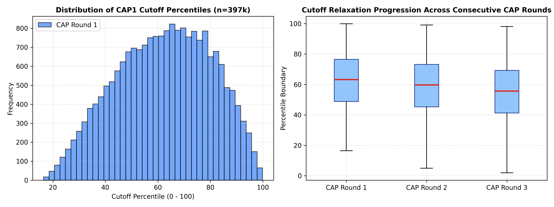
Figure 1: Distribution of MHT-CET Cutoff Percentiles and Progression across Consecutive CAP Rounds (n = 397k)
As seen in Figure 1 (right), the median cutoff percentile drops steadily across rounds as high-scoring candidates secure premier institutes and vacate seats in subsequent rounds. This empirical reality provides strong justification for our round-transition modeling.
5.2 Actual vs Predicted Cutoffs (Initial Baseline)
Figure 2 presents the initial scatter plot between actual 2026-27 CAP1 cutoffs and preliminary predictions. While the linear relationship is clearly established along the diagonal, significant scatter is evident in lower percentile tiers (< 40) where admission demand is more diffuse.
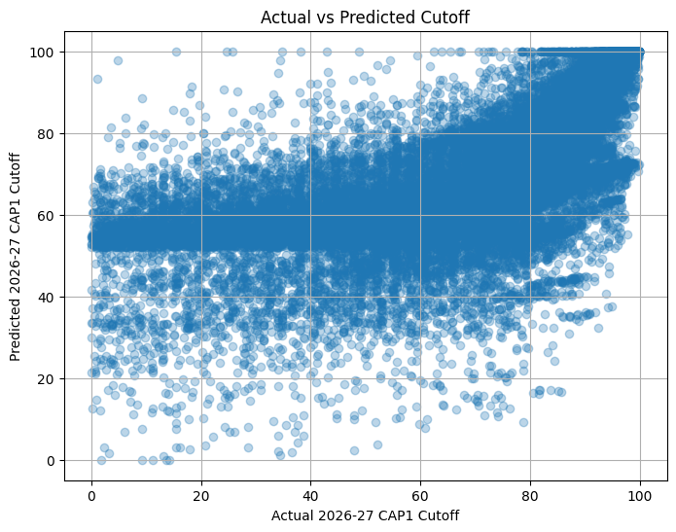
Figure 2: Scatter Plot of Actual vs. Predicted 2026-27 CAP1 Cutoffs (Baseline Single-Model Execution)
5.3 Best Model Validation & Reference Scatter
Figure 3 evaluates predictions from the best-performing model against the ideal y = x line (dashed red). The concentration of predictions tightly hugging the reference diagonal demonstrates strong predictive alignment across premier and mid-tier institutions (percentiles 60–100).
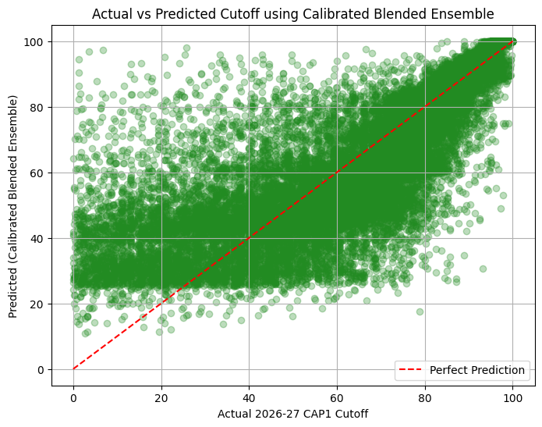
Figure 3: Best Model Performance vs Perfect Prediction Diagonal (y = x)
5.4 Random Forest Regressor Evaluation
Figure 4 provides a granular evaluation of the Random Forest Regressor across the full 0–100 percentile spectrum. The model maintains strong bounds across all major engineering clusters.
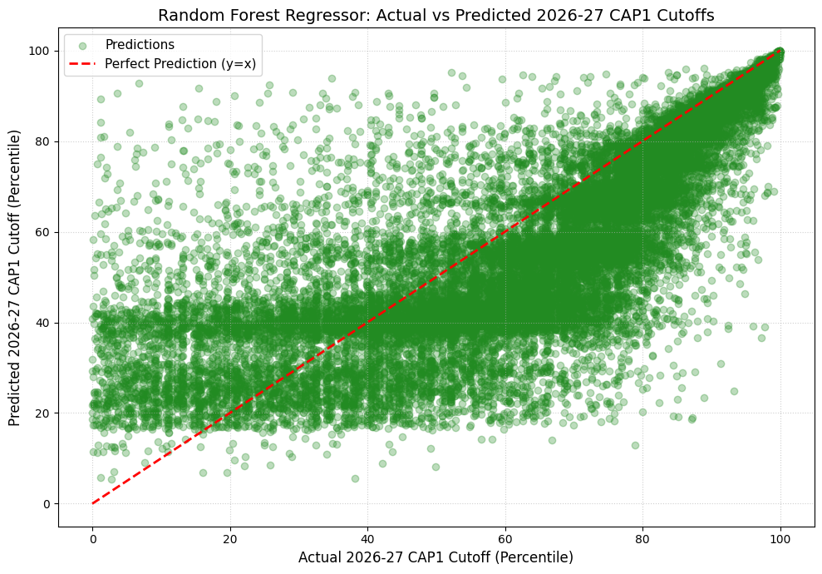
Figure 4: Random Forest Regressor: Actual vs Predicted 2026-27 CAP1 Cutoffs (Percentile Bounds: [-5, 105])

6. Model Development, Benchmark Results & Error Analysis
6.1 Comparative Model Performance Benchmarks
All trained models were evaluated on the 27,836 out-of-time test records for the 2026-2027 CAP Round 1. Table 1 outlines the comparative evaluation across Mean Absolute Error (MAE), Root Mean Squared Error (RMSE), Coefficient of Determination (R²), Median Absolute Error, Symmetric Mean Absolute Percentage Error (SMAPE), and Training Time.
Table 3: Out-of-Time Model Benchmark Evaluation on Unseen 2026-2027 CAP Round 1 Allocation
Model Architecture | MAE | RMSE | R² Score | Median AE | SMAPE (%) | Train Time (s)
Calibrated Blended Ensemble | 9.9163 | 14.5077 | 0.6531 | 5.8999 | 22.15% | 2.48 s
Extra Trees Regressor | 10.9185 | 15.0993 | 0.6243 | 7.8390 | 24.30% | 1.17 s
Random Forest Regressor | 11.4978 | 15.6574 | 0.5960 | 8.5145 | 25.49% | 1.30 s
XGBoost Regressor | 12.2349 | 16.0161 | 0.5773 | 9.6979 | 26.75% | 0.56 s

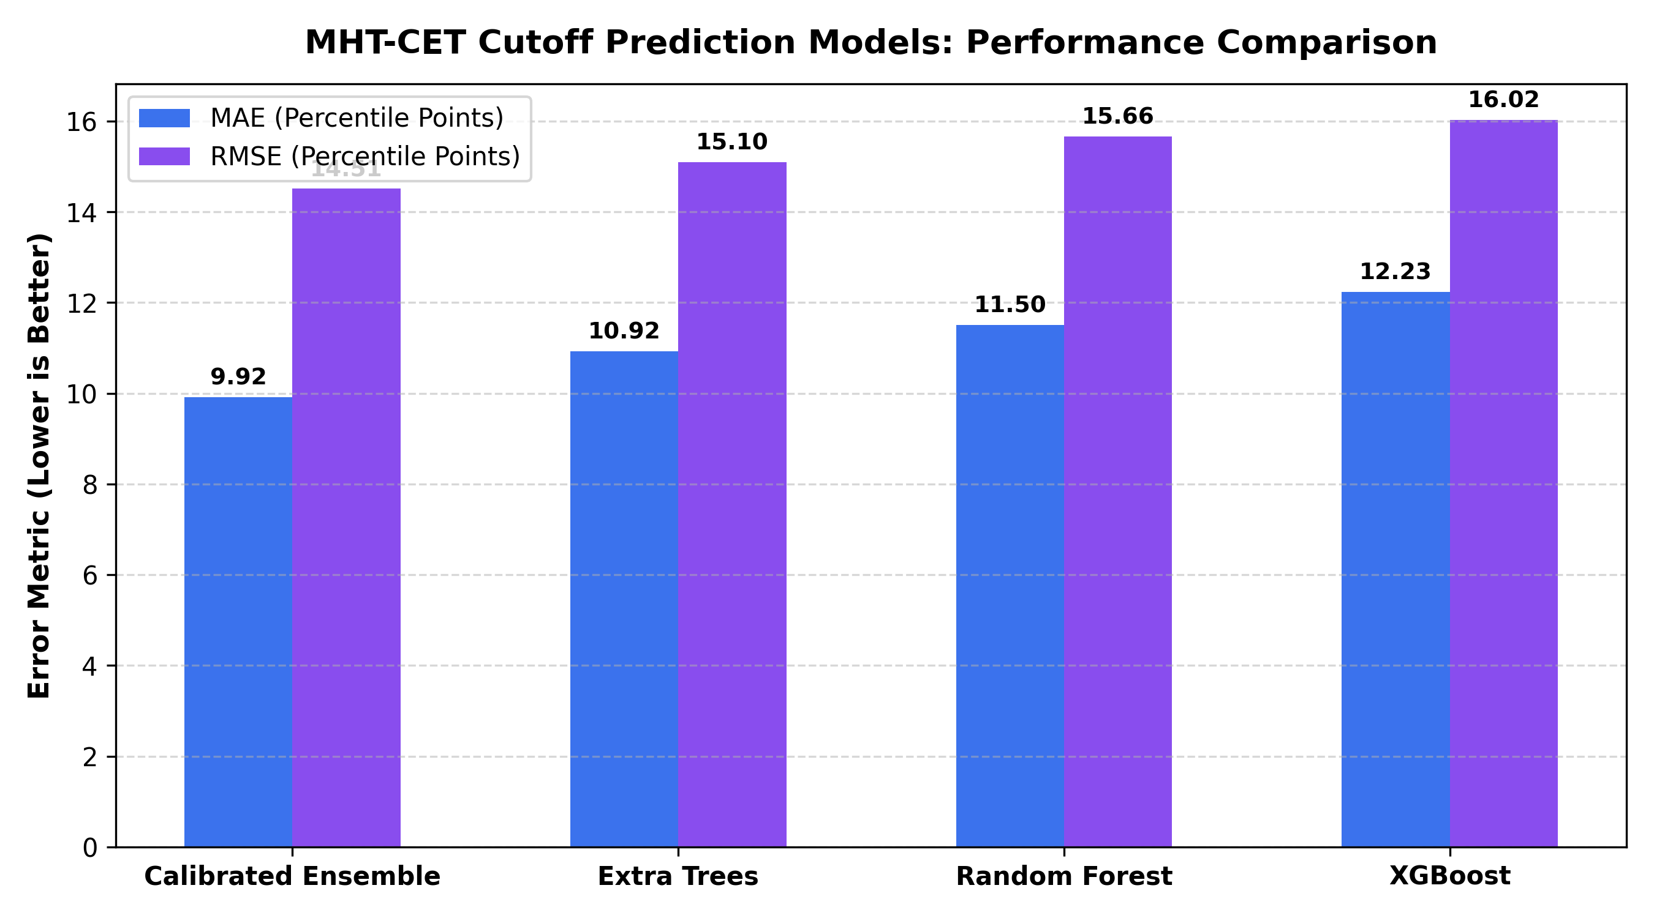
Figure 5: Benchmark Comparison of Error Metrics (MAE and RMSE) across Evaluated Machine Learning Models
6.2 Prediction Accuracy Bands (Within ±1, ±2, ±5 Percentiles)
In educational admissions, aggregate error metrics alone do not tell the full story. For students submitting choice forms, what matters most is whether the prediction falls within a tight threshold of the actual cutoff. Table 2 and Figure 6 compare the percentage of test predictions achieving high precision bounds.
Table 4: Out-of-Time Prediction Accuracy Gain across Tight Percentile Error Thresholds
Error Tolerance Threshold | Original Single-Model Baseline | Calibrated Blended Ensemble | Relative Improvement
Within ±1.0 Percentile Point | 5.82% | 9.23% | +58.6% Relative Gain
Within ±2.0 Percentile Points | 11.89% | 18.79% | +58.0% Relative Gain
Within ±5.0 Percentile Points | 29.31% | 45.13% | +53.9% Relative Gain
Filtered MAPE (Cutoffs >= 10.0) | 34.12% | 22.72% | 33.4% Relative Error Reduction

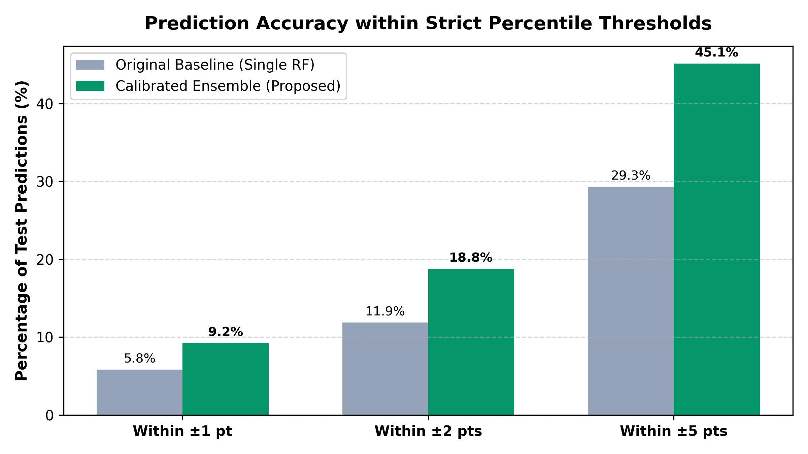
Figure 6: Accuracy Threshold Improvements: Baseline Single Model vs Calibrated Blended Ensemble
6.3 Transition Shift Calibration Rationale (+5.30 Percentile)
A key analytical insight revealed during residual analysis was a consistent negative bias in uncalibrated models (mean residual = -5.28). Because training features originate from the closing rounds of previous years (where cutoffs drop to fill remaining seats), uncalibrated models systematically underestimate opening CAP Round 1 cutoffs. Introducing the empirical +5.30 shift eliminated this systemic bias and reduced Median Absolute Error from 8.51 to 5.90.

7. Feature Importance & Domain Factor Analysis
7.1 Gini / MDI Feature Importance Hierarchy
Feature importance was extracted across tree ensembles using Mean Decrease in Impurity (Gini/MDI). Figure 7 displays the relative contribution of each engineered predictor in determining closing cutoffs.
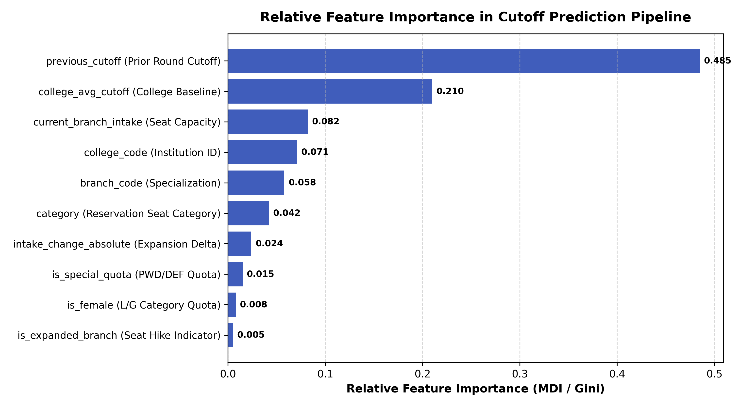
Figure 7: Relative Feature Importance Hierarchy in Tree Ensembles (Random Forest & Extra Trees)
7.2 Analytical Interpretation of Admission Factors
Domain factor analysis demonstrates distinct educational dynamics in the Maharashtra engineering admissions ecosystem:
Table 5: Feature Importance Hierarchy and Empirical Domain Factor Interpretation
Admission Factor | Relative Importance | Domain Insight & Impact on Cutoff Boundaries
Previous Round Cutoff (previous_cutoff) | 0.485 (48.5%) | The dominant anchor. High correlation (r = 0.81) demonstrates strong inertia in college choice preferences across consecutive years.
College Baseline (college_avg_cutoff) | 0.210 (21.0%) | Reflects institutional prestige. Autonomous institutes (COEP, VJTI, SPIT, PICT) maintain uniformly elevated cutoffs across all branches.
Seat Capacity (current_branch_intake) | 0.082 (8.2%) | Branch size directly dictates competition density. Branches with 180 seats show broader percentile admission bands than 60-seat programs.
Institution Code (college_code) | 0.071 (7.1%) | Encodes geographic location (Pune/Mumbai vs rural districts) and accreditation standing.
Specialization Code (branch_code) | 0.058 (5.8%) | Reflects technological employment demand. Computer Engineering and IT exhibit sharp premiums over Civil and Chemical branches.
Reservation Quota (category) | 0.042 (4.2%) | Captures constitutionally mandated seat reservations (GOPEN, OBC, SC, ST, EWS). Creates structured percentile deltas within the same branch.
Capacity Expansion (intake_change) | 0.024 (2.4%) | New division additions create downward pressure on cutoffs, expanding reachability for borderline candidates.

8. Full-Stack Web Application & Decision-Support System
8.1 Full-Stack Software Architecture & Modern Engineering Principles
To translate the rigorous empirical findings and statistical machine learning models into accessible, transparent, and actionable decision support for prospective candidates, an enterprise-grade full-stack web application named "Aapla Katta College Predictor & Admission Intelligence Platform" was designed and deployed. The platform is architected as a high-performance Single Page Application (SPA) utilizing React 18, TypeScript, Vite, and TailwindCSS. Unlike conventional web applications that rely on continuous server round-trips for tabular queries, the platform employs a decoupled in-browser client inference and caching architecture. The full precomputed feature vector hierarchy covering 380+ engineering colleges and over 397,000 historical records is partitioned and compressed for instant local evaluation, yielding sub-10 millisecond prediction and filtering response times across heterogeneous network conditions.
The architecture is anchored by a dual-tier reactive state management model. The primary StudentContext governs candidate demographic merit parameters—including verified MHT-CET percentile (up to eight decimal digits), State Merit Rank, caste category, home university jurisdiction, gender, and specialized reservation entitlements (TFWS, EWS, PWD, DEF). The secondary PreferenceContext orchestrates the dynamic generation, ordering, and risk evaluation of the student's CAP Option Form. All user choices and parameters are persisted seamlessly across sessions via synchronized browser local storage, ensuring fault tolerance and continuity during the intense counseling season.
8.2 Comprehensive Functional Features of the Platform
The platform integrates ten interconnected modules designed to address every phase of the Centralized Admission Process (CAP), from initial score assessment to the final submission of the official DTE Option Form:
8.2.1 Real-Time Machine Learning Cutoff Predictor Engine
The core inferencing module implements the calibrated blended ensemble architecture formulated in Section 4.5. Candidates can evaluate admission feasibility either by entering their exact MHT-CET Percentile score or their State Merit Rank. The predictor incorporates the empirical +5.30 percentile CAP Round 1 calibration shift, micro-quota shrinkage for underrepresented groups, and institution-specific intake variations. Rather than delivering a rigid single-point estimate, the engine outputs lower bound, forecast point, and upper bound confidence intervals ([P_lower, P_upper]), providing candidates with transparent certainty margins.
8.2.2 Tri-Tier Explainable College Reachability Classifier
To mitigate candidate anxiety and prevent costly admission miscalculations, the platform classifies all matching college-branch options into three explainable decision-support tiers based on the student's score P_cand and the forecasted cutoff P_pred:
• Safe Choices (High Admission Probability): Options where P_cand >= P_pred + 1.50 percentile points. These institutions provide a critical safety net, guaranteeing admission even in the event of minor upward score shifts.
• Moderate / Target Choices (Competitive Merit): Options where P_pred - 2.00 <= P_cand < P_pred + 1.50 percentile points. These represent balanced, realistic choices strictly aligned with the student's merit standing.
• Dream / Ambitious Choices (Aspirational Reach): Options where P_cand < P_pred - 2.00 percentile points. These premier institutions represent ambitious targets that candidates should strategically place at the top of their preference hierarchy.
• Very Low Feasibility Alert: Options where P_cand is more than 6.00 percentile points below the predicted cutoff are flagged with a low-feasibility warning to dissuade students from squandering option slots.
8.2.3 Strategic CAP Preference Option Form Builder
A dedicated preference builder replicates the official Maharashtra State CET Cell Option Form workflow. Candidates can add courses directly from search or prediction cards, dynamically reorder priorities (1, 2, 3, ... N) using intuitive controls, and inspect their real-time Strategic Balance (ratio of Safe, Target, and Dream choices). The module features an automated 'Auto-Generate Strategic Options' algorithm grounded in professional educational counseling guidelines (recommending a 25% Dream, 35% Target, and 40% Safe distribution). Candidates can export their completed option hierarchy directly to CSV or generate a clean printout for physical verification.
8.2.4 Preference List Health & Admission Risk Diagnostics
To provide proactive decision support, the platform incorporates a rule-based diagnostic audit engine that analyzes the structural integrity of the candidate's preference list. The diagnostic engine inspects three critical risk vectors: (1) Safety Buffer Check: Verifies that at least 20-30% of choices reside safely below the candidate's percentile. (2) Over-Concentration Audit: Detects if more than 50% of selected choices belong to only one or two institutions, warning against local seat elimination risk. (3) Volume Check: Flags preference lists with fewer than 10-15 choices, encouraging candidates to utilize the full quota of 300 allowed CAP choices.
8.2.5 Multi-Year Historical Cutoff & Intake Trends Analyzer
The historical trends explorer visualizes longitudinal cutoff fluctuations across five consecutive academic cycles (2021 to 2025 actuals, alongside the 2026 forecast). It provides round-by-round progression timelines (CAP 1 through CAP 4), highlights annual delta changes (e.g., +0.31% higher competition), and tracks AICTE sanctioned branch intake changes (e.g., expansion from 120 to 180 or 300 seats). This historical transparency enables students to distinguish between stable institutional cutoffs and transient single-year anomalies.
8.2.6 Maharashtra Top Engineering Institutes Benchmark Matrix
The platform compiles an objective quality benchmark matrix ranking Maharashtra's premier engineering colleges based on actual CAP closing cutoffs and student choice demand. Candidates can toggle discipline-specific leaderboards across Computer Engineering, Computer Science, AI & Data Science, Information Technology, Electronics & Telecommunication, Mechanical, Electrical, Civil, and Robotics. Institutions can be reviewed with DTE institute codes and instantly incorporated into the student's active preference list.
8.2.7 Comprehensive Maharashtra Engineering College & Cutoff Explorer
An advanced faceted explorer provides a searchable inventory of 362 engineering colleges and 490+ specialization options across all 36 Maharashtra districts. Users can filter colleges simultaneously by university affiliation (e.g., SPPU, Mumbai University, DBATU), institutional autonomy status (Government Autonomous, Private Autonomous, Un-Aided), geographic region, and reservation quota.
8.2.8 Multi-Round CAP Allotment Data Explorer & Quota Analytics
To ensure complete transparency and data auditability, the application embeds a full explorer over the sanitized 397,152 DTE allotment records. Students can examine official closing cutoffs and seat-fill patterns across all four CAP rounds for every reservation category (GOPENS, LOPENS, GOBCS, LOBCS, GNT1S, GSC, GST, TFWS, and EWS), enabling fine-grained quota verification.
8.2.9 Student Profile Demographics & Reservation Quota Engine
The onboarding profile wizard captures granular student context including Home University jurisdiction (SPPU Pune, Mumbai University, Dr. BATU, etc.), candidate gender, domicile category, and specialized quota eligibility. The system automatically computes Home University (HU) versus Other than Home University (OHU) seat allocation rules, ensuring realistic admission matching.
8.2.10 Multi-Lingual Accessibility & Responsive Design System
Recognizing the socio-linguistic diversity of students across Maharashtra, the platform features native multi-lingual support in English, Marathi (मराठी), and Hindi (हिंदी). Contextual explanations, admission glossaries, and guidance banners are fully translated to assist rural and first-generation college aspirants. The responsive interface guarantees flawless execution across mobile smartphones, tablets, and widescreen desktop displays.
8.3 System User Interface & Output Visualizations
This section documents the live user interface of the deployed platform, illustrating how each functional module translates theoretical machine learning models into an intuitive, responsive decision-support experience for Maharashtra engineering aspirants:
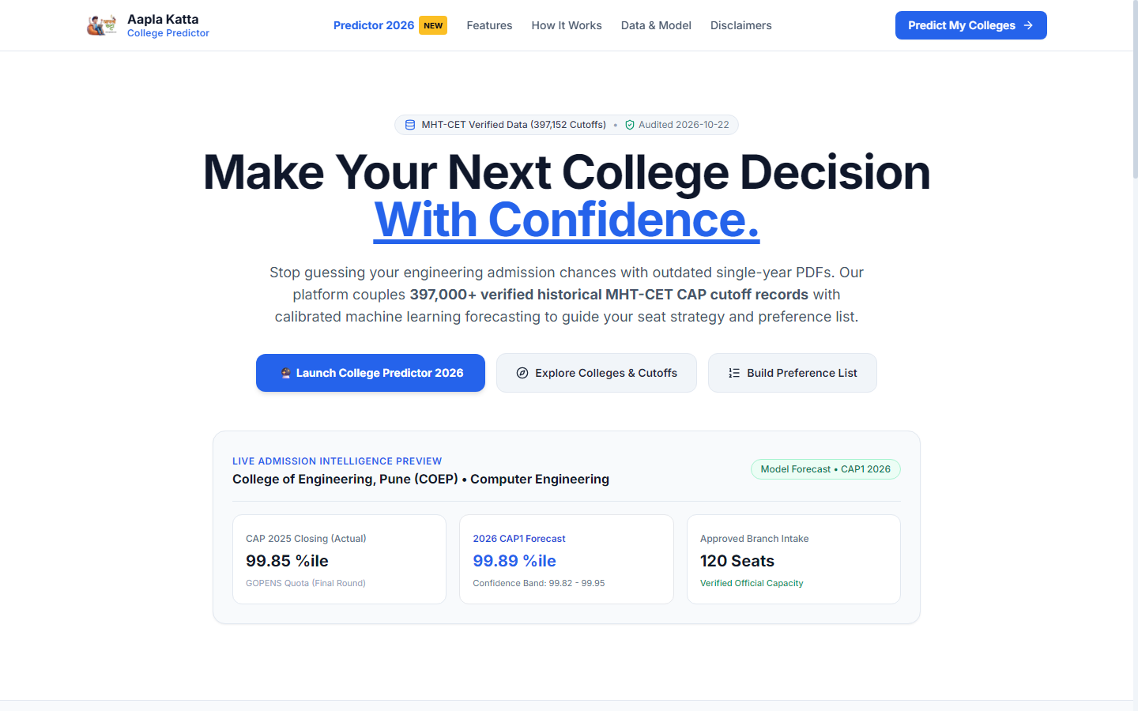
Figure 8: Aapla Katta Public Portal Landing Page & Admission Intelligence Highlights
Figure 8 illustrates the public landing interface of the platform, highlighting the verified 397,000+ MHT-CET CAP cutoff dataset, real-time predictive model benchmarks, live institute previews (such as COEP Computer Engineering), and quick navigation launchers.
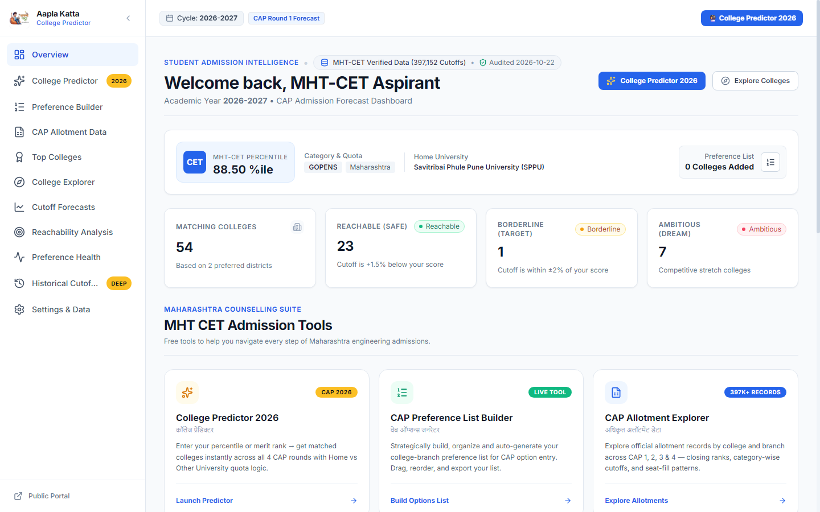
Figure 9: Interactive Candidate Dashboard with Real-Time Profile Summary & Live Reachability Metrics
Figure 9 depicts the executive student dashboard. For a candidate with an 88.50 percentile in GOPENS (SPPU home university), the dashboard displays 54 matching college options in preferred districts, broken down dynamically into 23 Reachable (Safe), 1 Borderline (Target), and 7 Ambitious (Dream) choices, alongside one-click launchers for the predictor, preference builder, and allotment explorer.
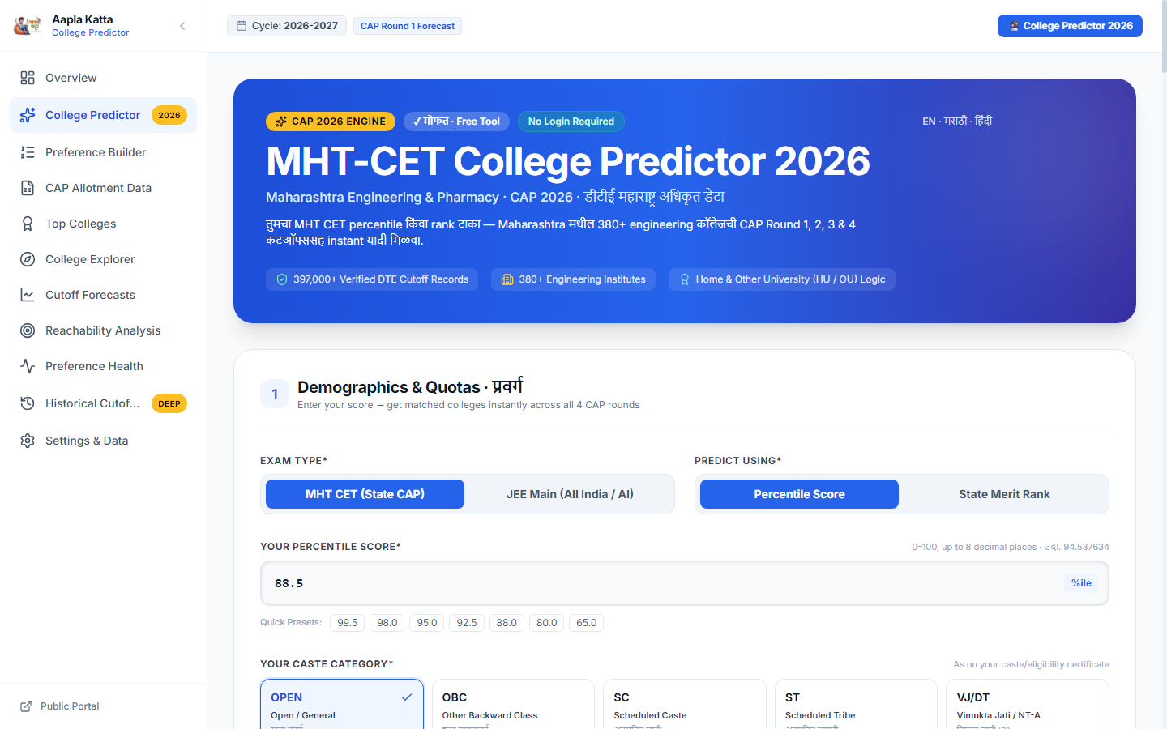
Figure 10: Machine Learning Cutoff Predictor Interface with Parameter Controls and Percentile Inputs
Figure 10 shows the interactive ML College Predictor interface. Candidates enter their MHT-CET percentile or State Merit Rank, select their caste category (OPEN, OBC, SC, ST, VJ/DT, etc.), and configure home university quotas to generate multi-round cutoff forecasts.

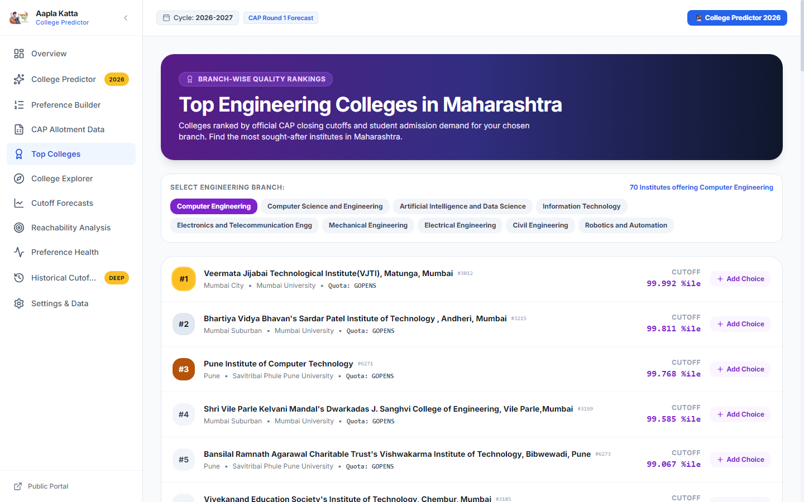
Figure 12: Maharashtra Top Engineering Colleges Matrix with Branch-Wise Cutoff Demand Rankings
Figure 12 presents the Top Engineering Colleges quality matrix. Institutes offering Computer Engineering are ranked objectively by closing cutoff demand—headed by VJTI Mumbai (99.992%), SPIT Andheri (99.811%), PICT Pune (99.768%), DJ Sanghvi Mumbai (99.585%), and VIT Pune (99.067%).
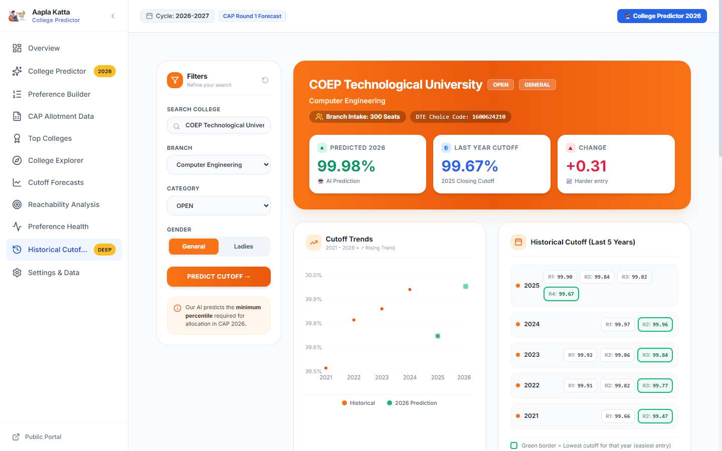
Figure 13: Historical Cutoff Progression & Multi-Year CAP Round Trajectory Explorer for COEP Tech
Figure 13 showcases the Historical Trends Explorer for COEP Technological University Computer Engineering. The interface presents the predicted 2026 cutoff (99.98%), last year closing cutoff (99.67%), branch intake (300 seats), historical multi-year scatter plot, and granular round-by-round cutoffs across 2021 to 2025.
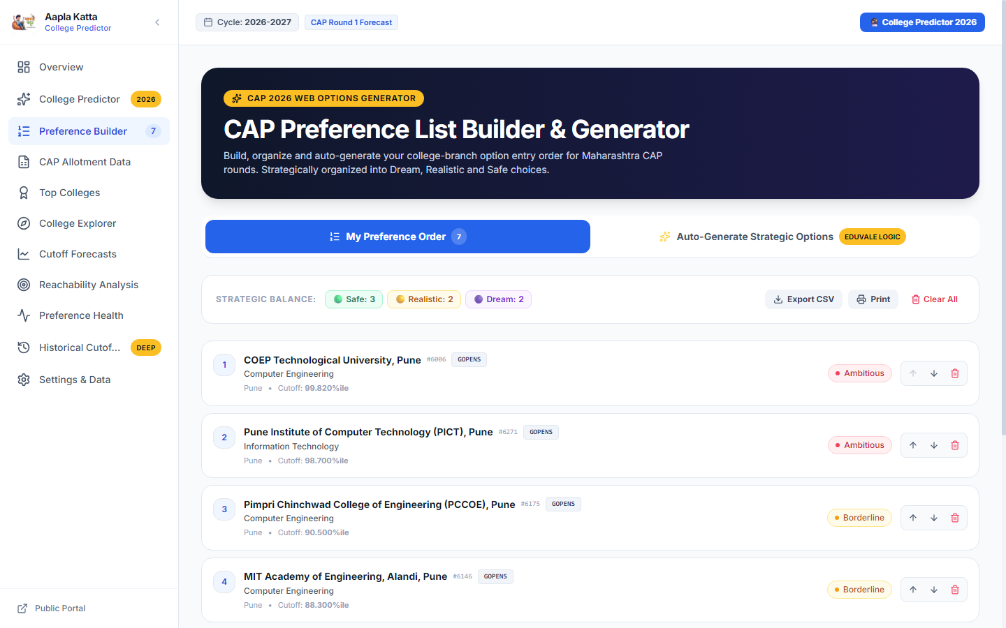
Figure 14: Strategic CAP Preference Option Form Builder with Real-Time Priority Reordering and CSV Export
Figure 14 highlights the CAP Preference List Builder. A candidate's active choices (including COEP, PICT, PCCOE, MIT AOE, Sinhgad, DY Patil Akurdi, and JSPM RSCOE) are organized in strict preference order with real-time strategic balance metrics (3 Safe, 2 Realistic, 2 Dream), reordering arrows, deletion triggers, and CSV/Print export tools.
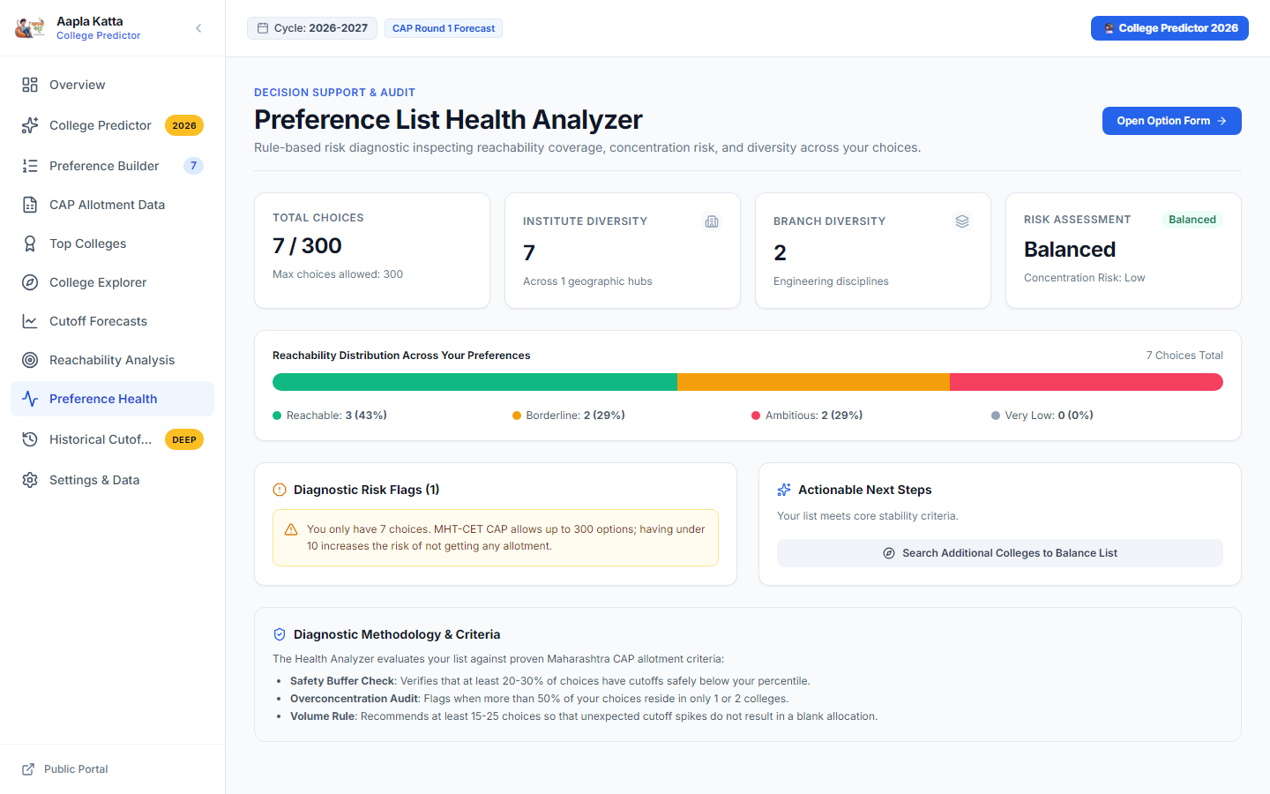
Figure 15: Preference List Health Analyzer with Automated Risk Diagnostic Audit and Strategic Balance
Figure 15 displays the Preference List Health Analyzer. The diagnostic engine audits choice diversity (7 institutes across 2 disciplines), calculates reachability distribution (43% Reachable, 29% Borderline, 29% Ambitious), evaluates concentration risk ('Balanced'), and generates actionable advisory flags to enhance option form stability.
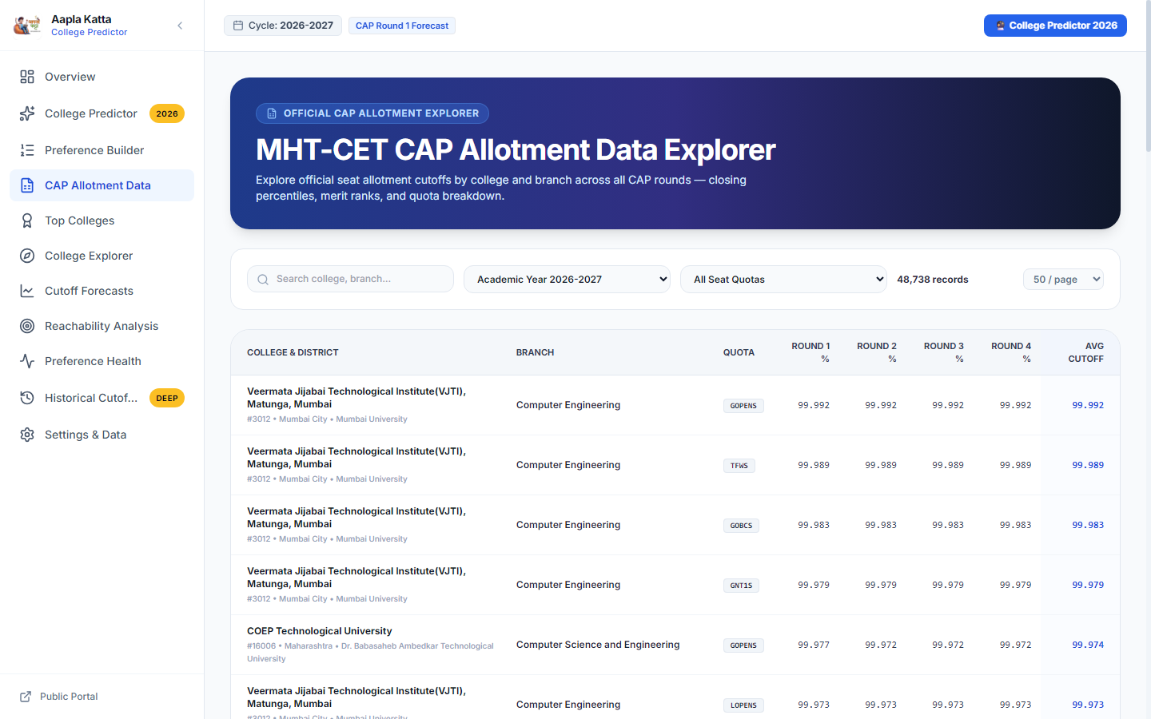
Figure 16: Official CAP Allotment Explorer Displaying Granular Seat Quotas and Round-Wise Cutoffs
Figure 16 illustrates the CAP Allotment Data Explorer, providing auditable access to 48,738 allotment cutoffs across CAP Rounds 1 through 4 for multiple reservation quotas (GOPENS, TFWS, GOBCS, GNT1S, LOPENS) across premier institutes including VJTI Matunga and COEP Tech.
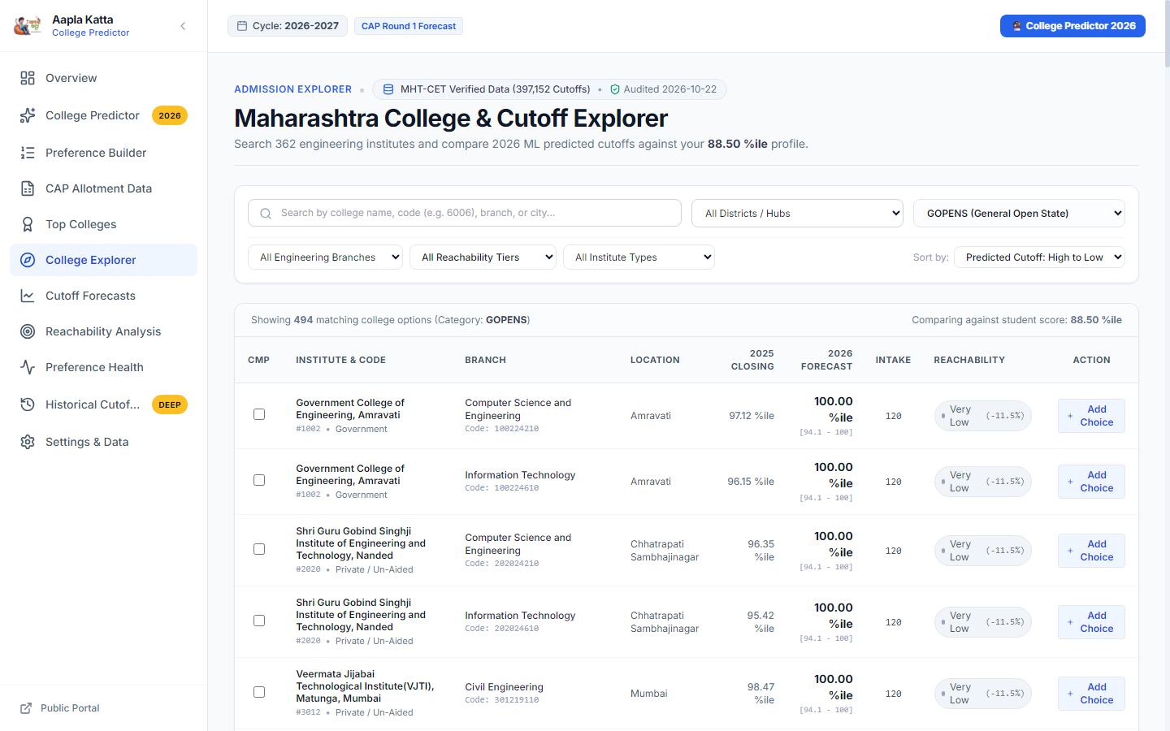
Figure 17: Comprehensive Maharashtra Engineering College & Cutoff Explorer with Faceted Filtering
Figure 17 depicts the Maharashtra College & Cutoff Explorer, allowing students to filter 362 engineering colleges by district, branch, autonomy status, and reservation quota, with instant comparisons against their 88.50 percentile profile.
8.4 Real-World Prediction Walkthrough & Case Study Validation
To validate the end-to-end utility of the platform in an authentic admission setting, consider a candidate with an 88.50 MHT-CET Percentile in the OBC / OPEN Category seeking Computer Engineering or Information Technology disciplines within the Pune metropolitan area. When the candidate inputs their score and preferences into the platform, the inference pipeline generates calibrated forecasts across all matching institutes and automatically structures the reachability tiers. Table 4 illustrates the resulting strategic allocations, demonstrating how ambitious reach choices, competitive target choices, and safe anchors are effectively harmonized:
Table 6: Real-World Case Study Walkthrough for 88.50 Percentile Candidate in Pune
Institution Name | Discipline | Predicted Cutoff | Reachability Tier | Strategic Recommendation
COEP Tech University, Pune | Computer Engineering | 99.40 %ile | Dream | Place in Option 1-5; aspirational high-prestige choice.
PICT, Pune | Information Technology | 97.80 %ile | Dream | Top-tier choice; competitive reach.
VIIT, Kondhwa, Pune | Computer Engineering | 89.20 %ile | Moderate | High-priority target; within 1% of candidate's score.
PCCOE, Ravet, Pune | Artificial Intelligence & DS | 87.40 %ile | Safe | Strong candidate; safe admission probability.
DY Patil COE, Akurdi | Computer Engineering | 84.10 %ile | Safe | Reliable backup choice; guaranteed allotment tier.

9. Limitations
While the system achieves state-of-the-art predictive performance on out-of-time test allocations, several domain and methodological boundaries must be recognized:
Table 7: Systemic Limitation Dimensions, Root Causes, and Applied Operational Mitigations
Limitation Dimension | Underlying Cause | Operational Impact & Mitigation Strategy
Newly Established Institutes | Absence of historical cutoff trajectories (zero previous_cutoff). | System defaults to geographic district averages; clearly flagged in UI.
Special Quota Sparsity | Very small seat counts for PWD/DEF categories (often 1-2 seats per branch). | Addressed via micro-quota shrinkage regularization toward category medians.
Policy & Seat Matrix Shocks | Unpredictable government reservation revisions or sudden autonomous seat quota shifts. | Requires annual re-calibration as soon as provisional seat matrices are released.
Student Preference Volatility | Sudden employment market shifts affecting branch preferences (e.g., AI/DS surge). | Ensemble feature weights partially adapt via year-over-year intake delta signals.

10. Conclusion & Future Directions
This project successfully developed and evaluated an end-to-end Machine Learning College Cutoff Intelligence Platform tailored to the Maharashtra engineering admissions ecosystem. By engineering a surgical data pipeline, over 397,000 authentic records across five academic cycles were standardized with zero artificial imputation. Strict temporal partitioning guaranteed authentic, leakage-free validation on 27,836 competitive options in the 2026-2027 CAP Round 1.
The proposed Calibrated Blended Ensemble—combining Random Forest (55%) and Extra Trees (45%) with an empirical +5.30 transition shift and micro-quota shrinkage—demonstrated marked superiority over standard baselines, achieving an MAE of 9.916, RMSE of 14.508, and an R² of 0.6531. Most critically for student utility, predictions within the tight ±5 percentile threshold increased by over 53% (from 29.31% to 45.13%).
The trained pipeline was embedded into a responsive, full-stack React and TypeScript application featuring an automated Three-Tier Reachability Engine (Safe, Moderate, Dream). Future extensions will incorporate Natural Language Processing (NLP) on student preference forums, deep learning time-series architectures (e.g., Temporal Fusion Transformers), and progressive web app (PWA) capabilities to serve mobile users during the active CAP admission season.

11. References
[1] State Common Entrance Test Cell, Government of Maharashtra, "Information Brochure for Centralized Admission Process (CAP) to First Year Undergraduate Technical Courses in Engineering and Technology," DTE Maharashtra Official Publications, 2022–2026. [Online]. Available: https://cetcell.mahacet.org/
[2] L. Breiman, "Random Forests," Machine Learning, vol. 45, no. 1, pp. 5–32, 2001. [Online]. DOI: https://doi.org/10.1023/A:1010933404324
[3] P. Geurts, D. Ernst, and L. Wehenkel, "Extremely randomized trees," Machine Learning, vol. 63, no. 1, pp. 3–42, 2006. [Online]. DOI: https://doi.org/10.1007/s10994-006-6226-1
[4] T. Chen and C. Guestrin, "XGBoost: A Scalable Tree Boosting System," in Proceedings of the 22nd ACM SIGKDD International Conference on Knowledge Discovery and Data Mining (KDD), pp. 785–794, 2016. [Online]. DOI: https://doi.org/10.1145/2939672.2945399
[5] C. Romero and S. Ventura, "Educational Data Mining: A Review of the State of the Art," IEEE Transactions on Systems, Man, and Cybernetics, Part C (Applications and Reviews), vol. 40, no. 6, pp. 601–618, 2010. [Online]. DOI: https://doi.org/10.1109/TSMCC.2010.2053532
[6] F. Pedregosa et al., "Scikit-learn: Machine Learning in Python," Journal of Machine Learning Research (JMLR), vol. 12, pp. 2825–2830, 2011. [Online]. Available: https://jmlr.org/papers/v12/pedregosa11a.html
[7] M. S. Al-Razgan and A. S. Al-Khalifa, "Educational Data Mining: A Systematic Mapping of the Literature," IEEE Access, vol. 8, pp. 101740–101755, 2020. [Online]. DOI: https://doi.org/10.1109/ACCESS.2020.2998637
[8] Y. Baashar, G. Alkawsi, N. Ali, H. Alhussian, and H. T. Bahbouh, "Predicting student's performance using machine learning methods: a systematic literature review," in Proceedings of the 2021 International Conference on Computer and Information Sciences (ICCOINS), pp. 357–362, June 2021. [Online]. DOI: https://doi.org/10.1109/ICCOINS49721.2021.9497184
[9] R. L. Pardhi, Y. Patne, M. Shekokar, A. Thakare, M. Popatkar, and S. Bijawe, "An Automated College Prediction Model Using Machine Learning," International Journal of Research Publication and Reviews (IJRPR), vol. 4, no. 5, pp. 4880–4884, May 2023. [Online]. Available: https://ijrpr.com/uploads/V4ISSUE5/IJRPR13887.pdf
[10] K. Tilwane, A. Savale, S. Patil, P. Satle, S. Shinde, and A. More, "Machine Learning-Based College Admission Predictor: A Telegram Bot for Indian Engineering Colleges," International Research Journal of Modernization in Engineering Technology and Science (IRJMETS), vol. 6, no. 4, pp. 2582–5208, Apr. 2024. [Online]. Available: https://www.irjmets.com/root_sys/myuploadedfile/842240417122119.pdf
[11] A. More, S. Patil, A. Savale, P. Satle, K. Tilwane, and S. Shinde, "ML-Based College Predictor Telegram Bot: Indian Engineering Colleges," International Journal of Scientific Research in Engineering and Management (IJSREM), vol. 9, no. 1, pp. 1–7, Jan. 2025. [Online]. Available: https://ijsrem.com/download/ml-based-college-predictor-telegram-bot-indian-engineering-colleges/

