A Project Report on

“Student Performance Analysis and Detection of Factors Responsible for Academic Performance”
Submitted to COEP Technological University, Pune
A Unitary Public University of Government of Maharashtra Master of Technology

In
Data Science
Submitted By:
Kunal K. Sarate (712652050)

Under the Guidance of Dr. Y. V. Haribhakta
Department of Computer Science and Engineering
COEP Technological University, Shivajinagar, Pune — 411005
(A Unitary Public University of Government of Maharashtra) Maharashtra, India (2026-27)

Table of Contents

- Abstract……………………………………………………...3
- Introduction………………………………………………….4
- Dataset Description………………………………………….5
- Methodology………………………………………………...5
- Exploratory Data Analysis (Outputs)……………………….7
- Model Development and Results…………………………..13
- Feature Importance and Factor Analysis………………..…14
- Outputs………………………………………………….….15
- Limitations………………………………………………...16
- Conclusion…………………………………………...17
- References……………………………………………17

1. Abstract
This project analyses a dataset of 10,000 student records with 14 attributes to identify the factors associated with academic performance, and builds a Streamlit-based decision-support application around the findings. The target variable is overall_score, together with its derived letter grade (A–F). A central finding of the project is that overall_score is an exact weighted combination of assignment, midterm, final exam, attendance and participation scores. Using those components as predictors therefore causes data leakage (R² = 1.000). To address this, two model setups were built: Setup A (behavioral and socio-demographic features only) and Setup B (full assessment features, shown for comparison). Linear/Logistic Regression, Decision Tree and Random Forest models were trained for both regression and classification.

Setup A reaches only R² = 0.023 for regression and a macro F1 of 0.215 for grade classification. Attendance is the strongest behavioral feature (Random Forest importance 0.306, Pearson r = +0.149). Study hours (r = −0.004), sleep, parent education, internet access and extra classes show negligible association with performance. Setup B classification reaches a macro F1 of 0.888 using Logistic Regression. The trained pipeline is deployed as a five-page Streamlit application that provides score prediction, grade prediction and an academic risk assessment.

Keywords: student performance, educational data mining, data leakage, regression, classification, Random Forest, Streamlit.

2. Introduction

2.1 Background

Academic performance is influenced by a mix of behavioral habits (attendance, study time, sleep), background factors (parental education, access to resources) and the students' actual assessment outcomes. Institutions want to know which of these factors can be acted on early, so that at-risk students can be supported before final results are declared. Educational data mining and machine learning offer a systematic way to quantify these relationships.

2.2 Problem Statement

To analyse student records, determine which factors are genuinely associated with overall academic performance, build predictive models for the overall score and grade without misleading data leakage, and present the results through an interactive decision-support tool.

2.3 Objectives

- Inspect, validate and clean the student performance dataset.
- Perform exploratory data analysis (EDA) to understand distributions and relationships.
- Detect and handle data leakage arising from the composition of overall_score.
- Develop and compare regression models (predicting score) and classification models (predicting grade).
- Identify and interpret the most influential factors using feature importance.
- Deploy the results as an interactive Streamlit application with risk classification and guidance.

2.4 Scope

The project covers a single cross-sectional dataset of 10,000 students. It reports associations, not causal effects, and the app is a demonstration of decision support rather than a production grading system.

3. Dataset Description

The dataset contains 10,000 records and 14 columns. Data integrity checks found no missing values and no duplicate rows, and all numeric columns fell inside their expected ranges.
Column | Type | Description
student_id | Integer | Unique identifier for each student
gender | Categorical | Male or Female
study_hours_per_day | Float | Daily study hours (1–10)
attendance_percentage | Float | Attendance percentage (40–100)
assignment_score | Float | Assignment score out of 100
midterm_score | Float | Midterm exam score out of 100
final_exam_score | Float | Final exam score out of 100
participation_score | Float | Participation score out of 100
internet_access | Categorical | Yes or No
extra_classes | Categorical | Yes or No
parent_education | Categorical | High School, Associate, Bachelor, Master, PhD
sleep_hours | Float | Daily sleep hours (4–9)
overall_score | Float | Overall score (regression target)
grade | Categorical | Letter grade A, B, C, D, F (classification target)

4. Methodology

4.1 Workflow
The project followed this pipeline: data upload → inspection → validation and cleaning → encoding and feature engineering → exploratory analysis → leakage analysis → model training (two setups) → evaluation → feature importance → deployment in Streamlit.

4.2 Tools and Technologies
Python 3, pandas and NumPy (data handling), Matplotlib and Seaborn (visualisation), scikit-learn (modelling and metrics), Google Colab / Jupyter (development) and Streamlit (application).

4.3 Data Validation
Every numeric field was checked against its expected range (study hours 1–10, sleep 4–9, attendance 40–100, component scores 0–100). Missing values and duplicate rows were counted; none were found, so no imputation or row removal was needed.

4.4 Encoding and Feature Engineering

- Binary encoding: internet_access and extra_classes (Yes = 1, No = 0); gender (Male = 1, Female = 0).
- Ordinal encoding: parent_education (High School = 0, Associate = 1, Bachelor = 2, Master = 3, PhD = 4).
- Grade encoding: F = 0, D = 1, C = 2, B = 3, A = 4.
- Engineered features: total_exam_score (midterm + final), continuous_evaluation (assignment + participation), study_to_sleep_ratio (study hours ÷ sleep hours), and attendance_category (High ≥ 85%, Medium 70–84%, Low < 70%).

4.5 Data Leakage Analysis
The analysis showed that the target is an exact weighted sum of its components:
overall_score = 0.20 × assignment + 0.25 × midterm + 0.35 × final_exam + 0.10 × attendance + 0.10 × participation

Any model that sees the component scores can simply reconstruct the target, giving R² = 1.0 without learning anything useful. Two setups were therefore defined:

Setup | Features | Purpose
A: Behavioral / Socio-demographic | study hours, attendance, sleep hours, internet access, extra classes, parent education, gender (7 features) | Realistic evaluation of what habits and background can explain
B: Full Assessment | Setup A features plus assignment, midterm, final exam and participation scores (11 features) | Comparison only; demonstrates leakage

4.6 Models and Evaluation

An 80/20 train–test split with random_state = 42 was used. For regression: Linear Regression, Decision Tree Regressor and Random Forest Regressor (100 trees), evaluated by MAE, MSE, RMSE and R². For classification of grade: Logistic Regression, Decision Tree Classifier and Random Forest Classifier (100 trees), evaluated by accuracy and macro-averaged precision, recall and F1. A confusion matrix was produced for the best Setup A classifier.

5. Exploratory Data Analysis (Outputs)

5.1 Distributions
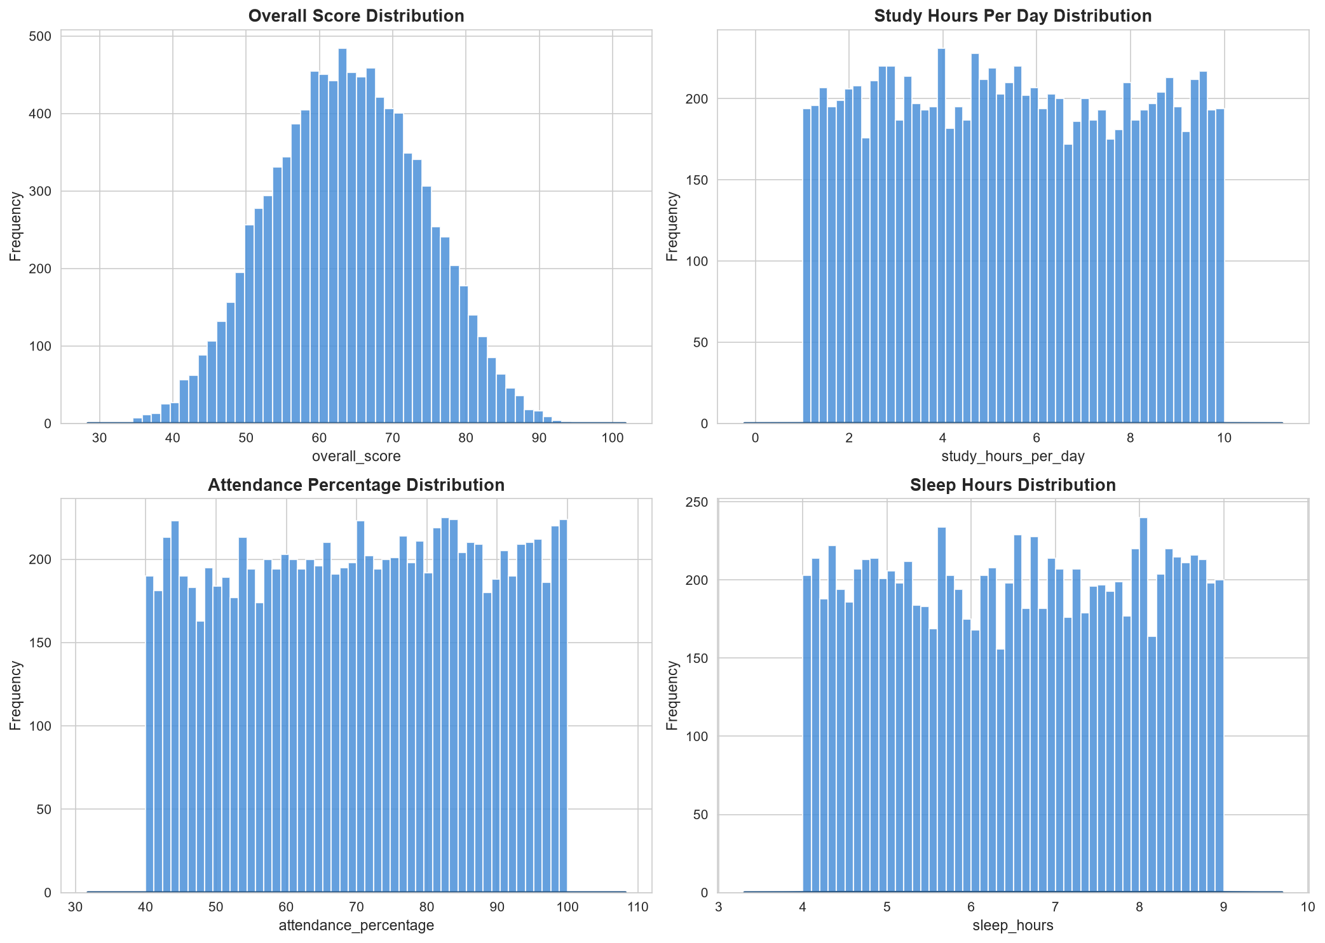
Figure 1: Distributions of overall score, study hours, attendance and sleep hours

overall_score is approximately bell-shaped, centred at about 63–64 and ranging from roughly 33 to 97. By contrast, study hours (1–10), attendance (40–100%) and sleep hours (4–9) are almost uniformly distributed across their ranges, with no pronounced peaks.

5.2 Grade Distribution
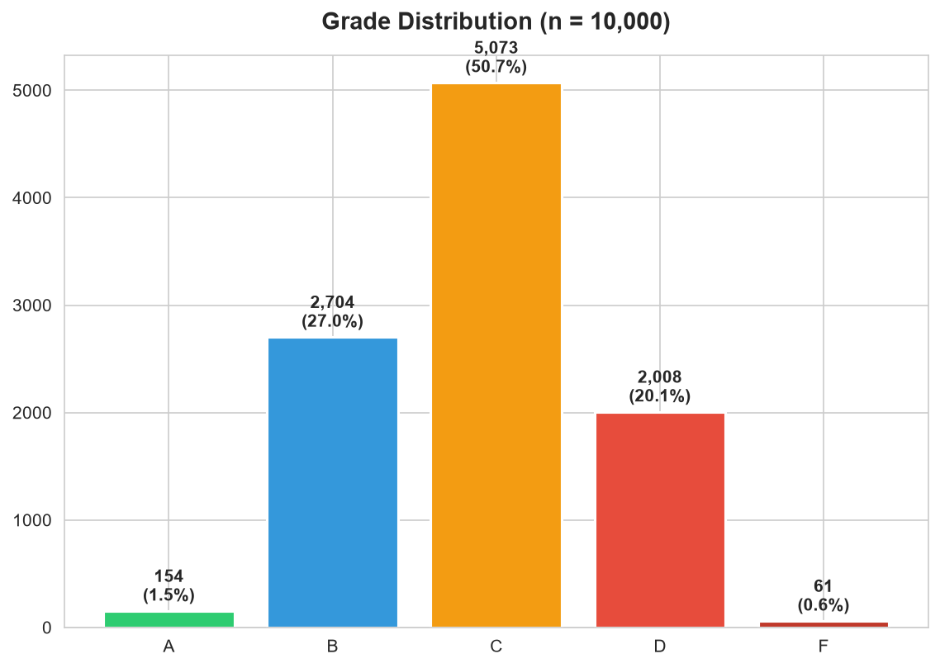
Figure 2: Grade distribution (n = 10,000)

Grade | Students | Share
A | 154 | 1.5%
B | 2,704 | 27.0%
C | 5,073 | 50.7%
D | 2,008 | 20.1%
F | 61 | 0.6%

The classes are heavily imbalanced: half of all students receive a C, while A and F together make up just over 2% of the data.

5.3 Attendance vs Overall Score
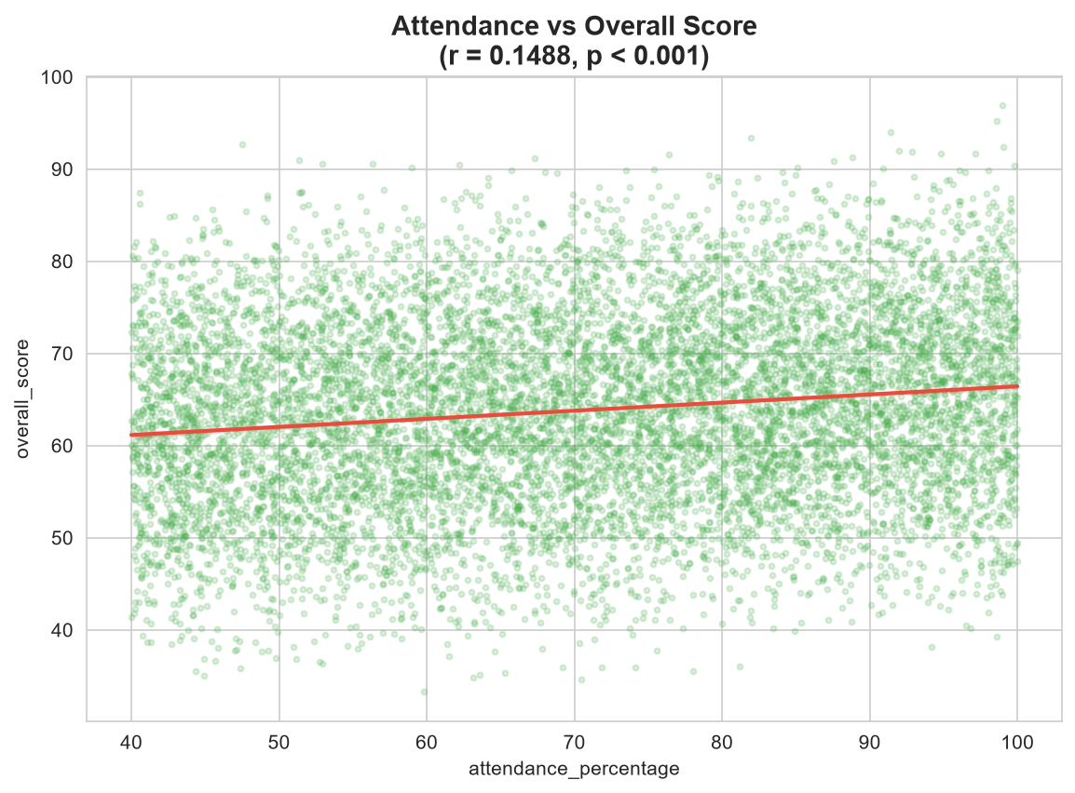
Figure 3: Attendance vs overall score

5.4 Study Hours vs Overall Score
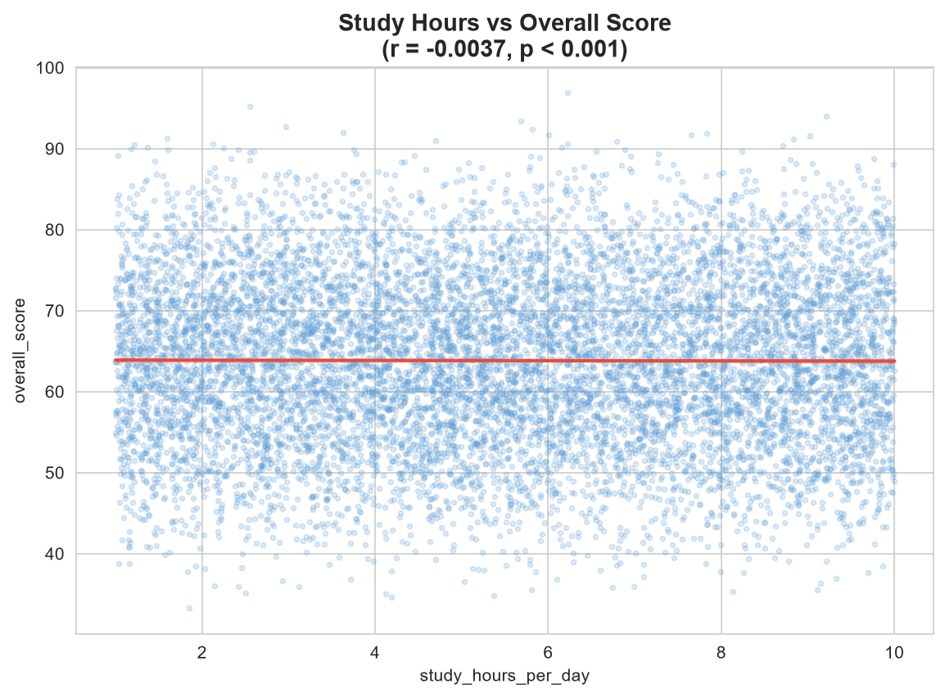

5.5 Parent Education
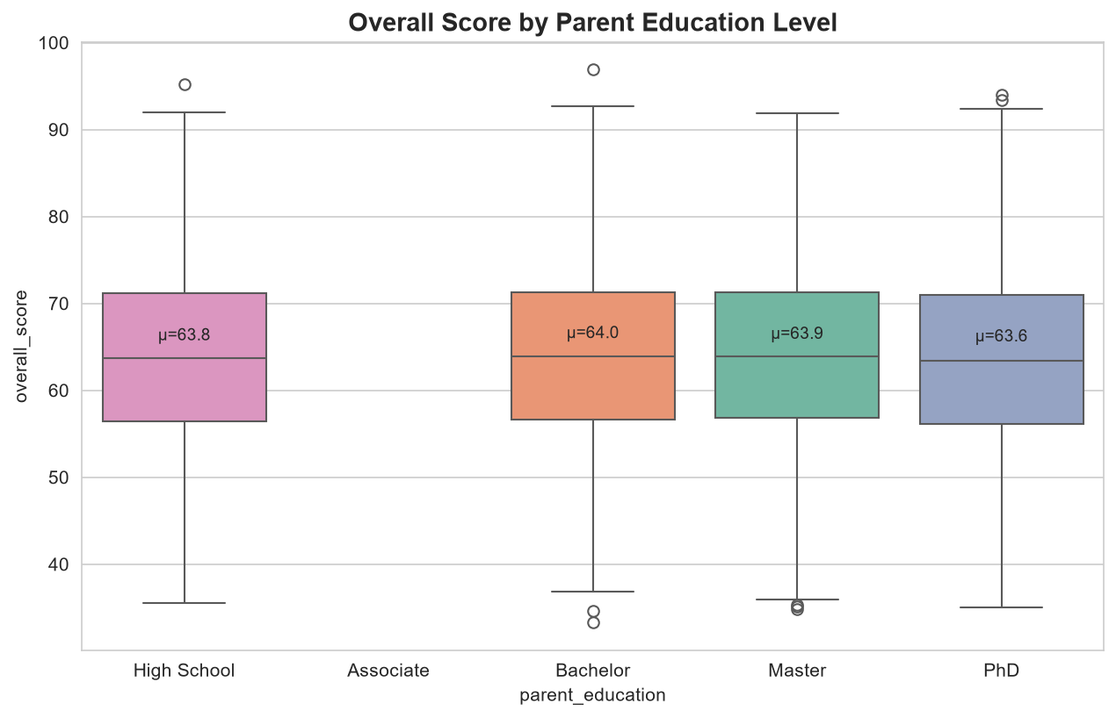

5.6 Extra Classes and Internet Access

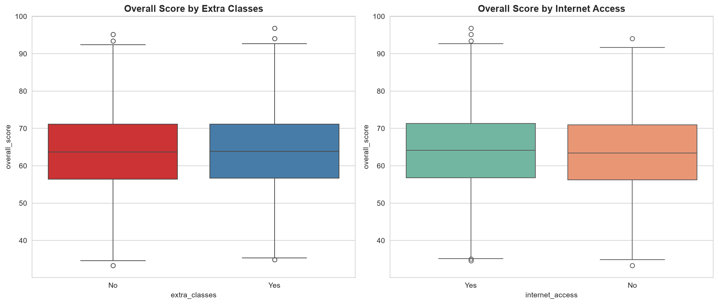

The boxplots for students with and without extra classes are nearly indistinguishable (medians around 63.7–63.9). Students with internet access show a marginally higher median (about 64) than those without (about 63), a very small difference relative to the spread of scores.

5.7 Correlation Analysis
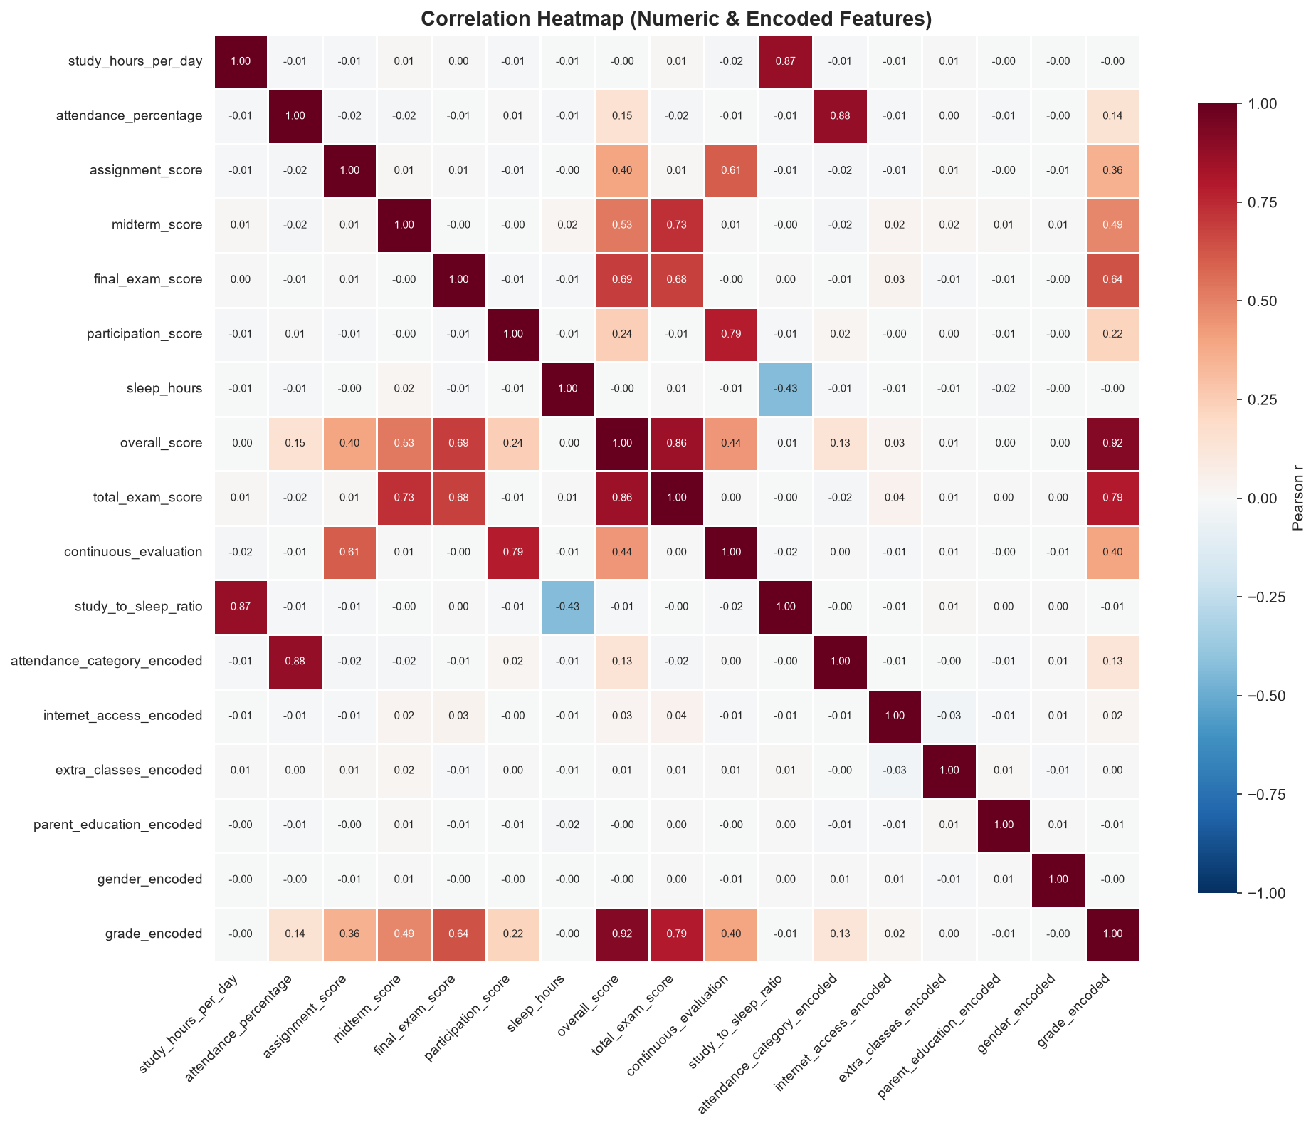
Figure 7: Correlation heatmap of numeric and encoded features

Correlations with overall_score from the heatmap:

Feature | Pearson r with overall_score
final_exam_score | 0.69
midterm_score | 0.53
continuous_evaluation | 0.44
assignment_score | 0.40
participation_score | 0.24
attendance_percentage | 0.15
study_hours_per_day, sleep_hours, parent education, gender | ≈ 0.00

6. Model Development and Results

6.1 Summary of Best Results

Setup | Task | Best Model | Score
A (Behavioral) | Regression | Linear Regression | R² = 0.023
A (Behavioral) | Classification | Random Forest | Macro F1 = 0.215
B (Full Assessment) | Regression | Linear Regression | R² = 1.000 (leakage)
B (Full Assessment) | Classification | Logistic Regression | Macro F1 = 0.888

6.2 Interpretation

- Setup A (behavioral):

R² of 0.023 means the seven behavioral and background features explain roughly 2.3% of the variance in overall score. The classifier's macro F1 of 0.215 is only slightly better than a model that guesses the majority class, which is unsurprising given the weak correlations and imbalanced grades.

- Setup B (full assessment):
Regression R² = 1.000 is not predictive skill; it is the model rediscovering the weighted formula. Classification is high (F1 = 0.888) but not perfect because grade boundaries are sharp and neighbouring grades overlap near cut-offs.

- Confusion matrix:
The Random Forest on Setup A (see the notebook output) is expected to favour the dominant C and B/D classes, in line with the class imbalance.

7. Feature Importance and Factor Analysis

Random Forest feature importance for Setup A ranks attendance_percentage first (0.306). The remaining importance is spread across study hours, sleep hours and the other features.

Interpretation of each factor, consistent with the correlation evidence:

Factor | Observation in this dataset
Attendance | Only factor with a clear positive association (r = +0.149); students above 85% attendance score higher on average
Study hours per day | No linear relationship (r = −0.004)
Sleep hours | No relationship (r ≈ 0.00)
Parent education | Group means within 0.4 points of each other
Internet access | Very small difference in medians
Extra classes | No visible difference
Gender | No relationship (r ≈ 0.00)

8. Outputs

8.1 Modules
- Executive Dashboard: high-level summary metrics of the dataset.
- Dataset Explorer & Upload: browse the data; a sidebar uploader accepts an optional student CSV (up to 200 MB).
- Exploratory Data Analysis: interactive versions of the plots in Section 5.
- ML Model Benchmarks: comparison of the trained regression and classification models.
- Score & Grade Predictor: the prediction and risk assessment interface.

8.2 Score & Grade Predictor: Sample Output

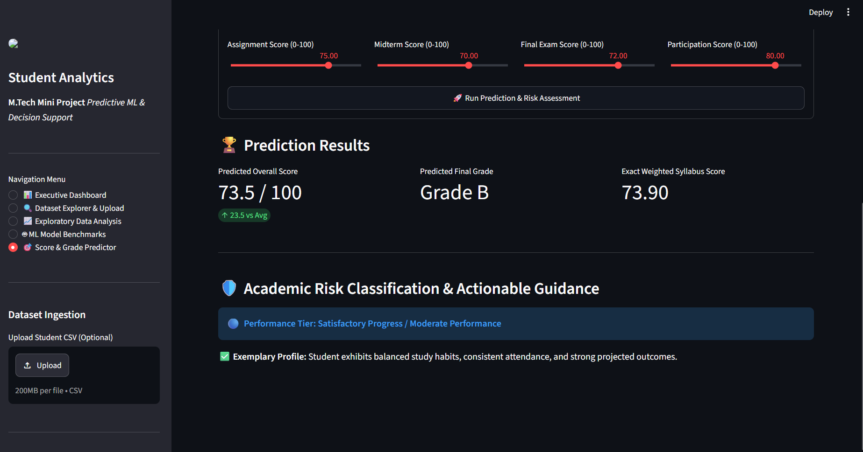
Figure 8: Streamlit Score & Grade Predictor, sample prediction

The user enters assignment, midterm, final exam and participation scores (0–100) with sliders and clicks Run Prediction & Risk Assessment. For the sample input of assignment 75, midterm 70, final exam 72 and participation 80, the app returns:

Output | Value
Predicted Overall Score | 73.5 / 100
Predicted Final Grade | Grade B
Exact Weighted Syllabus Score | 73.90
Performance Tier | Satisfactory Progress / Moderate Performance

10. Limitations

Limitation | Impact
Cross-sectional data (single snapshot) | Individual progress over time cannot be tracked
No multi-year tracking | Learning trends and interventions cannot be observed
No teacher or course identifiers | Teacher effectiveness and subject differences cannot be assessed
Self-reported study and sleep hours | Possible recall bias
Grade imbalance (A and F rare) | Classification biased toward C, B and D
No socioeconomic features | Background factors only partly captured
Near-uniform behavioral distributions and near-zero correlations | The data may be synthetic, so the findings may not generalise to real cohorts
Attendance is part of the target formula | Setup A is not entirely free of target-related information
Default hyperparameters, single train–test split | No cross-validation or tuning; metrics may vary with the split

12. Conclusion

This project analysed 10,000 student records to identify the factors associated with academic performance. It showed that overall score is an exact weighted combination of assessment components, so naive models achieve a perfect but meaningless R² of 1.0. By separating a behavioral setup (A) from a full-assessment setup (B), the study found that behavioral and socio-demographic factors explain only about 2.3% of score variance, with attendance the single most influential factor and study hours, sleep and parental education showing no meaningful effect. Models using assessment components classify grades well (macro F1 = 0.888) but this reflects the grading formula, not independent prediction.

The resulting Streamlit application turns the analysis into a practical decision-support tool that predicts score and grade and gives risk guidance. The main lesson is methodological: careful leakage detection and honest reporting of low predictive power are more valuable than impressive-looking accuracy figures.

13. References

- Y. Baashar, G. Alkawsi, N. Ali, H. Alhussian, and H. T. Bahbouh, “Predicting student’s performance using machine learning methods: a systematic literature review,” in Proceedings of the 2021 International Conference on Computer and Information Sciences (ICCOINS), pp. 357–362, Kuching, Malaysia, June 2021.

- E. S. Bhutto, I. F. Siddiqui, Q. A. Arain, and M. Anwar, “Predicting students’ academic performance through super vised machine learning,” in Proceedings of the 2020 In ternational Conference on Information Science and Communication Technology (ICISCT), pp. 1–6, Karachi, Pakistan, April 2020.

- Student Performance Prediction Using Machine Learning Algorithms Esmael Ahmed Information System, College of Informatics, Wollo University, Dessie 7200, Ethiopia Correspondence should be addressed to Esmael Ahmed; esmael.ahmed@wu.edu.et Received 2 January 2024; Revised 4 April 2024; Accepted 6 April 2024; Published 30 April 2024

- L. H. Alamri, R. S. Almuslim, M. S. Alotibi, D. K. Alkadi, I. Ullah Khan, and N. Aslam, “Predicting student academic performance using support vector machine and random forest,” in Proceedings of the 2020 3rd International Confer ence on Education Technology Management, pp. 100–107, London, UK, June 2020.

