**Lab Practical #01:**

Study of basic networking commands and IP configuration.

**Practical Assignment #01:**

1. Perform and explain various networking commands listed below:
   1. ipconfig
   2. ping
   3. getmac
   4. systeminfo
   5. traceroute / tracert
   6. netstat
   7. nslookup
   8. hostname
   9. pathping
   10. arp

## ipconfig

### Description:

**It stands for Internet Protocol Configuration and is used to display and manage the IP address and network settings of a computer. Display basic network information.**

|  |  |  |
| --- | --- | --- |
| No. | Option | Description |
| 1 | /all | Displays **detailed information** about all network interfaces on your system (such as Host Name, DNS servers, MAC address, etc.) |
| 2 | /release | Releases the **IPv4 address** assigned to your computer by the DHCP server. |
| 3 | /release6 | It releases the IPv6 address assigned by the DHCPv6 server. |
| 4 | /allcompartments | Displays **detailed configuration information** for **all network compartments** on the system. |
| 5 | /renew | Renews the **IPv4 address** for your computer and get fresh IPv4 from the DHCP server. |

### Implementation:

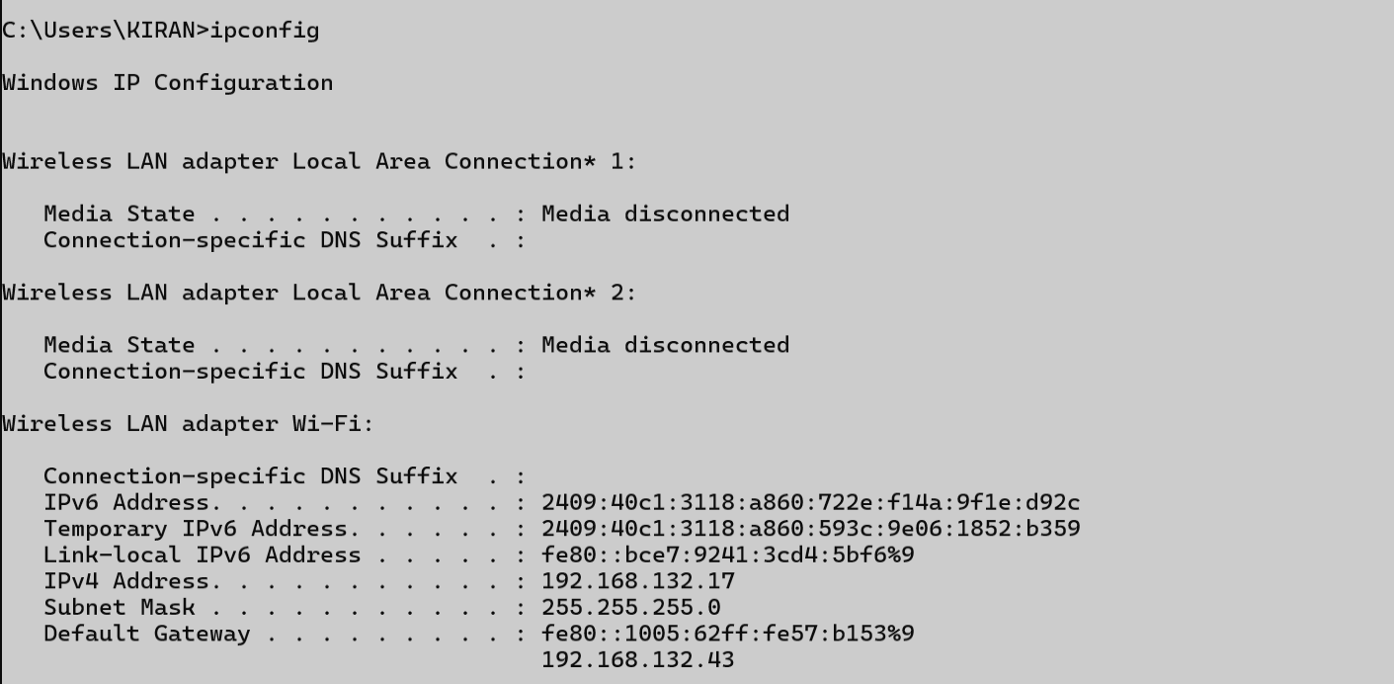

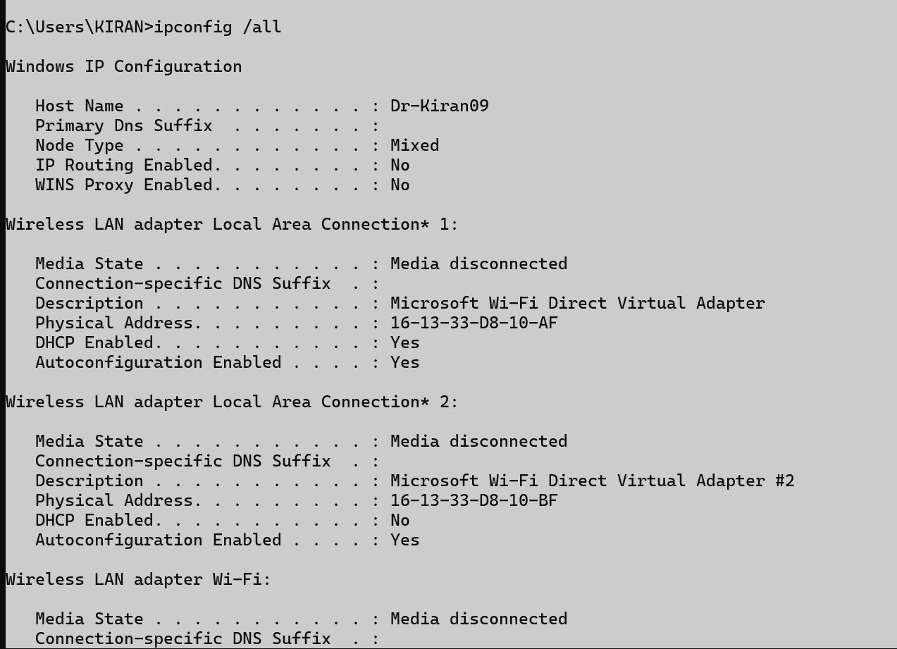

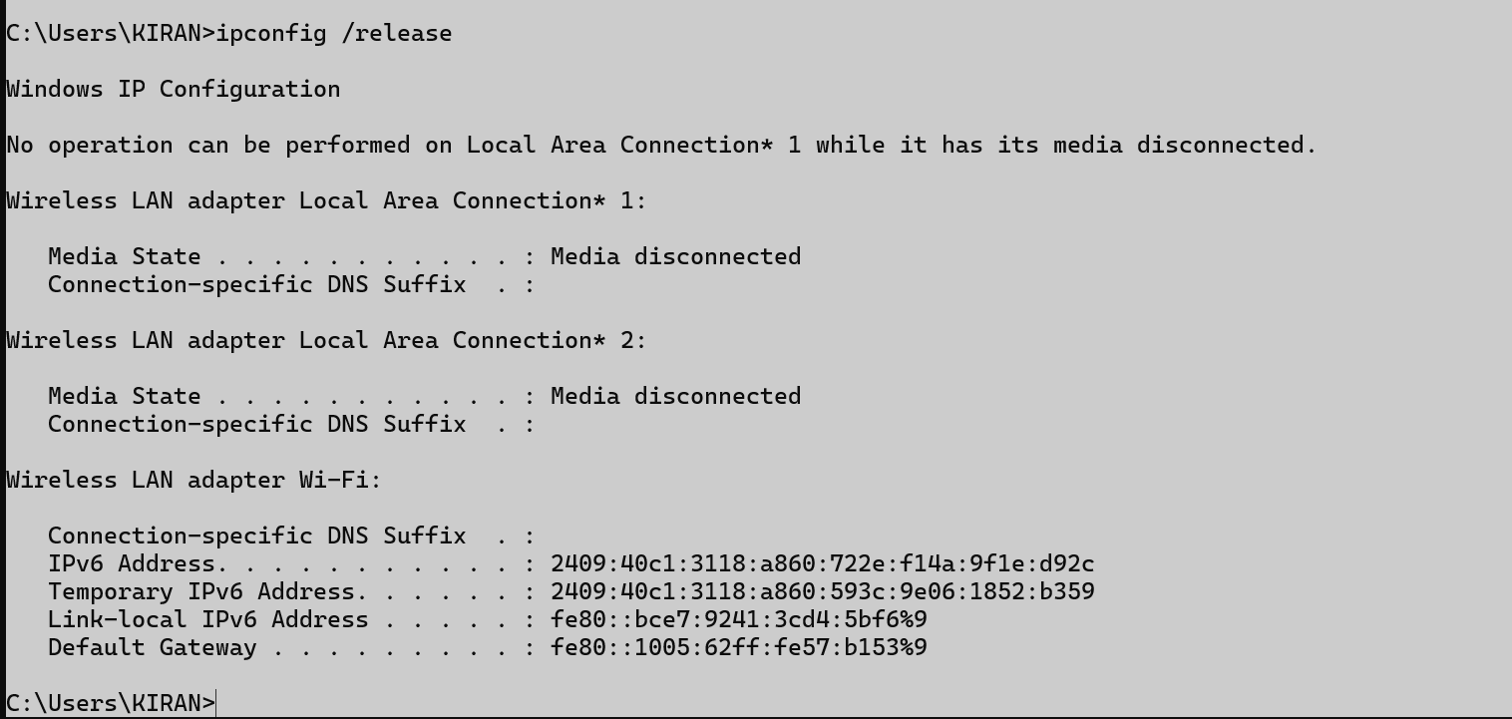

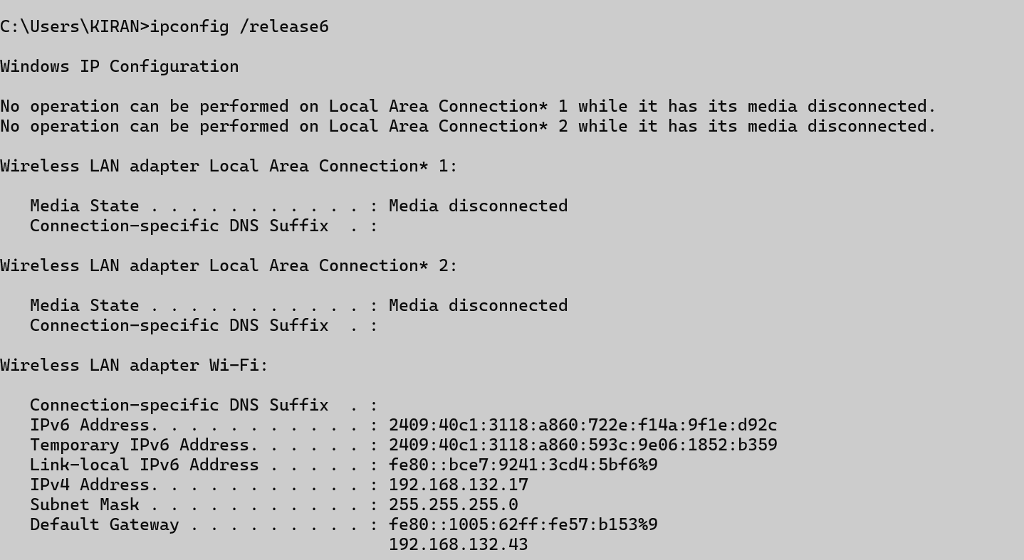

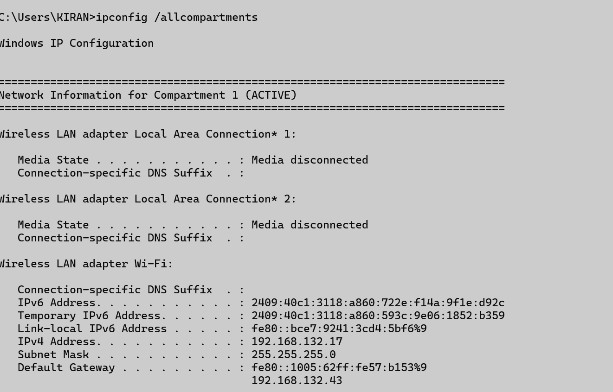

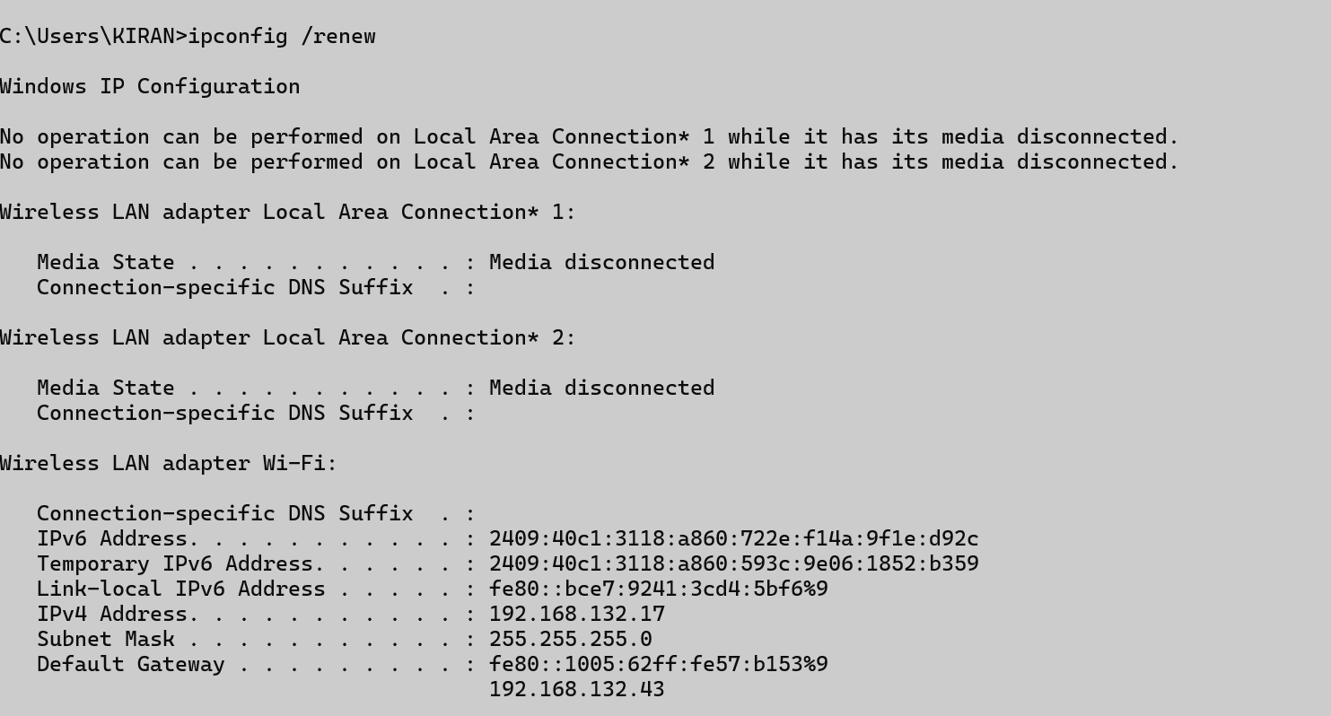

## ping

### Description:

**The ping command is used to test network connectivity between your device and another device (like a website or IP address). It sends ICMP Echo Request packets and waits for Echo Reply responses to check if the target is reachable and how long it takes.**

|  |  |  |
| --- | --- | --- |
| No. | Option | Description |
| 1 | -a google.com | Useful to check if a hostname can be resolved correctly. |
| 2 | -n 5 google.com | Sends a specific number of ping requests. |
| 3 | -4 google.com | Forces the ping command to use **IPv4** addresses only |
| 4 | -R google.com | This option is used to **record the route** that the ping packets take. |

### Implementation:

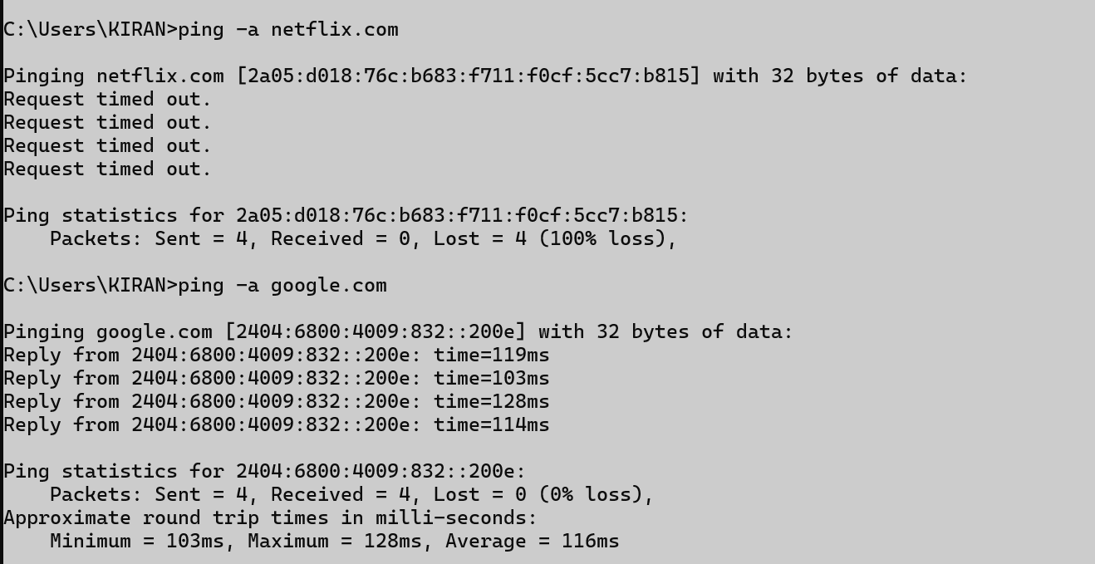

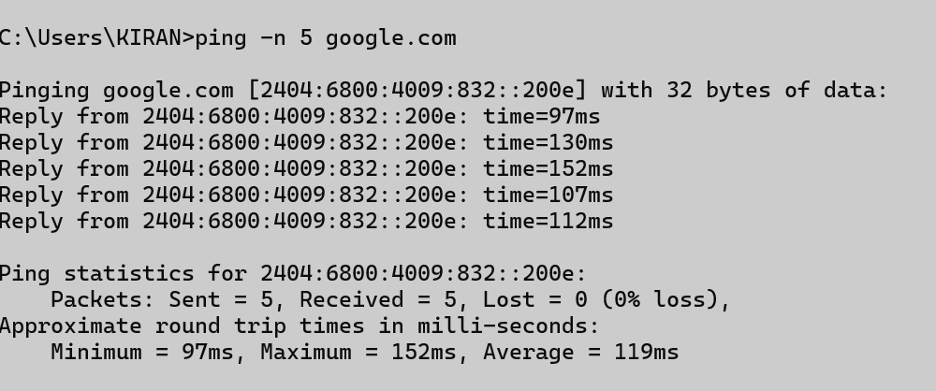

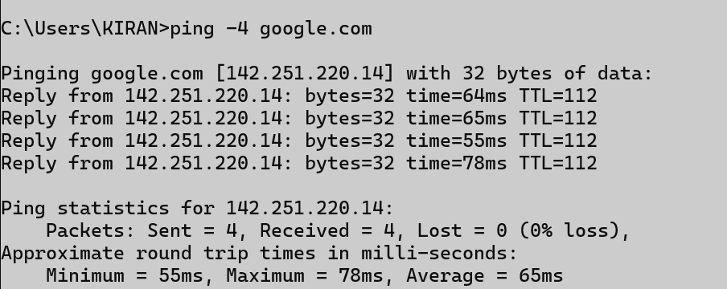

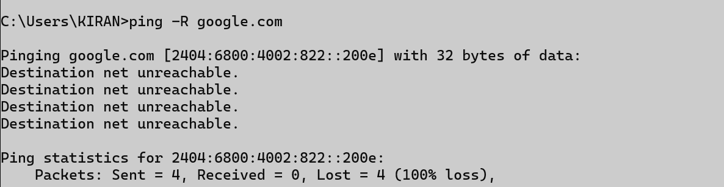

## getmac

### Description:

**Getmac displays the Media Access Control (MAC) addresses of the network interfaces (wired or wireless) on a system. It shows the physical address and transport name of all available network adapters.**

|  |  |  |
| --- | --- | --- |
| No. | Option | Description |
| 1 | /V | Displays **detailed (verbose)** information about each network adapter, including:   * MAC address * Connection name * Network adapter status * Transport name |
| 2 | /FO list | **Formats the output** as a **list** (Field: Value format), making it easier to read each adapter's info clearly, line by line. |
| 3 | /FO table /NH | Formats the output as a **table**, the default format.  removes the column headers from the table output. |

### Implementation:



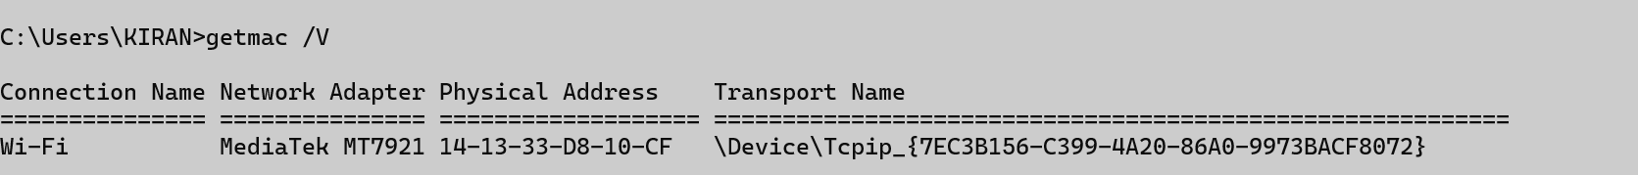



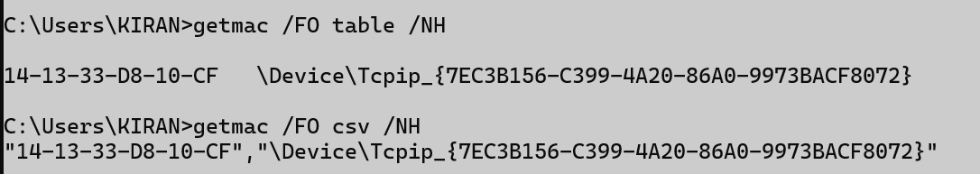

## systeminfo

### Description:

**systeminfo displays detailed configuration information about the computer and its operating system.This includes:**

* **OS name and version**
* **System manufacturer and model**
* **Processor, BIOS, and memory info**
* **Network card details**
* **System boot time and hotfixes installed**

|  |  |  |
| --- | --- | --- |
| No. | Option | Description |
| 1 | /FO TABLE | Displays the output in a **table format**, with each property and value shown in a two-column table. |
| 2 | /FO CSV /NH | Formats the output as **CSV (Comma-Separated Values)**, suitable for Excel or other spreadsheet tools. removes the column headers from the CSV output. |
| 3 |  |  |

### Implementation:

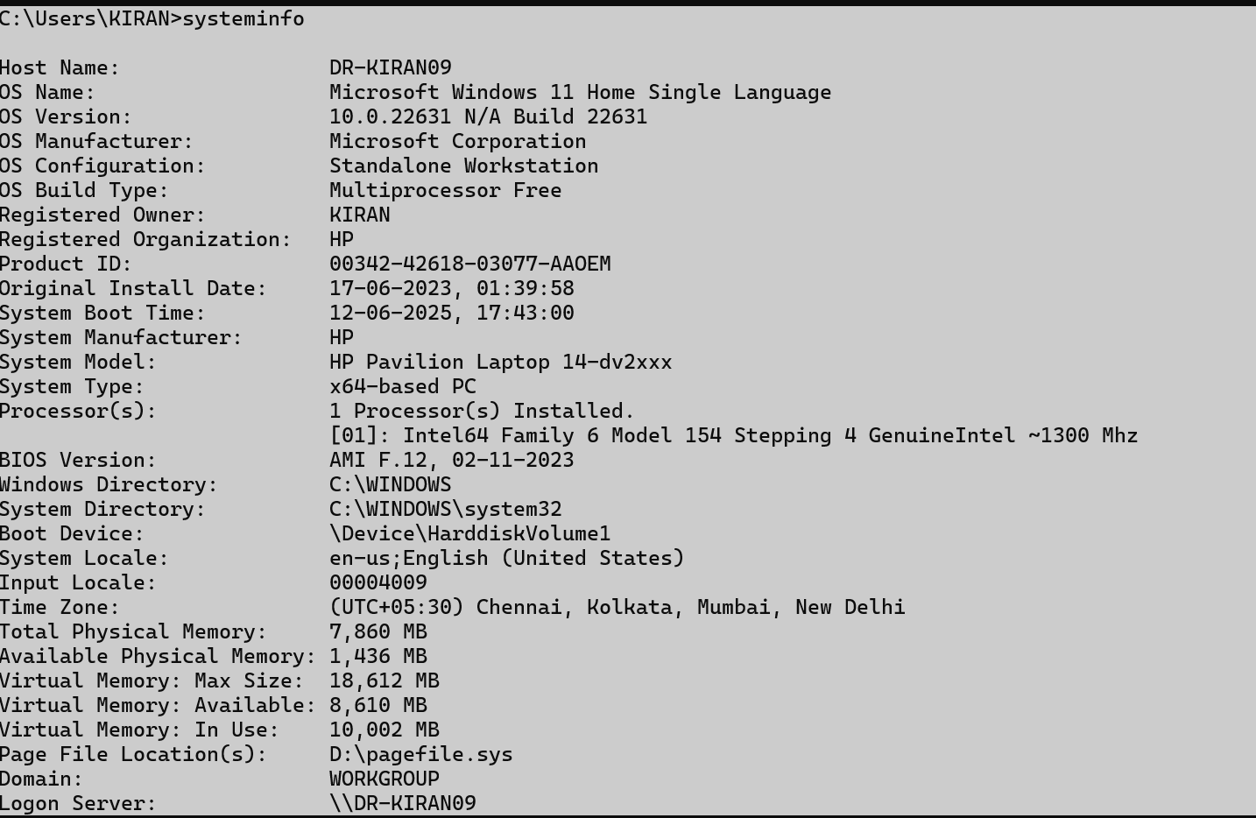

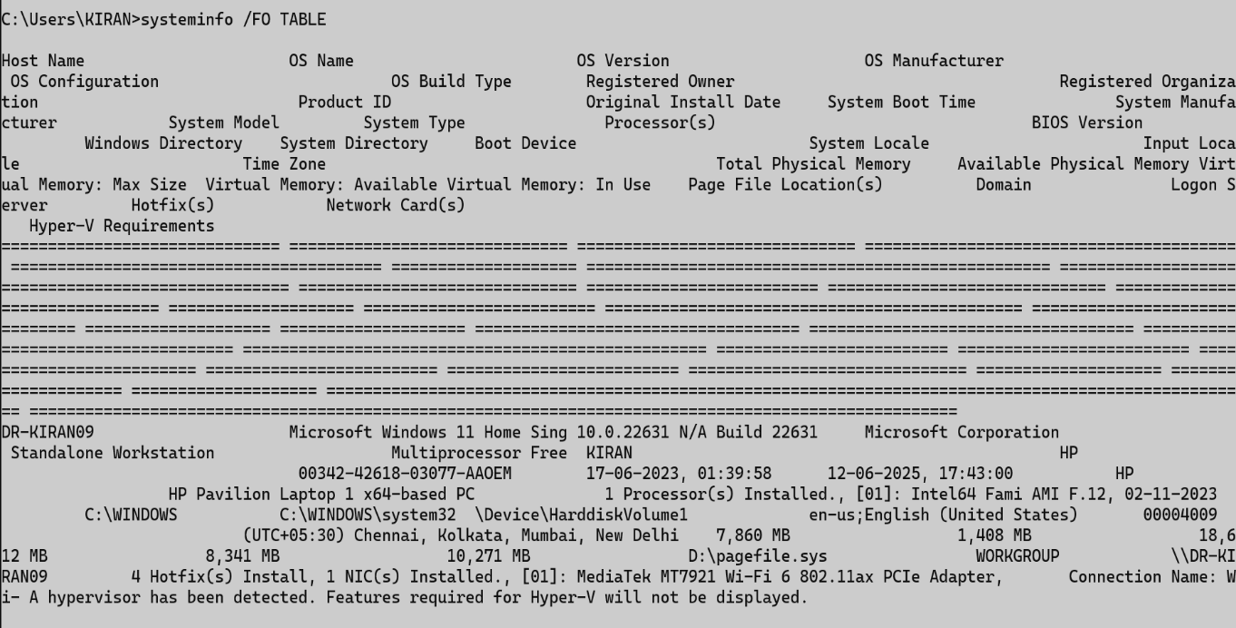

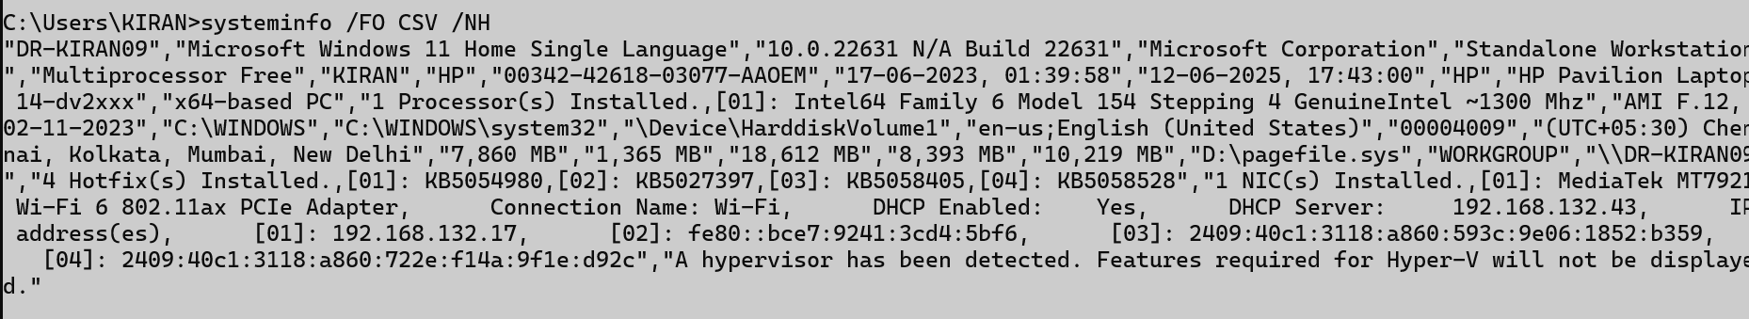

## traceroute/ tracert

### Description:

**tracert (short for trace route) is used to trace the path that packets take from your computer to a destination.**

|  |  |  |
| --- | --- | --- |
| No. | Option | Description |
| 1 | -d Netflix.com | This command traces the path to **netflix.com** without resolving IP addresses to **hostnames**, which makes the trace run **faster**. -d skips DNS lookup to save time. |
| 2 | -h number google.com | Sets the **maximum number of hops** (routers) that the trace will go through before giving up. Default is 30 hops. |
| 3 | -w timeout(4000) google.com | Sets the **timeout** in milliseconds to wait for each reply.The default is 4000 ms |

### Implementation:

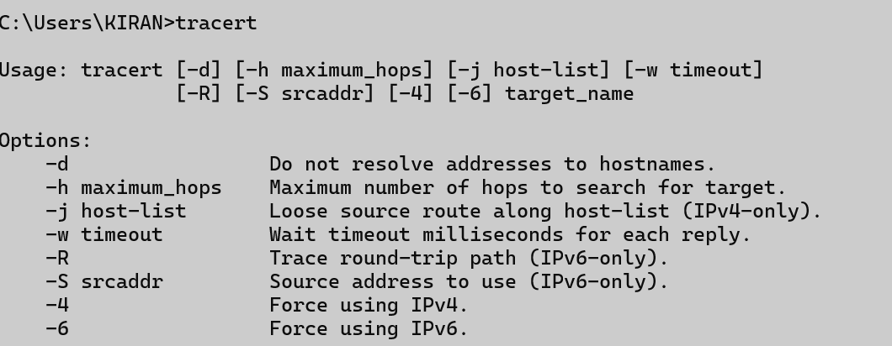

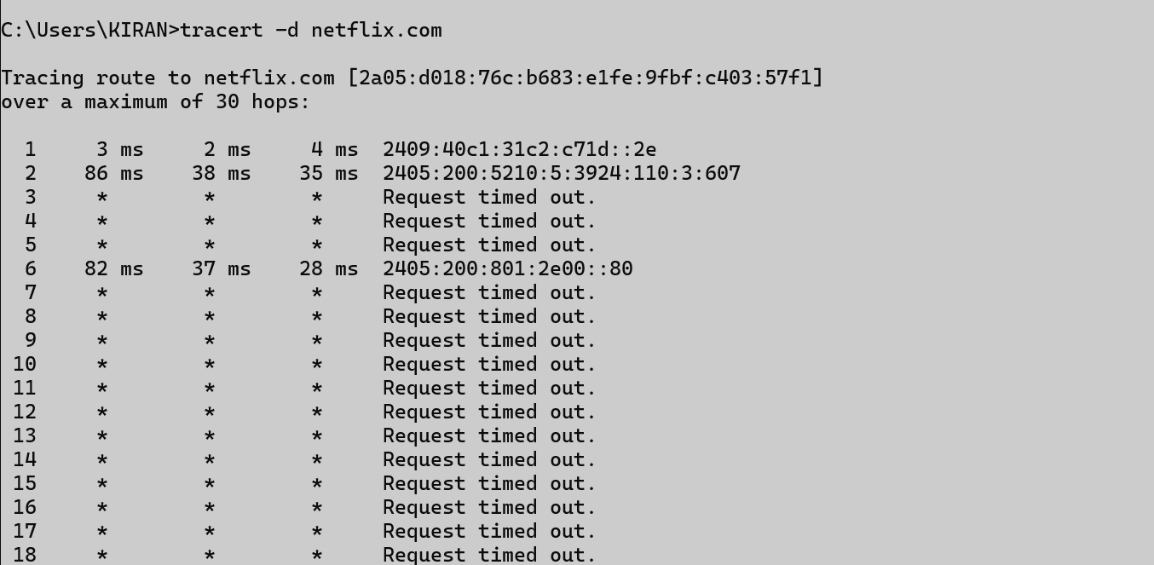

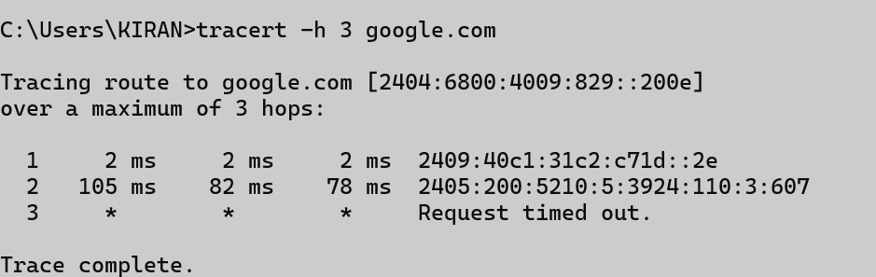

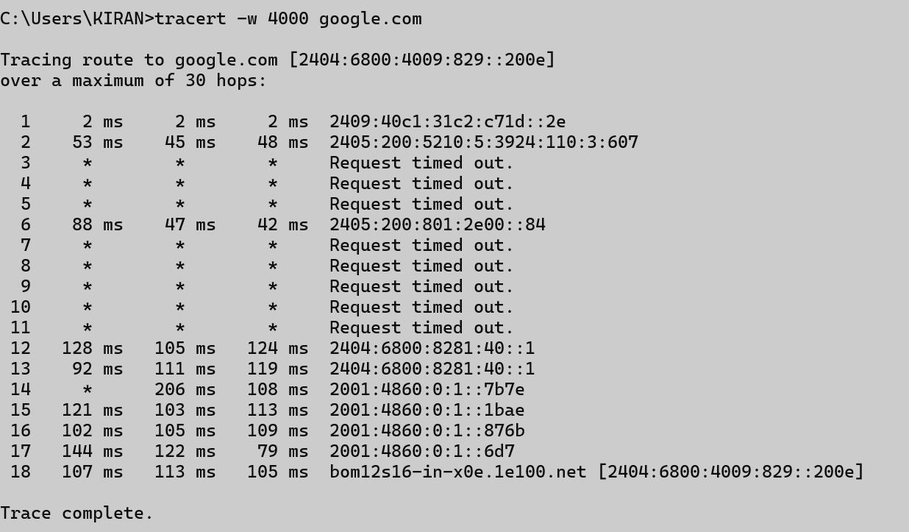

## netstat

### Description:

**netstat (short for Network Statistics) displays active network connections, listening ports, routing tables, interface stats, and more. It helps in monitoring network activity and troubleshooting issues.**

|  |  |  |
| --- | --- | --- |
| No. | Option | Description |
| 1 | -a | Displays **all active connections** and the **ports the computer is listening on** (both TCP and UDP). |
| 2 | -f | Shows **fully qualified domain names (FQDN)** for foreign addresses (instead of just IP addresses). |
| 3 | -r | Displays the **routing table**, showing how data is routed in your network. |
| 4 | -n | Displays addresses and port numbers in **numeric form**, skipping DNS lookup (faster output). |

### Implementation:

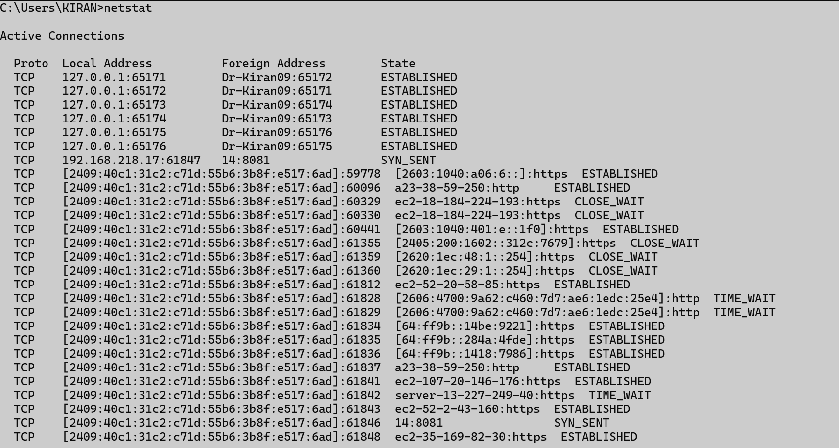

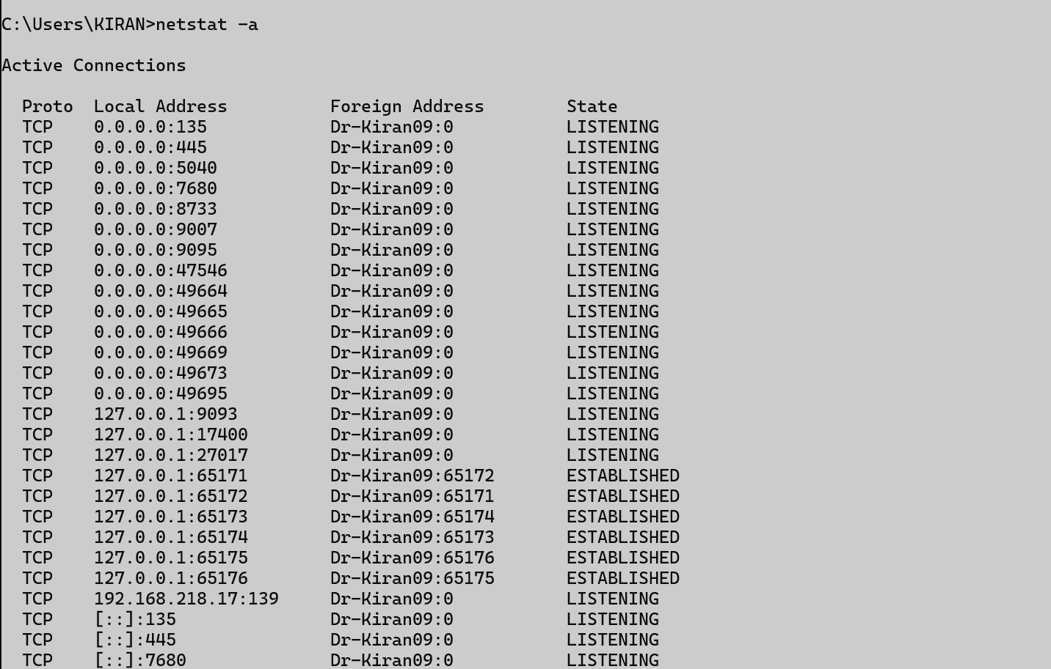

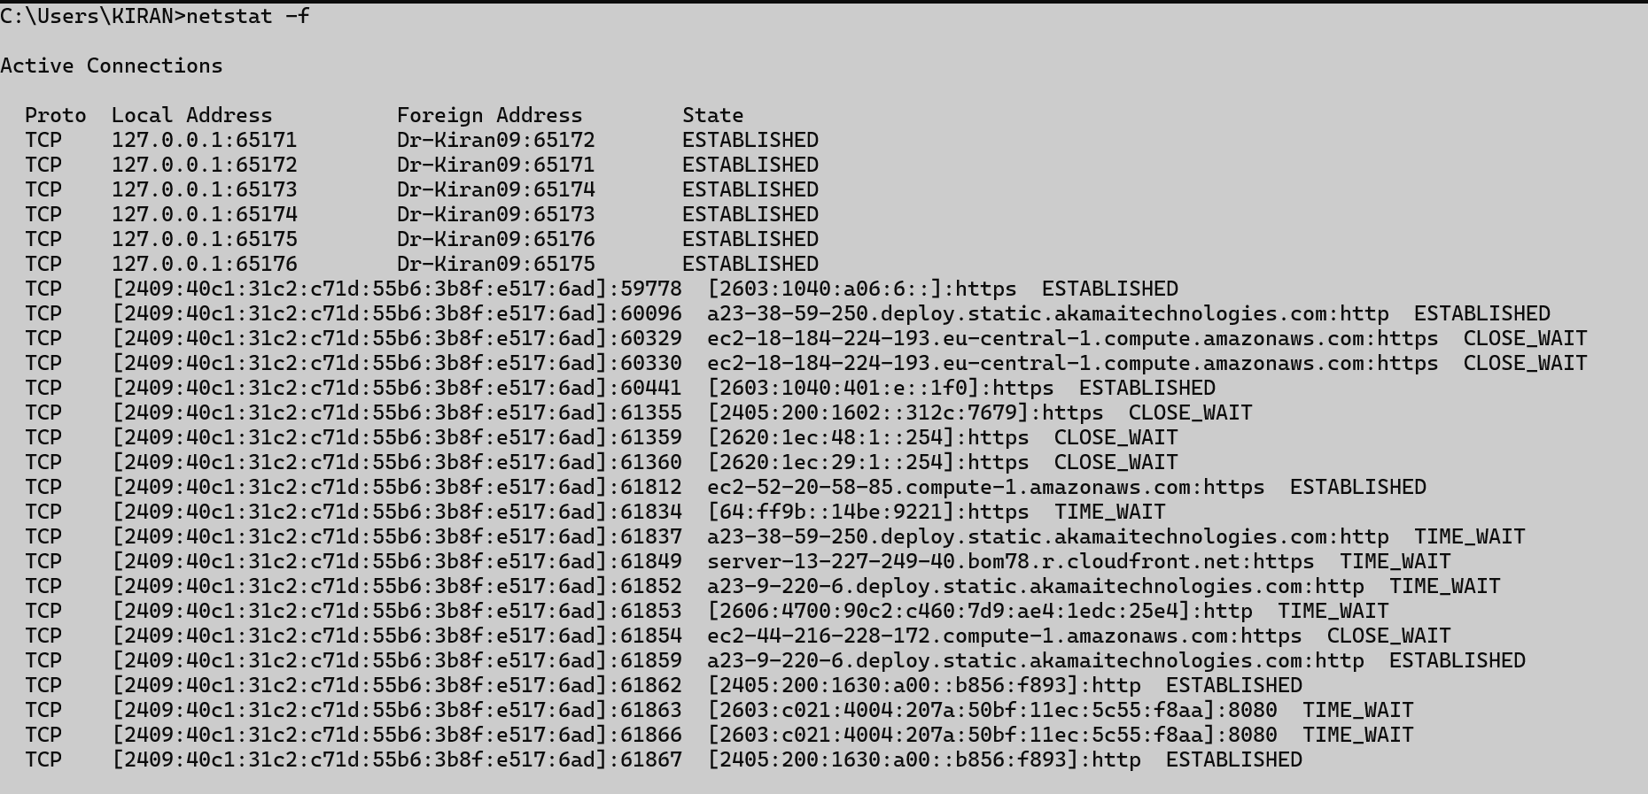

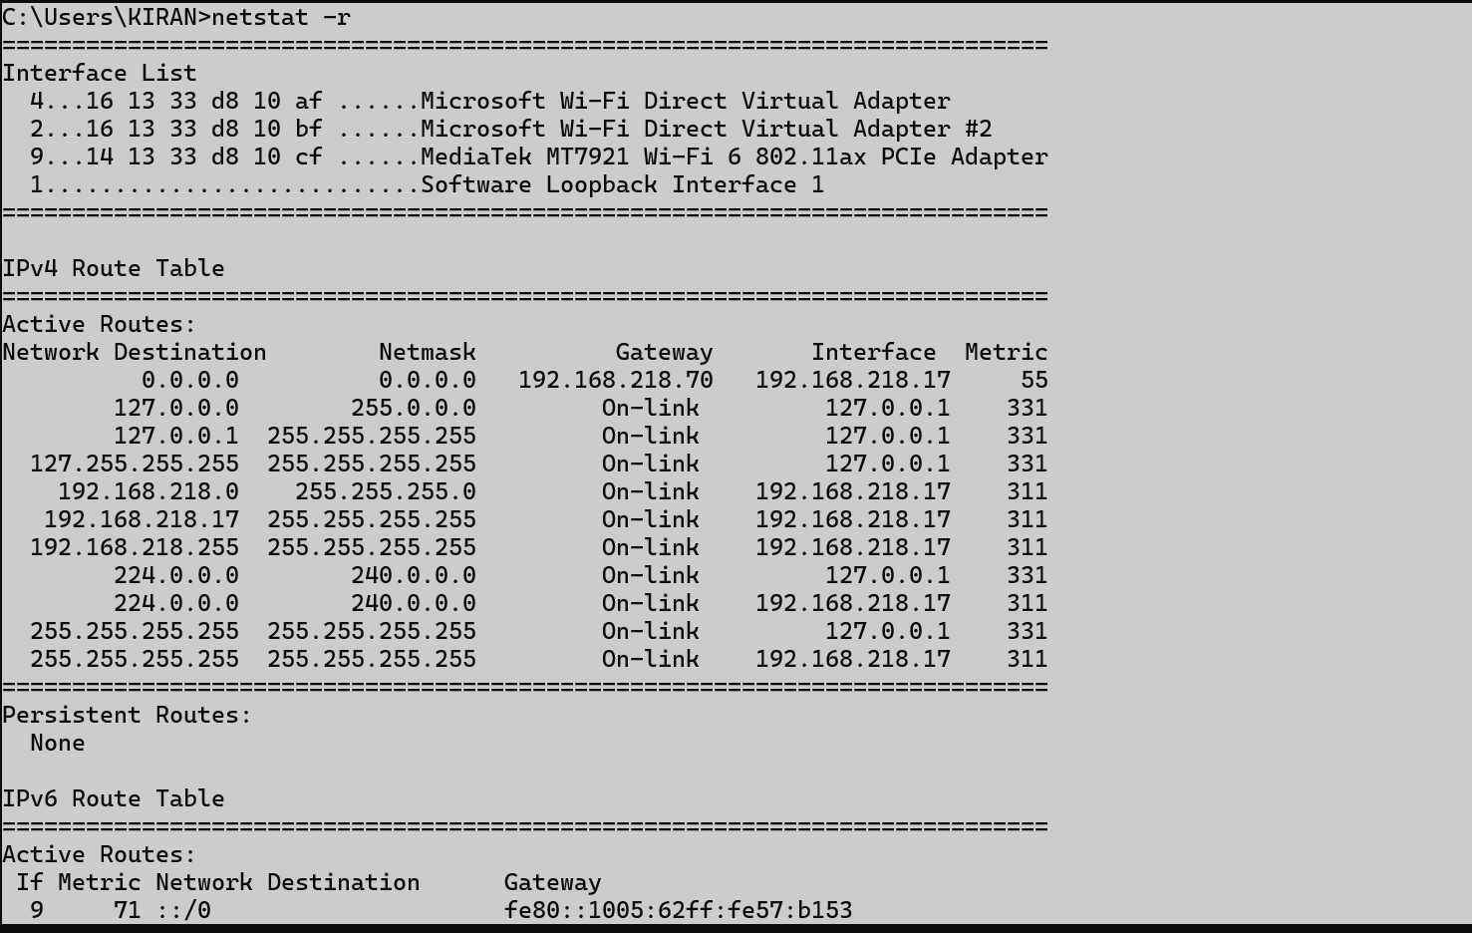

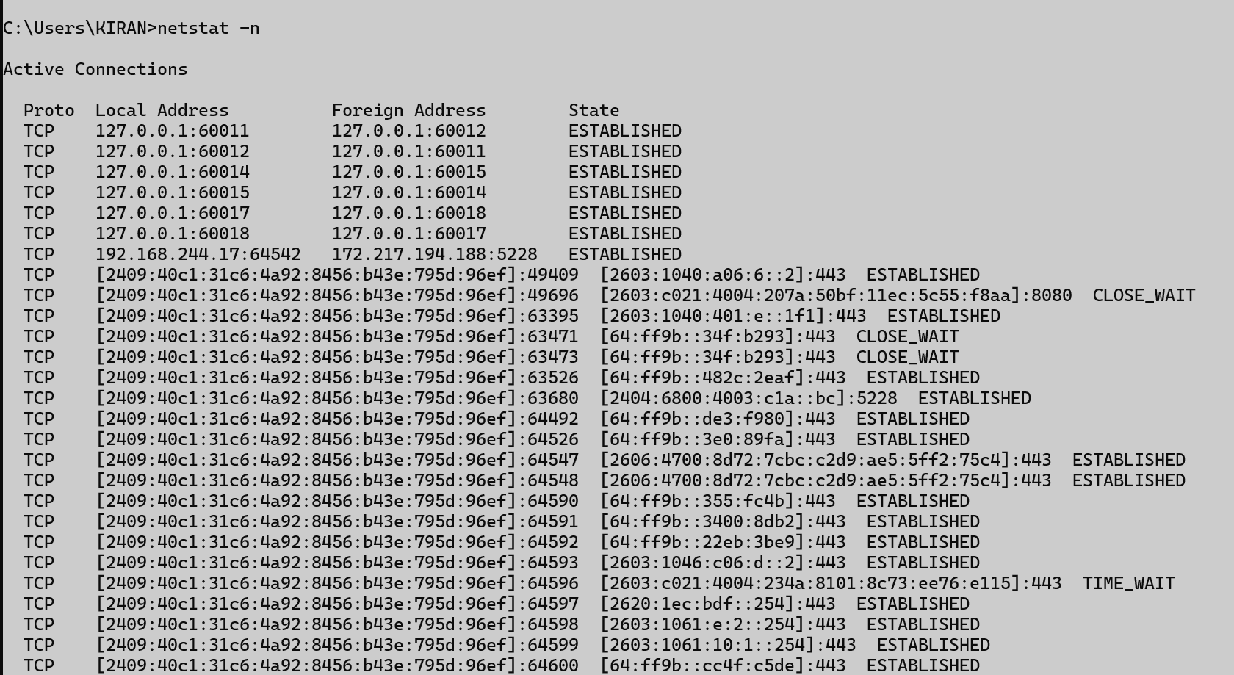

## nslookup

### Description:

**nslookup (Name Server Lookup) is used to query DNS (Domain Name System) to find the IP address of a domain or the domain name of an IP address.**

|  |  |  |
| --- | --- | --- |
| No. | Option | Description |
| 1 | nslookup  set type=A / AAAA  website name(google.com) | set type=A: Looks up the **IPv4 address** of the domain.  set type=AAAA: Looks up the **IPv6 address** of the domain. Used interactively within the nslookup prompt. |
| 2 | nslookup google.com | Performs a **simple DNS query** to find the **IP address** of google.com using the default DNS server. |
| 3 | nslookup google.com 8.8.8.8 | Queries the DNS record of google.com using a **specific DNS server** (8.8.8.8 is Google’s public DNS). |

### Implementation:

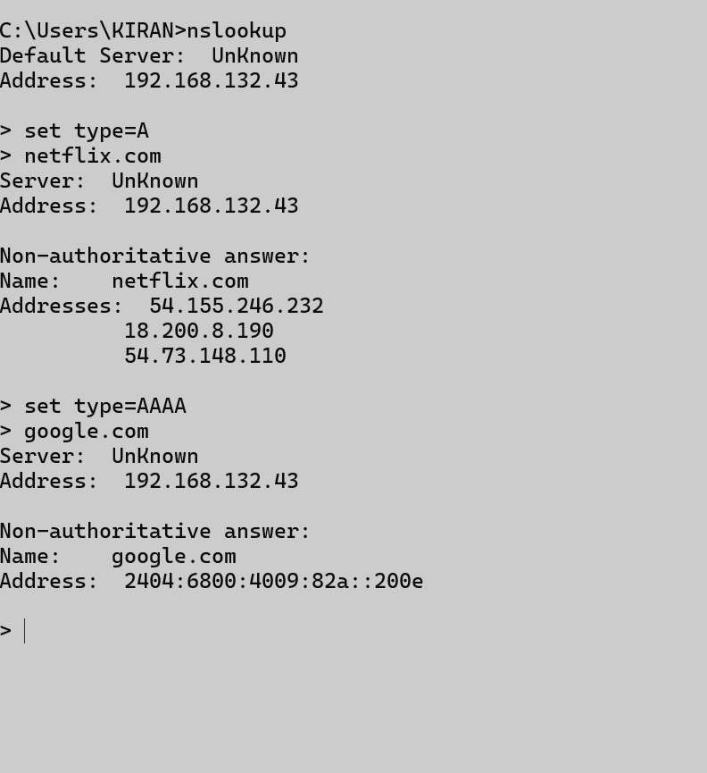

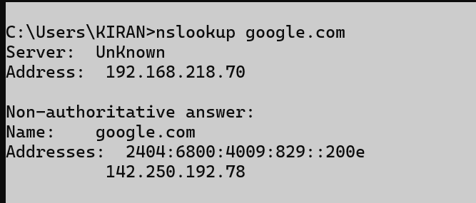

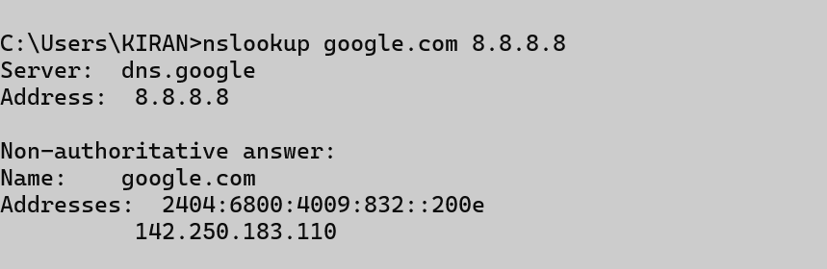

## hostname

### Description:

### The hostname command is used to display the name of the current computer (host) on a network.

### Implementation:

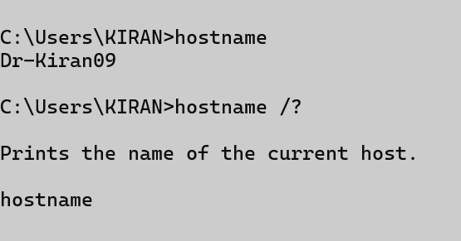

## pathping

### Description:

**pathping is a network diagnostic tool that combines the features of ping and tracert. It traces the route to a target and also provides packet loss statistics for each hop along the way.**

|  |  |  |
| --- | --- | --- |
| No. | Option | Description |
| 1 | -4 google.com | Forces the command to use **IPv4** only. |
| 2 | -g google.com | Specifies a **loose source route** along the specified host(s). |
| 3 | -6 google.com | Forces the command to use **IPv6** only. |
| 4 | -h number google.com | Sets the **maximum number of hops** to search for the target. |

### Implementation:

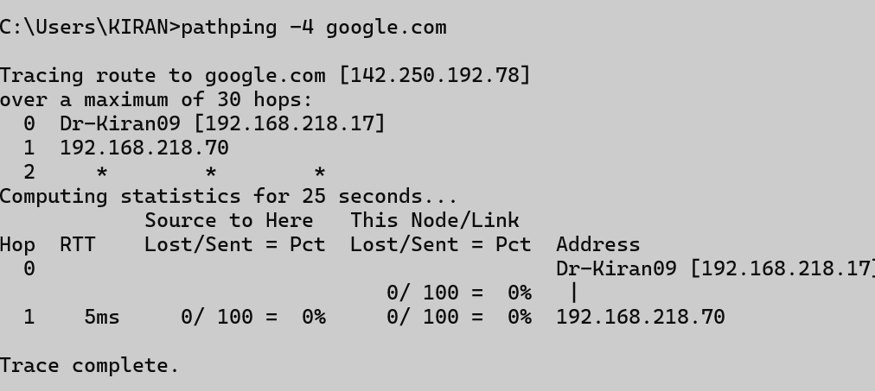

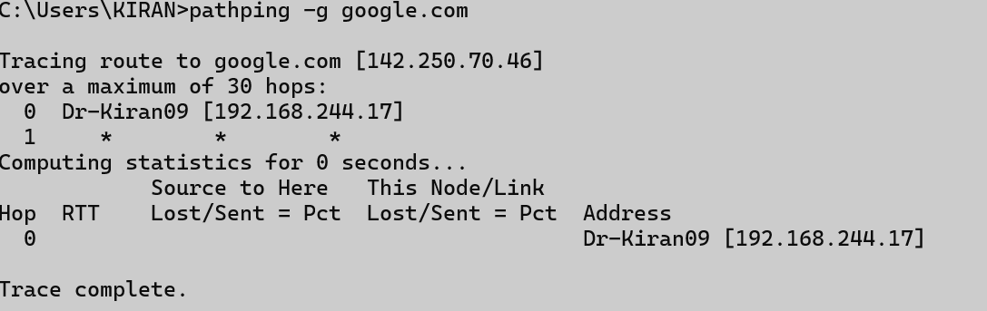

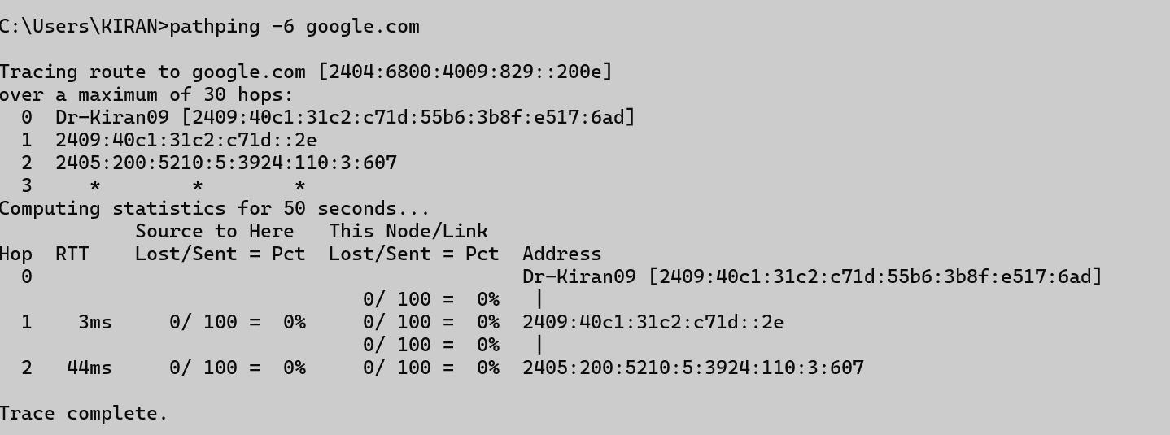

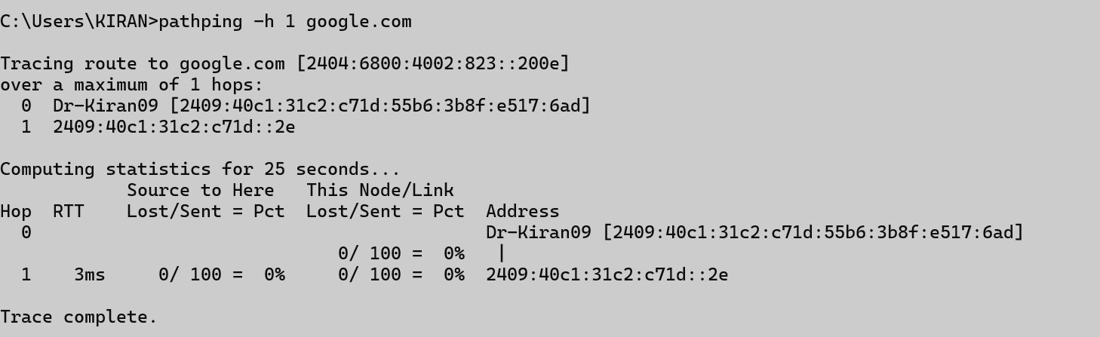

## arp

### Description:

**The arp command is used to view and manage the ARP cache, which maps IP addresses to MAC (physical) addresses on a local network. It helps in troubleshooting LAN communication issues.**

|  |  |  |
| --- | --- | --- |
| No. | Option | Description |
| 1 | -g | Displays the current **ARP table for all network interfaces.** |
| 2 | -d | Deletes a specific entry from the ARP table. |

### Implementation:

