**Lab Practical #03:**

Study of different types of network cables & connectors and crimping a LAN.

**Practical Assignment #03:**

1. List various networks cable. Also, write short description.
2. Difference between guided and unguided media.
3. Give cross-wired cable and straight through cable diagram (Color Code wise).

## List various networks cable and connectors. Also, write short description.

1. **Twisted Pair Cable:** 
   * **Description**:

* **Made of pairs of copper wires twisted together to reduce interference.**

**Types:**

* **UTP (Unshielded Twisted Pair):** Commonly used in LAN, cheaper, no extra shielding.
* **STP (Shielded Twisted Pair):** Has extra shield, used in noisy environments.

**Connector Used:** RJ-45

* + **Diagram**:

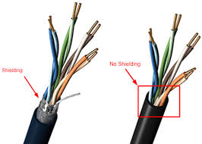

1. Coaxial Cable:
   * **Description**:

* **One copper wire in the center, surrounded by metal and plastic layers.**
* **Used in old networks, cable TV, and CCTV cameras.**
* **Good protection from signal interference.**
  + **Diagram**:

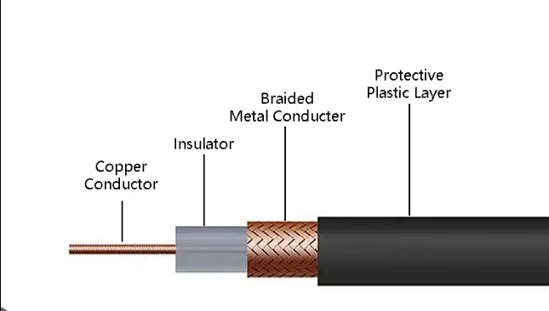

1. Fiber Optic Cable:
   * **Description**:

* **Uses glass or plastic threads to carry data as light signals.**
* **Very fast and used for long-distance or high-speed internet.**
* Diagram:

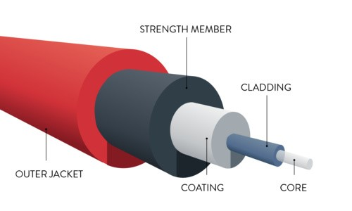

1. **Difference between guided and unguided media.**

|  |  |
| --- | --- |
| **Guided Media** | **Unguided Media** |
| **Data travels through physical cables or wires.** | **Data travels through air (no physical path.)** |
| **It is also known as Bounded or Wired Communication.** | **It is also known as Unbounded or Wireless Communication.** |
| **Generally faster and more stable** | **Slightly slower and can have interference.** |
| **This kind of media is more secure and difficult to tap.** | **This kind of media is less secure, and signals can be intercepted easily.** |
| **It is costly to install (wires and setup)** | **It is cheaper to install.** |
| **Example: Twisted Pair cable, Coaxial cable, Fiber optic cable** | **Example: Radio waves, Microwaves, Infrared waves** |
| **It cannot penetrate through the building.** | **It can penetrate through the building.** |
| **Used for shorter distance.** | **Used for longer distance.** |

## Give cross-wired cable and straight through cable diagram (Color Code wise).

1. Cross-wired Cable Diagram (Color Code)

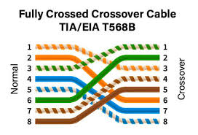

1. Straight Through Cable Diagram (Color Code)

