AI Based Dental Scan Report

# Patient Information:

|  |  |
| --- | --- |
| First Name: | {{ first_name }} |
| Last Name: | {{ last_name }} |
| Email: | {{ email }} |
| Gender: | {{ gender }} |
| Date of Birth: | {{ date_of_birth }} |
| Age: | {{ age }} |
| Contact Number: | {{ contact_number }} |
| Address: | {{ address }} |

**Observations:**

|  |  |
| --- | --- |
| Symptoms: | {{ symptoms }} |
| Previous Treatments: | {{ previous_treatments }} |
| Brushing Frequency: | {{ brushing_frequency }} |
| Tobacco Use: | {{ tobacco_use }} |
| other |  |

**Uploaded Image(s):**

{{ image_1 }} {{ image_2 }} {{ image_3 }} {{ image_4 }} {{ image_5 }}

**Analysis**

# Dental Condition Name: {{ condition }}

# Severity Percentage: {{ severity }}

# Information about the Condition:

# {{ info }}

# Home Cure or Remedy:

# {{ remedy }}

# Dietary Options or Food Solutions:

# {{ diet }}

# Call for Action:

# {{ action }}

# Recommended Actions:

Schedule a dentist consultation within 2 weeks.

Monitor for signs of pain or swelling.  
Early treatment prevents complex procedures.  
Do not delay if symptoms worsen.

# Oral Health Essentials – IntelliDent Tips

- Brush twice daily with fluoride toothpaste.  
- Replace toothbrush every 3 months.  
- Floss daily.  
- Avoid tobacco and sugary foods.  
- Visit your dentist every 6 months.  
- Use antiseptic mouthwash if prescribed.

# 📲 Try IntelliDent App:

Scan the QR code below to download our app and check your Oral Hygiene Score instantly.

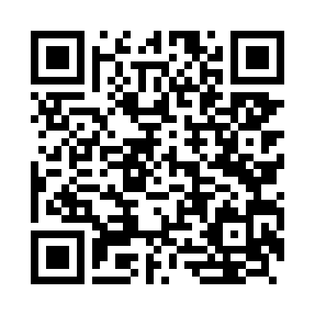

# ⚠ Disclaimers:

This report is AI-generated and intended for informational purposes only. Please consult a licensed dental professional for an accurate diagnosis and treatment plan.

# Contact Us:

Email: info@intellident-ai.com  
Website: www.intellident-ai.com  
Follow Us: @Intellident-ai

# About IntelliDent AI

IntelliDent is on a mission to make dental care more Affordable, Accessible, and Available to anyone, anytime, anywhere.  
  
Our AI-powered platform delivers instant dental reports, hygiene scores, and early diagnostic insights. Backed by experienced clinicians and technologists, IntelliDent helps bridge the gap between oral health awareness and real-time action.  
  
Key Features:  
- Instant Teeth Scanning & Scoring  
- Condition Detection (Caries, Periodontal Disease, etc.)  
- Mobile App for Daily Tracking  
- Seamless API Integration with Clinics