**FED ASSIGNMENT 02**

**Name of members:**

**Keshwindren Gandipanh (S10259469C)**

**Pey Zhi Xun (S10258774E)**

**Wireframes** :

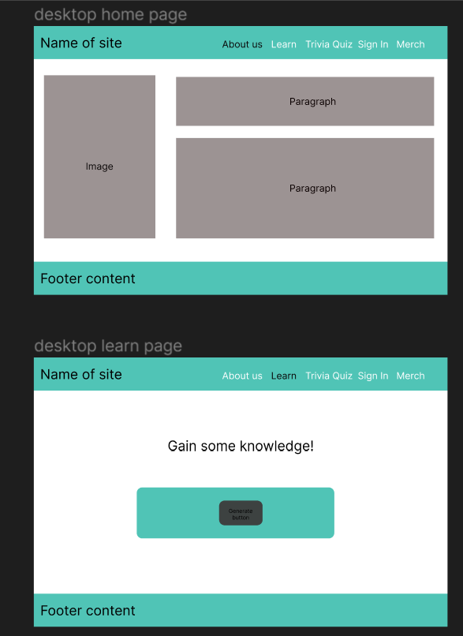

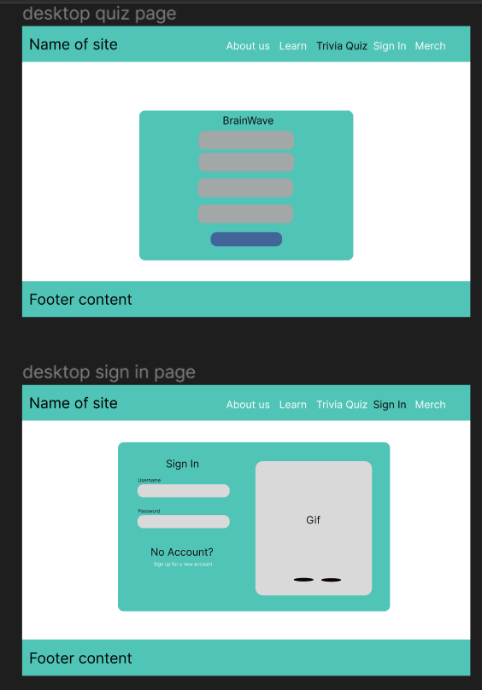

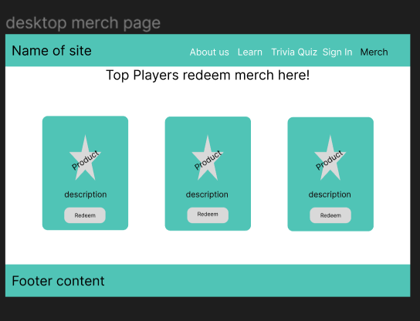

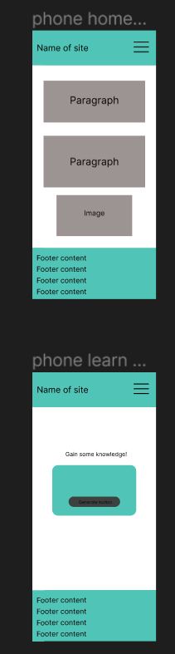 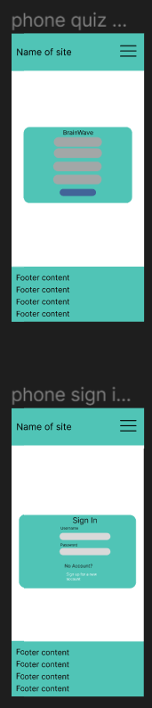 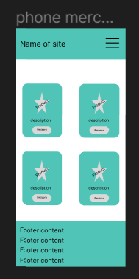

**RestDB Database after testing**

