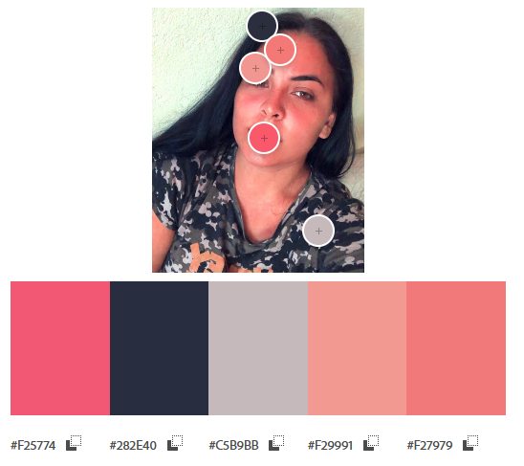

#F25774 | #282E40 | #C5B9BB | #F29991 | #F27979