Development Team Project Report – Machine Learning

Using Price Prediction and Listing Segmentation to Improve Airbnb’s New York City Marketplace Strategy

Business Question and Analytical Context
Airbnb’s New York City marketplace contains diverse listing types, prices, host behaviours and availability patterns. For executives, the challenge is not simply to describe average prices, but to understand which listing characteristics drive price and how listings can be grouped into commercially meaningful segments. This report addresses the business question: how can Airbnb use listing characteristics to predict price and identify strategic listing segments in New York City?
The analysis used the AB_NYC_2019 dataset, which contains 48,895 listings and 16 variables, including price, room type, neighbourhood group, minimum nights, number of reviews, reviews per month, host listing count and annual availability (Gomonov, no date). These variables make the dataset suitable for classical machine learning because they provide structured indicators of price, location, demand signals and host behaviour. However, the dataset does not include booking conversion, occupancy rate, guest ratings or realised revenue. Review activity was therefore treated as an imperfect proxy for demand rather than a direct measure of commercial performance.
Before modelling, missing values in reviews_per_month were filled with zero to represent listings with no recorded review activity. Listings with zero price were removed, reducing the dataset to 48,884 records. Extreme values were capped at the 99th percentile, with price capped at 799 and minimum nights capped at 45. This reduced the influence of outliers while preserving the overall marketplace structure. Categorical variables were encoded for regression, and numerical variables were standardised before K-means clustering because distance-based algorithms are sensitive to scale (scikit-learn developers, no date-a).

Exploratory Findings
Exploratory analysis showed that price varies strongly by room type and location. Entire homes or apartments were consistently more expensive than private and shared rooms across neighbourhood groups. Manhattan had the highest average price, particularly for entire homes or apartments, confirming that location and property type are central pricing drivers. The price distribution remained right-skewed even after outlier treatment, showing that most listings sit in lower-to-mid price bands while a smaller premium segment occupies the upper end of the market.
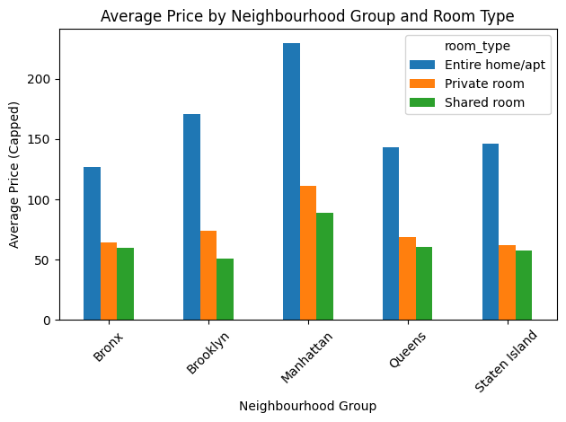
Figure 1. Average price by neighbourhood group and room type.

Price Prediction Results
Two regression models were compared. Linear Regression was used as a transparent baseline, while Random Forest was used as the main model because it can capture non-linear relationships between listing characteristics and price (Breiman, 2001). Random Forest outperformed the baseline, reducing MAE from 61.25 to 55.69 and improving R² from 0.283 to 0.372. This indicates that Airbnb prices are influenced by feature interactions that are not fully captured by a simple linear model. Nevertheless, the moderate R² shows that the dataset cannot fully explain price variation, likely because amenities, listing quality, photographs, seasonality and host reputation are not included.

Model | MAE | RMSE | R²
Linear Regression | 61.25 | 103.16 | 0.283
Random Forest | 55.69 | 96.50 | 0.372
Table 1. Model comparison for capped price prediction.

The Random Forest feature importance results show that room type was the strongest price driver, especially the distinction between private rooms and entire homes or apartments. Availability, Manhattan location, minimum nights, host listing count and review activity were also relevant. From a business perspective, Airbnb’s pricing guidance should not rely only on neighbourhood averages. A more useful pricing support tool should combine property type, location, availability, review activity and host scale to give tailored recommendations.
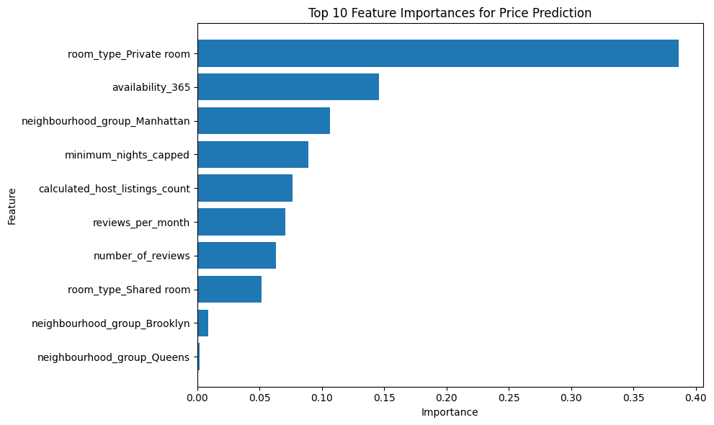
Figure 2. Top feature importances from the Random Forest price prediction model.

Strategic Listing Segmentation
K-means clustering was used to identify strategic listing segments (MacQueen, 1967). Although the silhouette score was highest for two clusters at 0.465, four clusters were selected because they offered more commercially useful segmentation while maintaining an acceptable score of 0.415. This reflects a practical analytics trade-off: the mathematically cleanest grouping is not always the most useful for executive decision-making. The PCA visualisation provided a simplified two-dimensional view of the clusters, with the first two components explaining 54.7% of variance and showing partial but meaningful separation.

Cluster | Segment label | Listings | Avg price | Key evidence | Business meaning
0 | Mainstream Occasional Listings | 34,063 | $144.77 | Low availability; low review activity | Core supply base; pricing and quality nudges
1 | High-Demand Value Listings | 9,162 | $127.69 | Highest reviews and reviews per month | Promote as strong value inventory
2 | Long-Stay Managed Listings | 5,100 | $153.81 | High minimum nights; more host listings | Separate long-stay pricing logic
3 | Premium Portfolio Listings | 559 | $273.93 | Highest availability and host scale | Policy, trust and governance monitoring
Table 2. K-means cluster summary and business interpretation.

The four clusters suggest different commercial behaviours. Mainstream Occasional Listings form the largest core supply base. High-Demand Value Listings have the lowest average price but strongest review activity, suggesting attractive inventory for price-sensitive guests. Long-Stay Managed Listings show high availability, longer minimum-night rules and larger host portfolios, indicating a more managed operating model. Premium Portfolio Listings are small in number but show the highest price, highest availability and very large host portfolios, suggesting a highly professionalised segment.
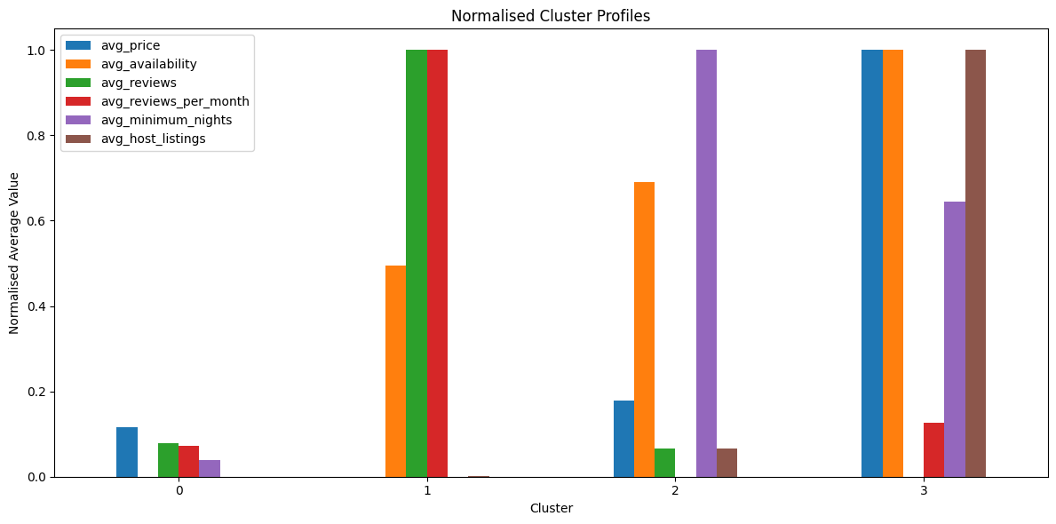
Figure 3. Normalised cluster profiles across price, availability, reviews, minimum nights and host scale.
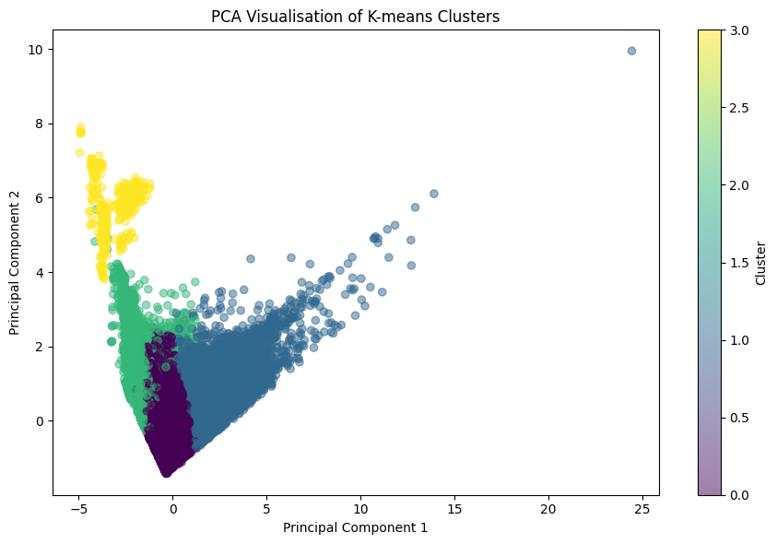
Figure 4. PCA visualisation of the four K-means clusters.

Business Implications and Conclusion
The business implication is that Airbnb should avoid a single marketplace strategy for all listings. High-demand value listings could be promoted as strong value inventory. Mainstream occasional listings may benefit from pricing nudges and listing-quality support. Long-stay managed listings may require different pricing logic because they operate differently from short-stay listings. Premium portfolio listings may require closer trust and policy monitoring because large professional hosts can affect neighbourhood balance and platform perception.
Compared with deep learning or advanced machine learning, classical machine learning is the most appropriate approach for this structured tabular dataset. Deep learning would be more suitable if image, review text or sequential booking data were available. Advanced methods such as self-supervised learning or neural architecture search may support anomaly detection, but would add complexity without clear business advantage here. Classical regression and clustering therefore provide the most interpretable and executive-ready insight.
In conclusion, Airbnb can use listing characteristics to support price prediction and identify meaningful strategic segments in New York City. The Random Forest model improves on a linear baseline and highlights the main price drivers, while K-means clustering reveals distinct listing behaviours. Although the dataset is incomplete for exact revenue optimisation, it provides a strong foundation for targeted pricing guidance, host support, inventory strategy and platform governance.

References
- Breiman, L. (2001) ‘Random forests’, Machine Learning, 45(1), pp. 5–32.
- Gomonov, D. (no date) New York City Airbnb Open Data. Kaggle. Available at: https://www.kaggle.com/datasets/dgomonov/new-york-city-airbnb-open-data (Accessed: 21 April 2026).
- MacQueen, J.B. (1967) ‘Some methods for classification and analysis of multivariate observations’, in Le Cam, L.M. and Neyman, J. (eds.) Proceedings of the Fifth Berkeley Symposium on Mathematical Statistics and Probability, Vol. 1. Berkeley, CA: University of California Press, pp. 281–297.
- scikit-learn developers (no date-a) KMeans. scikit-learn documentation. Available at: https://scikit-learn.org/stable/modules/generated/sklearn.cluster.KMeans.html (Accessed: 21 April 2026).
- scikit-learn developers (no date-b) RandomForestRegressor. scikit-learn documentation. Available at: https://scikit-learn.org/stable/modules/generated/sklearn.ensemble.RandomForestRegressor.html (Accessed: 21 April 2026).

