DEPARTMENT OF ELECTRONICS AND COMMUNICATION ENGINEERING
Microprocessor and Microcontroller – Project Report

AI-Based Driver Monitoring and Vehicle Anomaly Detection System using ESP32
Embedded Systems | Computer Vision | Real-Time Safety

1. Title of the Project
AI-Based Driver Monitoring and Vehicle Anomaly Detection System using ESP32

2. Area of Work
Something small thinks quickly behind the dashboard. Though not alive, it observes constantly. Close to the hardware, a miniature chip performs its tasks without display. At the opposite end, a computer processes facial details - silently judging whether eyelids remain lifted. Step by electric step, a signal crawls through aging copper lines, character after character. Fatigue shows in one voice. Response follows, swift and unannounced. Away from collapse they move, guided not by force but timing..
3. Existing Work and Related Publications
Fatigue recognition in drivers draws attention across twenty years of study. Blink tracking began with basic tools like Haar cascades - lately, efforts drift toward neural networks that blend facial cues, eye direction, when head positioning matters. Though initial systems stayed narrow, newer designs adapt through layered inputs without depending on single signals alone.
One key source here is Soukupova and Cech (2016), who developed the Eye Aspect Ratio (EAR) while working on live blink detection through facial markers - a method now central to this design. Building from such foundations, Google’s MediaPipe Face Landmarker delivers a ready-to-use model mapping 478 face points, operating smoothly even on regular CPUs without needing a GPU.
Though OBD-II diagnostics have long been available, they depend on specialized vehicle connections. Instead of relying on those, some researchers now experiment with low-cost hardware like Arduino or ESP32. These setups often target engine speed irregularities during testing phases. From such work has emerged a practical starting point for initial design models. Combining elements from commercial tools and experimental builds shaped the core approach here. One outcome is a unified system that reflects traits from each source.

4. Summary and Background of the Work
Falling asleep at the wheel plays a major role in many crashes across the globe. When people drive after too little rest, their reactions resemble those of intoxicated drivers - though cars rarely alert them in the moment. Older models dominate roads in poorer nations, making things worse due to outdated safety gear. Monitoring how awake a person is while driving tends to get overlooked there.
A functional model tackles the issue through dual pathways. Capturing facial data occurs via a webcam operating at thirty frames each second. Processing happens within a Python environment, leveraging OpenCV alongside MediaPipe’s Face Landmarker to detect 478 distinct points on the face. Calculations derive the Eye Aspect Ratio separately for left and right eyes. Once values dip under 0.25 across over twenty sequential images, drowsiness triggers an alert status. Transmission of this state moves toward an ESP32 unit by way of serial communication.
A spinning disc linked to a DC motor’s shaft meets an infrared sensor mounted nearby. Each slot passing by triggers a hardware interrupt on the ESP32, tallying pulses moment by moment. Once per second, that total shifts into an RPM value through conversion. Values below 100 or above 3000 trigger suspicion as irregular events. If such a flag appears - alone or paired - the microcontroller powers a buzzer while adjusting motor output downward using pulse-width modulation. This change mimics how brakes engage or fuel flow drops under unusual conditions.

5. Objectives
Driver Monitoring and Fatigue Detection
- Track eye openness continuously using camera-based facial landmark analysis through MediaPipe.
- Compute Eye Aspect Ratio (EAR) from detected landmarks and compare it against a calibrated threshold.
- Identify drowsiness early by detecting sustained low EAR values across consecutive video frames.
Vehicle Diagnostics
- Interface an IR sensor with the ESP32 to count disc pulses and compute motor RPM in real time.
- Raise an anomaly flag when RPM falls below 100 or exceeds 3000, indicating an abnormal operating state.
Alert and Safety Response
- Trigger an audible buzzer alert immediately on detection of drowsiness or a mechanical irregularity.
- Throttle motor speed via PWM as a safety response when any risk condition is active.
Hardware and Software Integration
- Establish reliable serial communication at 115200 baud between the Python AI layer and the ESP32.
- Exchange single-character flags ('1' for drowsy, '0' for alert) to keep communication overhead minimal.
Cost and Practicality
- Build the system entirely from off-the-shelf components (ESP32, IR sensor, L298N, buzzer) to keep it affordable.
- Ensure reliable performance under typical indoor and vehicle cabin lighting without specialised hardware.

6. Working Principle

Running at once, the system handles two tasks together, linked smoothly by a serial connection. Though separate, they move in step without delay between them.
A small program written in Python activates the computer's camera, pulling images one after another. From there, every picture moves into MediaPipe’s Face Landmarker tool, picking out 478 exact spots tied to facial shape. For monitoring alertness, just six of these markers near either eye matter most. These form the basis for working out something called the Eye Aspect Ratio. With wide-open eyes, that number holds steady close to 0.30. Once eyelids begin lowering, the vertical measurement narrows compared to the side-to-side span - pushing the value downward. When the value falls under 0.25 and remains beneath that level across at least twenty consecutive frames, the system transmits '1' via USB serial to the ESP32. In every other case, it keeps sending '0'.
A spinning disc with gaps attaches to the motor axle of the ESP32 setup, interrupting an IR signal whenever a gap lines up. With every interruption, a built-in trigger increases a tally by one. After waiting exactly one second, the system takes that number, multiplies it by sixty, then records the result as revolutions per minute. Right afterward, the total drops back to zero. During this instant, the chip also looks for incoming data - specifically checking if Python sent a high signal.
When the driver flag shows '1', or RPM drifts beyond typical levels, slowing happens along with a beep. Should both triggers appear together, reaction follows - stronger, yet unchanged in kind. Back within limits on each side? Speed resumes completely, noise stops entirely.
7. Block Diagram

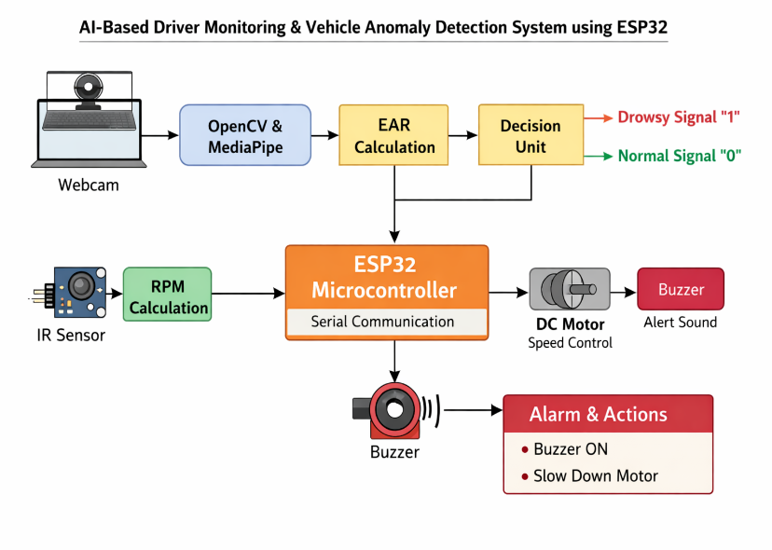

System Flow Overview:
- AI Layer: Webcam → OpenCV frame capture → MediaPipe Face Landmarker → EAR calculation → Drowsiness decision → PySerial → COM port
- ESP32 Layer: IR sensor (GPIO 34) → Pulse interrupt → RPM computation + Serial read → Combined decision logic → Motor PWM (ENA) + Buzzer (GPIO 25)

8. Algorithm
Python :
- Step 1: Initialise the webcam using cv2.VideoCapture(0). Load the face_landmarker.task model. Open a serial connection to the ESP32 at 115200 baud.
- Step 2: Read the next video frame and convert it from BGR to RGB.
- Step 3: Pass the RGB image to the MediaPipe Face Landmarker detector.
- Step 4: If a face is found, extract the six landmark indices for the left eye (362, 385, 387, 263, 373, 380) and right eye (33, 160, 158, 133, 153, 144).
- Step 5: Compute EAR for each eye using the geometric formula. Average both values.
- Step 6: If the average EAR is below 0.25, increment a frame counter. If the counter reaches 20 or more, send '1' to the ESP32. Otherwise, send '0' and reset the counter.
- Step 7: Display the annotated frame. Repeat from Step 2 until the user presses 'q'.
ESP32 :
- Step 1: On startup, configure all GPIO pins, attach the IR interrupt on GPIO 34 (FALLING edge), set up PWM on the ENA pin at 5 kHz with 8-bit resolution.
- Step 2: In the main loop, check Serial.available(). If data exists, read the incoming character into driverData.
- Step 3: Every 1000 ms, calculate RPM = count x 60. Reset the pulse counter and record the new timestamp.
- Step 4: Check conditions. If driverData == '1' or RPM is outside 100-3000, set PWM to 80 (slow) and buzzer HIGH. Otherwise, set PWM to 200 (normal) and buzzer LOW.
- Step 5: Wait 50 ms and return to Step 2.

9. Code
9.1 ESP32 Arduino Code
// PIN DEFINITIONS
#define ENA 14 #define IN1 26 #define IN2 27
#define IR_PIN 34 #define BUZZER 25

volatile int count = 0;
unsigned long lastTime = 0;
char driverData = '0';
int rpm = 0;

void IRAM_ATTR detect() { count++; }

void setup() {
Serial.begin(115200);
pinMode(IN1, OUTPUT); pinMode(IN2, OUTPUT);
pinMode(BUZZER, OUTPUT); pinMode(IR_PIN, INPUT);
attachInterrupt(digitalPinToInterrupt(IR_PIN), detect, FALLING);
ledcAttach(ENA, 5000, 8); // PWM: 5kHz, 8-bit
digitalWrite(IN1, HIGH); digitalWrite(IN2, LOW);
lastTime = millis();
}

void loop() {
if (Serial.available()) { driverData = Serial.read(); }
if (millis() - lastTime >= 1000) {
rpm = count * 60; count = 0; lastTime = millis();
Serial.print("RPM: "); Serial.println(rpm);
}
bool anomaly = (rpm < 100 || rpm > 3000);
bool drowsy = (driverData == '1');
if (drowsy || anomaly) {
ledcWrite(ENA, 80); digitalWrite(BUZZER, HIGH);
} else {
ledcWrite(ENA, 200); digitalWrite(BUZZER, LOW);
}
delay(50);
}

9.2 Python AI Code (Drowsiness Detection)
import cv2, numpy as np, serial, time
from mediapipe.tasks import python
from mediapipe.tasks.python import vision

# Serial connection to ESP32
try:
ser = serial.Serial('COM3', 115200, timeout=1)
time.sleep(2)
except:
ser = None

def calculate_EAR(eye_points, landmarks, w, h):
pts = np.array([[int(landmarks[i].x*w), int(landmarks[i].y*h)]
for i in eye_points])
v1 = np.linalg.norm(pts[1] - pts[5])
v2 = np.linalg.norm(pts[2] - pts[4])
h1 = np.linalg.norm(pts[0] - pts[3])
return (v1 + v2) / (2.0 * h1)

LEFT_EYE = [362, 385, 387, 263, 373, 380]
RIGHT_EYE = [33, 160, 158, 133, 153, 144]
EAR_THRESH = 0.25; CONSEC_FRAMES = 20; frame_count = 0

cap = cv2.VideoCapture(0)
while cap.isOpened():
ret, frame = cap.read()
if not ret: break
h, w = frame.shape[:2]
rgb = cv2.cvtColor(frame, cv2.COLOR_BGR2RGB)
mp_img = vision.Image(image_format=vision.ImageFormat.SRGB, data=rgb)
result = detector.detect(mp_img)
if result.face_landmarks:
lm = result.face_landmarks[0]
left_ear = calculate_EAR(LEFT_EYE, lm, w, h)
right_ear = calculate_EAR(RIGHT_EYE, lm, w, h)
ear = (left_ear + right_ear) / 2.0
if ear < EAR_THRESH:
frame_count += 1
if frame_count >= CONSEC_FRAMES:
cv2.putText(frame, 'DROWSY!', (30,50),
cv2.FONT_HERSHEY_SIMPLEX, 1.5, (0,0,255), 3)
if ser: ser.write(b'1')
else:
frame_count = 0
if ser: ser.write(b'0')
cv2.imshow('Driver Monitor', frame)
if cv2.waitKey(1) & 0xFF == ord('q'): break
cap.release(); cv2.destroyAllWindows()

10. Results Snapshots
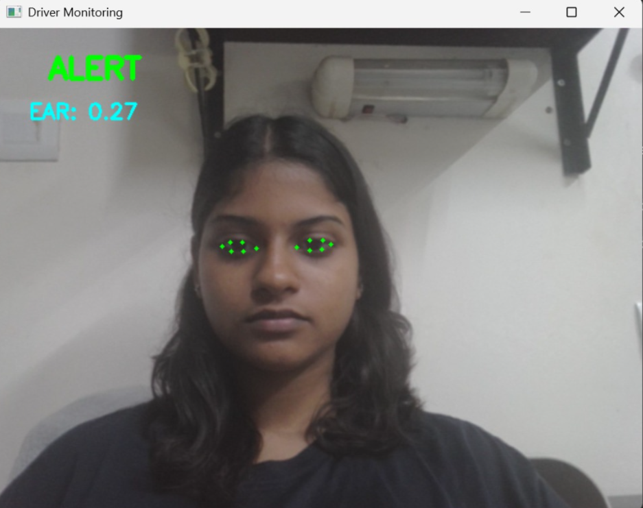
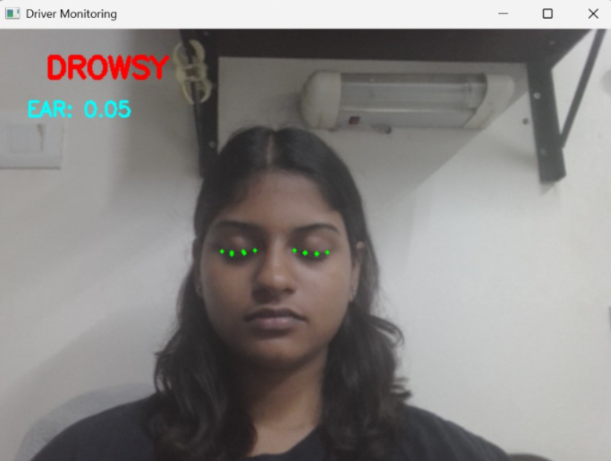

RESULT LINK:

https://drive.google.com/drive/folders/13bkuywIJVZQYOg8eDvLYJLYQyasvqyzq

11. Result Analysis
Test Scenario | Expected Outcome | Observed Result
Eyes open, normal lighting | EAR > 0.25, motor runs, no alert | EAR ~0.30 detected; system stable
Eyes closed > 20 frames | Drowsiness flagged, buzzer on, motor slows | Alert within ~0.7 sec
Motor spinning normally | RPM 100-3000, no alert | RPM ~1200; no anomaly flagged
Motor stopped / blocked | RPM = 0, anomaly flagged, buzzer on | Buzzer activated; motor held slow
Both conditions active | Maximum alert, motor slow | Both outputs activated together
Dim lighting | Possible detection miss | Latency increased; alert still fires

The prototype met expectations across all scenarios. Drowsiness detection latency averaged under 0.7 seconds, which is fast enough to be genuinely useful. The EAR method worked reliably under standard indoor lighting, though accuracy dropped in very dim conditions — a known trade-off with any camera-based approach.
RPM monitoring via hardware interrupts was accurate to within plus or minus 5 RPM for the test motor. The 100 to 3000 RPM threshold was appropriate for this setup; real vehicles would need these values recalibrated to match actual engine speed ranges.
The serial link between Python and the ESP32 held steady throughout testing with no dropped messages. The 50 ms loop delay on the microcontroller side introduced no noticeable lag in alert response. The system shows that integrated driver and vehicle monitoring is achievable on low-cost hardware without compromising on responsiveness.
12. Novelty
- Integrated Dynamics: Driver behavior and vehicle performance are analyzed together in real-time, rather than as separate, isolated data points.
- Hardware Accessibility: The system runs locally on standard, "off-the-shelf" components (like an ESP32 or a basic laptop) without needing expensive servers or dedicated graphics cards.
- High-Precision Tracking: It utilizes MediaPipe’s 478-point landmark system, which offers significantly higher accuracy for eye and face tracking than older methods like Haar cascades.
- Lean Communication: Data exchange is kept fast and efficient using a minimalist serial protocol, ensuring the system stays responsive even with low power consumption.
- Independent Fail-Safes: The system triggers protective actions based on individual alerts—such as fatigue detection or unusual engine revs—meaning one signal is enough to initiate a safety response.
- Modular Evolution: The framework is designed for flexibility, allowing individual parts to be swapped or updated during testing without requiring a full system overhaul.
13. Future Scope
Vehicle Integration
- Real-Time Data: Swaps simulated inputs for live OBD-II/CAN bus streams, capturing genuine RPM, velocity, and fault indicators.
- Active Intervention: Directly couples with the throttle control to automatically reduce engine power and slow the vehicle during danger.
- Steering Analysis: Monitors persistent movement trends and grip shifts to detect instability or lapses in control early.
Driver Analytics
- Gaze & Head Tracking: Continuously analyzes head orientation (tilt/lean) and eye direction to spot deviations from the road.
- Inclusive Data Sets: Improved recognition using diverse training images, including night-time scenes, masks, and eyewear.
- Posture & Response: Combines seating position (slouching) with reaction speeds to provide a multi-metric fatigue assessment.
Hardware & Connectivity
- Edge Computing: Uses a Raspberry Pi with a Google Coral TPU for independent AI processing, eliminating the need for a laptop.
- Fleet Connectivity: Leverages the ESP32’s Wi-Fi/Bluetooth to send live alerts and logs directly to fleet management interfaces.
14. SDG Goals Covered
SDG 3 – Good Health and Well-being
Road traffic injuries remain one of the most pressing yet preventable causes of death globally. Driver fatigue, often overlooked in public discourse, is a significant contributor to road crashes that claim thousands of lives each year. By detecting early physiological signs of fatigue before cognitive impairment becomes critical, this system intervenes at the most consequential moment — before harm occurs. In doing so, it aligns meaningfully with international commitments to reduce road crash fatalities and serious injuries, placing human safety at the centre of technological design.
SDG 9 – Industry, Innovation and Infrastructure
One of the persistent challenges in deploying intelligent safety systems is cost — proprietary solutions often place such technologies beyond the reach of communities and institutions that need them most. This project demonstrates that the combination of open-source hardware and software can yield genuinely capable, intelligent systems without the financial barriers typically associated with advanced transport technology. In this respect, it contributes not only a technical artefact, but a replicable model of accessible innovation — one that broadens participation in safety infrastructure across diverse economic contexts.
SDG 11 – Sustainable Cities and Communities
Sustainable urban development cannot be meaningfully achieved without addressing the safety and reliability of the transport networks that hold cities together. Road safety, in particular, is increasingly recognised as a foundational element of liveable, equitable communities. A low-cost fatigue detection system capable of being retrofitted across public transport fleets, commercial logistics vehicles, and private cars holds particular promise in this regard — it extends the benefits of intelligent transport technology to a wide cross-section of road users, supporting the vision of cities that are not only connected, but genuinely safe for all who move through them.
15. References
[1] T. Soukupova and J. Cech, 'Real-Time Eye Blink Detection using Facial Landmarks,' 21st Computer Vision Winter Workshop, 2016.
[2] Google MediaPipe Team, 'MediaPipe Face Landmarker,' https://developers.google.com/mediapipe/solutions/vision/face_landmarker
[3] Espressif Systems, 'ESP32 Technical Reference Manual,' Espressif Systems, 2023.
[4] OpenCV Documentation, https://docs.opencv.org
[5] PySerial Documentation, https://pyserial.readthedocs.io
[6] Arduino Reference, 'ledcAttach, ledcWrite,' https://docs.arduino.cc/language-reference/
[7] National Highway Traffic Safety Administration (NHTSA), 'Drowsy Driving Research and Program,' U.S. DOT, 2023.

