AUTOMATIC LIGHT CONTROLLER (IN HOME
APPLIANCES) Technical Report

TABLE OF CONTENTS:

1. Introduction 2.Objective 3.Components and Tools 4.Literature Survey
- Methodology
- Circuit Design
- Work Plan
- Expected Outputs 9.Analysis 10.References

INTRODUCTION

To design and implement an automatic light control system for home appliances using CD4017 IC and IR SENSOR, enabling intelligent switching based on environmental inputs such as light intensity or occupancy.

PROBLEM STATEMENT:
In many households, lights are manually operated regardless of ambient lighting conditions, leading to unnecessary energy consumption and inconvenience—especially for elderly or disabled individuals. Existing automated lighting systems often rely on microcontrollers or complex logic circuits, which increase cost, complexity, and maintenance requirements.
This project aims to design and implement a low-cost, reliable, and sensor-driven automatic light controller using only analog components such as Light Dependent Resistors (LDRs), comparators, and relay circuits. The system will detect ambient light levels and switch home lighting ON or OFF accordingly, without requiring any programming or digital logic, making it ideal for simple residential automation and energy-saving applications.

OBJECTIVE

Design a Logic-Based Control Circuit
Develop a combinational logic circuit using basic CD4017 IC to automate light switching based on input conditions like ambient light or motion detection.

Eliminate Manual Intervention
Enable automatic operation of lighting systems to reduce human effort and improve convenience, especially in frequently used areas like hallways, bathrooms, or outdoor spaces.

Optimize Energy Consumption
Ensure lights are activated only when necessary, minimizing electricity usage and contributing to sustainable energy practices.

Demonstrate Practical Use of Logic Gates
Showcase how simple digital components can be used to solve real-world problems without relying on microcontrollers or software programming.

Integrate Sensor Inputs
Interface the integrated circuit with sensors such as LDRs (Light Dependent Resistors) or IR motion detectors to provide real-time environmental feedback. Ensure Cost-Effective Implementation Use readily available components to build a low-cost, scalable solution suitable for homes, hostels, or small offices.

Enhance System Reliability and Responsiveness
Design the circuit to respond quickly and accurately to input changes, ensuring consistent performance under varying conditions.

Promote Hands-On Learning and Simulation
Encourage circuit simulation using tools like Proteus or Multisim to validate logic behavior before physical prototyping.

Explore Future Extensions
Lay the groundwork for integrating more advanced features like time-based control, dimming, or wireless switching using hybrid analog-digital systems.

COMPONENTS USED

CD4017 IC
Acts as a decade counter; can be used for timing control or sequencing light activation based on sensor input. LM358 IC
Dual operational amplifier used as a comparator to process signals from sensors (e.g., IR or LDR) and generate control logic.

BC547 Transistor
Functions as a switch or amplifier; drives the relay based on comparator output.

100µF & 1000µF Capacitors (25V)
Used for power supply filtering and timing delay circuits to stabilize voltage and reduce noise.
- 220Ω Resistors (×4)
Current limiting for LEDs and IR emitter; protects components from overcurrent.

10k Resistor
Used in voltage divider circuits or pull-up/pull-down configurations for stable signal levels.

10k Trimmer
Adjustable resistor to fine-tune the comparator’s reference voltage or sensor sensitivity.
- LEDs (5mm ×2)
Visual indicators for power status and light activation.

IR LED Pair (Emitter & Detector)
Detects motion or presence; triggers the comparator when an object interrupts the IR beam.

1N4007 Diode
Flyback diode across the relay coil to protect the transistor from voltage spikes during switching.

5V SPDT Relay
Electromechanical switch that controls the AC light load based on the transistor’s output.

Connectors & IC Base
Provide modularity and ease of assembly; allow safe mounting and replacement of ICs and wiring.

Acrylic Sheet or Customised PCB
Physical base for mounting components; ensures durability and organized layout for deployment.

TOOLS USED

- Breadboard – for prototyping the circuit without soldering
- Multimeter – to measure voltage, current, and check continuity
- Soldering iron and solder wire – for permanent circuit assembly (if moving to PCB)
- Wire stripper and cutter – for preparing jumper wires and connections
- Power supply unit or battery pack – to provide regulated voltage (5V or 12V)
- Logic probe or oscilloscope – for testing logic gate outputs and signal flow
- Simulation software – like Proteus, Multisim, or LTspice for virtual testing
- PCB design software – such as KiCad or Eagle, if you're planning a custom board
- Schematic drawing tools – like Fritzing or EasyEDA for documentation and block diagrams

LITERATURE SURVEY

- Introduction to Motion-Based Lighting Systems
Automatic lighting systems based on motion detection have gained popularity for energy conservation and convenience. These systems activate lights only when movement is detected, reducing unnecessary power usage and enhancing security. Unlike microcontroller-based designs, this approach uses discrete ICs and analog components for simplicity and cost-effectiveness.
- Role of CD4017 in Sequential Control
The CD4017 is a decade counter IC that responds to clock pulses and activates one of its 10 outputs sequentially. In motion-sensing applications, it receives pulses from an IR sensor and toggles the output state, effectively controlling the light. This eliminates the need for complex programming and allows for straightforward timing and control logic.
- Use of LM358 as a Comparator
The LM358 dual op-amp is configured as a comparator to process analog signals from the IR sensor. When motion is detected, the voltage across the IR detector changes, and the LM358 outputs a digital HIGH signal. This signal acts as a clock input for the CD4017, initiating the switching sequence.
- BC547 Transistor and Relay Switching
The BC547 NPN transistor is used to drive the relay, which controls the high-power AC load (e.g., a bulb). When the CD4017 output goes HIGH, it biases the transistor, allowing current to flow through the relay coil. A diode (1N4007) protects the transistor from back EMF generated by the relay.
- Energy Efficiency and Practical Deployment
Studies show that motion-activated lighting systems can reduce electricity consumption by up to 30% in residential and institutional settings. These systems are especially effective in areas with intermittent occupancy, such as staircases, corridors, and outdoor spaces.
- Advantages Over Microcontroller-Based Systems
While microcontrollers offer flexibility, the use of discrete components like CD4017 and LM358 provides a robust, low-cost alternative. These systems are easier to build, require no programming, and are ideal for educational and DIY applications.

- Applications and Future Scope
Beyond home automation, this circuit can be adapted for street lighting, washroom automation, and security lighting. Future enhancements may include integrating ambient light sensing (via LDR), adjustable delay timers, or wireless control modules.

PROTOTYPE DESIGN METHODOLOGY

Component Selection
  - Choose analog components suitable for sensor-based automation:
  - IR LED pair (emitter & detector) for motion/presence detection
  - LM358 op-amp for signal amplification and comparator logic
  - BC547 transistor for relay driving
  - CD4017 IC for optional timing or sequencing
  - Passive components (resistors, capacitors, diode) for biasing, filtering, and protection

Sensor Calibration
  - Align the IR emitter and detector to ensure accurate interruption detection.
  - Use a 10k trimmer to adjust the comparator’s reference voltage for optimal sensitivity.

Signal Conditioning
  - Feed the IR detector output to LM358 configured as a comparator.
  - Set threshold voltage using voltage divider and trimmer to define detection limits.

Control Logic
  - When IR beam is interrupted, LM358 output goes HIGH.
  - This triggers BC547 transistor to energize the relay coil.
  - 1N4007 diode protects the transistor from back EMF.

Relay Switching
  - Relay contacts switch the AC light load ON/OFF based on sensor output.
  - LED indicators show system status (e.g., power ON, light ON).

Power Supply Setup

  - Use regulated 5V or 12V DC supply.
  - Capacitors (100µF, 1000µF) stabilize voltage and suppress noise.

Assembly and Mounting
  - Connect components on a breadboard for initial testing.
  - Transfer to customized PCB or acrylic sheet for final deployment.
  - Use connectors and IC bases for modularity and maintenance.

Testing and Optimization
  - Test under various lighting and motion conditions.
  - Adjust trimmer and sensor alignment for reliable switching.
  - Verify relay operation and LED indicators.

CIRCUIT DESIGN
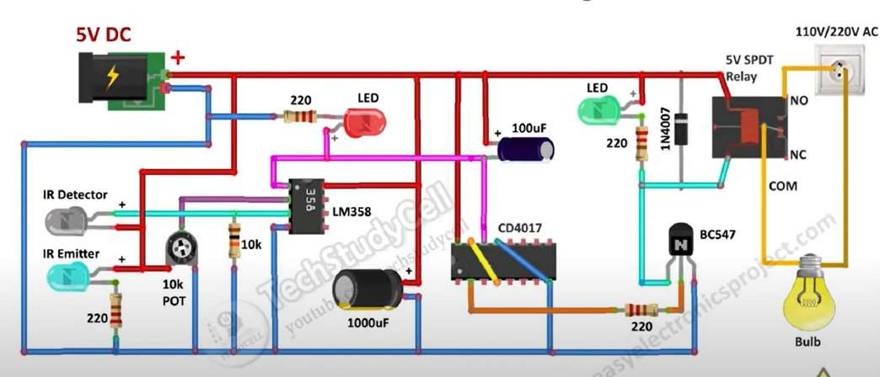

This design integrates:
- IR sensor pair for motion/presence detection
- LM358 as a comparator to process IR signals
- CD4017 for optional timing or pulse sequencing
- BC547 to drive the 5V SPDT relay
- Relay to switch the AC bulb
- Passive components for filtering, biasing, and protection

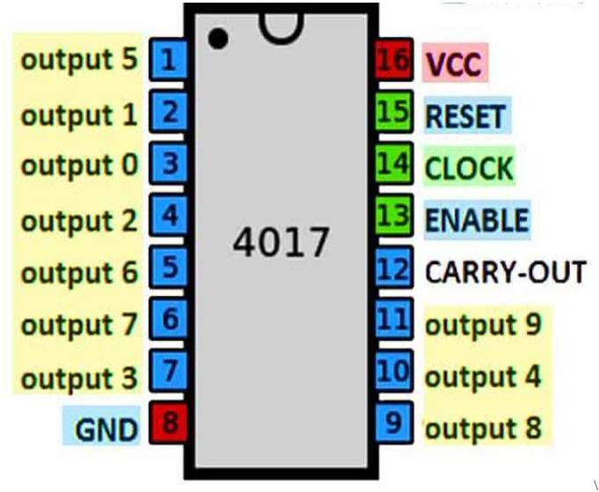

WORK PLAN

Phase 1: Research & Planning
  - Conduct literature review on sensor-based light control systems.
  - Define problem statement, objectives, and scope.
  - Finalize component list (IR pair, LM358, CD4017, BC547, relay, etc.).
  - Draft initial block diagram and flowchart.

Phase 2: Circuit Design
  - Design schematic using LM358 for IR signal comparison.
  - Integrate CD4017 for timing/sequencing (if needed).
  - Add BC547 transistor and relay for AC load switching.
  - Include protection components (diode, capacitors, resistors).

Phase 3: Breadboard Testing
  - Assemble circuit on breadboard.
  - Test IR detection and comparator output.
  - Verify relay switching and LED indicators.
  - Adjust trimmer for sensitivity calibration.

Phase 4: PCB Design & Fabrication
  - Create PCB layout using software (e.g., EasyEDA, KiCad).
  - Print or etch PCB / mount on acrylic sheet.
  - Solder components and test continuity.

Phase 5: Final Assembly & Deployment
  - Install system in a test environment (e.g., room or corridor).
  - Monitor performance under different lighting and motion conditions.
  - Fine-tune sensitivity and timing if needed.

Phase 6: Documentation & Review
  - Capture images of circuit, PCB, and deployment.
  - Prepare technical report: problem statement, methodology, circuit diagram, flowchart, and results.
Include references, component roles, and future scope

EXPECTED OUTPUT

- The system should automatically switch ON the light when motion or presence is detected via the IR sensor.
- The light should remain OFF when no motion is detected or ambient light is sufficient (if LDR is included).
- The relay should activate reliably to control a 110V/220V AC bulb without manual intervention.
- The LED indicators should reflect system status (e.g., power ON, light ON).
- The circuit should operate without any microcontroller or logic gates, relying solely on used components.
- The system should be stable, responsive, and energy-efficient, suitable for real-world deployment in homes or corridors.

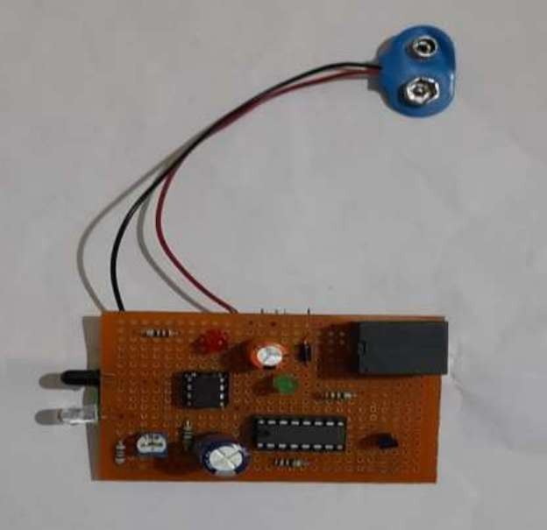

ANALYSIS

ADVANTAGES

Educational Value
  - Great for Learning: Helps students understand sensor interfacing, comparator logic, and relay control.
  - Simulation-Friendly: Easy to test in Proteus, Multisim, or breadboard setups before PCB fabrication.

Assistive Technology
  - Accessibility for Elderly or Disabled: Reduces dependence on manual switches, enhancing safety and independence.

Scalable Design
  - Modular Expansion: Can be extended to multiple rooms or zones with simple duplication.
  - Customizable Thresholds: Setpoint levels can be adjusted to suit different lighting needs.
- Convenience & Comfort
  - Hands-Free Operation: Lights turn ON/OFF automatically based on ambient light—no need to manually flip switches.
  - Night-Time Assistance: Ideal for bedrooms, hallways, and bathrooms where visibility is crucial after dark.
- Energy Efficiency
  - Reduced Power Consumption: Prevents lights from staying ON unnecessarily during daylight.
  - Smart Usage: Activates lighting only when needed, optimizing electricity usage.
- Simplicity & Reliability

  - No Programming Required: Unlike microcontroller-based systems, analog controllers work without code.
  - Robust Design: Fewer components mean lower chances of failure and easier troubleshooting.
- Cost-Effective
  - Low Component Cost: Uses basic components like LDRs, op-amps, and relays—affordable and widely available.
  - Minimal Maintenance: Once installed, it requires little upkeep.

DISADVANTAGES

Limited Precision
Sensitivity depends on component tolerances; ambient light variations may cause inconsistent switching.

No Programmability
Unlike microcontroller-based systems, it lacks flexibility for advanced features like timers, remote control, or adaptive thresholds.

Component Aging
LDRs and relays can degrade over time, affecting performance and reliability.

Bulky for Multi-Room Use
Scaling the system across multiple rooms requires duplicating the entire circuit, increasing cost and complexity.

Manual Calibration Needed
Setpoint voltage for the comparator must be manually tuned, which can be tedious and environment-specific.

  - Prepare technical report: problem statement, methodology, circuit diagram, flowchart, and results.
  - Include references, component roles, and future scope.

REFERENCES
- Soyoung Hwang and Donghui Yu, International Journal of Software Engineering and Its Application, Vol. 6, No. 3, July 2012.
- Richu Sam Alex, International Journal of Engineering and Advanced Technology (IJEAT), Vol. 3, Issue 4, April 2014.
- Raja R, Dr. K. Uday Kumar, International Journal of Advanced Research in Electrical, Electronics and Instrumentation Engineering, Vol. 3, Special Issue 2, April 2014.
- K.Subramanyam, K. Baskar Reddy, P. Ajay Kumar Reddy, International Journal of Engineering Research and Application (IJERA), ISSN: 2248-9622, www.ijera.com, Vol. 3, Issue 4,
July–August 2014

