**Day 02_Assignment**

Docker pull

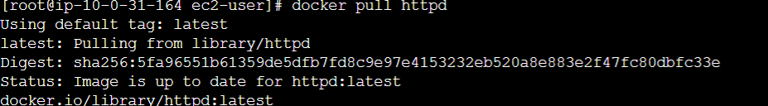



Git Clone

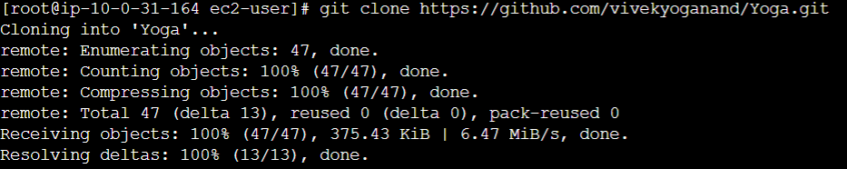

Docker Commit



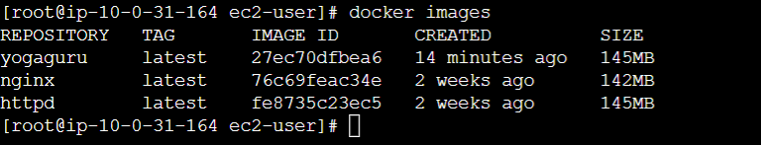

Docker Push

