**Day 08 Assignment**

**Nodes:**

To get all nodes which are available



Created a pod that is scheduled on the node with label and showing the node which the pod is running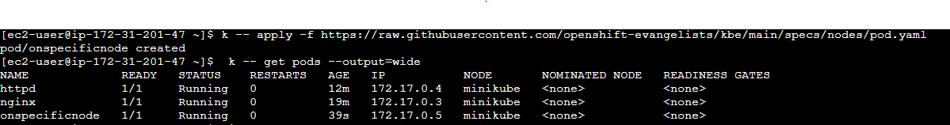

**NameSpace:**

To display list of default namespaces

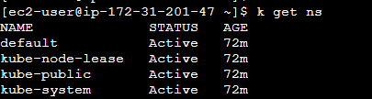

Describe the default namespace

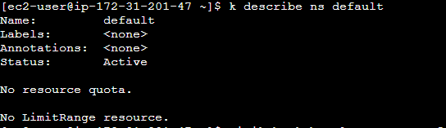

Namespace test is created

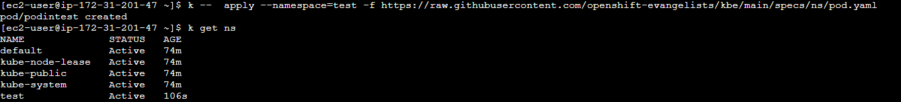

Getting the pod with namespace test



After deleting a pod



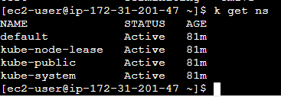

**Environment variables:**

Launching a pod with environment variable simple_service_version with version 1.0



Showing the Application is running on the pod with environment variable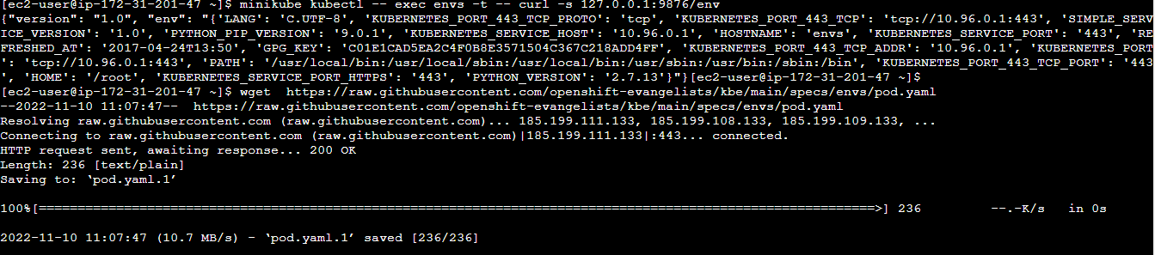

To display the environment variables within the pod

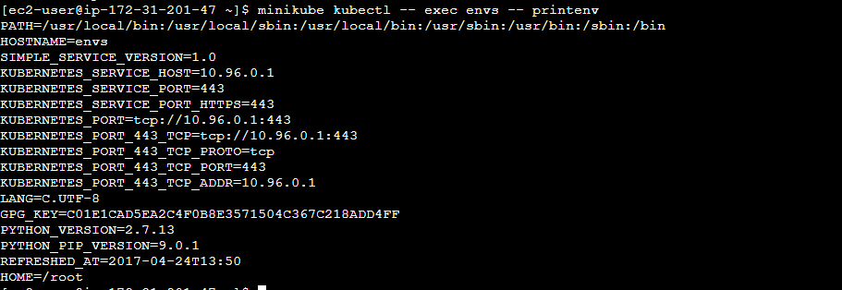

After deleting the env



**Healthcheck:**

Creating a pod that expose an endpoint /health

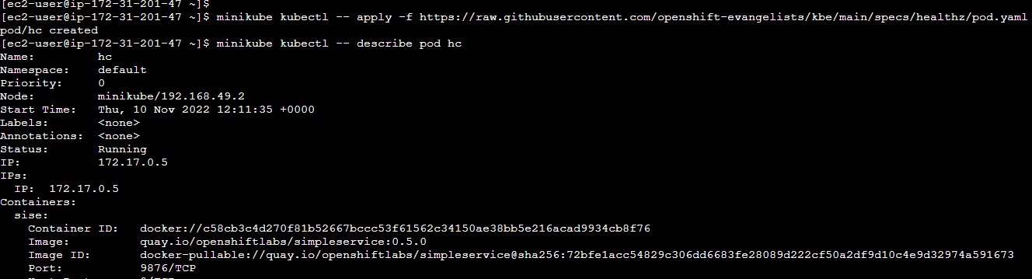

Pod sepecification

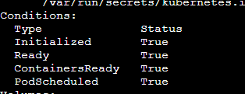

Creating a pod with name badpod



Badpod restarted several times because of failing health checks

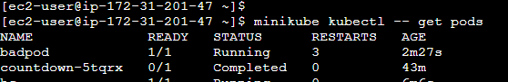

**Logging:**

Creating a pod logme that runs a container



To view five recent log lines in the logme pod

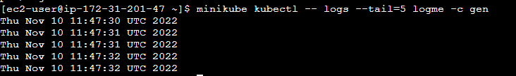

Printing the logs of container in a pod

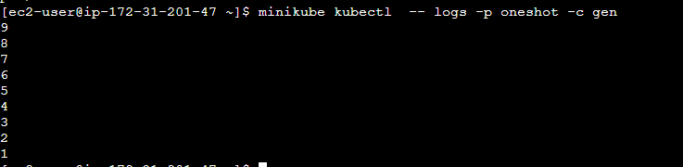

After deleting the oneshot and logme pod

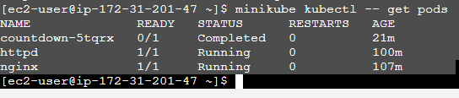

**Label:**

Creating a pod initially with one label



Displaying the labels

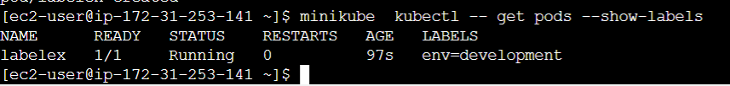

Adding label to the pod



Filtering the label owner=michel using selector



Selecting pods that labelled with env=development





Contains two labels env=development and env = production

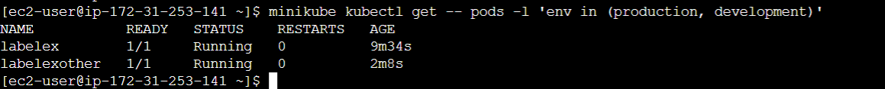

Deleting the environment



**Deploy:**

Created a deployment called sise-deploy that produces two replicas



Result is separated by source type created by deployment 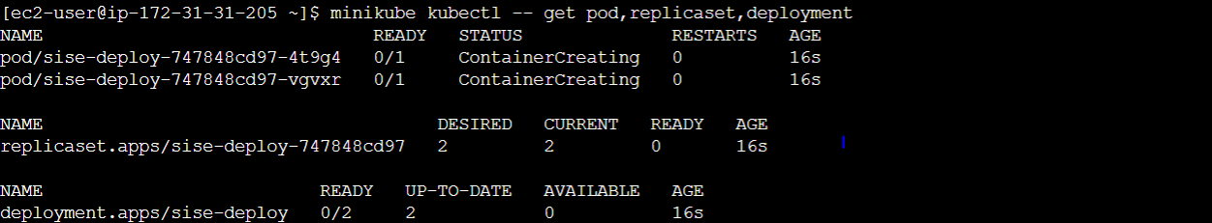

Rolling back to any specific version



Deleting the sise-deploy



After deleting the sise-deploy, child resources also deleted

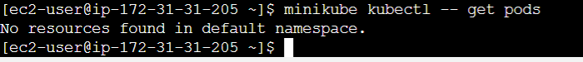

**Jobs:**

Created a job name countdown



Logs during the execution

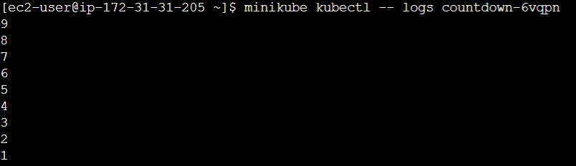

Deleting the job named countdown



After deleting the job



**Pods:**

Launching a pod using the container with port



Status of running pods

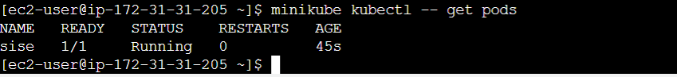

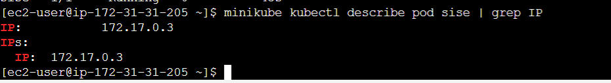

Verifying primary web service process is responding or not



After deleting the pods



Creating from a manifest



Showing pod information

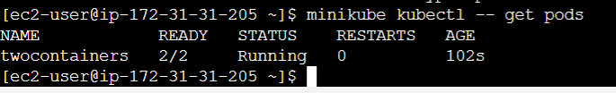

Deleting the pods



After deleting the pods

