Application name: The Cake Ordering System

Final Project

Git Hub Link:

Main Window:

The main window has the cake image as the background. On the image background, I have created logo “The Cake” and “Order Now” button for navigation. The “Order Now” button, I have changed the style when we move the mouse to the button. The button and text “Order Now” will change the colors. When the customer would like to order items, they can click on the Order Now button. It will go to another new window for ordering app.

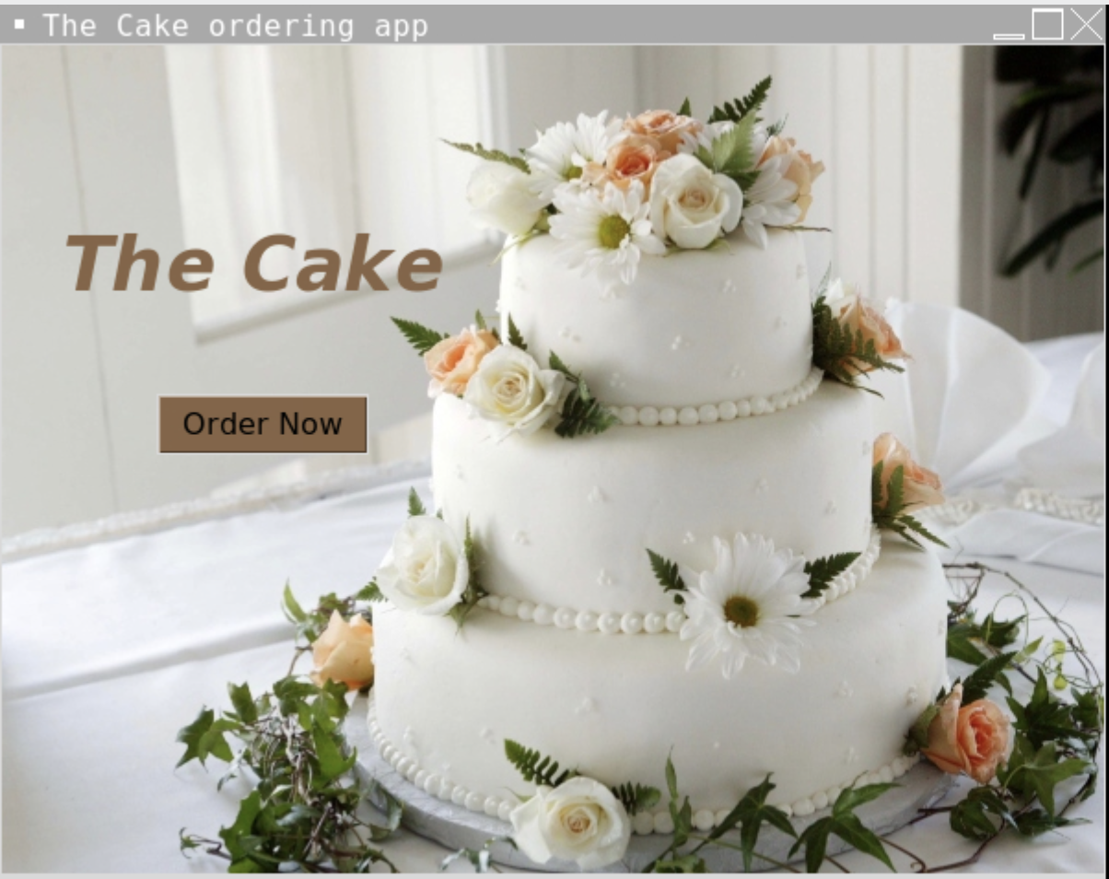

New Window:

The new window is The Cake Ordering App as the tittle of the application. I have created customer name, phone number and address for the customers input their information in the frame1. The frame2 has menu and prices of the all items. Also, the customer can input the quantity they would like to order in the box below “Qty”. In addition, I have created frame3 for radiobutton flavors. The frame3 has four flavors that customer can choose which flavors they would like to order. I also created the description box for the customer to write the detail of their order. I have created 4 buttons in the new window. First button is total button which calculate all the total of the order. Second button, is reset button which the customer can reset their order. Third button is order button which the customer purchase their order. Last button is exit button which customer want to leave the app.

Process the order:

This picture below shows the process of the ordering app that allow customer to input their information and order.

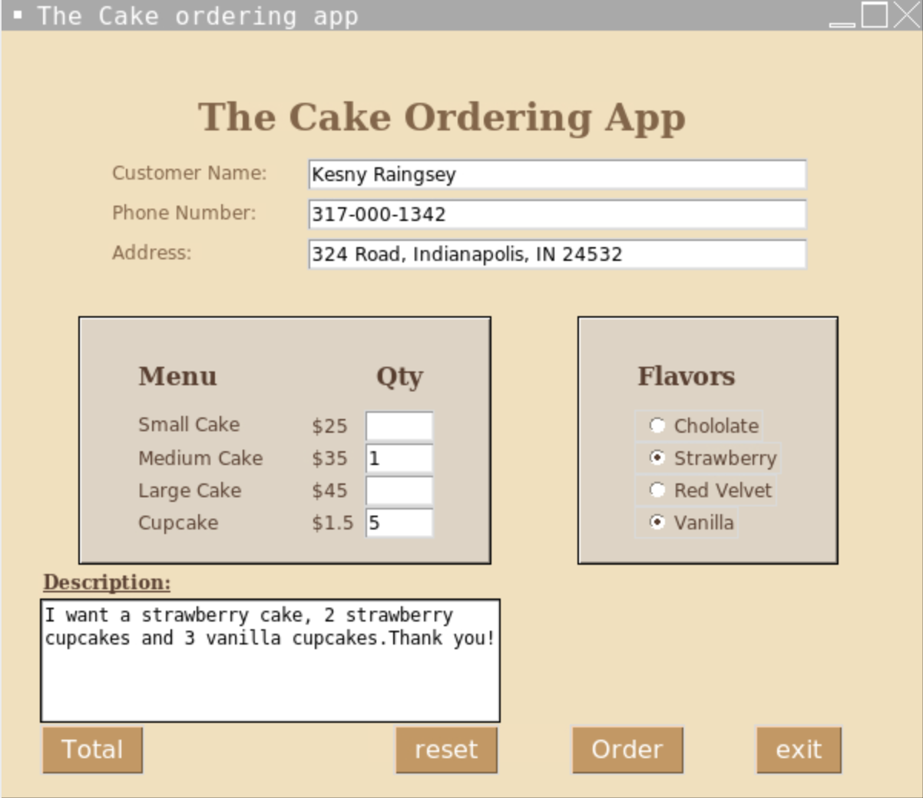

Total Button:

This picture below shows the total of the order that total price, tax, and total included tax below the flavors frame. Also, when the customer click on total button, some of the quantity will disabled since customer don’t order it.

Reset Button:

This picture below shows all the order and information have been reset when the customer click on reset button. The customer will able to process the order again.

Order Button:

This picture below shows the order is complete. I have created the order button for customer to place their order and everything will disable. When the customer click the order button, customer will not be able to change their order or information.

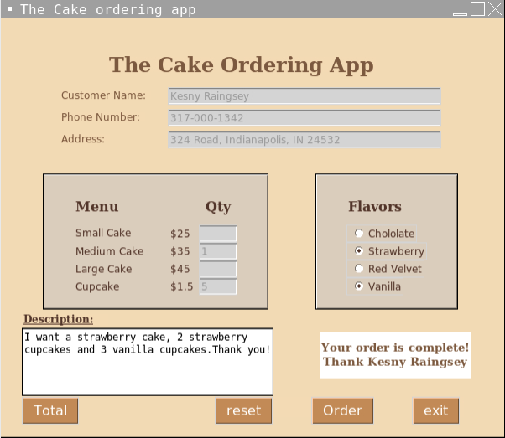

Exit Button:

This picture below asked the customer want to exit the system or continue. If yes, everything will close. If no, the customer can continue purchase their order.

Invalid Information:

This picture below shows the invalid information. It requires customer to input their information, customer name, phone number and address. When the customer click on order, it will has a error message box that show Invalid information to complete their information.

