
Geospatial Intelligence Block Report
ACTION AREA I
BLOCK AC

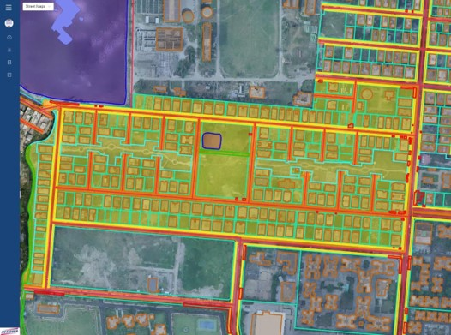
BLOCK/AC | Akash Adhikary & Subhendu Kumar Panja
Date: 12/01/2023 | P: +91 9163827816 | Y: akash.adhikary@shanta.in  &  subhendu.panja@shanta.in
STATEMENT OF CONFIDENTIALITY | This report is a part of an ongoing contract with Newtown Kolkata Development Authority and is issued for parties under contract only. Terms and Conditions of contract preside over all parties and their actors.
FSIPL/NKDA/R/003

Hello World

