
Geospatial Intelligence Block Report
ACTION AREA I
BLOCK AC

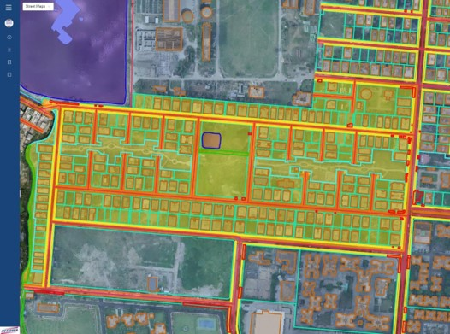
BLOCK/AC | Akash Adhikary & Subhendu Kumar Panja
Date: 12/01/2023 | P: +91 9163827816 | Y: akash.adhikary@shanta.in  &  subhendu.panja@shanta.in
STATEMENT OF CONFIDENTIALITY | This report is a part of an ongoing contract with Newtown Kolkata Development Authority and is issued for parties under contract only. Terms and Conditions of contract preside over all parties and their actors.
FSIPL/NKDA/R/003

Total Area of Block |  | Area in Sq. Km. | Area in Sq. Mt. | Area in Acres.
 |  | 0.14 | 142129.41 | 35.12
Structure of Block |  | Boundary Area |  | Total % Area
 |  | In Sq. Mt. | In Acres | 100
Private Space
 | Private Commercial | 0 | 0.00 | 0.00
 | Residential | 76473.75 | 18.90 | 53.81
 | Govt. Commercial | 0 | 0.00 | 0.00
 | Housing Complex | 0 | 0.00 | 0.00
Public Space
 | Government | 14259.07 | 3.52 | 10.03
 | Motorable Roads | 19495.55 | 4.82 | 13.72
 | Footpath | 4873.41 | 1.20 | 3.43
 | Cycle Track | 584.46 | 0.14 | 0.41
 | Parks and Green | 14430.05 | 3.57 | 10.15
 | Waterbody | 701.82 | 0.17 | 0.49
Other |  | 11311.3 | 2.80 | 7.96
Occupancy
 | Visibly Occupied | Visibly Under Cons. | Visibly Vacant | Total No. of Plots
Private Commercial | 0 | 0 | 0 | 0
Residential | 157 | 22 | 50 | 229
Govt. Commercial | 0 | 0 | 0 | 0
Housing Complex | 0 | 0 | 0 | 0
Government | 3 | 1 | 7 | 11
**(Building Occupied: Sanctioned Plot, Which Have Received Completion Certificate, Plot Availing Construction Power, Plot Availing Permanent Water Connection, Per Plot Revenue Tax, Trade License Data Not Integrated)
ACTION AREA - 01
AC Block
Summary
Report
FSIPL/NKDA/R/003

