
Geospatial Intelligence Block Report
ACTION AREA - I
BLOCK AC

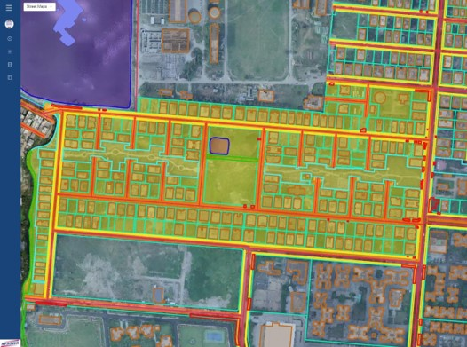
BLOCK AC | Akash Adhikary & Subhendu Kumar Panja
Date: 12/01/2023 | P: +91 9163827816 | Y: akash.adhikary@shanta.in  &  subhendu.panja@shanta.in
STATEMENT OF CONFIDENTIALITY | This report is a part of an ongoing contract with Newtown Kolkata Development Authority and is issued for parties under contract only. Terms and Conditions of contract preside over all parties and their actors.
FSIPL/NKDA/R/003

Total Area of Block |  | Area in Sq. Km. | Area in Sq. Mt. | Area in Acres.
 |  | 0.14 | 142129.41 | 35.12
Structure of Block |  | Boundary Area |  | Total % Area
 |  | In Sq. Mt. | In Acres | 100
Private Space
 | Private Commercial | 0 | 0 | 0
 | Residential | 76473.75 | 18.9 | 53.81
 | Govt. Commercial | 0 | 0 | 0
 | Housing Complex | 0 | 0 | 0
Public Space
 | Government | 14259.07 | 3.52 | 10.03
 | Motorable Roads | 19495.55 | 4.82 | 13.72
 | Footpath | 4873.41 | 1.2 | 3.43
 | Cycle Track | 584.46 | 0.14 | 0.41
 | Parks & Green | 14430.05 | 3.57 | 10.15
 | Waterbody | 701.82 | 0.17 | 0.49
Other |  | 11311.3 | 2.8 | 7.96
Occupancy
 | Visibly Occupied | Visibly Under Cons. | Visibly Vacant | Total No. of Plots
Private Commercial | 0 | 0 | 0 | 0
Residential | 157 | 22 | 50 | 229
Govt. Commercial | 0 | 0 | 0 | 0
Housing Complex | 0 | 0 | 0 | 0
Government | 3 | 1 | 7 | 11
**(Building Occupied: Sanctioned Plot, Which Have Received Completion Certificate, Plot Availing Construction Power, Plot Availing Permanent Water Connection, Per Plot Revenue Tax, Trade License Data Not Integrated)
ACTION AREA - I
BLOCK AC
Summary
Report
FSIPL/NKDA/R/003

Block Specific Insights
Roads | Footpaths | Greenery | Canals
- No of roads: 23  - Road's Length: 3913.31 mt.(Approx)  - Roads are sharing with adjacent blocks:  - Adjacent Block: AF,AD,AG,AA  - Street no. of roads: 32,39,41,51,64  - Road Segment Length: 1633.50 mt.(Approx)  - Street no. sharing with adjacent block:  - 51 with AA Block  - 64 with AD & AG Block  - 39, 41 & 42 with AF Block  - Major Road Problem: NA | - Street with footpath: 32, 47, 51, 64, 41  - Street with partial footpath: 39  - Street without footpath: 34, 36, 38, 40, 42, 43, 44, 46, 48, 49, 50, 52, 54, 56, 58, 60, 62 | - Area: 14430.05 sq. mt.  - No. of trees: 197  - Green Verges and Public Parks:  - AC Block Park  - NKDA Park  - NKDA Sensory Park | - "C" Canal: 338.86 mt.
Water Bodies | Waste Bin | Major Construction Sites | Cycle Track
- Perimeter: 99.79 mt.  - Area: 701.82 sq. mt.  - Clean: Not Verified  - Swimmable: Not Verified | NA | 23 Nos | - Cycle Track Length: 1800.17 mt. (Approx)  - Street no. with cycle track: 64, 41  - Major Problem: NA  - Cycle route: No
Street Lights |  | Parking |  | Public Market |  | Stubble Burning |  | Others
100 |  | 00 |  | 00 |  | NA |  | - Neighbourhood Center: 001
Police Stations/ Fire Stations |  |  | Water & Drainage Network |  |  | Public Art |  | - Neighbourhood Center: 001
00 |  |  | - No. of water tanks: 01  - Water tanks list:  - Water Tank 01  - Water logging: NA  - Water Harvesting Pit: NA |  |  | NA |  | - Neighbourhood Center: 001
Rooftop Solar |  |  |  |  |  | Public Gym |  | - Neighbourhood Center: 001
NA |  |  |  |  |  | NA |  | - Neighbourhood Center: 001
FSIPL/NKDA/R/003

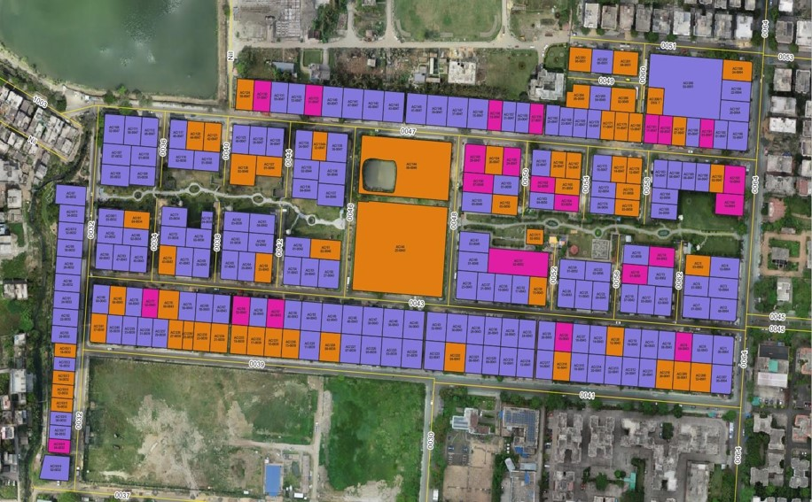

ACTION AREA - I
BLOCK: 'AC' PLOT DETAILS - PART 01
FSIPL/NKDA/R/003

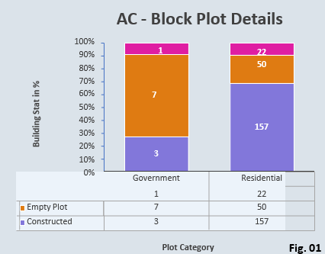
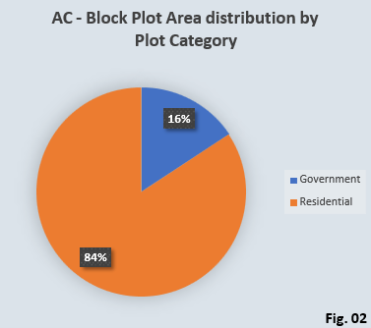
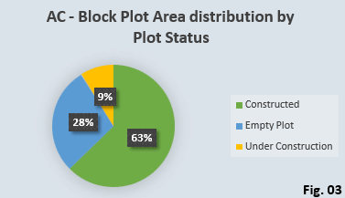

Plot Category | Plot Area In Sq. Mt. | No. of Plots
Government | 14259.071 | 11
Residential | 76473.782 | 229
Grand Total | 90732.853 | 229
Building Status | Plot Area In Sq. Mt. | No. of Plots
Constructed | 56874.875 | 160
Empty Plot | 25770.417 | 57
Under Construction | 8087.561 | 23
Grand Total | 90732.853 | 229
ACTION AREA - I
BLOCK: 'AC' PLOT DETAILS - PART 02
FSIPL/NKDA/R/003

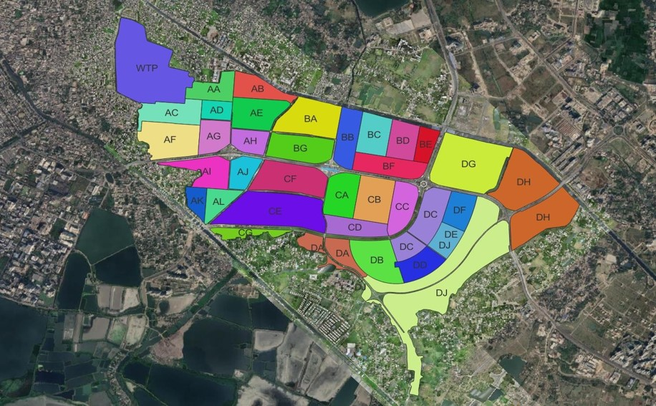

ACTION AREA - I
BLOCK: 'AC' OVERVIEW
FSIPL/NKDA/R/003

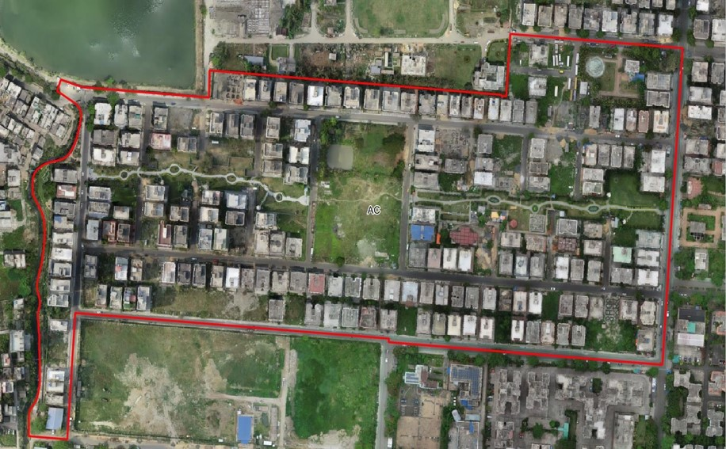

ACTION AREA - I
BLOCK: 'AC' BOUNDARY
FSIPL/NKDA/R/003

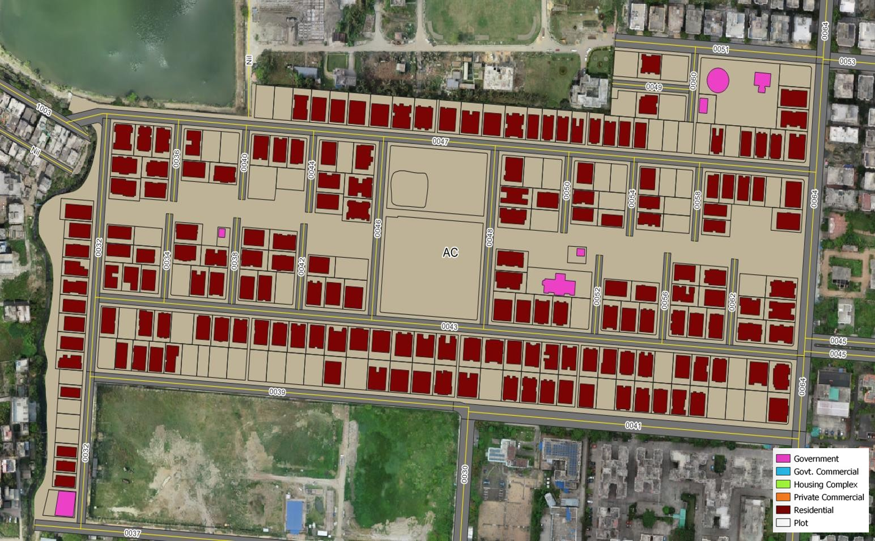

ACTION AREA - I
BLOCK: 'AC' BUILT-UP AREA
FSIPL/NKDA/R/003

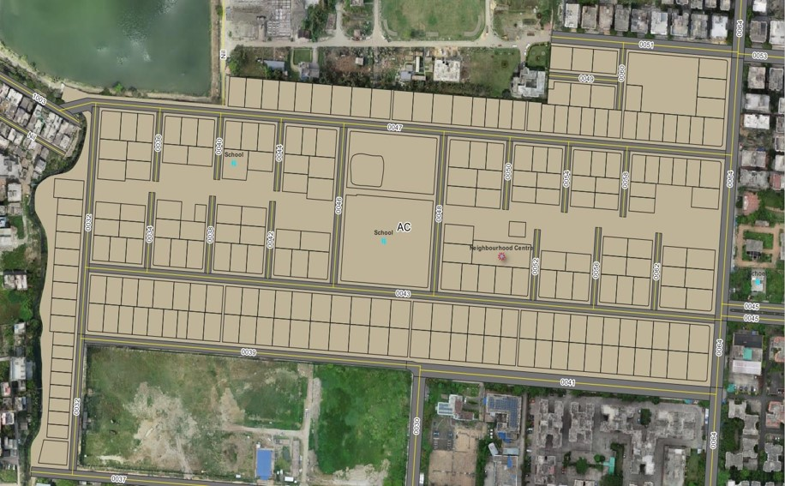

ACTION AREA - I
BLOCK: 'AC' AMENITIES AND POI
FSIPL/NKDA/R/003

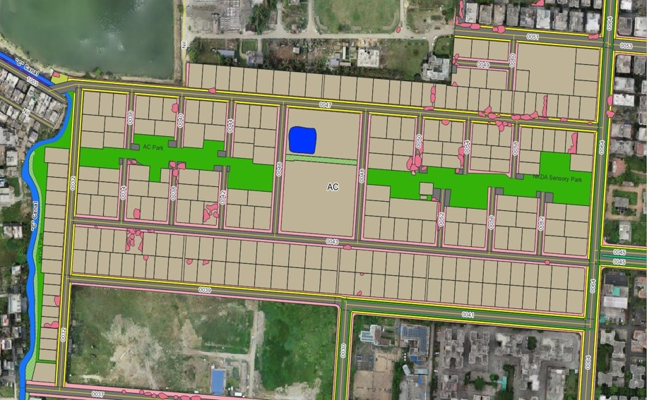

ACTION AREA - I
BLOCK: 'AC' OTHER FEATURES
FSIPL/NKDA/R/003

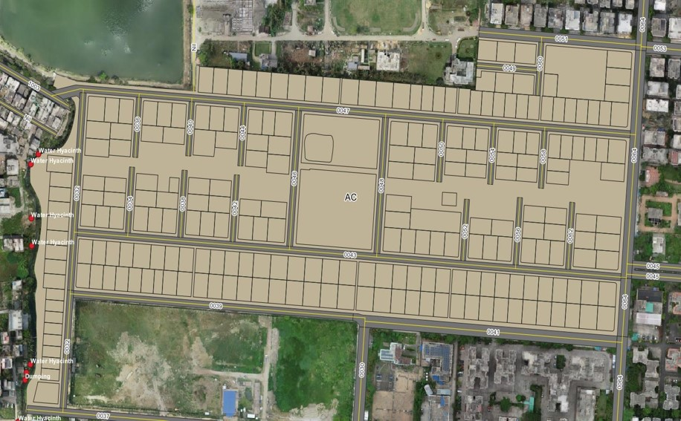

ACTION AREA - I
BLOCK: 'AC' ACTIONABLE POINTS
FSIPL/NKDA/R/003

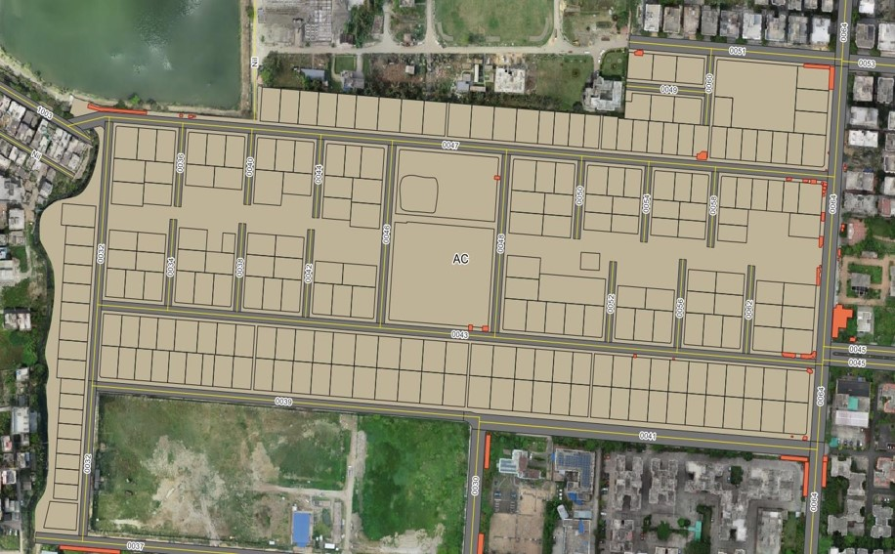

ACTION AREA - I
BLOCK: 'AC' OCCUPIED UNTAXED AREA (ENCROACHMENT)
FSIPL/NKDA/R/003

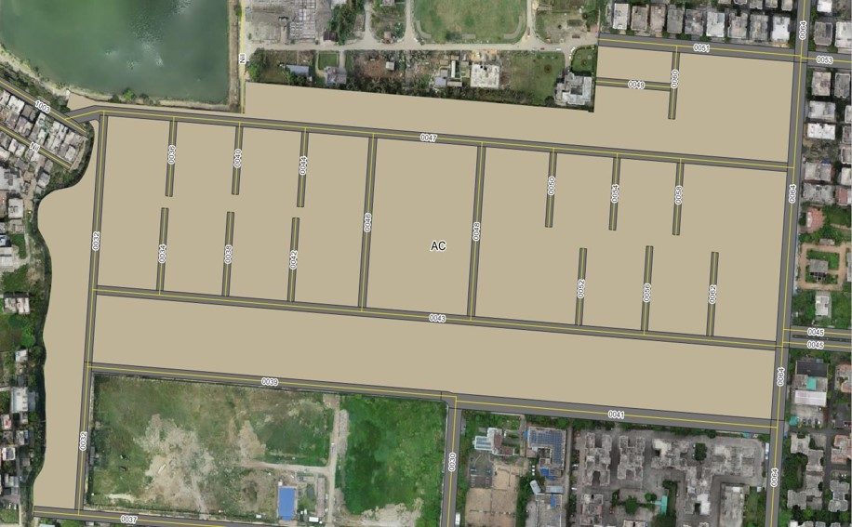

ACTION AREA - I
BLOCK: 'AC' ROAD DETAILS
FSIPL/NKDA/R/003

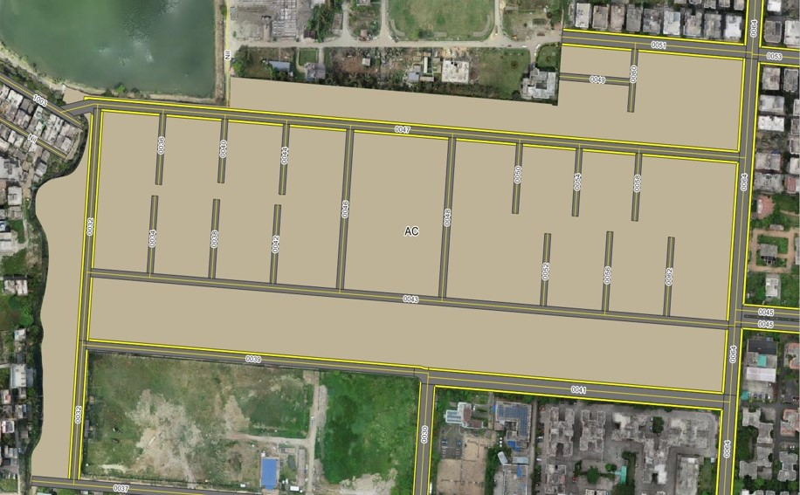

ACTION AREA - I
BLOCK: 'AC' FOOTPATH DETAILS
FSIPL/NKDA/R/003

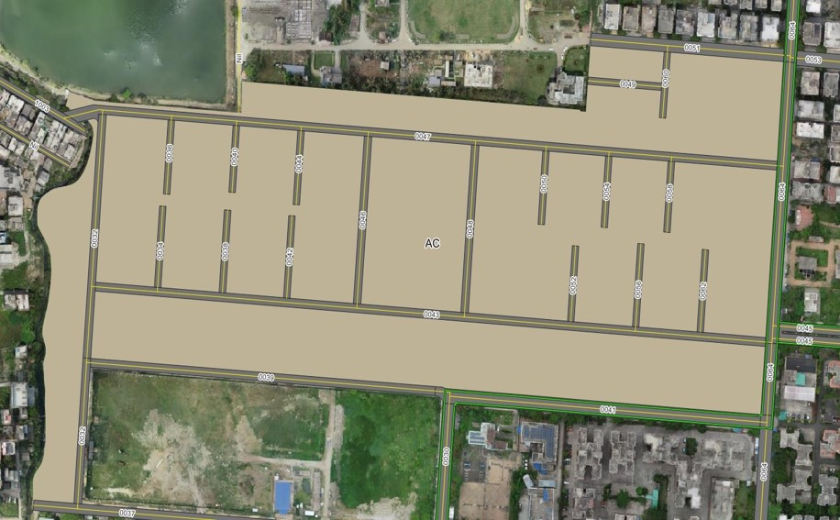

ACTION AREA - I
BLOCK: 'AC' CYCLE TRACK DETAILS
FSIPL/NKDA/R/003

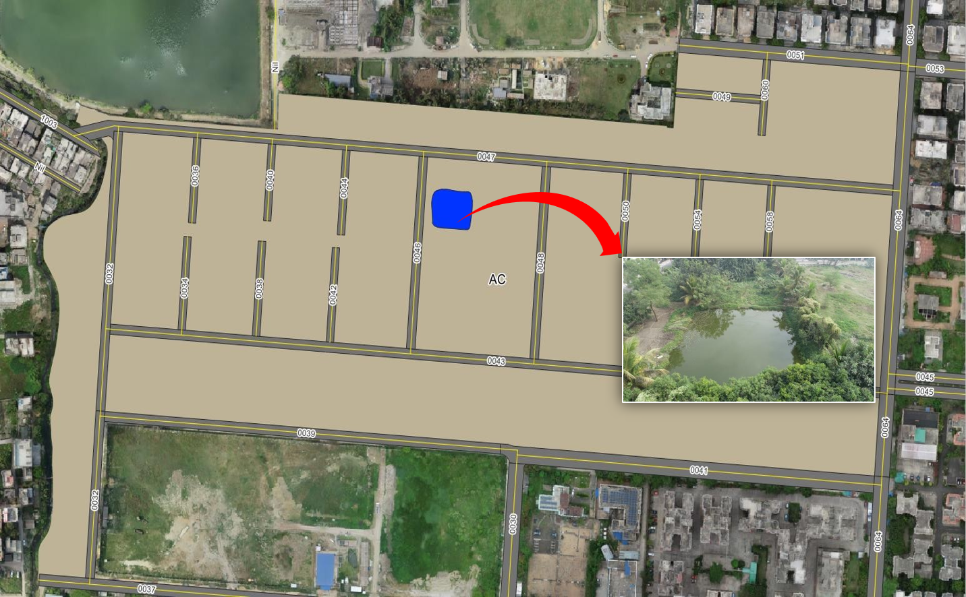

ACTION AREA - I
BLOCK: 'AC' WATERBODIES DETAILS
FSIPL/NKDA/R/003

ACTION AREA - I
BLOCK: 'AC' GREENERY DETAILS
FSIPL/NKDA/R/003

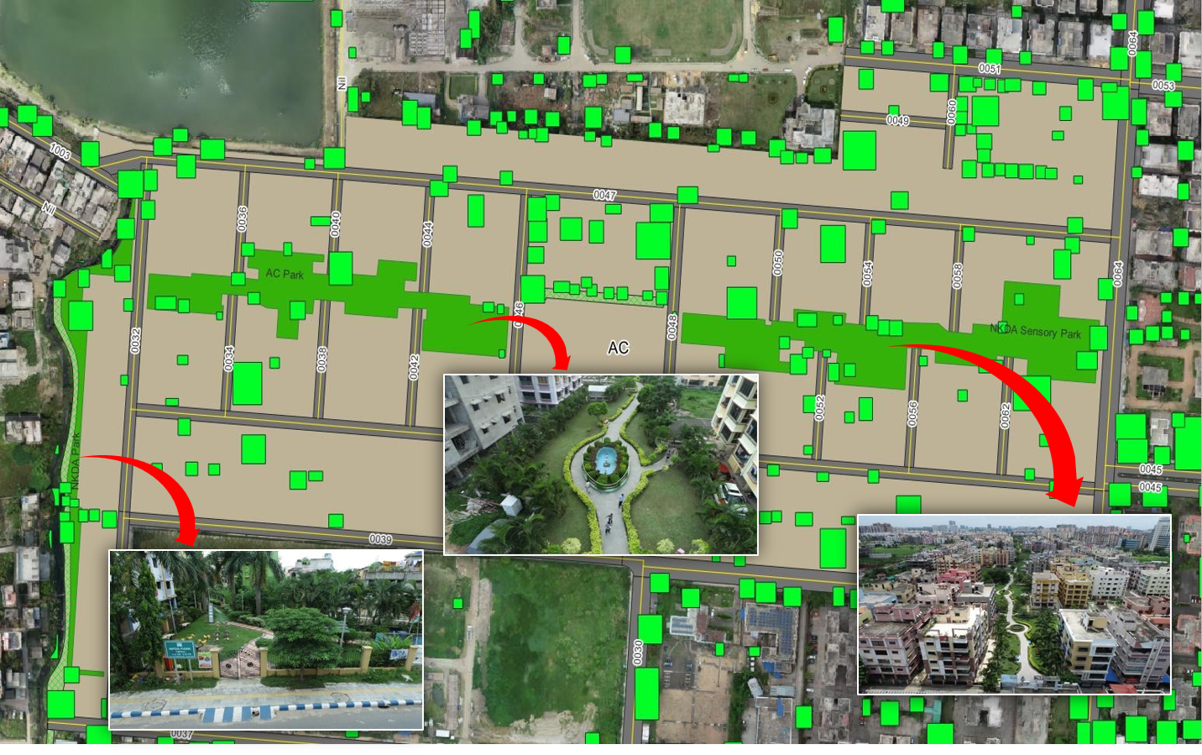

ACTION AREA - I
BLOCK: 'AC' WATERBODIES DETAILS
FSIPL/NKDA/R/003

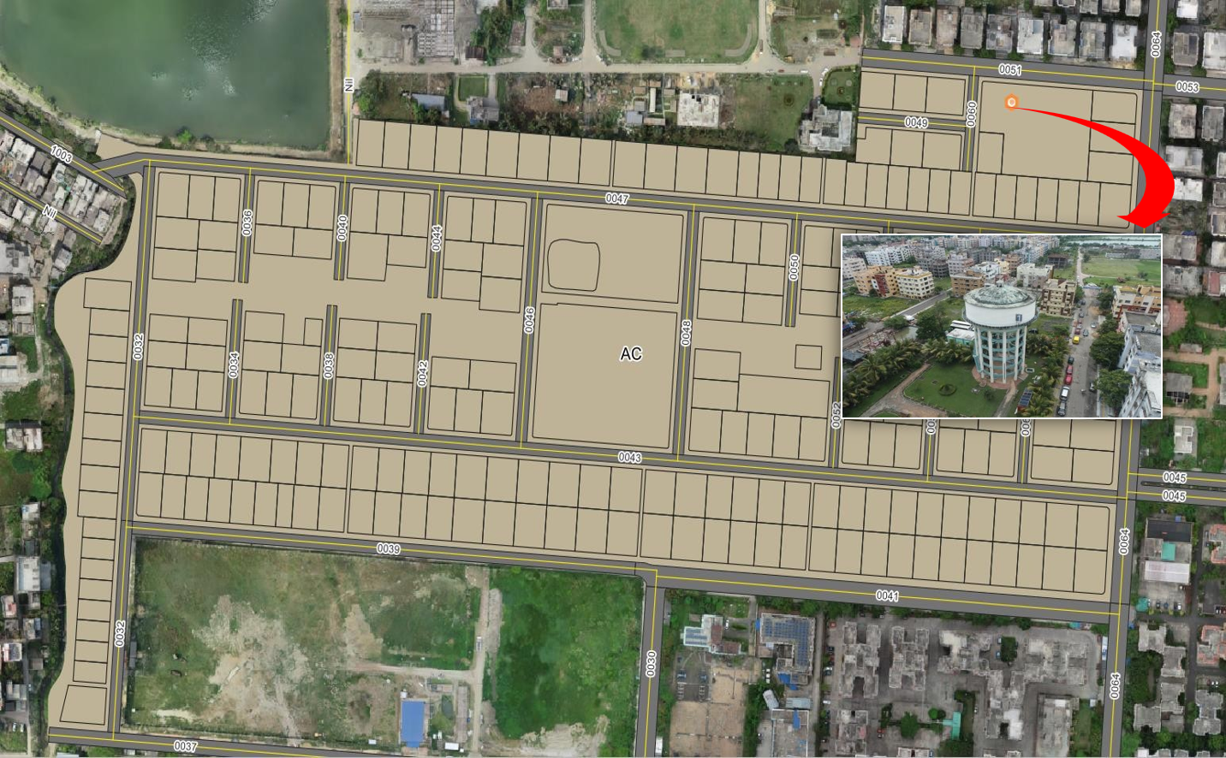

ACTION AREA - I
BLOCK: 'AC' WATER TANK
FSIPL/NKDA/R/003

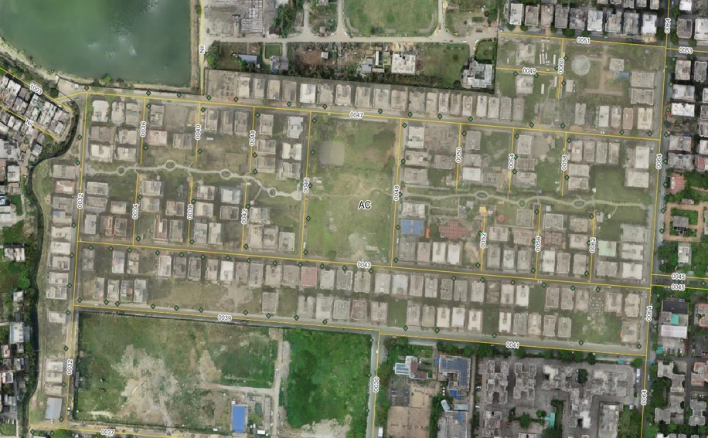

ACTION AREA - I
BLOCK: 'AC' STREET-LIGHT DETAILS
FSIPL/NKDA/R/003

