**Idea: CardsGame: Blackjack (Twenty-One)**

Net ID：kz2193 Name: Kexin Zhou

**Game description: Blackjack** is one of themost widely played casino banking game in the world, it uses [decks](https://en.wikipedia.org/wiki/Playing_card) of 52 cards and descends from a global family of casino banking games known as [Twenty-One](https://en.wikipedia.org/wiki/Twenty-One_(card_game)). Blackjack players do not compete against each other. The game is a comparing card game where each player competes against the dealer.

1. Advanced concepts：

UI: game page

Network: multiple players could join and play the game at the same time on the network

Multi-thread: each thread attaches to one player

1. Roles in the game: dealer(server) and player*3(client)
2. **Rules of Game:**

blackjack= A +J/Q/K

each player competes against the dealer

//specific rules of the game listed in another submitted file: rules of blackjack.pdf

1. **Plan to realize**
2. Design UI for players to take in the behaviors from players, Eg. Join, ready, hit, stand in the game, UI also reveal the current status of players
3. Use network to connect players and dealer and let them exchange message and play together
4. Use multithread to allow 3 players deal with one dealer one by one in a game
5. The behavior of dealer will be controlled by my program not a real person, who will randomly draw cards and send cards to other players
6. Players’ decision in game will be processed in my program and give them feedback in result box on UI.
7. **UI design: (about the structure)**

From dealer aspect: From player1 aspect:

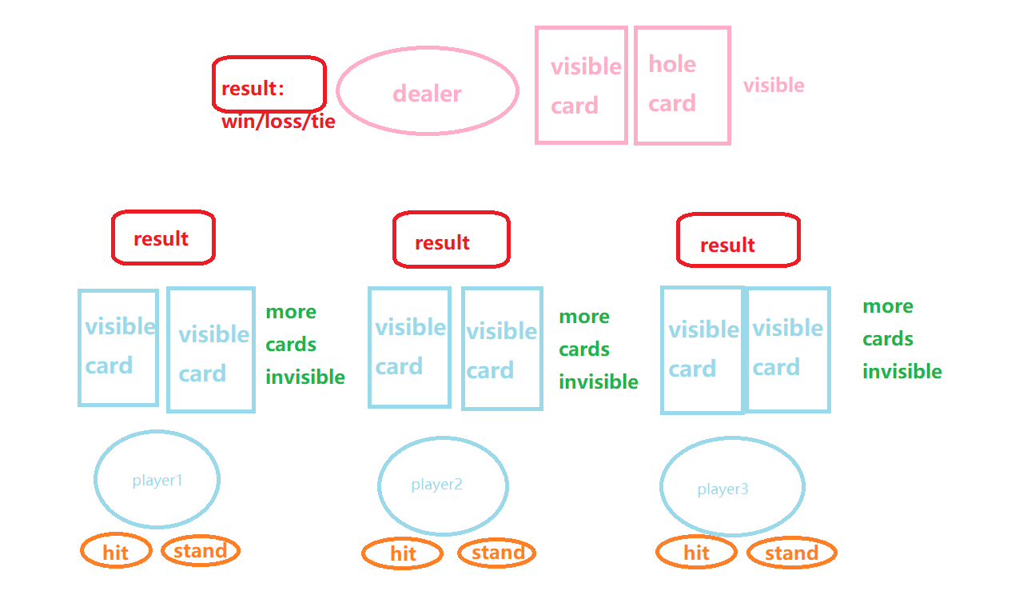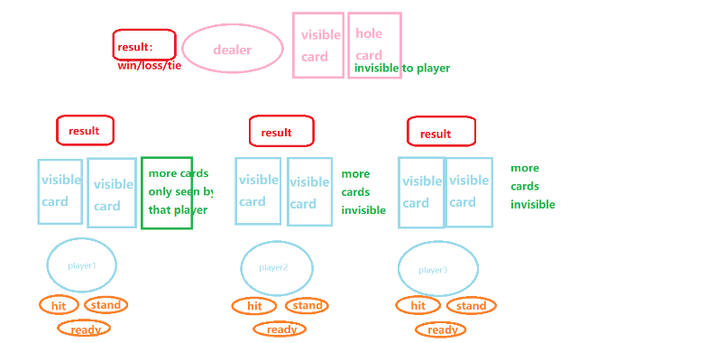

1. **Class design(roughly)**

