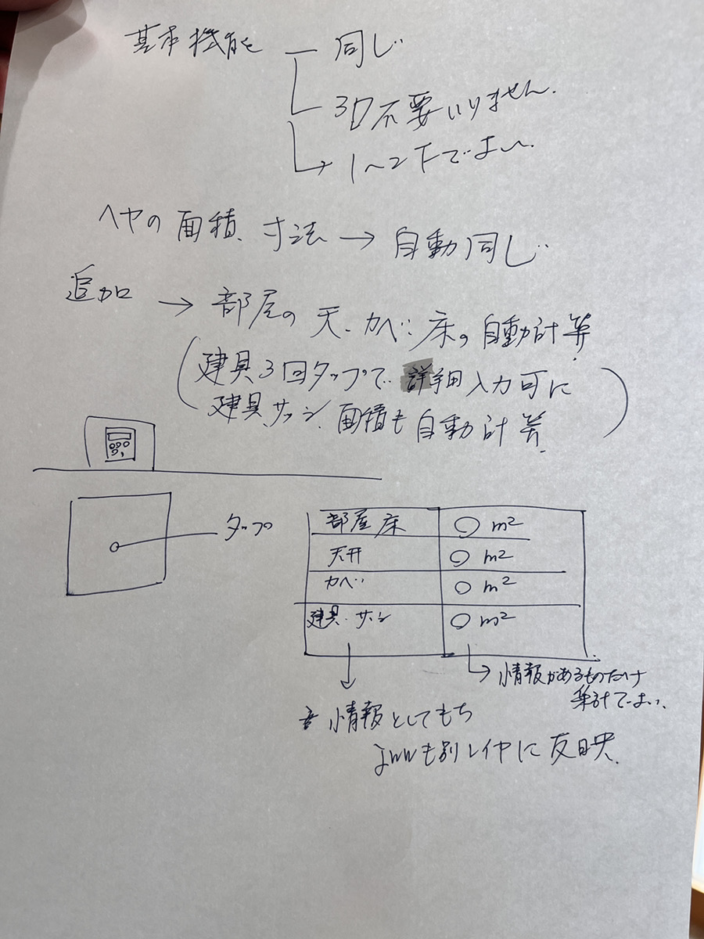

The basic functions are the same.

3D function is not necessary.

Automatic calculation of area and dimensions

Add => Automatic calculation of the room's ceiling, walls, and floor

(User can enter details by tapping fittings 3 times

The area occupied by fittings must also be automatically calculated.)

Floor(部屋床)

Ceiling(天井)

Wall(カベ)

Fittings(建具)

Just a synthesis of the information that exists is fine.

This information must be reflected in jww as well (reflected in other layers).

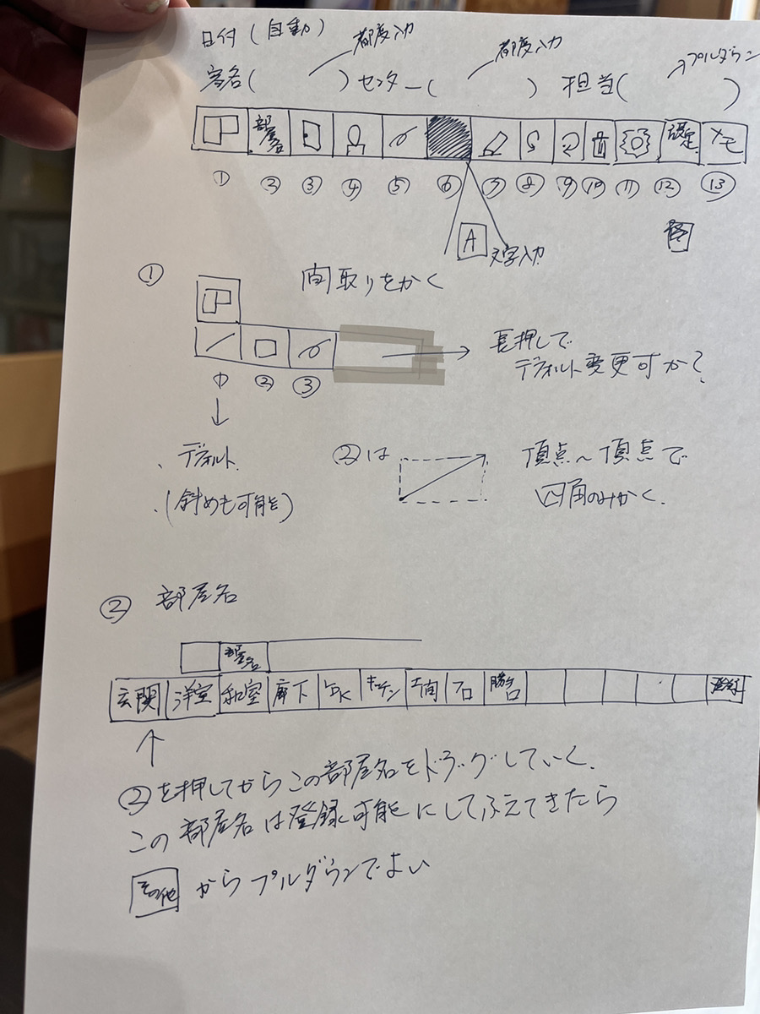

Date (auto)

Customer name (enter each time) Center (enter each time) Contact person (drop down)

日付

客名 センター 担当

1

straight, square, freedom line

When the user presses and holds, a notification will appear asking "Do you want to change defaults?" (デフォルトを変更しますか？)

2 Room name(部屋名) dropdown

玄関, 洋室, 和室, 廊下, LDK, キッチン

I would like to allow the user to set the room name by dragging 2 (Room Name).

Please add a feature that allows users to register room names.

The last field is the registration button[新規登録]

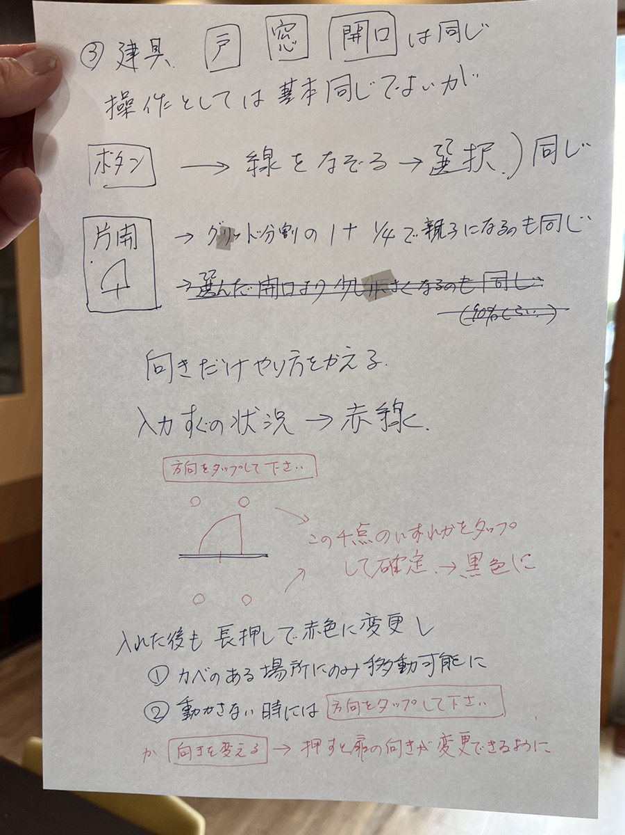

3 fittings

Door(戸), window(窓), and opening(開口) are the same as the existing app

The operation can be the same as the existing app, but

Button => Follow the line => Select (same as existing app)

grid division 1+1/4 and Being a parent and child is the same as the existing app.

Change only the direction

Immediately after input, it is displayed as a red line.

Tap a direction

Tap one of these four dots to determine the direction, and it will change to black.

Even after you decide on the direction and the color changes to black, you can press and hold to change the color to red and change the direction.

* This can only be moved to places where there are walls.
* When not moving, “Tap direction” becomes “Change direction.” =>Click to change the door direction. (I don't understand this part either. What do you think?)

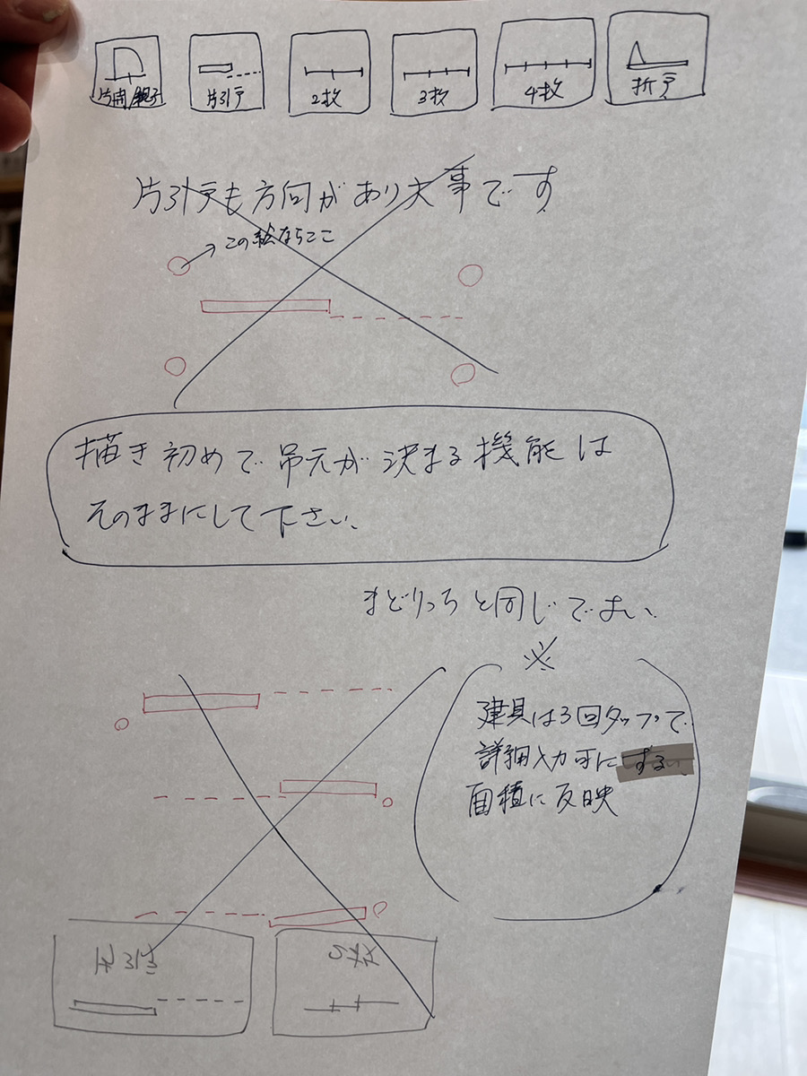

片開親子, 片引戸, ２枚, 3枚, 4枚, 折戸

The function that determines the hanging at the beginning of the drawing is

Please leave it as is.

Same as the existing app.

Users can enter detailed information by tapping 3 times on fittings.

Area is reflected

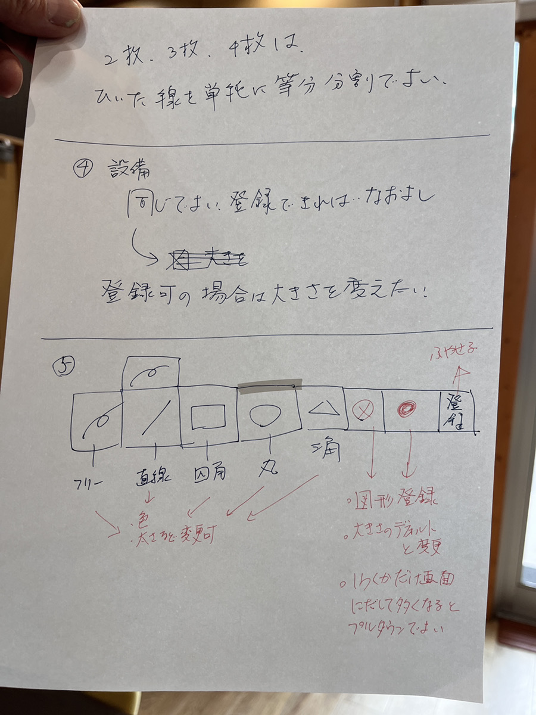

２枚, 3枚, 4枚 is

okay to simply divide the split line into equal parts.

4 facility

It is better to be the same.

If users can register, it would be nice to be able to change the size.

5

Free, Straight, rectangular, circle, triangle

Color and thickness can be changed

Add shape

Change size

If it overflows the screen, a dropdown is fine.

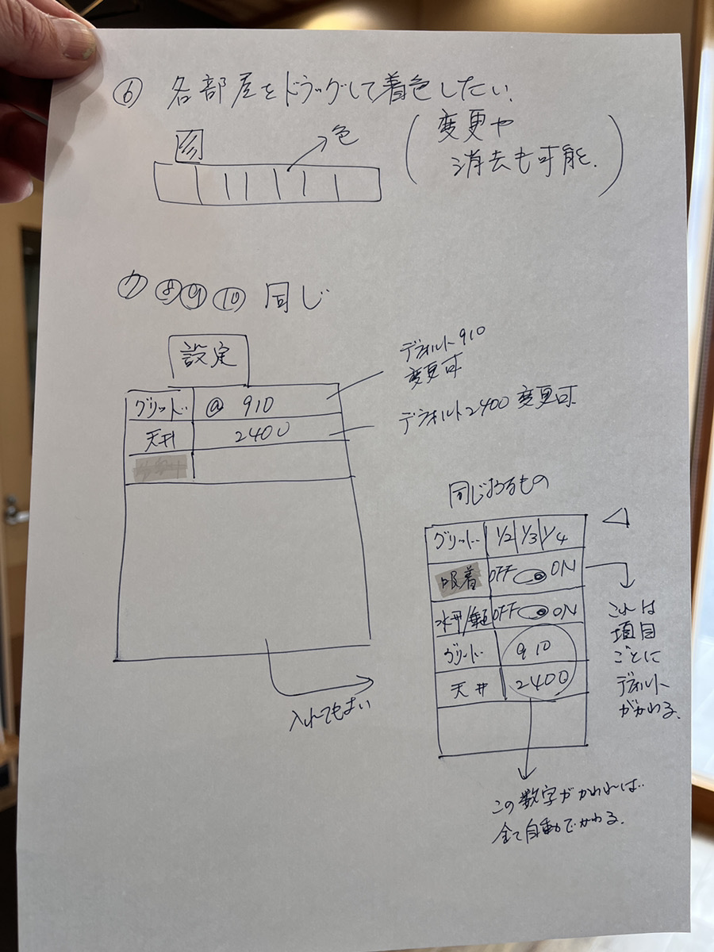

6 I want to color each room by dragging the color.

Colors can be changed and deleted

7, 8, 9, 10 are the same as the existing app

Setting

Grid @ 910 (Default is 910, changeable)

Ceiling 2400 (Default is 2400, changeable)

(It would be good to include the following.)

Same thing -

Grid 1/2 1/3 1/4

(This default changes for each item) Adsorption off/on

XX/XX off/on

Grid @ 910

Ceiling 2400

If this number changes, everything

will change automatically.

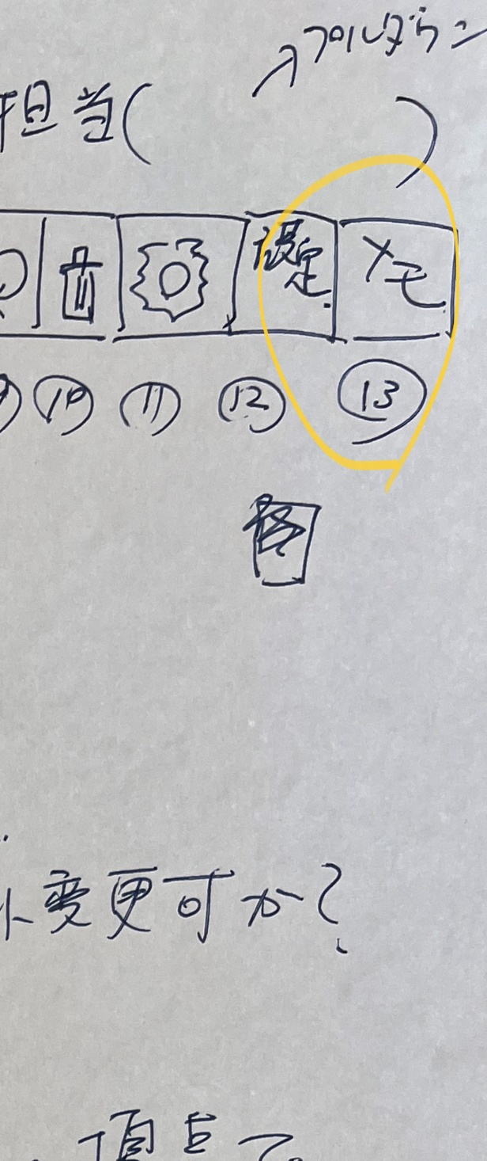

Also, I would like a "memo" function. I think it would be nice to always have a page where you can doodle by hand.

free line and eraser