

**MINISTERUL EDUCAȚIEI, CULTURII ȘI CERCETĂRII**

**AL REPUBLICII MOLDOVA**

**Universitatea Tehnică a Moldovei**

**Facultatea Calculatoare, Informatică şi Microelectronică**

**Departamentul Informatică şi Ingineria Sistemelor**

**RAPORT**

***Laborator nr.1***

***Disciplina: “Managementul Bazelor de date”***

**Efectuat:**

**Calancea Cătălin** MI-222

**Verificat:**

**Perebinos Mihail,** *a.u.*

**Chișinău – 20****24**

**Cuprins:**

1__POO__PARTEA__1.pdf 3

2__L1_RO_intr_PHP_OOP.pdf 14

**1__POO__PARTEA__1.pdf**

**Exemplul 1 :**

<?php

class Aritmetica

{

public $x = 2; public $y = 3;

public function Suma ( ) { return $this -> x + $this -> y;

}

}

$a = new Aritmetica; echo "Suma nr: "; echo $a->x+$a->y;

?>

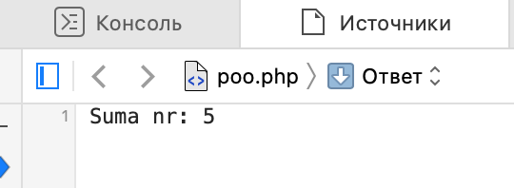

**Exemplul 2 :**

<?php

class Aritmetica {

var $x = 2;

var $y = 3;

function Suma() {

return $this->x + $this->y;

}

function Produs() {

return $this->x * $this->y;

}

}

$a = new Aritmetica();

echo $a->Suma() . " <br>";

echo $a->Produs() . " <br>";

?>

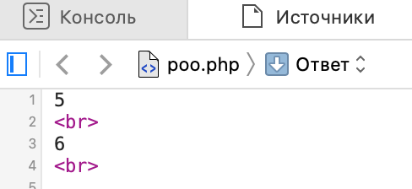

**Exemplul 3 :**

<?php

class Urs {

var $nume;

var $varsta;

var $sex;

var $culoare;

var $greutate;

function vaneaza() {

echo $this->nume . " vaneaza. <br>";

}

function mananca() {

echo $this->nume . " mananca. <br>";

}

function doarme() {

echo $this->nume . " doarme. <br>";

}

}

$daddy = new Urs;

$daddy->nume = "Tata urs";

$daddy->varsta = 8;

$daddy->sex = "mascul";

$daddy->culoare = "negru";

$daddy->greutate = 300;

$mommy = new Urs;

$mommy->nume = "Mama urs";

$mommy->varsta = 7;

$mommy->sex = "femela";

$mommy->culoare = "negru";

$mommy->greutate = 310;

$baby = new Urs;

$baby->nume = "Puiul urs";

$baby->varsta = 1;

$baby->sex = "mascul";

$baby->culoare = "negru";

$baby->greutate = 180;

$daddy->vaneaza();

$mommy->mananca();

$baby->mananca();

$mommy->doarme();

$daddy->doarme();

$baby->mananca();

?>

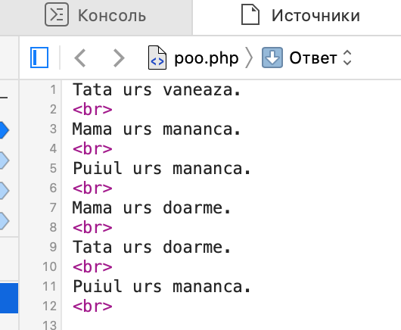

**Exemplul 4 :**

<?php

class Oameni

{

public $varsta;

public $ocupatie;

public $insurat;

public $iq;

public $nume;

function __construct($nume, $varsta, $ocupatie, $insurat, $iq)

{

$this->nume = $nume;

$this->varsta = $varsta;

$this->ocupatie = $ocupatie;

$this->insurat = $insurat;

$this->iq = $iq;

}

function spuneSalut()

{

echo "Buna, ma numesc " . $this->nume . ", am " . $this->varsta . " de ani, " . ($this->insurat ? "sunt" : "nu sunt") . " insurat, sunt " . $this->ocupatie . " si am IQ " . $this->iq;

}

}

$ion = new Oameni("Ion", 20, "inginer", false, 50);

$ion->spuneSalut();

?>

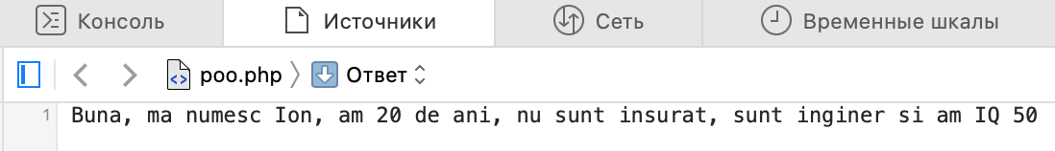

**Exemplul 5 :**

<?php

class Student

{

public $year; // an

public $age; // vârsta

public $name; // nume

// constructor

function __construct($y = "4", $a = "22", $n = "")

{

$this->year = $y;

$this->age = $a;

$this->name = $n;

}

// metode

function setYear($y)

{

$this->year = $y;

}

function getYear()

{

return $this->year;

}

function setAge($a)

{

$this->age = $a;

}

function getAge()

{

return $this->age;

}

function setName($n)

{

$this->name = $n;

}

function getName()

{

return $this->name;

}

function afisare()

{

echo "Numele este " . $this->name . ", anul este " . $this->year . ", vârsta este " . $this->age . ".<br>";

}

}

$st = new Student("2020", "20", "Petru");

echo "Primul an este " . $st->getYear() . "<br>";

$st->setYear("1998");

echo "Al doilea an este " . $st->getYear() . "<br>";

echo "Primul nume este " . $st->getName() . "<br>";

$st->setName("Ion");

echo "Al doilea nume este " . $st->getName() . "<br>";

echo "Prima varsta este " . $st->getAge() . "<br>";

$st->setAge("30");

echo "A doua varsta este " . $st->getAge() . "<br>";

$stud = new Student();

$stud->afisare();

$stud = new Student(2);

$stud->afisare();

$stud = new Student(2, 20);

$stud->afisare();

$stud = new Student(5, 30, "Petru");

$stud->afisare();

?>

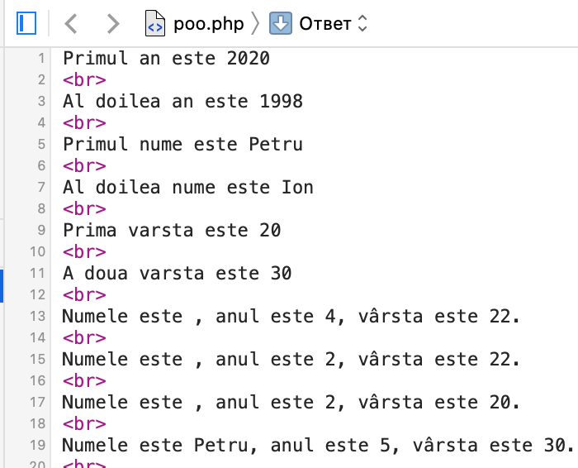

**Exemplul 6 :**

<?php

class Aritmetica

{

public $x = 2; public $y = 3; function Suma ( ) {

return $this -> x + $this -> y;

}

function Produs ( ) {

return $this -> x * $this -> y;

}

}

class Aritmetica3 extends Aritmetica

{

var $z = 4;

function Suma3 ( ) {

return $this -> x + $this -> y + $this -> z;

}

function Produs3 ( ) {

return $this -> x * $this -> y * $this -> z;

}

}

$a = new Aritmetica3;

echo "Suma primelor doua nr (functie din clasa de baza): "; echo $a -> Suma ( ) . " <br>";

echo "Produsul primelor doua nr (functie din clasa de baza): "; echo $a -> Produs ( ) . "<br>";

echo "Suma celor trei numere: (functie din clasa extinsa)"; echo $a ->Suma3 ( ) . "<br>";

echo "Produsul celor trei numere: (functie din clasa extinsa)"; echo $a -> Produs3 ( ) . "<br>";

?>

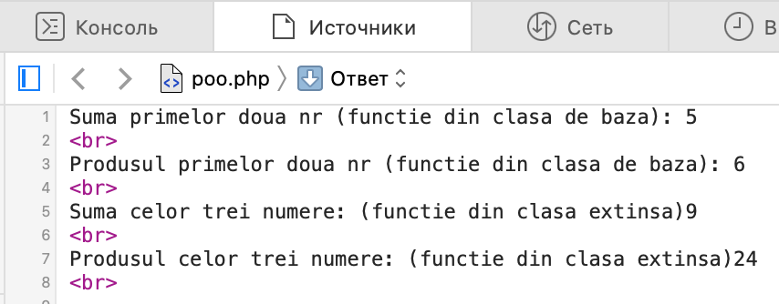

**Exemplul 7 :**

<?php

class Student {

public $age; // varsta

function setAge($age) {

$this->age = $age;

}

function getAge() {

return $this->age;

}

}

class GoodStudent extends Student {

// date-membru

public $prizes; // premii

// metode

function setPrizes($p) {

$this->prizes = $p;

}

function getPrizes() {

return $this->prizes;

}

}

$goodstud = new GoodStudent;

// apel de metodă din clasa de bază

$goodstud->setAge(21);

// apel de metodă din clasa derivată

$goodstud->setPrizes(2);

echo "Studentul cu varsta: " . $goodstud->getAge() . " a castigat premiul: " . $goodstud->getPrizes();

?>

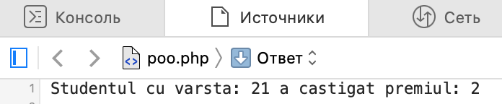

**Exemplul 8 :**

<?php class A {

var $msg = "Buna seara"; function scrie ( ) {

echo $this -> msg;

}

}

$a = new A;

$s = serialize ($a);

// salvarea sirului intr-un fisier

$fp = fopen ("fisier", "w"); fputs ($fp, $s);

fclose ($fp);

?>

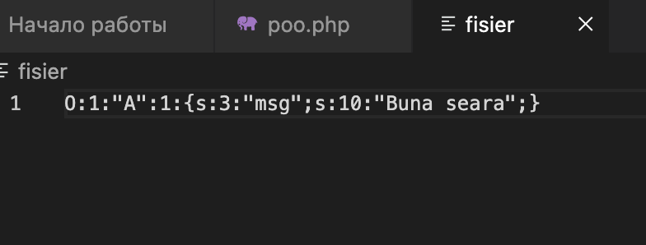

**Exemplul 9 :**

<?php

function inc (&$var)

{

$var++;

echo "var: ".$var."<br>";

}

$a = 5; inc ($a);

inc ($a);

inc ($a);

echo "a: ".$a;

?>

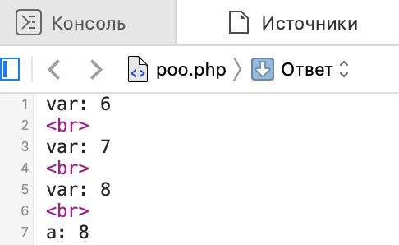

**Exemplul 10 :**

<?php

$x = 'MarPlo.net';

$y = &$x;

echo $y; // MarPlo.net

// Se modifica valoarea lui $x, si va afecta si pe $y

$x = 'CoursesWeb.net';

echo '<br/>'. $y; // CoursesWeb.net

// Se modifica valoarea lui $y, se schimba si la $x

$y = 'php.net';

echo '<br/>'. $x; // php.net

?>

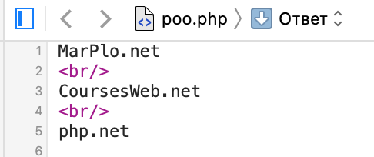

**Exemplul 11 :**

<?php

function foo(&$a) {

$a = $a + 2;

}

$x = 7;

foo($x);

echo $x; // 9

?>

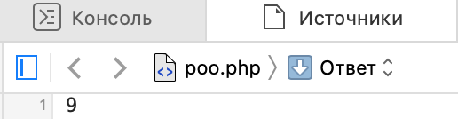

**Exemplul 12 :**

<?php

$var1 = 135;

$var2 = 250; function Suma() {

GLOBAL $var1, $var2; return $var1 + $var2;

}

echo "Suma este ". Suma();

?>

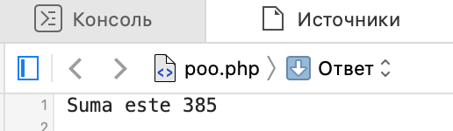

**Exemplul 13 :**

<?php

function v_local() {

$x = 5;

echo "<br />In corpul functiei x = $x";

}

$x = 2;

echo "<br />In corpul scriptului x = $x"; v_local();

echo "<br />In corpul scriptului x = $x";

?>

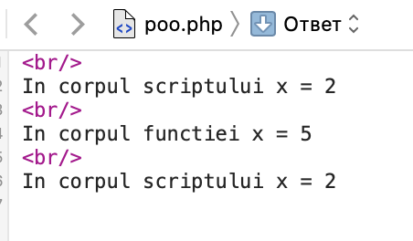

**Exemplul 14 :**

<?php

function v_local() {

$x = $x + 1;

echo "<br /> x = $x";

}

function v_static() { STATIC $x;

$x = $x + 1;

echo "<br /> x = $x";

}

v_local(); v_local(); v_local();

v_static(); v_static(); v_static();

?>

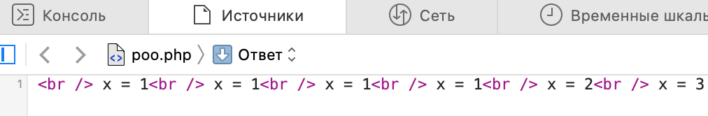

**Exemplul 15 :**

<?php

function p_valoare($a) {

$a = 1;

}

function p_referinta(&$a) {

$a = 1;

}

$b = 0;

p_valoare($b);

echo "<br /> \$b = $b";

$b = 0;

p_referinta($b);

echo "<br /> \$b = $b";

?>

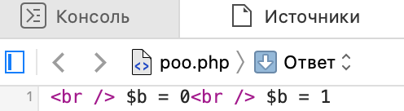

**Exemplul 16 :**

<?php

$a = 100;

function funct() {

$a = 70;

echo "<h4>$a</h4>";

}

funct();

echo "<h2>$a</h2>";

?>

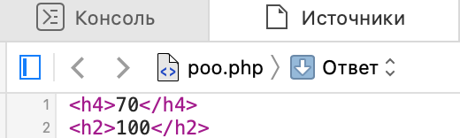

**Exemplul 17 :**

<?php

$a = 1;

$b = 2; function Sum()

{

global $a, $b;

$b = $a + $b;

}

Sum(); echo $b;

?>

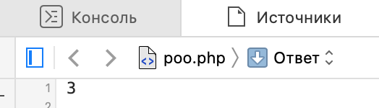

# 2__L1_RO_intr_PHP_OOP.pdf

**Exemplul 1 :**

**class.exemplu.php**<?php

class exemplu

{

public $site = 'Programam.Ro';

public function limbaj()

{

echo 'Imi place limbajul <b>PHP</b><br/>';

}

}

?>

**Poo.php**<?php

include 'class.exemplu.php';

$obiect = new exemplu;

echo 'Variabila <b>$site</b> din clasa <b>exemplu</b> are valoarea <u>'.$obiect->site.'</u><br/><br/>';

$obiect->limbaj();

?>

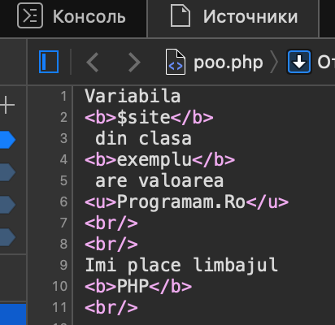

**Exemplul 2 :**

**class.exemplu.php**

<?php

class exemplu

{

function __construct($nume)

{

echo "<br/>A fost creata o noua instanta cu

parametru <b>$nume</b> cu valoarea <u>{$nume}</u><br/>";

}

}

?>

**poo.php**

<?php

include 'class.exemplu.php';

$obiect = new exemplu('Programam');

$obiect2 = new exemplu('OOP');

?>

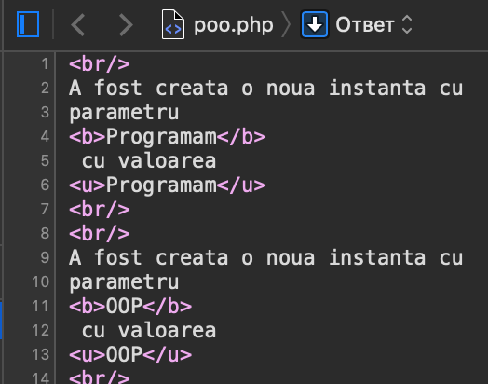

**Exemplul 3 :**

**class.exemplu.php**

<?php

class exemplu

{

function __construct($nume)

{

$this->nume = $nume; // salvam variabila in clasa

echo "<br/>A fost creata o noua instanta a clasei cu parametru <b>$nume</b

cu valoarea <u>{$nume}</u><br/>";

}

function __destruct(){

echo "<br/>Obiectul deschis cu parametru <b>{$this->nume}</b>a fost distrus.<br/>";

}

}

?>

**poo.php**

<?php

include 'class.exemplu.php';

$obiect = new exemplu('Distrus de noi');

$obiect2 = new exemplu('OOP');

unset($obiect);

echo '<hr/>Dupa se termina executia scriptului.<hr/>';

?>

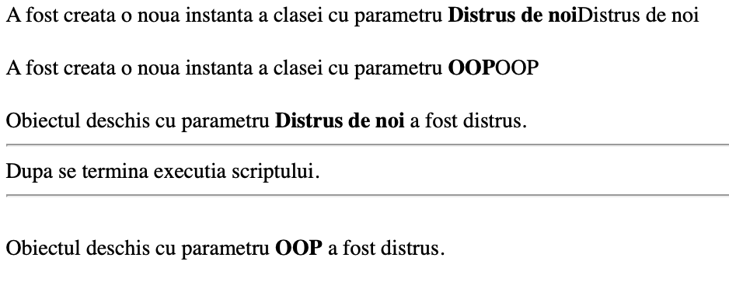

**Exemplul 4 :**

<?php

class masina {

private $motor;

private $putere;

private $masina;

public function __construct() {

$this->motor = 1.0;

$this->putere = '20cp';

$this->masina = 'golf';

}

public function modifica_motor($motor_) {

$this->motor = $motor_;

}

public function modifica_putere($putere_) {

$this->putere = $putere_;

}

public function modifica_masina($masina_) {

$this->masina = $masina_;

}

public function toString() {

echo 'Masina: ' . $this->masina .

'<br> Motor: ' . $this->motor .

'<br> Putere: ' . $this->putere . '<br>';

}

}

$ob=new masina();

$ob->toString();

$ob->modifica_masina("Passat");

$ob->modifica_motor("2.5");

$ob->modifica_putere("180cp");

$ob->toString();

?>

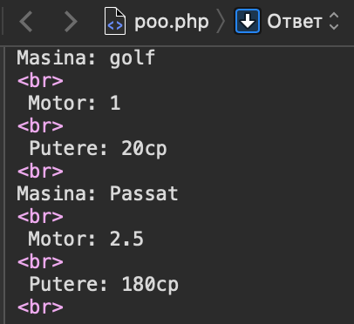

**Exemplul 5 :**

<?php

class Phone {

protected $brand;

protected $model;

protected $price;

public function __construct($_brand, $_model, $_price) {

$this->brand = $_brand;

$this->model = $_model;

$this->price = $_price;

}

public function getBrand(): string {

return $this->brand;

}

public function getModel(): string {

return $this->model;

}

public function getPrice(): float {

return $this->price;

}

public function setBrand($_brand) {

$this->brand = $_brand;

}

public function setModel($_model) {

$this->model = $_model;

}

public function setPrice($_price) {

$this->price = $_price;

}

}

$my_phone = new Phone('Apple', 'iPhone 13', 1000);

echo $my_phone->getBrand() . '<br />';

echo $my_phone->getModel() . '<br />';

echo $my_phone->getPrice() . '<br />';

echo '<br />';

$my_phone->setBrand('Samsung');

$my_phone->setModel('Galaxy S20');

$my_phone->setPrice(800);

echo $my_phone->getBrand() . '<br />';

echo $my_phone->getModel() . '<br />';

echo $my_phone->getPrice() . '<br />';

?>

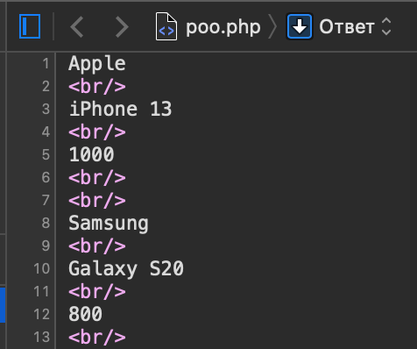

**Exemplul 6 :**

<?php

class A {

private $a = 1;

public function getA() {

return $this->a;

}

public function someMethod() {

return $this->getA();

}

}

$obj = new A();

echo $obj->someMethod() . '<br>';

class Dog {

private $age;

private $name;

public function __construct($name = '', $age = 0) {

$this->age = $age;

$this->name = $name;

}

public function getName() {

return $this->name;

}

public function getAge() {

return $this->age;

}

}

$sharik = new Dog('Шарик', 3);

echo $sharik->getName() . '<br>';

$pusya = new Dog('Пуся', 5);

echo $pusya->getName() . '<br>';

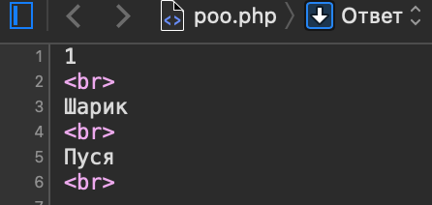

**Exemplul 7 :**

<?php

class produs

{

public $denumireProdus = "Cactus";

public $numeProducator = "Flora SA";

public $dataProducerii = "12/12/2014";

public $num=5;

public $pretUnitar = 90;

public $zero=0;

public $one=1;

Public $two=2;

public $array = array("foo", "bar", "hallo", "world");

function afiseazaDate()

{

return "{$this->denumireProdus}, {$this->numeProducator}, {$this->dataProducerii}, {$this->pretUnitar}"; }

function square($num)

{

return $num * $num;

}

function small_numbers()

{

return $this->array;

}

}

$produs1 = new produs();

$produs1->denumireProdus = 'Begonie';

$produs1->numeProducator = 'Plante SA';

$produs1->dataProducerii = '01/01/2015';

$produs1->pretUnitar = 70;

$produs1->num=6;

echo "Descriere produs: <br>".$produs1->afiseazaDate()."</br><br />"; echo $produs1->square($produs1->num); echo "<br>";

foreach ($produs1->array as $key => $value)

{

echo "{$key} => {$value} "."<br/>";

}

echo "<br>";

print_r($produs1->array);

echo "<br/>";

list ($zero, $one, $two) = $produs1->array;

echo "<br>"."Drink is $zero and $one makes it special $two."."<br/>";

echo "<br>"."$zero has $two."."<br/>";

list( , , $two) = $produs1->array;

echo "<br>"."I need $two!";

?>

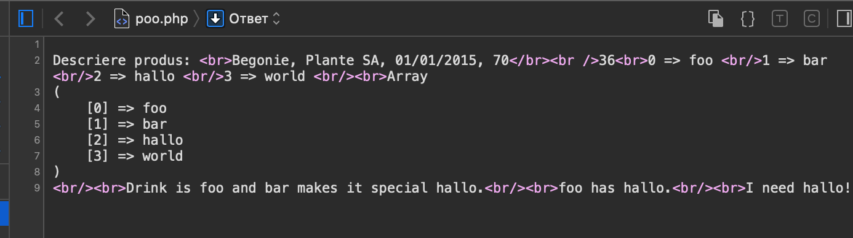

**Exemplul 8 :**

<?php

class a_1

{

public $nume;

private $Private_name;

protected $Protected_name;

public function salutare()

{

echo "<br>".$this->nume."Salut!</br>";

}

public function pocasel($a)

{

$this->nume = $a;

echo "<br>".$this->nume."Pocasel!</br>";

}

}

?>

<!DOCTYPE HTML PUBLIC "-//W3C//DTD HTML 4.01//EN" "http://www.w3.org/TR/html4/strict.dtd"> <HTML>

<HEAD>

<meta http-equiv="Content-Type" content="text/html; charset=utf-8">

<title>CLASA</title>

</head>

<body>

<?php

include_once 'classes/class.a_1.php';

var_dump(include_once 'classes/class.a_1.php');

$config = include_once('classes/class.a_1.php');

var_dump($config);

print_r($config);

$obj=new a_1;

$obj->salutare();

$obj->nume = "Misca";

$obj->salutare();

$obj->pocasel("Chistol");

$obj->salutare();

echo "trece";

?>

</body>

</html>

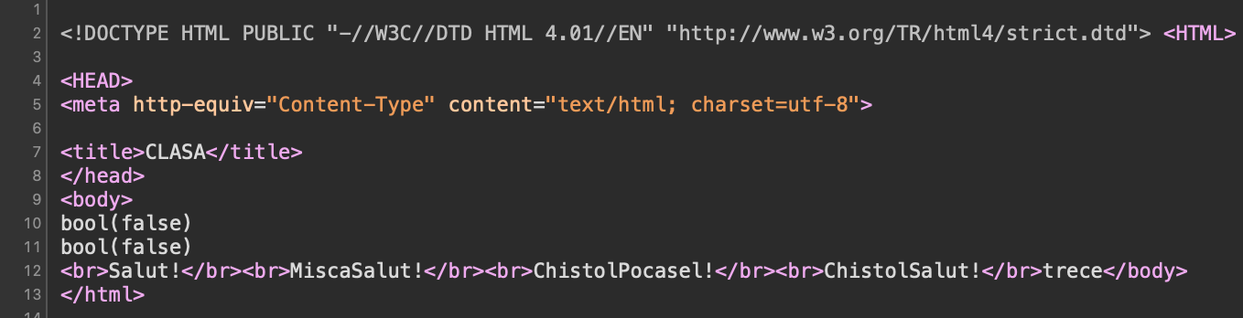

**Exemplul 9 :**

**class.exemplu.php**

<?php

class a_2

{

private $nume;

function __construct($a = "sa vedem cum lucreaza clasa cu constructorul") {

$this->nume = $a;

}

function Salut() {

echo "<h1>".$this->nume."! Salut!</h1>";

}

}

?>

**poo.php**

<?php

include_once "class.exemplu.php";

$obj0 = new a_2();

$obj1 = new a_2("Ionica");

$obj2 = new a_2("Valiusa");

$obj0->Salut();

$obj1->Salut();

$obj2->Salut();

?>

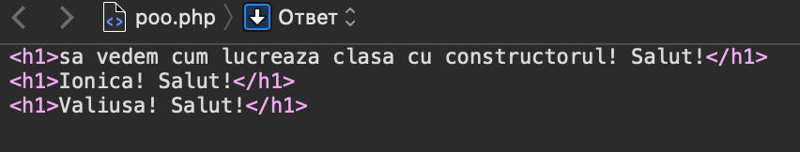

**Exemplul 10 :**

**class.tabel.php**

<?php

class Tabel

{

private $headers = array();

private $data = array();

function __construct($headers)

{

$this->headers = $headers;

}

function addRow($row)

{

$tmp = array();

foreach ($this->headers as $header) {

if (!isset($row[$header])) $row[$header] = "";

$tmp[] = $row[$header];

}

array_push($this->data, $tmp);

}

function output()

{

echo "<PRE><B>";

foreach ($this->headers as $header) echo "$header ";

echo "</B><BR>";

foreach ($this->data as $y) {

foreach ($y as $x) echo "$x ";

echo "<BR>";

}

echo "</PRE>";

}

}

?>

**poo.php**

<html>

<head>

<title>Utilizare clasa Tabel</title>

</head>

<body>

<?php

include_once "class.tabel.php";

$test = new Tabel(array("a", "b", "c"));

$test->addRow(array("a" => 1, "b" => 3, "c" => 2));

$test->addRow(array("b" => 1, "a" => 3));

$test->addRow(array("c" => 1, "b" => 3, "a" => 4));

$test->output();

?>

</body>

</html>

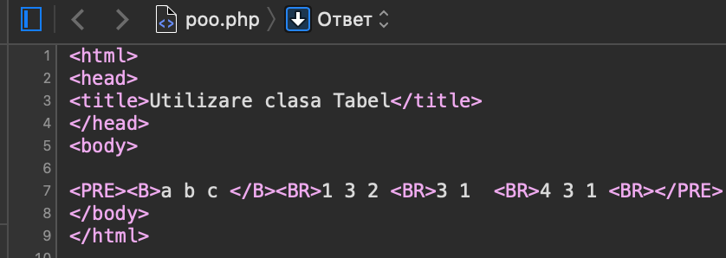

**Exemplul 11 :**

<html>

<head>

<title>CLASE MOSTENITE </title> </head>

<body>

<?php

class a_3

{

public $nume = "Ioana";

function Salutare()

{

echo "<H1>".$this->nume."! Salutare!</H1>";

}

}

class a_4 extends a_3

{

function Salutare()

{

echo "<H1>".$this->nume."! OOOO...Ne-am intilnit!</H1>";

}

}

$obj = new a_4();

$obj->Salutare();

?>

</body>

</html>

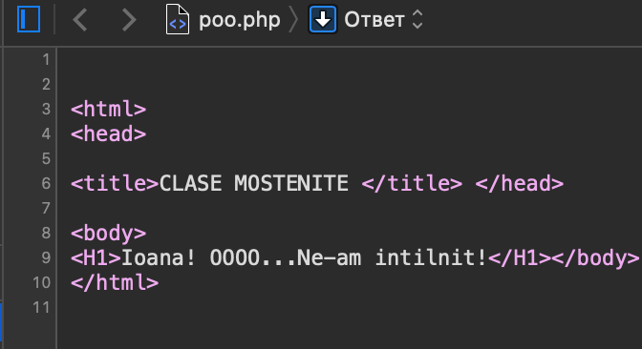

**Exemplul 12 :**

<?php

class Tabele

{

public $headers = array();

public $data = array();

function __construct($headers)

{

$this->headers = $headers;

}

function addRow($row)

{

$tmp = array();

foreach ($this->headers as $header) {

if (!isset($row[$header])) $row[$header] = "";

$tmp[] = $row[$header];

}

array_push($this->data, $tmp);

}

}

class HTMLTabele extends Tabele

{

public $cellpadding = "7";

public $bgcolor;

function __construct($headers, $bg = "#CDCDCD")

{

parent::__construct($headers);

$this->bgcolor = $bg;

}

function setCellpadding($padding)

{

$this->cellpadding = $padding;

}

function output()

{

echo "<table cellpadding='".$this->cellpadding."'><tr>";

foreach ($this->headers as $header) {

echo "<th bgcolor='".$this->bgcolor."'>".$header."</th>";

}

echo "</tr>";

foreach ($this->data as $y) {

echo "<tr>";

foreach ($y as $x) {

echo "<td bgcolor='".$this->bgcolor."'>".$x."</td>";

}

echo "</tr>";

}

echo "</table>";

}

}

?>

<html>

<head>

<title>Clase Tabele si HTMLTabele</title>

</head>

<body>

<?php

$test = new HTMLTabele(array("a","b","c"), "#00FFFF");

$test->setCellpadding(5);

$test->addRow(array("a"=>1,"b"=>3,"c"=>2));

$test->addRow(array("b"=>1,"a"=>3));

$test->addRow(array("c"=>1,"b"=>3,"a"=>4));

$test->output();

?>

</body>

</html>

