********************************************************************************

To run our program we need to have a proper setup on different platforms, since this project is an amalgamation of multiple things.

***PYTHON***

1. For Python
   1. Download python 3.7
   2. Download pycharm
2. Create a new project
   1. Give a suitable project name
   2. Set the interpreter to python 3.7
   3. Choose virtual environment vendor??
   4. Copy the python code in the a new ?? of the project
   5. Go to file-> settings -> project interpreter and add packages “Request and keyboard”

Note: Check whether you have package pip or not

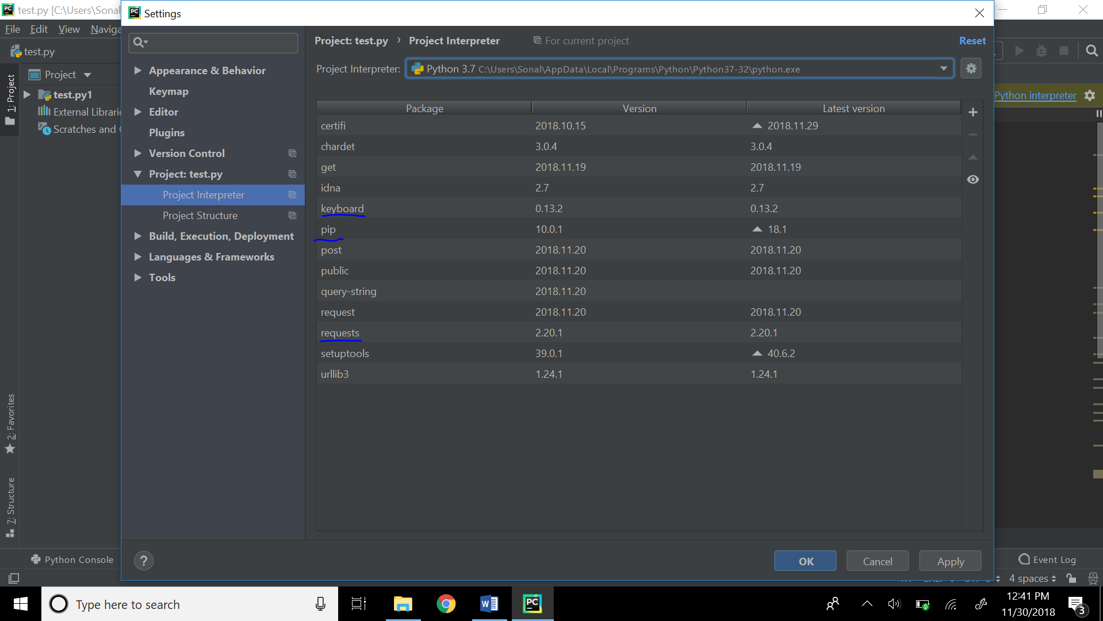

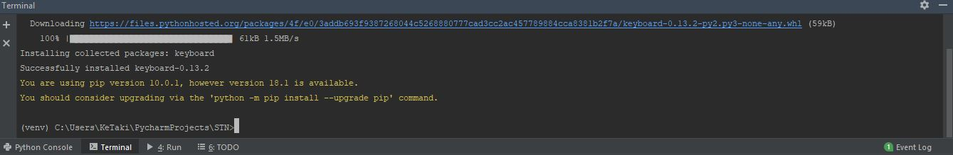

1. Run the python code
2. If you see an error, terminate the code and resume

***Website***

We have already created the website and its going to be active for another 6 months.

But just in case you want to set your own website here are the steps

1. Create an account on 000webhostapp.com
2. You will be assigned a domain name
3. In the htdocs folder copy the index php file
4. Goto database you will see the database id, password copy this and put in the index php to make the php file your own
5. Got to php my admin of your domain
   1. Go to SQL
   2. Type query to create table (attached in the folder)
   3. You will have one table “Action” that will have time phrase and text
   4. Now the website is ready to be deployed

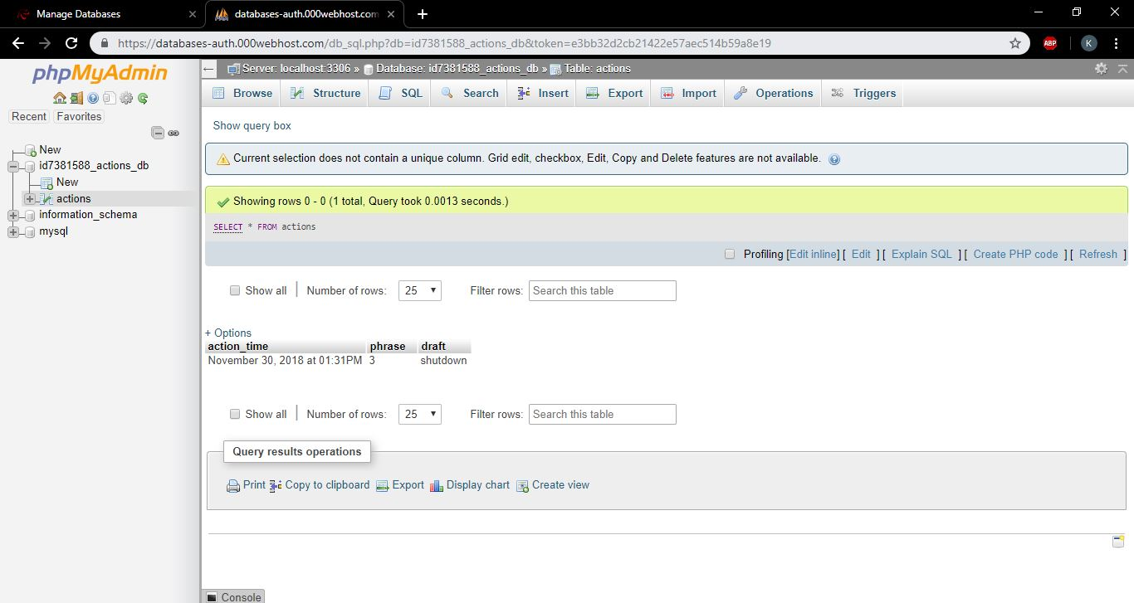

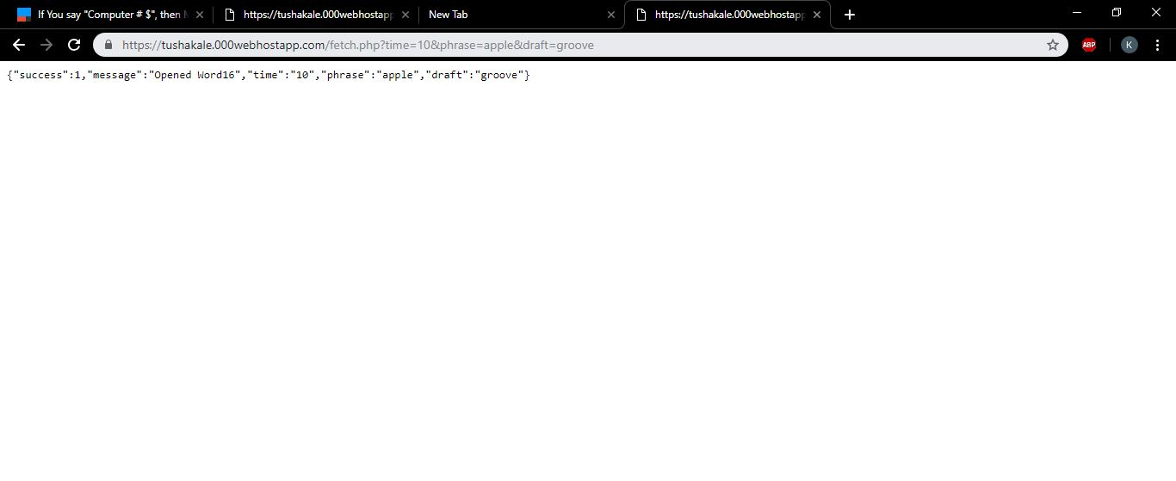

***IFTTT***

You need to create 3 IFTTT applets  
Creation of applet in IFTTT, Task 1 of part 1.  
Step 1: - Choose a service  
Here we choose google assistant   
Step 2: - Choose a trigger (*Say a simple phrase*)  
Here we have chosen a simple text (Open Word). We need to complete the trigger fields Like ways to say the phrase.   
Step 3: - Click on then that, Choose an action service.  
Here we have chosen Webhooks as it is specified in the project description.  
Step 4: - Complete action triggers  
Here we have given an URL that sends a web request  
https://tushakale.000webhostapp.com/index.php?time= {{CreatedAt}}&phrase= {{NumberField}}&draft= {{TextField}}

Or you can use the one you created

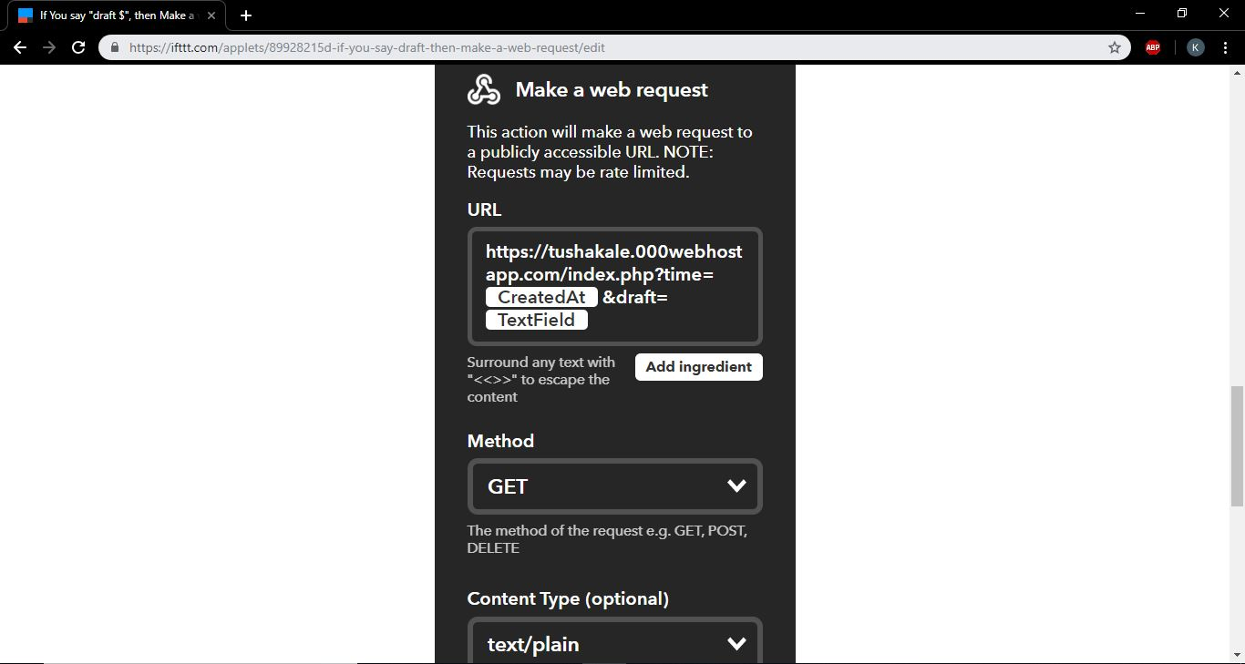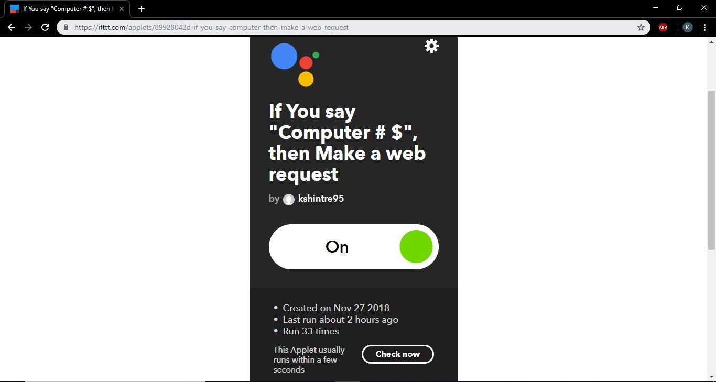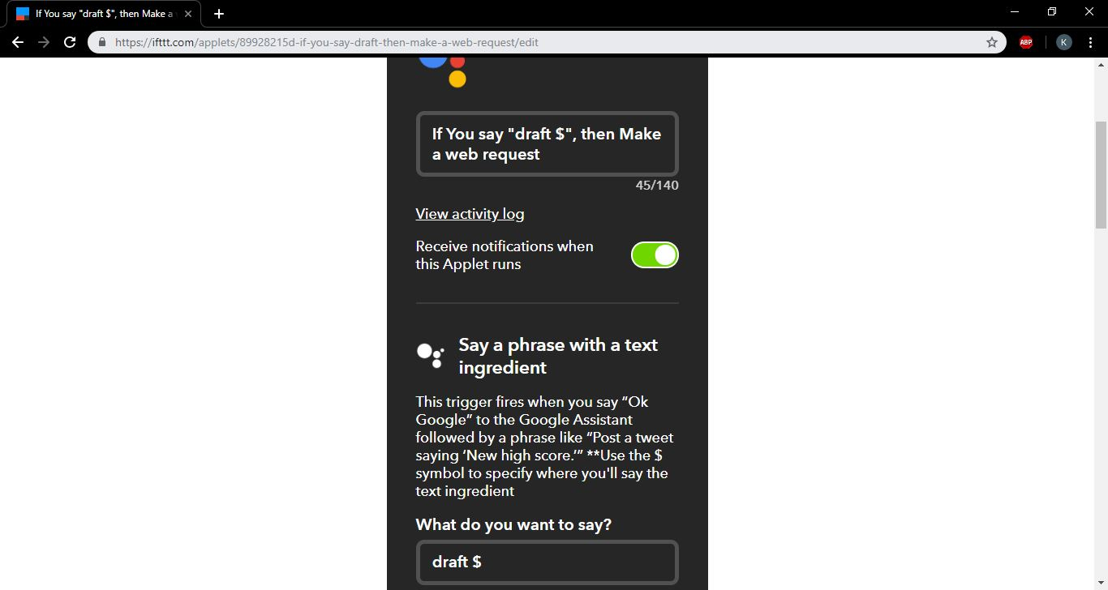

***Dialogflow***

First Login to your Dialogflow account   
Import the IoT_customization Folder  
You can see the our customization

