**Software Version Description (SVD)**

Include the version identifier for the final release of your application.

* We started development with version v0.0.0
* For each feature added, version incremented by 0.1.0
* For each bug fixes and review comment fixes, version incremented by 0.0.1
* Final software – v1.0.0

Include list of issues resolved since prior release (if any)

1. Issues faced on deciding proper naming of files, classes, function and variables. We resolved this issue by referring the **PEP-8 (A style guide for Python).**

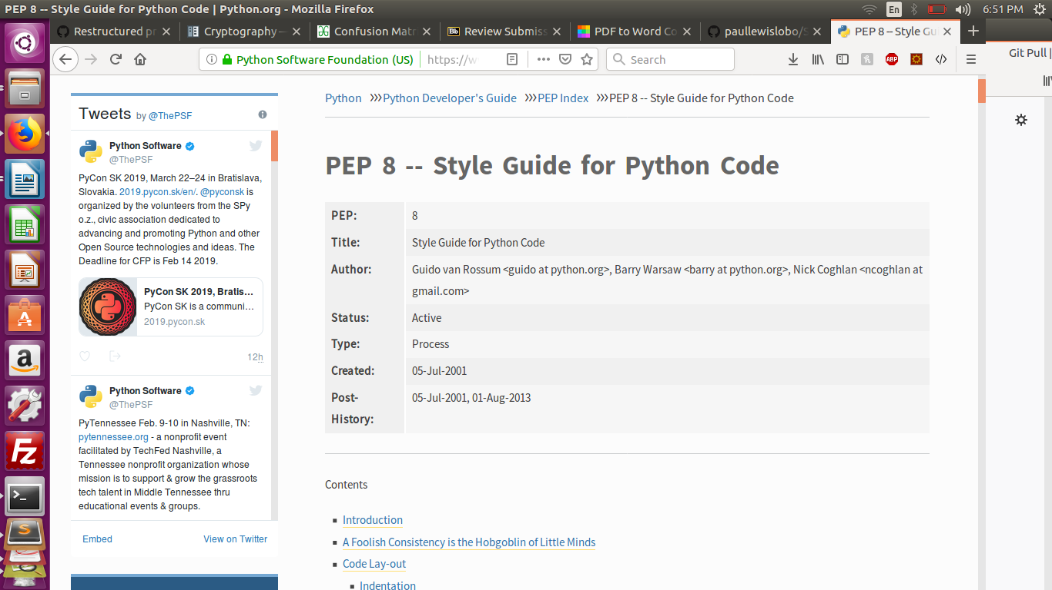

1. 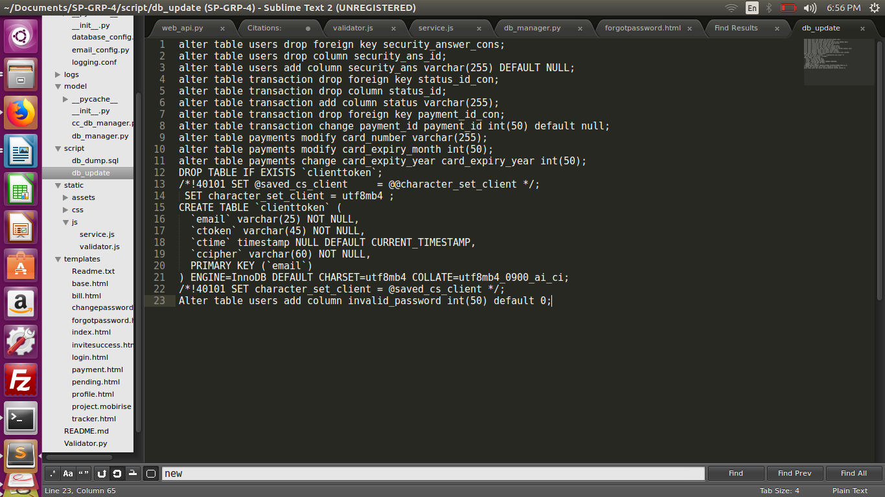Many a times during development, there was need for alterations in database schema and it was difficult to create a new schema every time. So we created a script with all the alteration commands done on db tables, and stored in under scripts folder in the software.
2. Implementation of some features brought dependency of external libraries. So we combined every requirement and documented all dependencies required to successfully run the application, in **README.md** file.

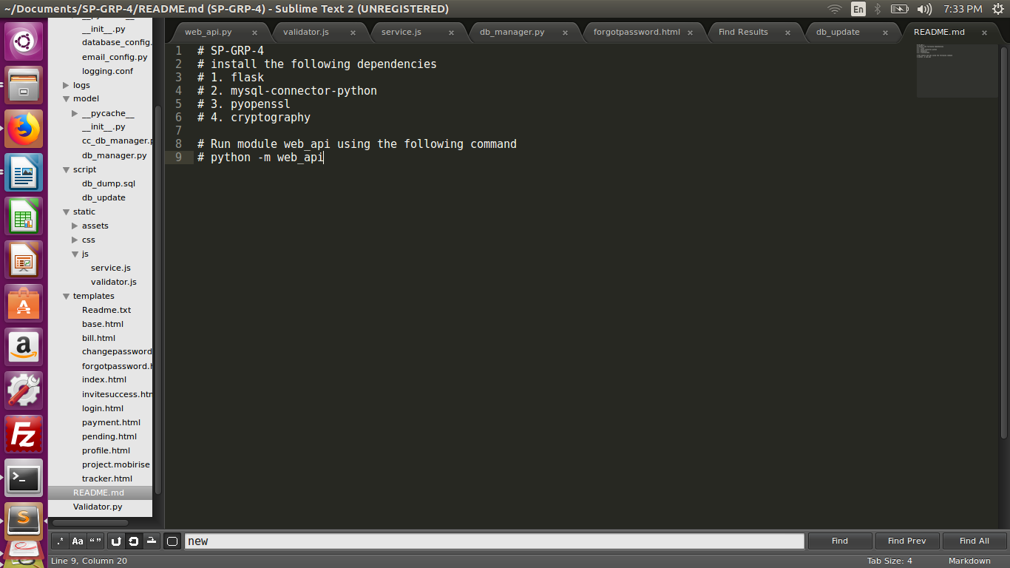

Include list of known issues that weren’t resolved (if any).

1. We couldn’t use domain name for the project, because it was paid.
2. Because of unavailability of domain name, Google Authentication couldn’t be integrated, because it required domain to route back to the application.
3. We planned to host our web application on a server, but since it was paid, and free one’s had so many limitations, so we decided to keep it locally.

List of dependencies:

Compiler Version: Python 3.7

Operating System: No dependency

Package Dependencies:

* Flask v1.0.2
* Secrets v3.6
* mysql-connector-python v8.0.13
* cryptography v1.2.3
* PyOpenSSL 18.0.0

Database Management System: MySQL v14.14

Application Server: None

Web Server: Flask