**Standard Normal Distribution:**

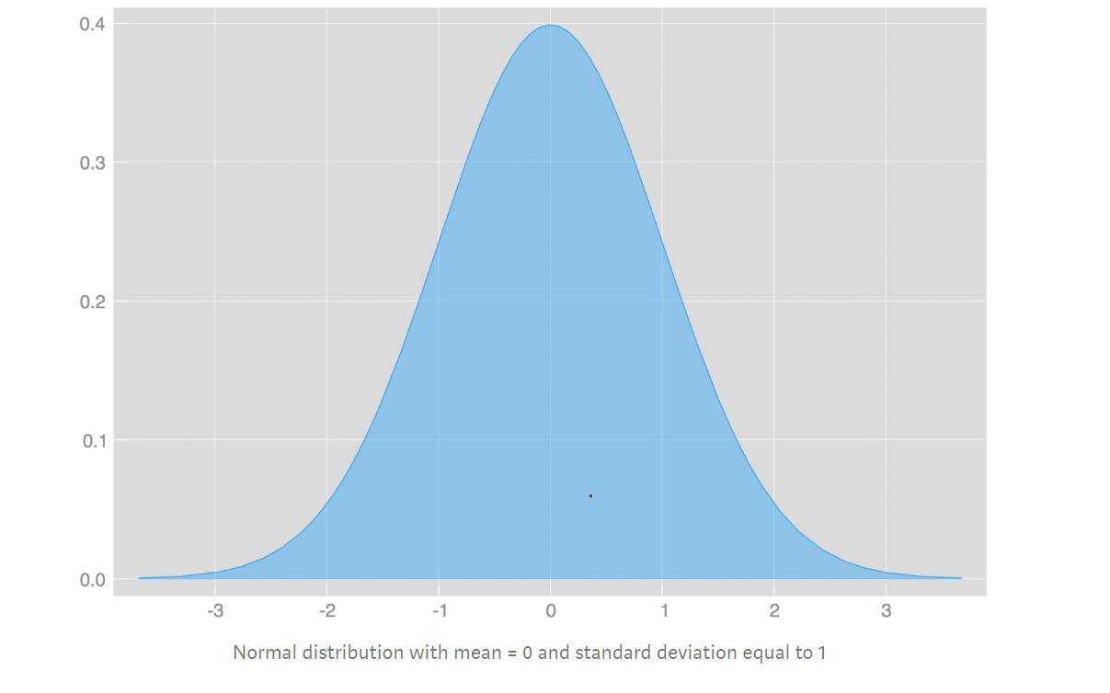Recall that a **random variable**is a variable whose value is the outcome of a random event

A **probability distribution** is a list of all of the possible outcomes of a random variable along with their corresponding probability values.

Sometimes we are concerned with the probabilities of random variables that have continuous outcomes. Examples include the height of an adult picked at random from a population or the amount of time that a taxi driver has to wait before their next job. For these examples, the random variable is better described by a continuous probability distribution. When we use a probability function to describe a continuous probability distribution we call it a **probability density function** (commonly abbreviated as pdf).

**Probability Density Function:**

Histograms (Frequency Distribution) ->

y-axis shows the frequency or count

x-axis shows the variables

As the number of intervals(bins) in the histogram increase, the histogram smoothens to give a bell curve

In a PDF->

Let’s take the example of weight variable of a number of people:

Y-axis: % of distribution( % of the total number of weight values that fall within a bin(or an interval say 60-70)

X-axis: weight values ( generally divided into bins or intervals, 60-70,70-80, etc)

Sum of the area under the curve=1

**Cumulative Density Function( CDF):**

The cumulative distribution function gives you the cumulative probability associated with a function.

 It is a similar concept to a [cumulative frequency table.](https://www.statisticshowto.com/cumulative-frequency-distribution/) With a table, the frequency is the amount of times a particular number or item happens. The cumulative frequency is the total counts up to a certain number:

