# **Topic:** Real-time Age and Gender Prediction from Webcam with Keras and OpenCV

**Project Objective:**

The objective of our project is to predict the age and gender of a person.

Facial analysis has recently garnered a lot of attraction in the computer vision world. The traits of a person's face determine their identification, age, gender emotions, and ethnicity. Security and video surveillance, electronic customer relationship management, biometrics, electronic vending machines, human-computer interface, entertainment, cosmetology, and forensic art are just a few of the real-world applications where age and gender classification might come in handy.

**Information About the Dataset:**

Dataset Link: <https://www.kaggle.com/mariafrenti/age-prediction>

Dataset Link: <https://www.kaggle.com/jangedoo/utkface-new>

 This is a large-scale face dataset with long age span (range from 0 to 116 years old). The dataset consists of over 20,000 face images with annotations of age, gender, and ethnicity.

**Details of the Work and Insights:**

**Model Accuracy**

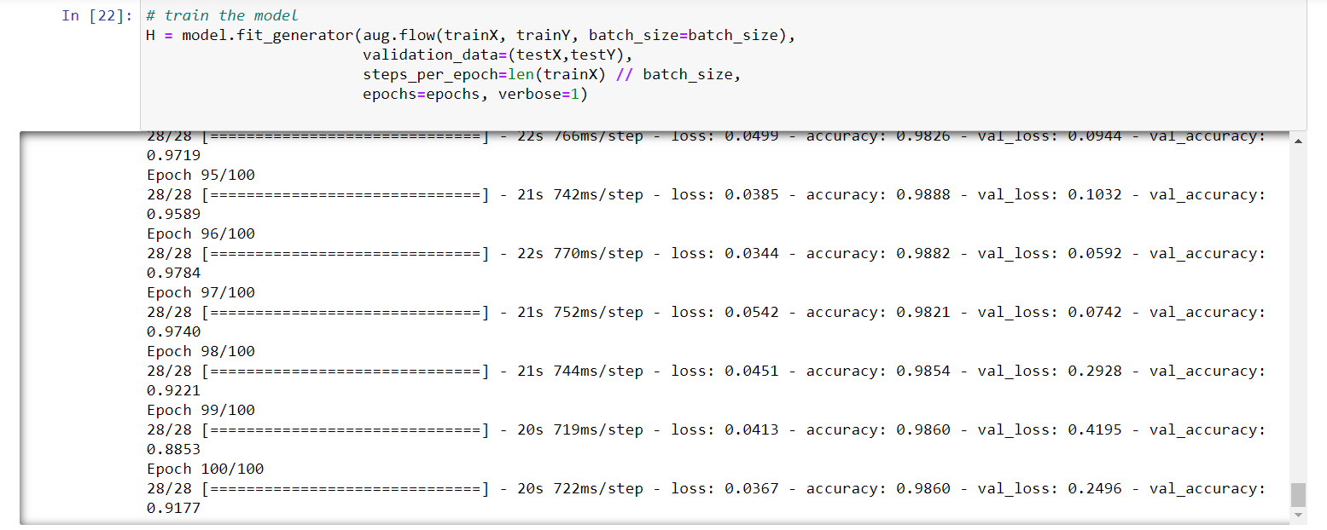

Here, we can see accuracy after 100 epoch is 0.9860.

**Visualization of Model Accuracy and Model Loss**

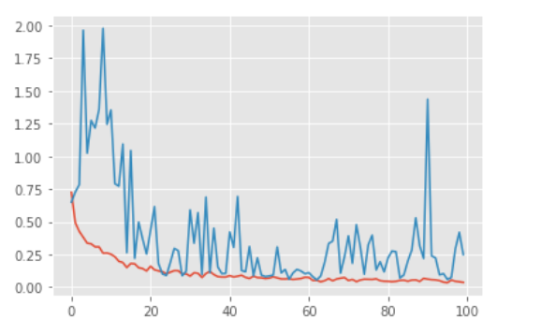

The validation accuracy is around 91.7% and Validation loss is 24.96%. Since the dataset was not unbalanced therefore the predictions of the model are not biased towards any particular class.

**Testing of the Model**

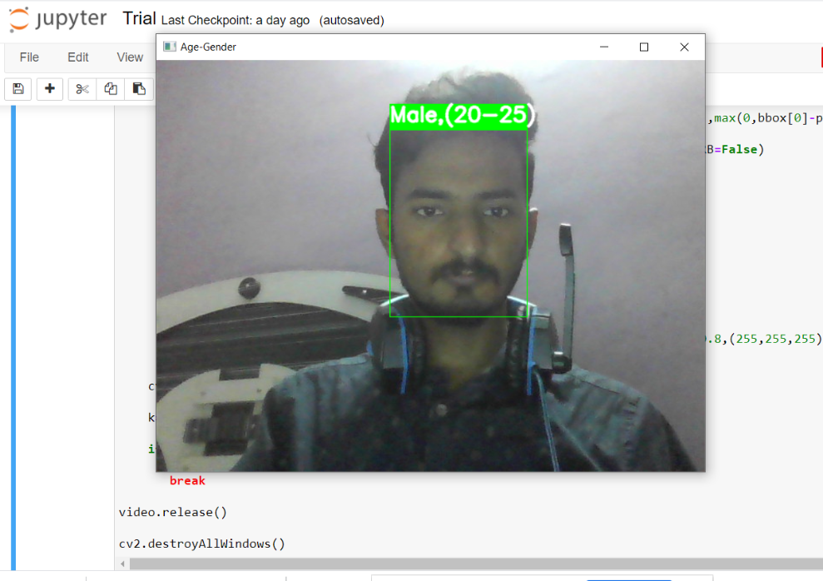

Name: Mohammad Anzar Asif (Through Web-Cam)

Gender: Male

Age: 22 years

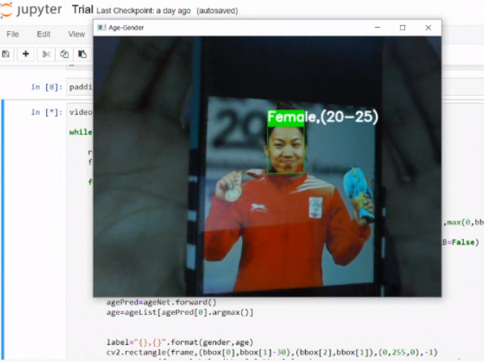

Name: Chanu Saikhom Mirabai(image from mobile)

Gender: Female

Actual Age: 26

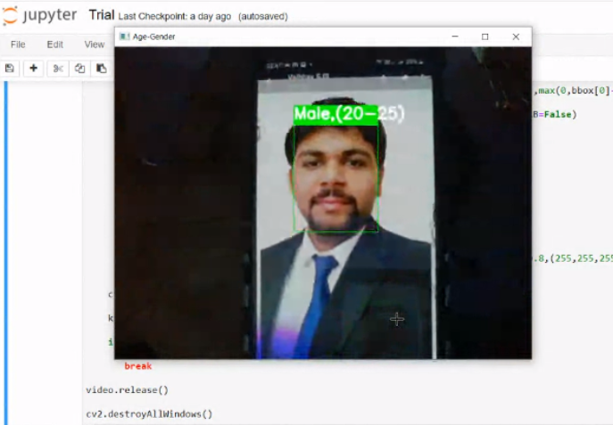

Name: Vaibhav Srivastava (image from mobile)

Gender: Male

Age: 22 years

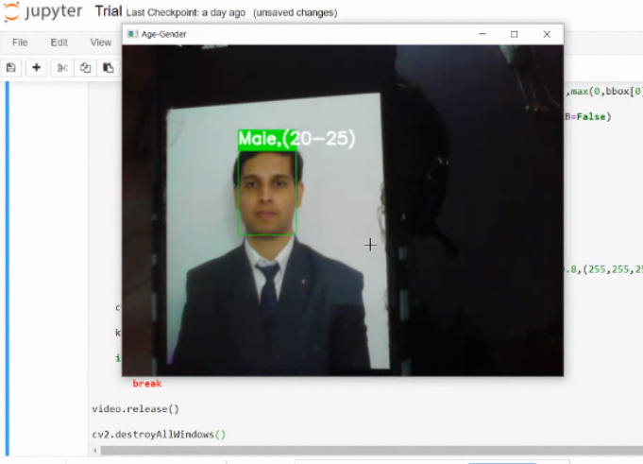

Name: Nikhil Shah (image from mobile)

Gender: Male

Age: 25 years

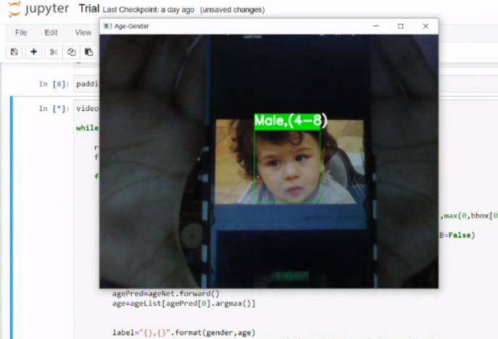

Name: Taimur Ali Khan Pataudi (image from mobile)

Gender: Male

Actual Age: 4 years

**Note:** We have built the CNN model for both Age and Gender Prediction but due to lack of resources and Limited Capabilities of our System, we were not able to deploy the model built for age prediction therefore we have used the pre-Trained model only for Age prediction.