**Mini Project Report on**



**SMOKE DETECTION USING ARDUINO**



**Submitted in partial fulfillment of the requirement for the award of the degree of**

**BACHELOR OF TECHNOLOGY**

**IN**

**COMPUTER SCIENCE & ENGINEERING**

**Submitted by:**

**Student Name University Roll No.**

**Ketan Singh Rautela**  **2018881**

***Under the Mentorship of***

**Dr. Upma Jain**

**Assistant Professor**



**Department of Computer Science and Engineering**

**Graphic Era (Deemed to be University)**

**Dehradun, Uttarakhand**

**January 2023**



**CANDIDATE’S DECLARATION**

I hereby certify that the work which is being presented in the project report entitled **“Smoke detection using Arduino ”** in partial fulfillment of the requirements for the award of the Degree of Bachelor of Technology in Computer Science and Engineeringof the Graphic Era (Deemed to be University), Dehradun shall be carried out by the under the mentorship of **Dr. Upma Jain, Assistant Professor**, Department of Computer Science and Engineering, Graphic Era (Deemed to be University), Dehradun.

Name University Roll no. **signature**

Ketan Singh Rautela 2018881

**Table of Contents**

|  |  |  |
| --- | --- | --- |
| **Chapter No.** | **Description** | **Page No.** |
| Chapter 1 | Introduction | **1-2** |
| Chapter 2 | Literature Survey | **3** |
| Chapter 3 | Methodology | **4-8** |
| Chapter 4 | Result and Discussion | **9-10** |
| Chapter 5 | Conclusion and Future Work | **11** |
|  | References | **12** |

**Chapter 1**

**Introduction**

Air is one of the assets of human existence that can be obtained freely. proper and awful air quality can affect human health and activities. smooth air can cause a person to sense relaxed in a certain area that allows them to do activities nicely and have amusing life. alternatively, terrible air quality because of pollution can truely interfere with lifestyles activities because it is polluted with various sorts of toxic materials originating from natural pollutants, vehicle pollutants, and cigarette smoke pollution which are dangerous to human fitness. Cigarette smoke is one of the air pollutions. inhaling other people's cigarette smoke is more dangerous than smoking your very own cigarette. Even the risks that ought to be borne by way of passive people who smoke are three times that of lively people who smoke. Cigarette smoke is also very damaging to the fitness of sufferers in hospitals, particularly a person suffering from bronchial asthma. For human beings with allergies who experience troubles in their airlines, their asthma can relapse sometimes because of inhaling cigarette smoke. And from preceding studies that talk the detection of cigarette smoke, there are pretty a number of them, which includes a cigarette detection device in a closed room based totally at the net of factors (IoT) . design of a cigarette smoke detection system using an Arduino-primarily based short Message service (SMS) Alert, hearth detection is very crucial for protection of surroundings and safety of human beings. The detection of fireplace and smoke in video is specially relevant in industrial tracking and surveillance used to monitor homes and surroundings as part of an early caution mechanism that reports ideally start of fireplace. Video-based structures can detect out of control fires at an early degree before they develop into catastrophe. The benefit of fireplace detection generation primarily based on video are:

1] detection strategies are very intuitive.

2] fire detection with high real-time has no delay as a result of induction time as transmission and induction is higher than smoke and temperature because of speed of light. three] remote surveillance cameras can be adjusted freely, consequently detection range is larger.

3] technology has higher reliability and real-time performance.

Video fire detection has become has grow to be warm topic for the researcher in the discipline of fireplace detection. Detection strategies based on image information are more powerful than different techniques which use sensor or multisensory wi-fi community structures. hearth detection can improve the accuracy of the fireplace alarm, actual-time and the robustness. fireplace detection era can be divided into exceptional sub-categories based totally on:

1] The purpose flame or smoke detection.

2] The spectral range of the digital camera used.

3] The range of the system. Smoke and hearth detection is hard in particular in open environment along with power plant life, chemical plants as they affect the surrounding area. also video surveillance used in military fields and business programs.

Smoke is the good indicator of fireplace. For early fire detection machine traits of smoke need to think about while dealing with photo information. reaction to surroundings conditions, unsteady nature of smoke, form and semi-transparency are the distinctive traits of the smoke. Texture, rigid movement, coloration, form are the functions of hearth. If the most efficient algorithms may be followed for every part of detecting motion area and extracting fireplace traits, the device performance can be advanced.

**Chapter 2**

**Literature Survey**

There had been many previous studies that discussed smoke detection, there are quite a number of them, such as a cigarette detection machine in a closed room primarily based on the internet of things (IoT). design of a cigarette smoke detection gadget using an Arduino-primarily based short Message provider (SMS) Alert .design of the multiple warning system for detecting cigarette smoke the use of an Arduino based MQ-a hundred thirty five sensor .layout and build an alarm for detection of cigarette smoke and noise within the study room routinely based totally on a microcontroller . design of a smoke detector in a smoking room using an MQ-2 sensor with an Atmega328 microcontroller . Sensor, microcontroller, and IoT based smoke and fireplace detection gadget layout . layout and build a detector and neutralizer of indoor cigarette smoke the usage of the Arduino-based totally PI (Propositional fundamental) technique . design and build a smoke and flame detector for fitness and hearth prevention primarily based on Arduino Uno and GSM Sim900A (Hamdani et al., 2019). As stated detection of hearth is very vital parameter in many fields of business area, forest place, and many others. After many scientific research and have a look at happening the flame detection and smoke detection, a few algorithms are specifically designed for this reason. those algorithms designed until now on fireplace detection via movies are, statistical shade version, spatioTemporal Flame Modelling and Dynamic Texture analysis and now an afternoon’s optical mass waft estimators is getting interest.

**Chapter 3**

**Methodology**

The tools and materials we use in designing a CO2 level detector in a smoke-free room consist of hardware and software, including:

**Hardware**

The hardware used includes:

a. A computer with a minimum specification of Dual Core Ram 2Gb works as a place to run Arduino Applications.

b. Minimum Arduino Uno Microcontroller System is the main minimum board in running the Arduino Uno microcontroller .

c. 16x2 LCD as a tool to display the result of reading the percentage value of CO . gas content

d. Buzzer as a tool to make sound .

e. Relay as regulator On/Off Cooling Fan.

f. MQ2 sensor as a CO . gas detection sensor.

g. Power Supply 9 V as a microcontroller and relay power supply .

**Software**

The software used in this research are:

a. Windows 7 Ultimate 32 Bit: The operating system used to run all the software on the computer.

b. Arduino IDE 1.8.2: a software used in developing microcontroller applications starting from writing source programs, compiling, uploading, and testing terminals.

c. Fritzing 0.9.3b.pc: open-source software that can be used to design electronic circuits.

d. Microsoft Visio 2007: a computer application program used to create diagrams, flowcharts, and network schematics.

e. Proteus 8 Professional: software for PCB design with PSpice simulation at the schematic level.

**System planning**

This design is made to simplify the process of designing a CO2 level detector in a smoke-free room. The series of tools is shown in Figure 1.

The following is a flowchart of the way the CO2 degree detection tool works. In discern 2 there is a series of Flowchart programs for detecting CO2 levels in a smoke-free room wherein this system starts offevolved from the beginning then the supply may be mounted with an MQ2 sensor, a software so one can locate CO2 stages if it is greater than 20% then the fan and alarm will switch on.

**Set of tools**

By using the Fritzing application, the following tool design is obtained, this co2 level detector works based on input from the MQ2 sensor which will read the co2 level, then the HX711 module will process the data, then be notified to NodeMCUESP8266 and controlled by Arduino, which then

Node MCU instructs the fan and buzzer to live.

**Code Used in Arduino Ide is -**

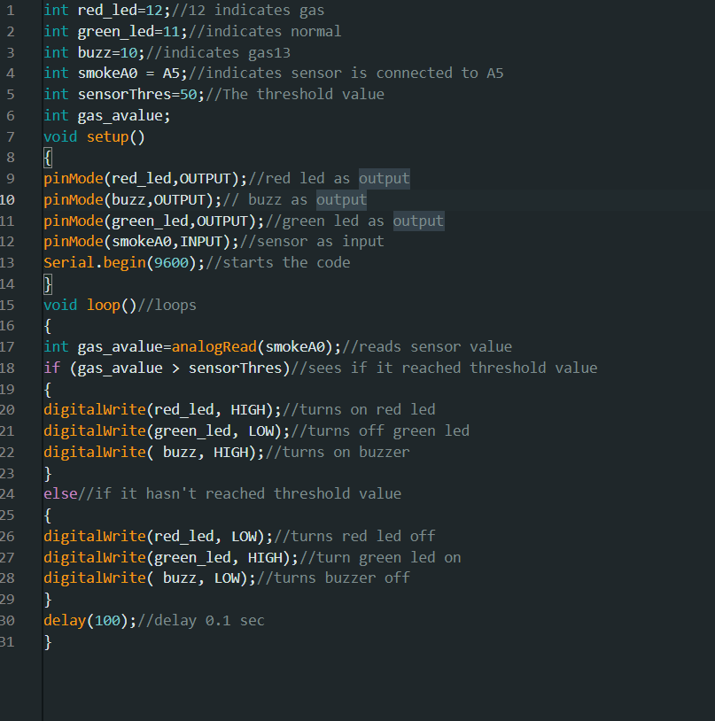

**Chapter 4**

**Result and Discussion**

**Hardware implementation**

Hardware implementation for making prototypes is using one MQ-2 sensor, Arduino Uno, and Cooling Fan, assembled using a beard, for voltage divider using 5V Relay, 5v buzzer, while liquid crystal display to Arduino output to examine the content price as soon as feasible in the check procedure attempt.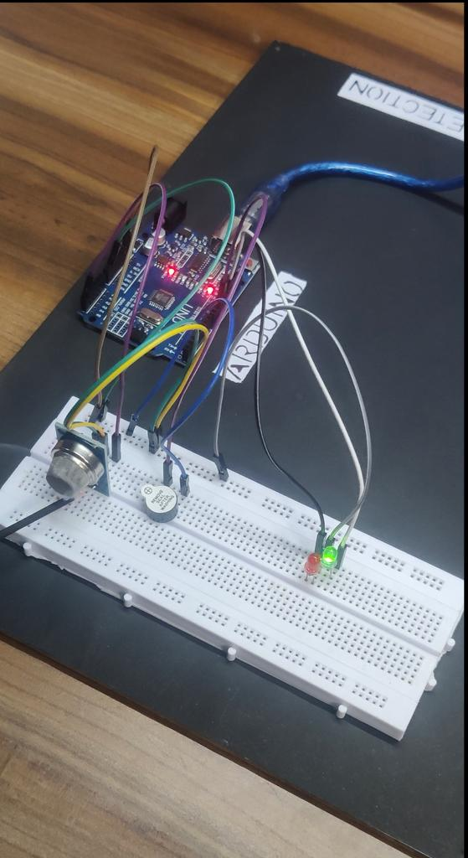

**DISCUSSION**

Trying out the detection and cleansing device of cigarette smoke turned into done at three unique places, namely at Raja coffee, Primer Caffe, and mahajan mai Kantin, and the effects showed that open areas had better CO2 tiers than closed areas because they were clean to stumble on and easy the usage of a colling fan.

**Chapter 5**

**Conclusion and Future Work**

The capability of this smoke detector to detect the presence of cigarette smoke in the air depends on the concentration of smoke, the distance from the source and sensor, and the direction of movement of the smoke. and from the results of tests carried out at three locations, it was explained that a closed room equipped with a colling fan to clean cigarette smoke levels made the room cleaner and reduced co2 levels.

The **Smoke Detector Market** was valued at USD 1.80 billion in 2020 and is **expected** to reach USD 2.90 billion by 2026, at a CAGR of 8.3% over the forecast period 2021 - 2026. ... In a **fire**, **smoke** and deadly gases tend to spread farther and faster than heat, leading to death from inhalation of **smoke** and toxic gases. The proposed system will give the combine result at the output whether smoke and fire is present or not. The system performance can be improved with the use of optimal algorithms for detecting motion area and extracting features of fire. Neural network based outputs from both flame and smoke modules are combined to get a final output with different states as: both smoke and flame are present, fire with smoke but without flame, fire with flame but without smoke and non-fire i.e. no smoke and no flame. The enhanced system will performed well than the existing system in terms of detection rate.

**References**

1. Candra, R. A., Suherman, & Ilham, D. N. (2021). Amplitude range data validation in Internet of Things (IoT) sensor. IOP Conference Series: Earth and Environmental Science, 644(1).

2. Candra, Rudi Arif, Ilham, D. N., Hardisal, H., & Sriwahyuni, S. (2019). Light Control Design by Using Social Media Telegram Applications Based on Internet Of Things (IOT). SinkrOn, 3(2), 200.

3. Hamdani, D., Handayani, E., & Risdianto, E. (2019). Rancang Bangun Alat Pendeteksi Asap Rokok Dan Nyala Api Untuk Penanggulangan Kesehatan Dan Kebakaran Berbasis Arduino Uno Dan GSM SIM900A. Jurnal Ilmu Fisika | Universitas Andalas, 11(1), 37–46. 46.2019

4. Mandarani, P., Ariani, R., Jurusan, D., Informatika, T., Industri, F. T., Jurusan, M., … Nanggalo, K. (2016). Perancangan Sistem Deteksi Asap Rokok Menggunakan Layanan Short Message Service ( Sms ) Alert Berbasis Arduino. Jurnal TEKNOIF, 4(2), 66–75.

5. Ratnasari, I. D. (2018). Rancang Bangun Alarm Deteksi Asap Rokok dan Kebisingan Pada Ruang Kelas Secara Otomatis Berbasis Mikrokontroler. Elinvo (Electronics, Informatics, and Vocational Education), 3(2), 54–60.

6. Utomo, B. T. W., & Saputra, D. S. (2016). Simulasi Sistem Pendeteksi Polusi Ruangan Menggunakan

Sensor Asap Dengan Pemberitahuan Melalui SMS (Short Message Service) Dan Alarm Berbasis

Arduino. Jurnal Ilmiah Teknologi Informasi Asia, 10(1), 56–68.

7. I. Bosch, A. Serrano, and L. Vergara, “Multisensor Network System for Wildfire Detection Using

Infrared Image Processing”, Hindawi Publishing Corporation, the Scientific World Journal, Volume

2013.

8. Martin Mueller, Peter Karasev, Ivan Kolesov, and Allen Tannenbaum, “Optical Flow Estimation for

Flame Detection in Videos”, IEEE Transactions On Image Processing, Vol. 22, No. 7, July 2013.