Pavankumar Bhadane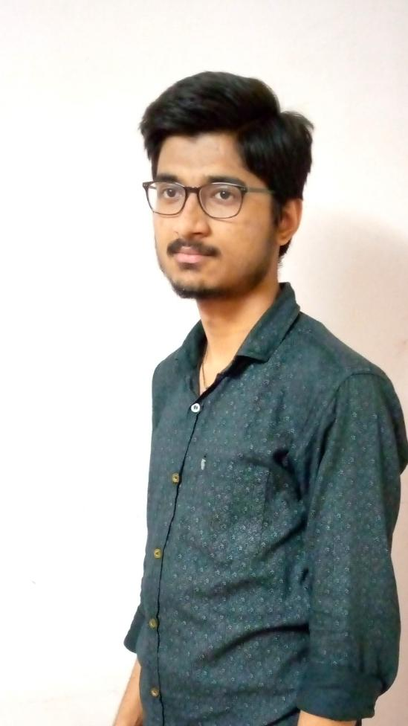

Android Developer

Email: [pavan49719@gmail.com](mailto:pavan49719@gmail.com)   
Mobile: +91 9359875192   
LinkedIn: [pavan-bhadane-033b26205](https://www.linkedin.com/in/pavan-bhadane-033b26205/)  
GitHub: [Pavan49719](https://github.com/Pavan49719)

# SKILLS

* **Proficient:** C/C++,App Development(Flutter), Python.
* **Moderately Experience:** Java.
* **Familiar:** Arduino, REST API.

# **EXPERIENCE**

| Itanta Analytics (Pune, IN) *-  Android developer intern* NOVEMBER 2021 - FEBRUARY 2022  Alert app - alerts and alarms notifications, Graphs for data analytics. Used REST APIs. Integration of FCM (Firebase Cloud Messaging) and Pushy Notification Services. | Winter of Code 2.0 2021 ([WoC 2.0 ‘21](https://gdsc-woc.tech/)) [Certificate](https://drive.google.com/file/d/1ZfDpVslKcaITU_md-sRPXM7MFtzh38EL/view?usp=sharing) (Open Source Program - Contributor) *Organization:* [*Dezenix*](https://dezenix.com/) *Project Name:* [*Native Frontend Flutter*](https://github.com/Dezenix/native-frontend-flutter) DECEMBER 2021 - FEBRUARY 2022 |
| --- | --- |
| HackClub Summer of Code ([HSoC ‘22](https://soc.hackclubrait.co/))  (Open Source Program - Mentor) *Organization:* [*The Robotics Forum*](https://www.vitpunerobotics.com/#/) *Project Name:* [*Flutter UI Templates*](https://github.com/The-Robotics-Forum/flutter-ui-templates) JULY 2022 - AUGUST 2022 |  |

# Achievements

| IEEE Hackathon - National Level Project Competition Rank - 1st Runner Up - [Certificate](https://drive.google.com/file/d/1Sz1kSgX-0EpqGJ3-q9hbseRXoRHBFiJw/view?usp=sharing) Organized by IEEE Pune Section & IEEE IMS Student Chapter, Pune 3rd June 2022 | WCE Hackathon - National Level Hackathon Rank - 2st Runner Up  Organized by Walchand college of engineering & FinIQ company 27th June 2022 |
| --- | --- |
| Internal SIH - Smart India Hackathon Organized by VIT Pune 26th March 2022  SIH 2022 Finalist (Selected) August 2022 |  |

# PROJECTS

| Smart Application For Enhancing Dairy SAFED - सफेद[*Github*](https://github.com/Pavan49719/safed)Tech Stack *- Flutter, Dart, Blockchain, Firebase.*   * QR Code based tracking of the Milk Supply Chain (MSC) * Decentralized storage of the records * A single platform for all the dairy farmers, collectors, processors and milk importers | Bluetooth PC controller app *-* [*Github*](https://github.com/Pavan49719/bluetooth-pc-controller-app)Tech Stack *- Flutter, Dart, Java, Robot Library, Serial Port Protocol RFCOMM*   * A cross platform app which integrates computer peripherals such as keyboard and mouse with the phone by using Bluetooth technology. * Gyroscope feature to enhance user gaming experience. |
| --- | --- |
| Safety Assistant - IoT & Application interface[*Github*](https://github.com/Pavan49719/safed)Tech Stack *- ESP32, MPU6050, MQ2, IR Sensor and Flutter, Web-sockets*  * A safety assistant and post accident assistant application * Integration of IoT device and App using web-sockets * Sends live location to ambulance & police automatically. |  |

# **EDUCATION**

| Vishwakarma Institute of Technology, Pune *B-Tech Computer Engineering* Third Year  CGPA: 9.15 | Bharat English School, Shivajinagar, Pune  *HSC Maharashtra State Board* FEB - 2020  Percentage: 89.8 % Mathematics: 100 |
| --- | --- |
| Baburaoji Gholap School, Pune  *SSC Maharashtra State Board* 2018  Percentage: 91.20 % Mathematics: 98 |  |

# CO-CURRICULAR

* Sponsorship Admin at The Robotics Forum (TRF) VIT Pune.
* Co-ordinator at Computer Society of India (CSI) VIT Pune.
* Flutter Developer at The Robotics Forum (TRF) VIT Pune.  
  (A club focused on researching in software domains like Computer Vision, ML/AI, Cybersecurity and AR/VR and development)
* Android Developer at Developer Student Club Google (DSC).