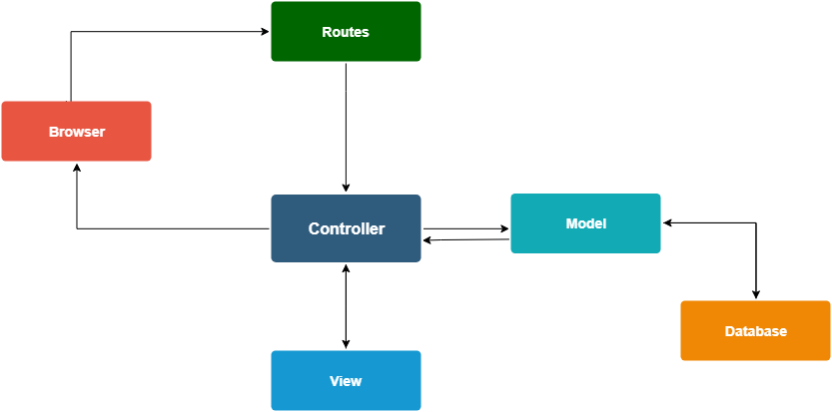
Controllers

profesorController.php
studentController.php

Models

taskModel
loginModel
userModel
profesorModel
studentModel
postModel
themeModel

Views

cards.html
form.html
index.html
login.html
signUp.html
progress.html
search.html
settings.html
user.html
view-profs.html

