|  |
| --- |
| Tata Capital |
| Scope of Work |
|  |

BY



@Applied Cloud Computing Private Limited

|  |  |  |  |  |  |
| --- | --- | --- | --- | --- | --- |
| **Version** | **Date** | **Author** | **Description** | **Type** | **Requester Name** |
| 1 | 11-10-2023 | Ajay Badhe | Scope of Work | - | Anurag Srivastava |

**Table of Contents**

**Project Overview 3**

**Executive summary 3**

**Business Requirement 3**

**Pain Points in the current State 3**

**Project Success Criteria or Future State 4**

**Dependencies 4**

**In-scope 5**

**Out of Scope 6**

**ARCHITECTURAL DIAGRAM 6**

**RACI Matrix 7**

**Project Execution / summary of milestones & DELIVERABLE 8**

**ACC COSTING 9**

**TERMS & CONDITIONS 9**

# **Project Overview**

## **Executive summary**

This business requirements document has been prepared for Tata Capital for Developing a Summarization Bot for Legal Reports on Mortgage Loans utilizing ChatGPT and Generative Artificial Intelligence technology. This document is intended for our clients and internal stakeholders.

## **Business Requirement**

Overview of Requirement:

* The aim is to develop an advanced AI-powered summarization bot for Tata Capital's mortgage loan division. This bot, utilizing ChatGPT technology, must condense complex legal reports submitted by lawyers or legal agencies.
* Additionally, it should efficiently address inquiries from credit managers, offering precise responses related to both the submitted reports and property details.
* The objective is to enhance the efficiency of the mortgage loan division by providing swift and accurate information retrieval, saving time and decision-making process for credit managers.

## **Pain Points in the current State**

Credit Managers have to often deal with extensive legal reports and documents related to mortgage loans. Mistakes or discrepancies in the provided data can lead to erroneous decisions, potentially resulting in financial losses for the institution. Coordinating with lawyers and legal agencies to clarify aspects of legal reports can be challenging. Delays in communication hinder the resolution of uncertainties, impacting the entire process. Addressing these and many more pain points through the implementation of an AI powered summarization bot using ChatGPT can significantly streamline communication, enhance data accuracy, and alleviate the challenges faced by both credit managers and lawyers/Legal Agencies.

## **Project Success Criteria or Future State**

* The Chatbot leverages OpenAI's LLM (Large Language Model) to extract and interpret data from Legal Reports.
* By applying this data to OpenAI, the Chatbot can answer questions related to the extracted information. This process allows for efficient retrieval of property-related details, enabling users to obtain accurate and timely information through natural language queries
* Integration of the solution with the Customer PI data which is securely stored on servers located within Indian Demography.
* Seamless deployment of the solution scope within the Tata Capital Domain with LDAP Integration.
* The bot accurately summarizes legal reports related to mortgage loans and provides a simple interface enabling credit managers to interact and receive summarized information.
* Regular testing and evaluation for continuous improvement based on user feedback.
* The solution generates report-specific prompts reflecting information within the legal report and concise summaries of legal reports entered into the system.
* The solution undergoes iterative training sessions, ensuring continuous learning and adaptation.

## **Dependencies**

‘Tata Capital’ will approve requirements at various stages:

1. Approval for Scope of work
2. Approval for Business Requirement Document
3. Approval for Designs
4. Approval for UAT Sign-Off
5. Go-Live Plan
6. Go-Live Sign-off
7. Azure/AWS account creds
8. Report format and samples.
9. Server Access for Customer PI Data
10. All the predefined Prompts for Credit Managers.
11. Training frequency for the BOT (Monthly or Weekly)
12. Encumbrance Certificate Format
13. Questions/Criteria for Lawyers or Legal Team while uploading the Report
14. Number of files that will be uploaded - Single or Multiple?
15. Naming convention for the files that are to be uploaded

## **In-scope : Proposed Solution**

The solution is intended to assist Credit Managers and Legal Teams at TATA CAPITAL LIMITED in summarizing reports, managing questions and answers, and performing other tasks. The product's user interface will cater to three distinct roles:

* Admin Access :
  + Admin access refers to the level of privileges and permissions granted to a user within a system, application, or network, allowing them to manage and control all aspects of the system
  + Implement secure user authentication mechanisms to ensure that only authorized lawyers and legal team members can access the report uploading interface.
  + Role-based access control, allowing different levels of access and functionalities based on the user's role within the legal team.
* Credit Managers :
  + Limited access for credit managers ensures that they have sufficient privileges to search within the system.
  + The Credit Managers can only search for and access information relevant to their reports, demography and requirements.
* Lawyers or Legal Team :
  + Limited access for lawyers ensures that their permissions are restricted within the system. Their access is specifically tailored based on their need to upload and interact with reports.
  + This limited access ensures that lawyers can only perform actions related to their role, such as uploading reports as per role assigned and interacting with the specific functionalities required for their tasks.

Interface for **Credit Managers** :

* The Login Interface will be integrated with the Tata Capital environment.
* This section will provide an Intuitive and user-friendly interface where credit managers can input their search queries and prompts. Incorporating search functionalities, allowing credit managers to search for specific legal reports or summaries based on keywords, dates, or report names.
* The resultant output will be visible to Credit Mangers as per the search keywords entered.
* Store history of summarized reports, allowing credit managers to access past summaries for reference and version control for reports, enabling credit managers to track changes and updates made by the bot.

Interface for **Lawyers or Legal Team** :

* This section will provide an interface where lawyers and legal team members can upload legal reports, documents, and related files securely.
* Drag-and-drop or file selection features for convenient report uploading.
* Include fields for adding metadata and relevant tags to uploaded reports, such as case number, customer name, application number, Web-top ID, report type, and date.
* Implement version control features to track changes made to uploaded reports, ensuring a detailed revision history. Allow lawyers to view previous versions of reports and restore specific versions if needed.
* Support various file formats for report uploads, including PDF, Word, Excel, and image files. Implementing document conversion features to ensure compatibility with the required formats.
* Provide visual indicators and progress bars to show the status of report uploads, ensuring transparency for users. Implement notifications or email alerts to inform lawyers about the successful upload of their reports or any issues encountered during the process.
* Implement validation checks to ensure that uploaded reports meet the required criteria, such as file size limitations and format specifications. Provide informative error messages and suggestions for correcting issues if a report upload fails.

## **Out of Scope**

Any changes requested on Ad- hoc basis apart from the solution described in this document will be considered out of scope.

**ARCHITECTURAL DIAGRAM**

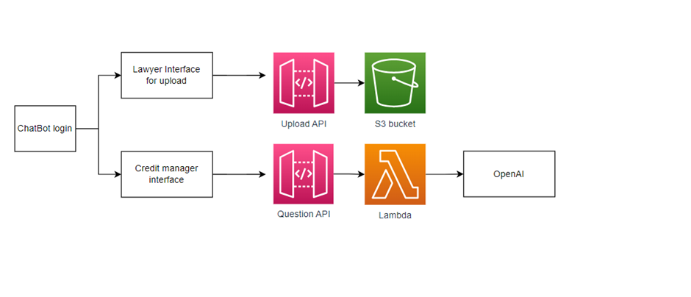

**Note** : The technical architectural diagram is designed with the assumption that AWS services will be utilized. If different cloud services are chosen, the technical architecture will need to be modified accordingly.

The initial interface of the Chatbot will have a login system. Upon logging in, there will be two different user roles: a lawyer and a credit manager. The lawyer, in addition to the standard features, will have the capability to upload PDF files. To facilitate this, an API will be implemented, enabling the upload of files to an S3 bucket.

Once the PDF file has been uploaded to the S3 bucket, the second interface will be accessible to the credit manager. The credit manager will be able to ask questions related to the data. The system will utilize an API to transmit these questions to a Lambda function, which will be triggered upon API invocation. The Lambda function will then extract the necessary data from the PDF and apply the data and the question to Open-AI.

OpenAI will process the provided data and question and generate a response. This response will be sent back to the API, which will then present it to the credit manager.

# **RACI Matrix**

|  |  |  |  |  |
| --- | --- | --- | --- | --- |
| **Tasks/Activities** | **Responsible** | **Accountable** | **Consulted** | **Informed** |
| Project initiation & Kick-off | Partner | CUSTOMER | AWS | CUSTOMER |
| Discovery | Partner | Partner | AWS/CUSTOMER | AWS/CUSTOMER |
| Design | Partner | Partner | AWS/CUSTOMER | AWS/CUSTOMER |
| Implementation | Partner | Partner | AWS/CUSTOMER | AWS/CUSTOMER |
| Code Build | Partner | Partner | AWS/CUSTOMER | AWS/CUSTOMER |
| Code Review | CUSTOMER | CUSTOMER | AWS | AWS |
| Validation | Partner | CUSTOMER | Partner | AWS |
| Sign-off | CUSTOMER | CUSTOMER | AWS/Partner | AWS/Partner |

# **Project Execution / summary of milestones & DELIVERABLE**

|  |  |  |  |
| --- | --- | --- | --- |
| **Project Phase** | **Est. Completion Date** | **Milestones** | **Deliverable** |
| Foundation Phase | (2 Weeks) | * General team introduction and understanding of roles and responsibilities * Escalation points, Communication plan, Risks and issue reporting mechanism * Project Kick-off * Completion & Sign-off for documents - SOW & Design Wireframe * Setup required infrastructure with security best practices * Configure required cloud services and components for development and execution * Access to operational source systems of the data and sample data encryption & compliance needs * Architecture definition and Walk-through * Finalize Design of Portal | * Project Plan * Kick off Deck * Development environment running with proper access to all members. * Approved Architecture diagram |
| Development Phase | (9 Weeks) | * Understand the requirements and procedures that are in scope * Develop scripts on the preferred tech stack * Implement portal on the preferred tech stack * Perform unit testing on the preferred tech stack * Sign off from Customer | * Source code and related artifacts * Performance bench-marking for the UAT runs. |
| Testing Phase | (2 Weeks) | * Optimization of the Architecture * Security Implementations * Testing Documentations | * Standard Operating Procedure |

# **Resources**

|  |  |
| --- | --- |
| **Resources** | **Count** |
| Project Manager | 1 |
| BA | 1 |
| Gen AI Specialist | 1 |
| Python Back-end Engineer | 1 |
| React UI Engineer | 1 |
| Cloud Engineer | 1 |
| QA | 1 |

# **ACC COSTING**

|  |  |  |
| --- | --- | --- |
| **One Time Implementation** | **Currency** | **Amount** |
| AI Powered Summarization BOT | INR | 30,00,000/- |

**Note:** Pricing can go higher or lower depending on the scope being added or removed for the current

SOW.

**Payment Terms:**

50% - Advance

25% - at the time on UAT

15% - After successful Testing

10% - After Go Live

# **TERMS & CONDITIONS**

• No-Hire Provision.

• Use of AWS Services is Subject to AWS Customer Agreement as displayed on AWS Website.

• Customer agrees to be a marketing reference for AWS and ACC respectively in the form of an

Online Logo, Case Study and Video Testimonial.

• Customers will be responsible for AWS Services consumption and will be making payments for

the same to AWS directly.

• ACC will not be liable if there are any delays on deliverables from the Client or any Third-Party

Vendor.

• Maintaining Project timelines is of paramount importance; it is advice that the client will support

and provision ACC with the list of prerequisites and Dependability called out in the SOW. Any

delay caused by the client to provision the dependability or prerequisites might have an added

effect to the costing