Problem statement: -we have to create a chatbot in which lawyer will upload the pdf files of property documents and then credit manager will ask the questions based on those property or all summarize info of property tree structure

there will be two interfaces first for lawyer and second for credit manager

Solution: -

First way: - First Api which will upload file to s3 and then second Api which will take question but the problem is for each question every time it will search it in all pdfs so it will take time for response

Upload API

S3

Lawyer Interface

lambda

OpenAI

Question API

Credit manager interface

Second way: - First API uploads files to s3 and then lambda will run and details of each pdf will get stored in DB and there will be some unique field of property and then using that unique field credit manager will ask the question and lambda will extract the data from DB and then paste it on OpenAI

Upload API

Lambda

DB

S3

Lawyer Interface

Lambda

(Extract the data from DB and paste it on OpenAI)

OpenAI

Question API  
using Unique Filed

Credit manager interface

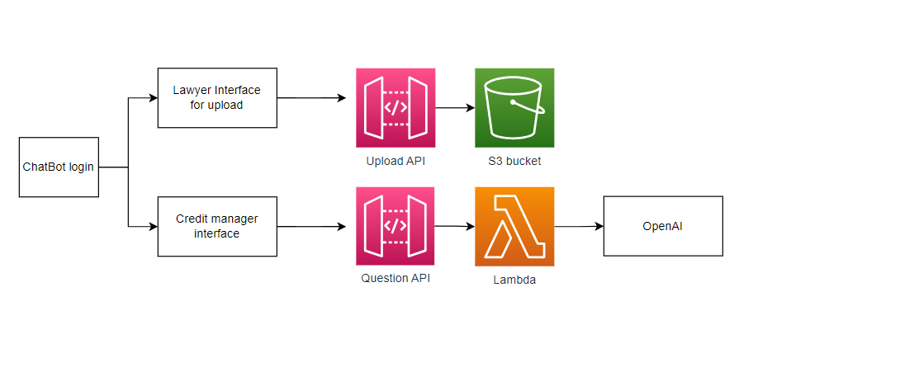

The initial interface of the chatbot will have a login system. Upon logging in, there will be two different user roles: a lawyer and a credit manager. The lawyer, in addition to the standard features, will have the capability to upload PDF files. To facilitate this, an API will be implemented, enabling the upload of files to an S3 bucket.

Once the PDF file has been uploaded to the S3 bucket, the second interface will be accessible to the credit manager. The credit manager will be able to ask questions related to the data. The system will utilize an API to transmit these questions to a Lambda function, which will be triggered upon API invocation. The Lambda function will then extract the necessary data from the PDF and apply the data and the question to OpenAI.

OpenAI will process the provided data and question and generate a response. This response will be sent back to the API, which will then present it to the credit manager.

SQL LIte

login

Flask Post APi

OpenAI