We were able to identify 148 outlier in capital gain attribute. All 148 data points had capital gain of 99,999. Since next largest capital gain is 41,310 with no large gaps in values till zero we can confirm all 148 data points as outliers. For next steps of data processing we dropped all 148 rows of data.
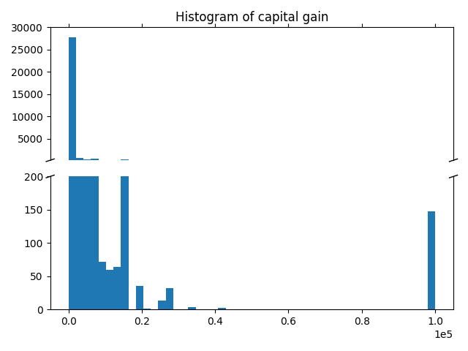

In original dataset there is five continuous and one ordinal attributes. Looking at normalized density distribution of attribute final weight, it is apparent that density distribution is not affected by classification attribute we aim to predict. This means that we can disregard this attribute.
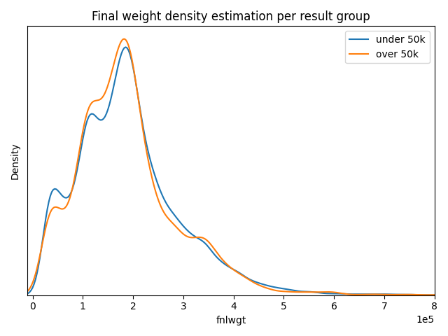

Moving on to next continuous attribute, capital gain and capital loss are both non-negative integers. Since we can represent capital loss as negative capital gain, we can join these two attribute which can take negative values. Interesting thing to note about capital gain is that most people do not have capital gain or capital loss. This can be clearly seen in mode of capital gain or histogram of capital gain.
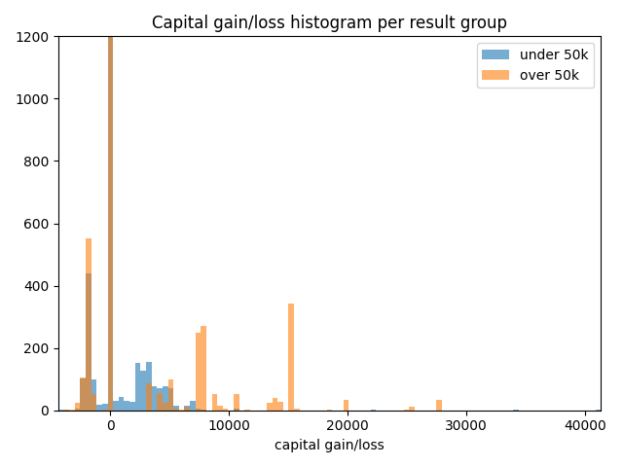
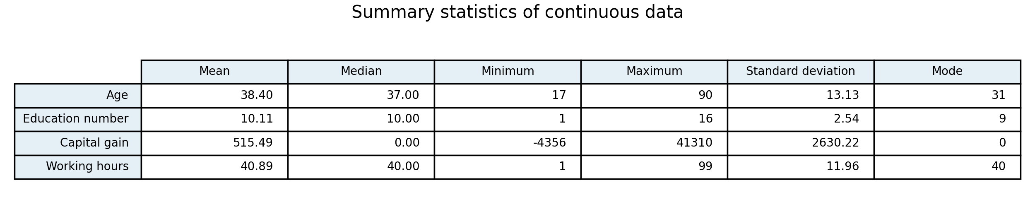

As for age attribute, it can be noted that people who earn more, tend to be older as seen in figure.
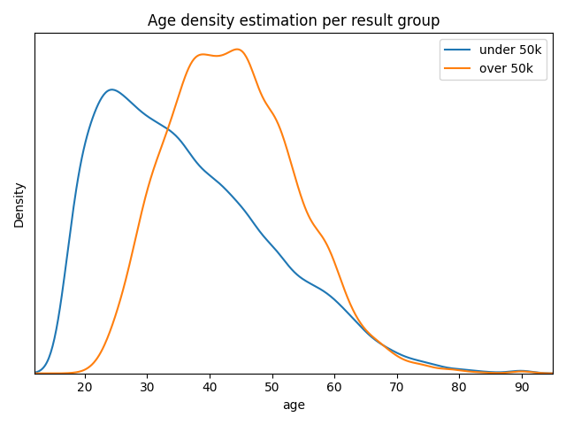

Attribute working hours per week, also shows positive correlation between earnings and work hours as seen in figure X.
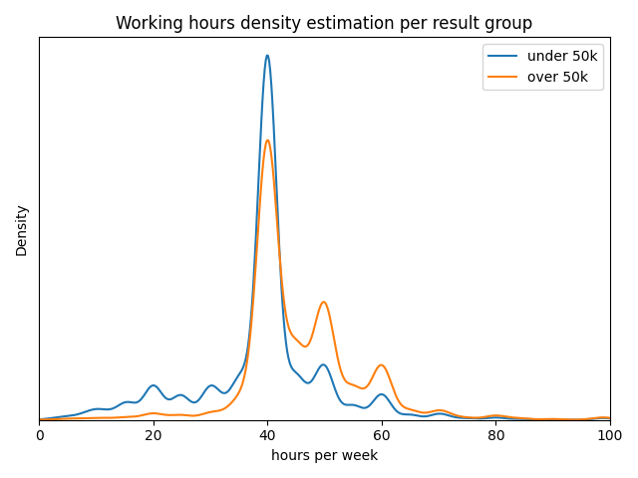

Last numerical attribute, education number, also shows positive correlation towards higher salaries.
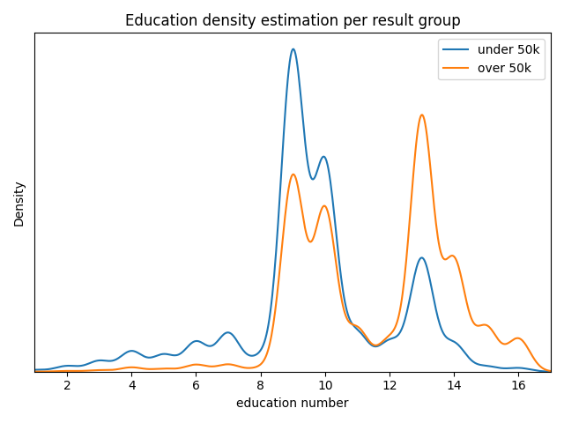
Dataset contains another seven nominal attributes: sex, native country, race, workclass, occupation, marital status, relationship.

Sex attribute shows us, that females are under presented in dataset, and also that higher ratio of males have higher salaries.
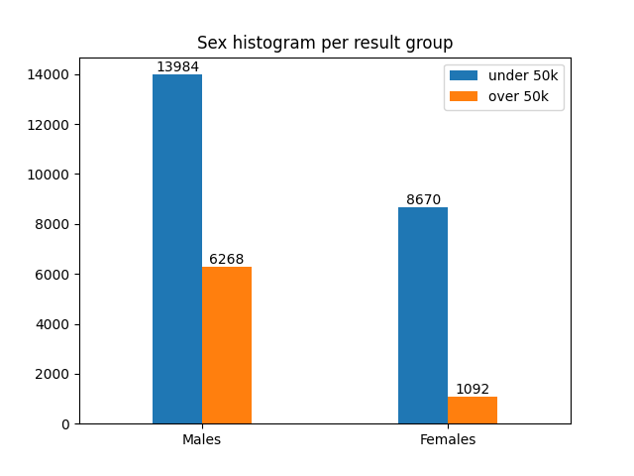

Native country contains ten unique values. Problem is that United-States represents approximately 90% of data points as seen in figure X.
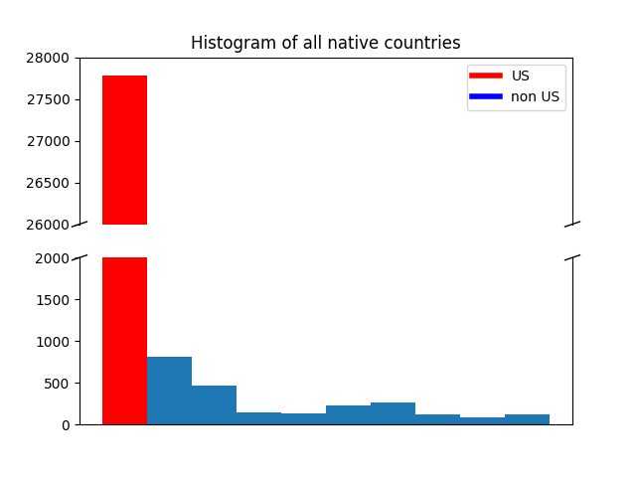

Since all other country other than US contains small number of observations, we decided to aggregate all other countries to one category.

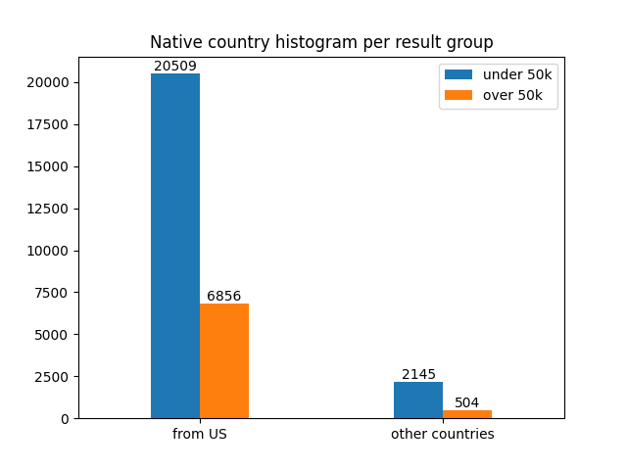

Race attribute contains five unique values:
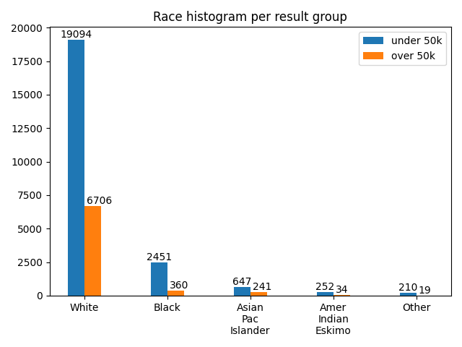

Work class contains seven unique values:
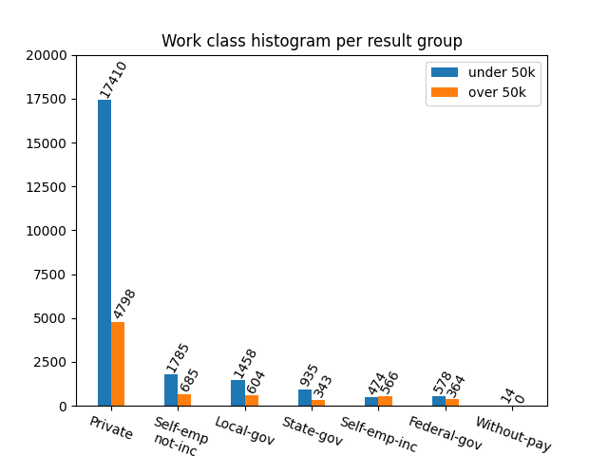

Occupation has by for most categories, 14:
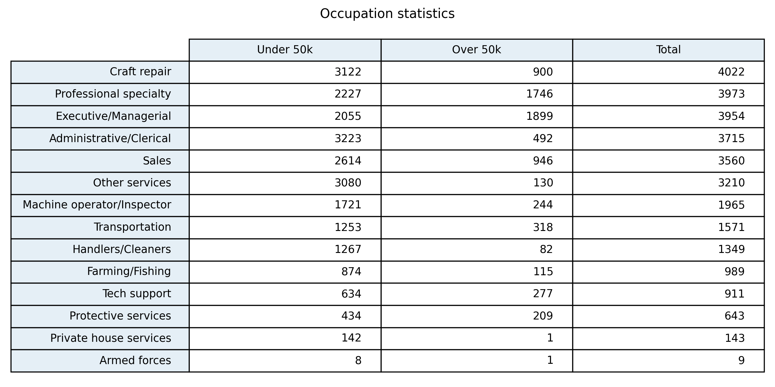
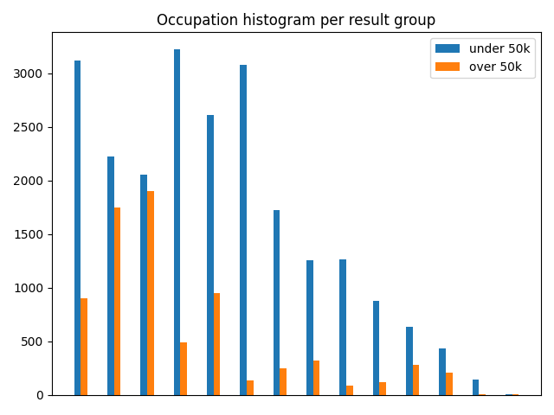

From figure X we can see that two best paid occupations are professional specialty, executives and managers.

Marital status contains seven unique attributes:
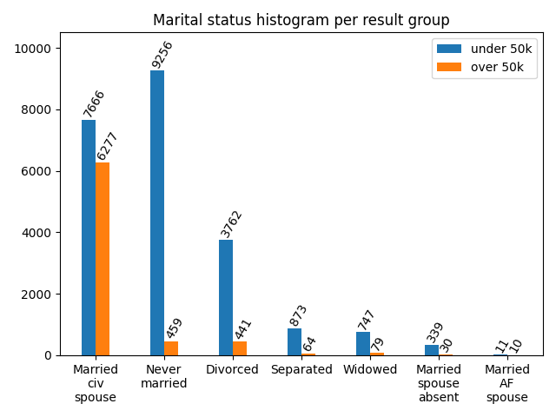

Maybe we can join married civil spouse and married armed forces spouse, maybe also separated and spouse absent.

relationship: Wife, Own-child, Husband, Not-in-family, Other-relative, Unmarried.

Relationship contains five unique values, after joining wife and husband together as married:
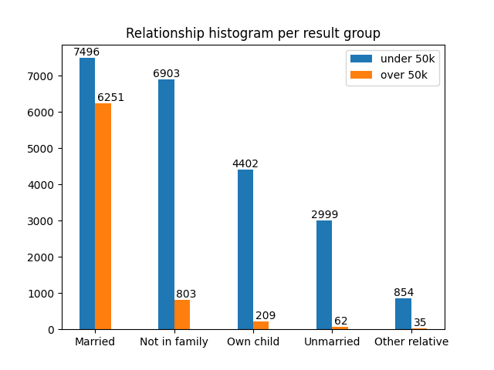

At first sight it may seem that marital-status and relationship represent same thing, and indeed relationship-married means marital status as married to civil or armed forces spouse. We can observe this fact in figure X.
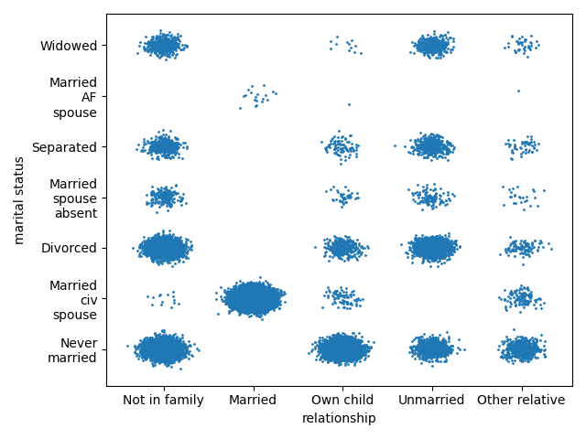

None of the continuous attributes appear to be normal distributed, which in most cases, can be easily explained. Age is generally not normal distributed in population. Education number is ordinal attribute so we also do not expect it to be normal distributed. Working hours are also not normal distributed because usual work week contains 40 work hours. Lastly capital gain/loss do not appear to be normal distributed, mostly because majority of people have no capital gain/loss.

Next we can look at correlation between attributes. First, we transform all nominal data using 1 of K transformation. Than we can compute correlation matrix. Figure X shows gray scale bitmap with absolute values of correlation:
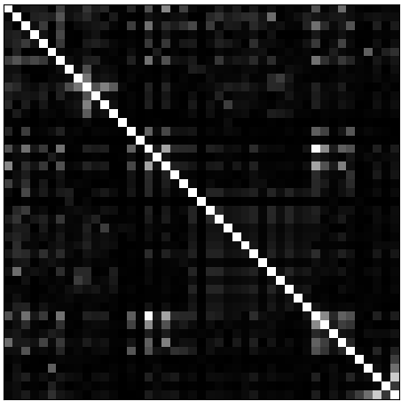

By far the biggest correlation is between Married-civ-spouse and Married. We have a lot of strong correlations above absolute 0.5 between marital-status and relationship:
marital-status | relationship
Married-civ-spouse | Married
Married-civ-spouse | Not-in-family
Never-married | Married

Another interesting correlations are between attributes in one category:

marital-status: Married-civ-spouse X Never-married
relationship: Married X Not-in-family
workclass: Local-gov X Private
workclass: Private X Self-emp-not-inc
race: Asian-Pac-Islander X White
race: Black X White

These can be easily explained by the fact than in 1 of K encoding, one attribute means that all other are not present, meaning negative correlation. The most useful correlations(over 0.4 in absolute values) are between categories:

age X never-married
age X own-child
education X professional specialty
sex X married-civ-spouse
sex X married
result X married-civ-spouse
result X married

Some of these can be easily explained as for example age and never married, but correlation between sex and relationship status is surprising. We can also note correlation between married and category we aim to predict.

Our classification problem appear to be feasible to some extent. From almost all attributes we can notice some bias toward one classification category. On the other hand it is unlikely to get extremely low error rate because none of the attributes seems to strongly discriminate one of the classification categories.

Since 75% of data are people who earn under 50k, we could get 25% error rate by simply always predicting lower earnings. Previous attempts by others achieved error rate as low as 15%. We should thus aim for error under 20%.

For principal component analysis, we first normalized the all data. After applying 1 of K encoding data contains 44 columns. We can achieve 0.9 variance explained with 30 principal components and 0.95 can be achieved using 33 components.
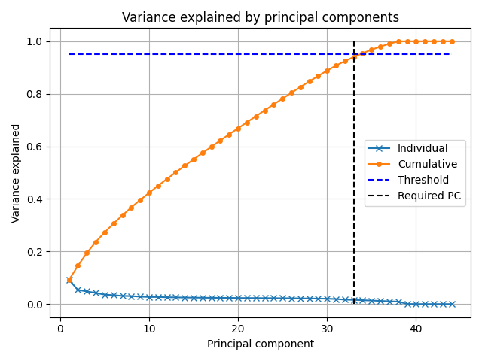

We can try to visualize projections of first four principal component back to original attributes:
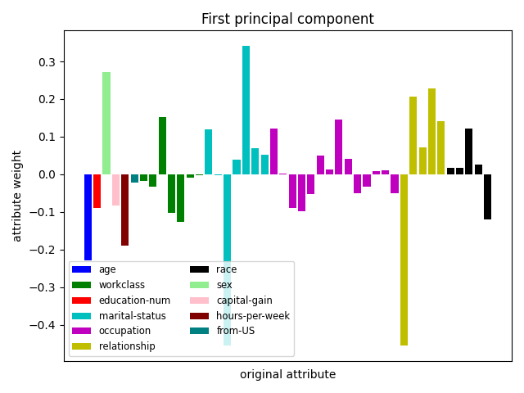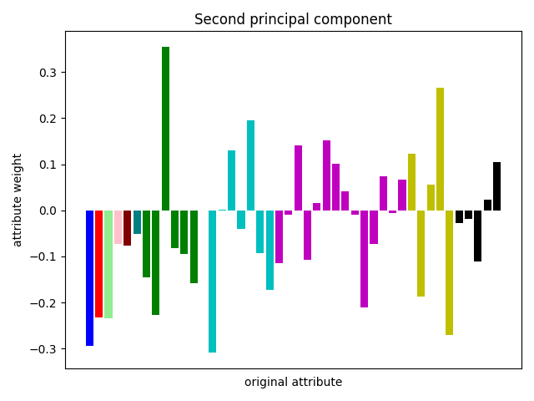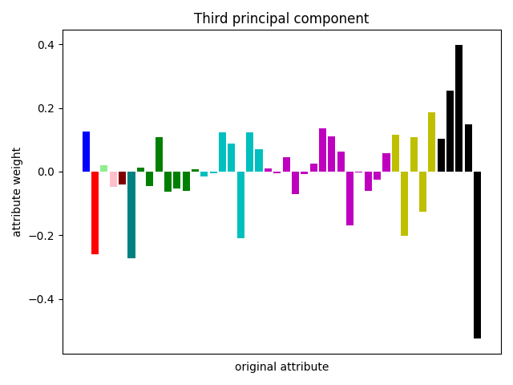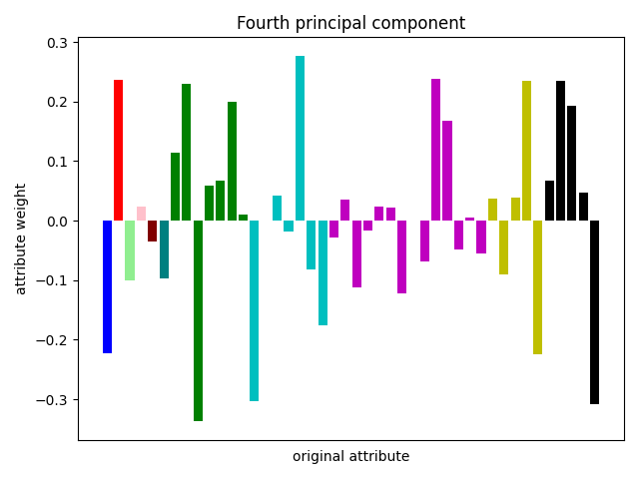
First principal component might for example represent young females who never married.

Lastly we can look at data projected onto original attributes and first 3 principal components.

