Requirements:

The UI should print out the following in the Console and look like this:

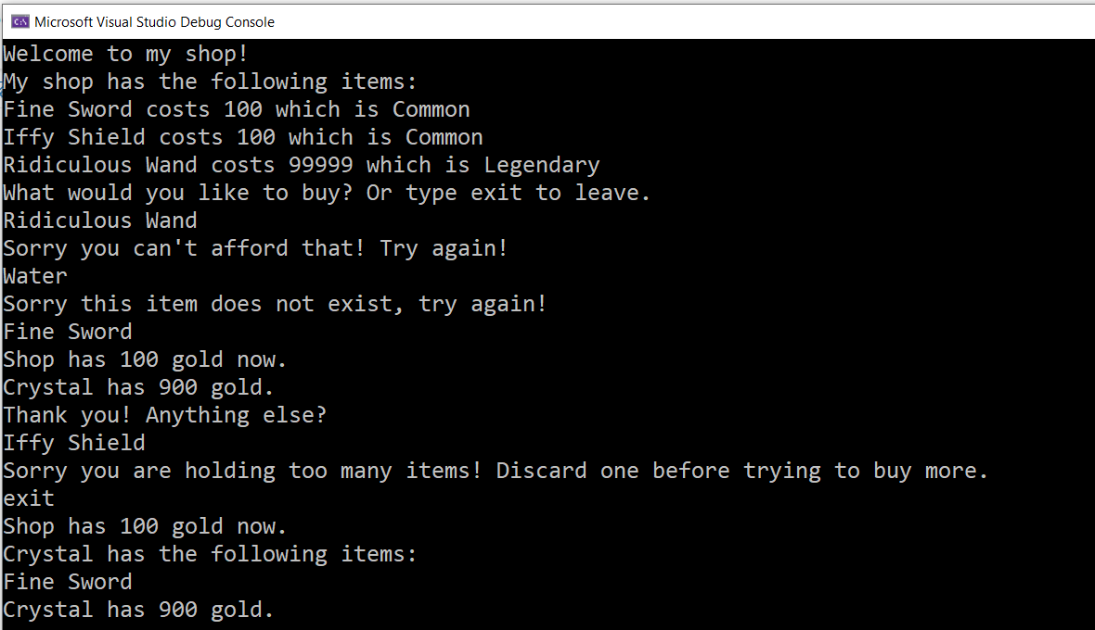

As a **Player**, I want to be welcomed by the shop and have the shop list out all **items**, its **cost**, and its **rarity**.

As a **Player**, I want to be able to type in the **Name** of an **Item** and purchase it.

As a **Shop**, I will tell a **Player** “Thank you! Anything else?”, and complete the purchase (if they can afford the **Item** and have space for it).

As a **Shop**, I will tell a **Player** “Sorry this item does not exist, try again!” if they typed in an **Item** that I do not have.

As a **Shop**, I will tell a **Player** “Sorry you can't afford that! Try again!” if they cannot afford the item.

As a **Shop**, I will tell a **Player** “Sorry you are holding too many items! Discard one before trying to buy more.” if the **Player** is holding too many **Items** above their **Item Capacity**.

As a **Player**, I want to be able to exit the shop by typing “**exit**” and I should get a summary of my Items and Gold, plus the Shop’s Gold amount upon exit.

--

Shop:

* What properties will it need?
* What methods should it have?

Items:

* What properties will it need?
* What methods should it have?

Player:

* What properties will it need?
* What methods should it have?

Bonus Features after the exercise is completed:

* The Shop should offer an option to allow the Player to Discard an Item
* The Shop should offer an option to pay the Shop “500 gold” to increase the Player’s Item Capacity by 1
* The Shop should offer an option to allow the Player to Sell an Item. Once the Item is sold to the Shop, the Shop should then offer the Item for sale as part of the Inventory