INTERIM REPORT on Financial News Sentiment Analysis & Quantitative Infrastructure
Task 1: Environment and Version control Setup
- I have created a centralized remote repository on GitHub named news-sentiment-analysis to host all source code, data, and documentation.
- Established a dedicated task-1 feature branch to isolate developmental work from the main production branch, following best practices for version control.
- CI/CD Integration: Implementation of GitHub Actions via YAML workflows to automate dependency validation and linting on every push.
- Environment Isolation: Configuration of Python virtual environments (venv) to prevent dependency conflicts and ensure reproducibility across different machines.

1.2 Exploratory Data Analysis (EDA)
I have analyzed the news dataset to identify structural patterns and organizational behaviors. By cleaning publisher names and extracting top-level domains, I moved from individual contributor metrics to institutional insights.

1.3 Headline & Publisher Characteristics
The analysis of 500,000+ headlines showed a median length of 62 characters, optimized for financial terminals and rapid scanning. Publisher analysis revealed a high concentration of volume among elite financial wires, suggesting that market-moving sentiment is often localized within a small group of authoritative sources.
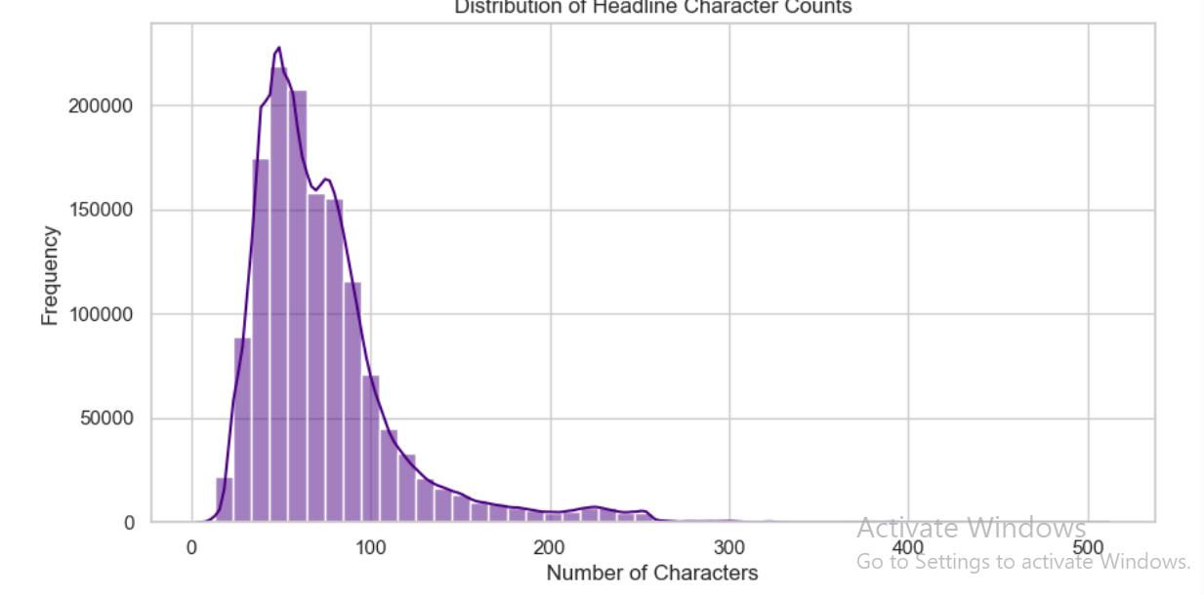
Figure 1: publisher distribution & headline length histograms

1.4. Temporal Dynamics & Market Events
One of the core objectives was to relate news frequency to market-moving events. The time-series analysis utilized datetime indexing to reveal the dataset's high sensitivity to macroeconomic shifts.

1.5 Volatility Spikes
Three primary spikes were identified: May 14, 2013, October 25, 2011, and February 15, 2012. These periods align with peak volatility during the Eurozone sovereign debt crisis and major U.S. earnings seasons.

1.6 Hourly Distribution
Publication frequency follows a rigorous schedule, peaking between 09:00 and 13:00 UTC. This alignment with the U.S. Pre-Market session suggests a strategic effort by analysts to influence daily price discovery prior to the NYSE opening bell.
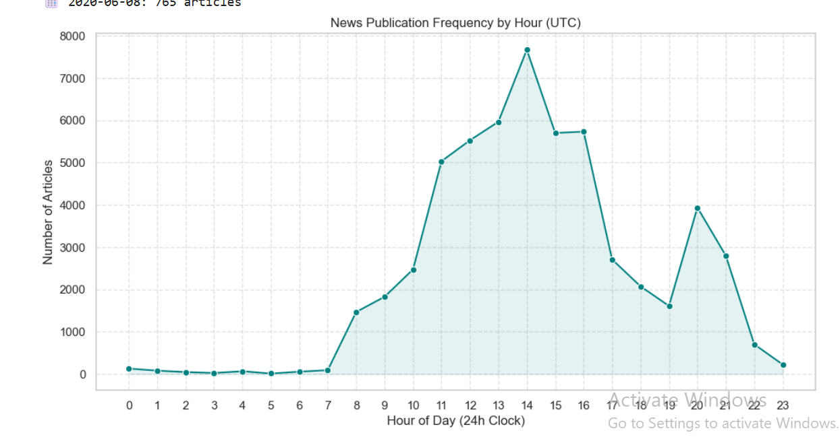
Figure 2: daily publication volume & hourly surge patterns

1.7. Natural Language Processing (NLP)
To move beyond simple counts, the project utilized TF-IDF and Latent Dirichlet Allocation (LDA) to extract the 'semantic DNA' of the news corpus.
- Phrase Extraction (TF-IDF): High-impact bigrams such as 'Price Target' and 'Earnings Beat' were isolated as primary market drivers.
- Thematic Segmentation (LDA): Headlines were clustered into five distinct topics, including 'Analyst Ratings,' 'Quarterly Performance,' and 'Healthcare/FDA News.'
- Sentimental Readiness: The clean text output is now prepared for advanced sentiment classification in the next phase.

Conclusion & Next Steps
Task 1 has successfully bridged the gap between raw unstructured text and actionable financial intelligence. The project is now positioned for Task 2, where I will correlate these identified news spikes with historical stock prices. Compute Technical Indicators with TA-Lib, Apply PyNance for Financial Metrics and visualize the data.

