 | Faculty of Computer Science and Mathematics

Lab Exercise 2

Name: | AHMAD ISA ISKANDAR BIN CHOI SUNG BOK
Matric Num: | S80787



Overview:

This in-class exercise extends Lab Exercise 2. You will apply tables (including colspan and rowspan), forms (text inputs, radio buttons, checkboxes, drop-down lists and labels) and semantic HTML tags (header, nav, section, article and footer) to solve a realistic problem.
There are two problems. Your lecturer will assign one problem to you, or you may be asked to complete both.

Learning Outcomes
- Create tables with headers and merged cells using colspan and rowspan.
- Build forms with appropriate input types, correctly linked labels and grouped radio buttons.
- Structure a web page using semantic HTML tags.
- Identify and correct errors in tables, forms and semantic structure, and validate code using the W3C Validator.

Best of luck!

Problem A: Faculty Event Page with Schedule and Registration
Your faculty is organising a one-day event, for example a Programming Workshop, a Career Day or a Hackathon. The organising committee needs a simple web page that shows the event schedule and allows students to register. Build the page using HTML only (no CSS). You may choose any event name, date and activities.

Instructions
Create a file named lab2_ExerA.html that contains the following:

Semantic Structure
  - A <header> containing an <h1> with the event name and a short tagline.
  - A <nav> with internal links (e.g. href="#schedule", href="#register", href="#about") that jump to each section of the page.
  - At least three <section> elements, each with an id: About the Event, Event Schedule and Registration.
  - Inside the About section, two <article> elements, each introducing one speaker or one activity (with an <h3> and a <p>).
  - A <footer> with the organiser name and a copyright line using &copy;.

Event Schedule Table
  - A table with border="1" and header cells (<th>) for Time, Activity, Venue and Person in Charge.
  - At least 6 rows of activities from morning to evening.
  - Use colspan at least once (e.g. a “Lunch Break” row that spans across Activity, Venue and Person in Charge).
  - Use rowspan at least once (e.g. two consecutive sessions held in the same venue).

Registration Form
Create a form with action="register.html" and method="post" that contains:
  - Text inputs for Full Name, Matric Number and E-mail, each with a <label> whose for matches the input id.
  - Radio buttons for Year of Study (Year 1 – Year 4). All radio buttons must share the same name
so only one can be selected.
  - Checkboxes for the sessions the student wants to join (at least 3 choices).
  - A drop-down list (<select>) for Programme or Faculty with at least 4 options.
  - A submit button.

Comments
  - Use comments (<!-- ... -->) to explain each section of your code.

Submission
Save the file as lab2_ExerA.html, validate it at https://validator.w3.org (Validate by File Upload), and submit it (Submit lab2_ExerA.html and Screenshot of validation) through Github

VALIDATION:
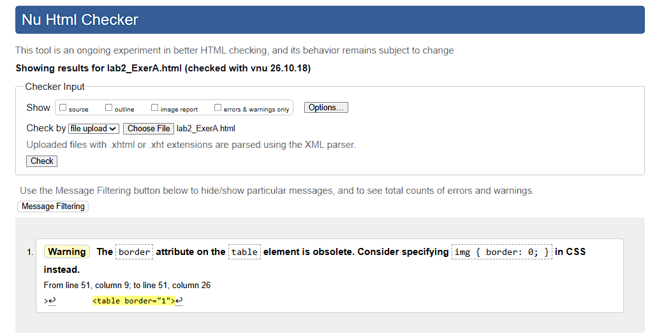

Code(lab2_ExerA.html):

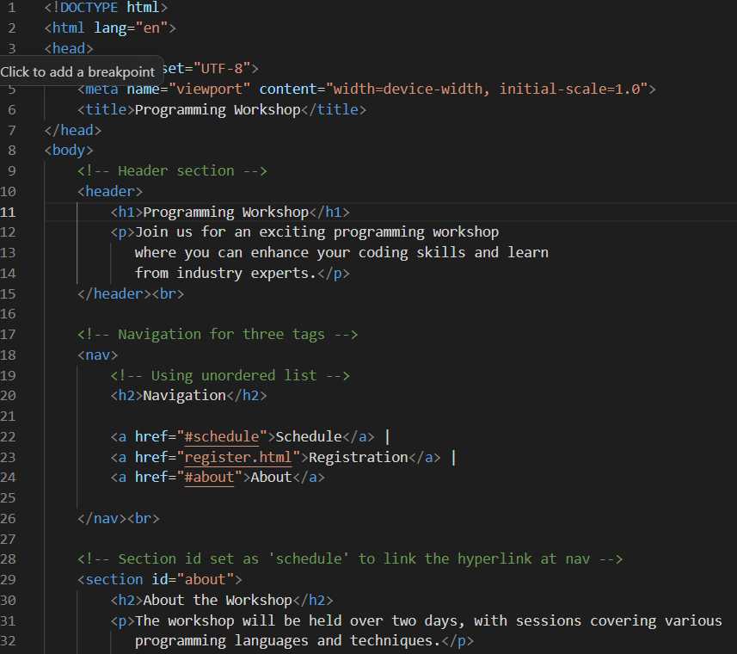
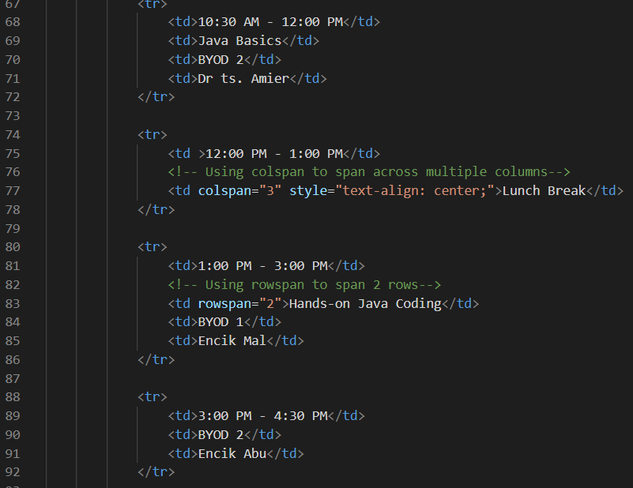

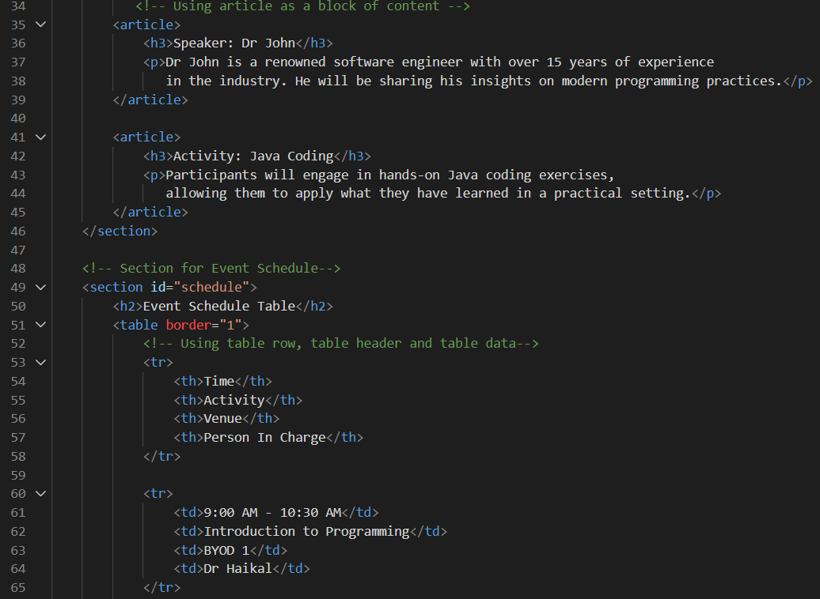

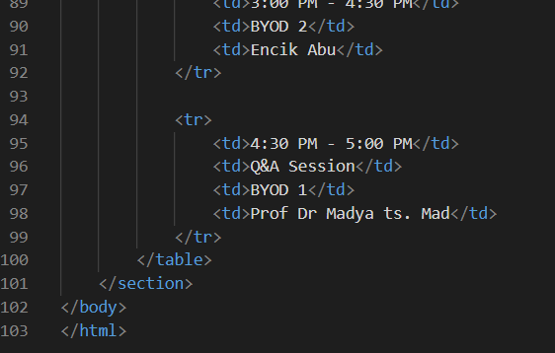

Code (register.html) 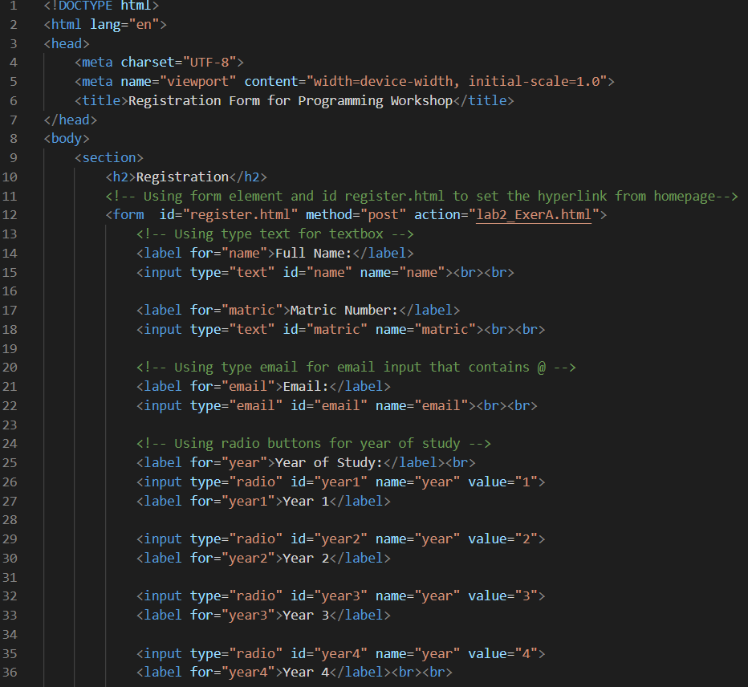

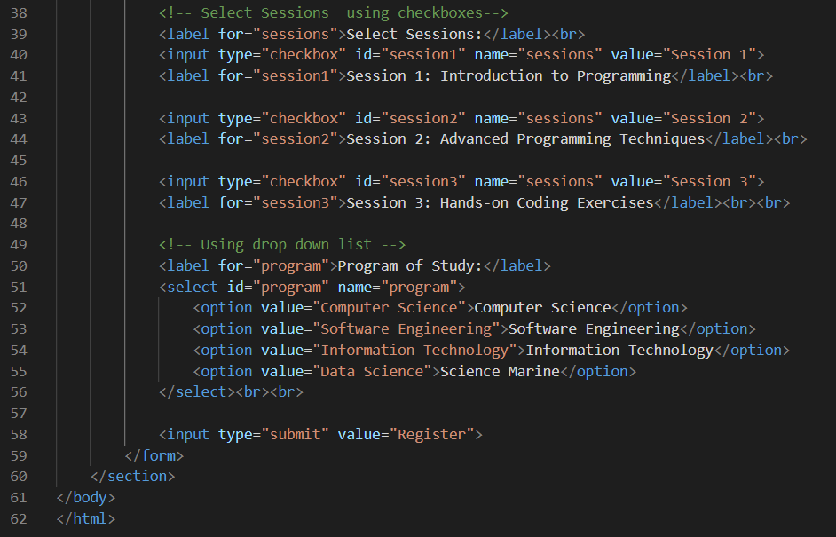

Problem B: Course Feedback Page (Debugging and Extend)

A student helper created a Course Feedback page for CSF3133. The page shows a feedback summary table and a feedback form, but it contains several errors. Some radio buttons can be selected at the same time, clicking some labels does nothing, and the table looks broken. Your tasks are to find and fix the errors, then extend the page.

Given Code

- <!DOCTYPE html>
- <html lang="en">
- <head>
- <meta charset="utf-8">
- <title>Course Feedback</title>
- </head>
- <body>
- <header>
- <h1>CSF3133 Course Feedback</h1>
- </head>
- <nav>
- <a href="#results">Results</a> | <a href="#form">Feedback Form</a>
- </nav>
- <section id="results">
- <h2>Feedback Summary</h2>
- <table border="1">
- <tr>
- <th>Week</th>
- <th>Topic</th>
- <td>Rating</td>
21 </tr>
22 <tr>
23 <td>1</td>
24 <td>Introduction to HTML</td>
25 <td>4.5</td>
26 <tr>
27 <td>2</td>
28 <td colspan="3">Tables and Forms</td>
29 </tr>
30 <tr>
31 <td>3</td>
32 <td>Semantic HTML<td>4.0</td>
33 </tr>
- </table>
- </section>
- <section id="form">
- <h2>Give Your Feedback</h2>
- <form action="submit_feedback.php" method="post">
- <label for="name">Name:</label>
- <input type="text" id="fullname" name="name"><br>
- <label>Overall rating:</label><br>
- <input type="radio" id="good" name="good" value="good">
- <label for="good">Good</label>
- <input type="radio" id="poor" name="poor" value="poor">
- <label for="poor">Poor</label><br>
- <input type="checkbox" id="lab" name="lab" value="yes">
- <label for="labs">I attended all labs</label><br>
- <input type="submit" value="Submit">
- </from>
- </section>
- <footer>
- <p>Copyright &copy 2026 CSF3133</p>
- </footer>
- </body>
- </html>

Instructions
Part 1. Find and Fix the Errors
- Copy the given code into a new file named lab2_ExerB.html.
- Identify and correct all errors. At the top of the <body>, write an HTML comment listing each error and the line number, e.g. <!-- Error 1 (Line 1): missing <!DOCTYPE html> -->.
- Validate your corrected file at https://validator.w3.org. Your final page must show “No errors or warnings to show”.

Part 2. Extend into a Two-Page Website
- Table: add rows for Week 4 and Week 5. Both weeks cover the same topic “Mini Project”, so use rowspan="2" on the Topic cell. Add a final row “Average Rating” that uses colspan="2".
- Form: add an E-mail text input with a matching <label>, a third radio option “Average”, a group of at least 3 checkboxes “Topics I want more practice on”, and a
<select> for Section/Group (at least 3 options).
- Semantic HTML: add a new <section id="comments"> titled “Student Comments” that contains two <article> elements, each with an <h3> (student name) and a <p> (comment). Add a link to this section in the <nav>.
- Use comments to explain each new section of your code.

Submission
Save the file as lab2_ExerB.html, validate it at https://validator.w3.org (Validate by File Upload), and submit it (Submit lab2_ExerB.html and Screenshot of validation) through Github

Validation:
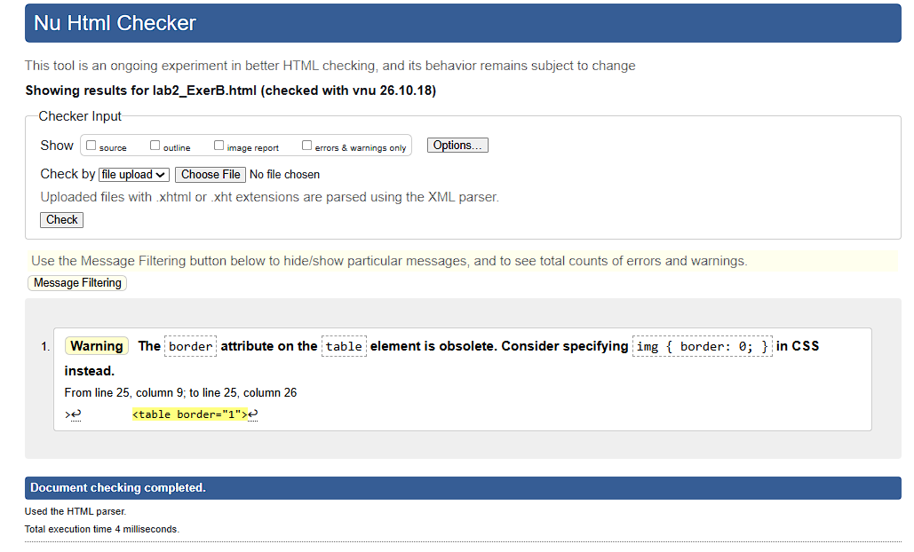

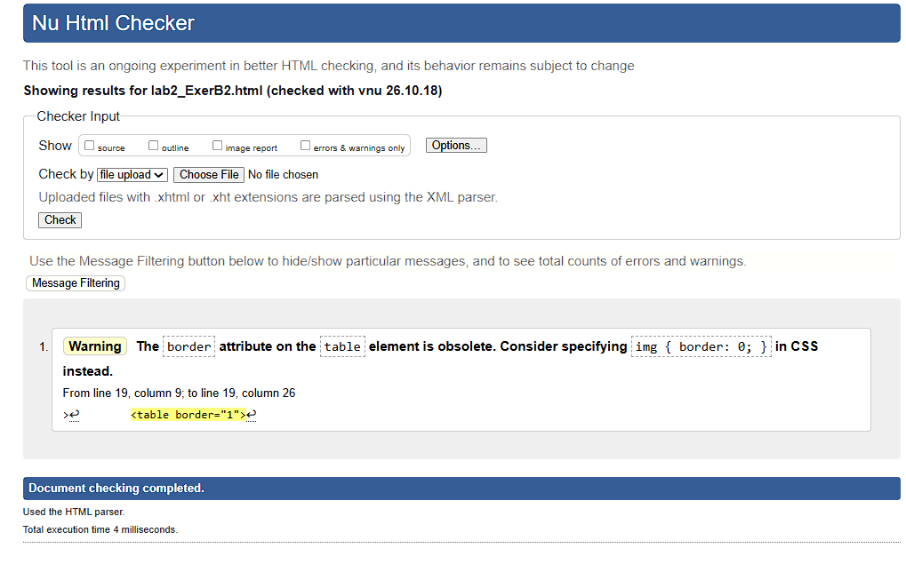

Code (lab2_ExerB.html)
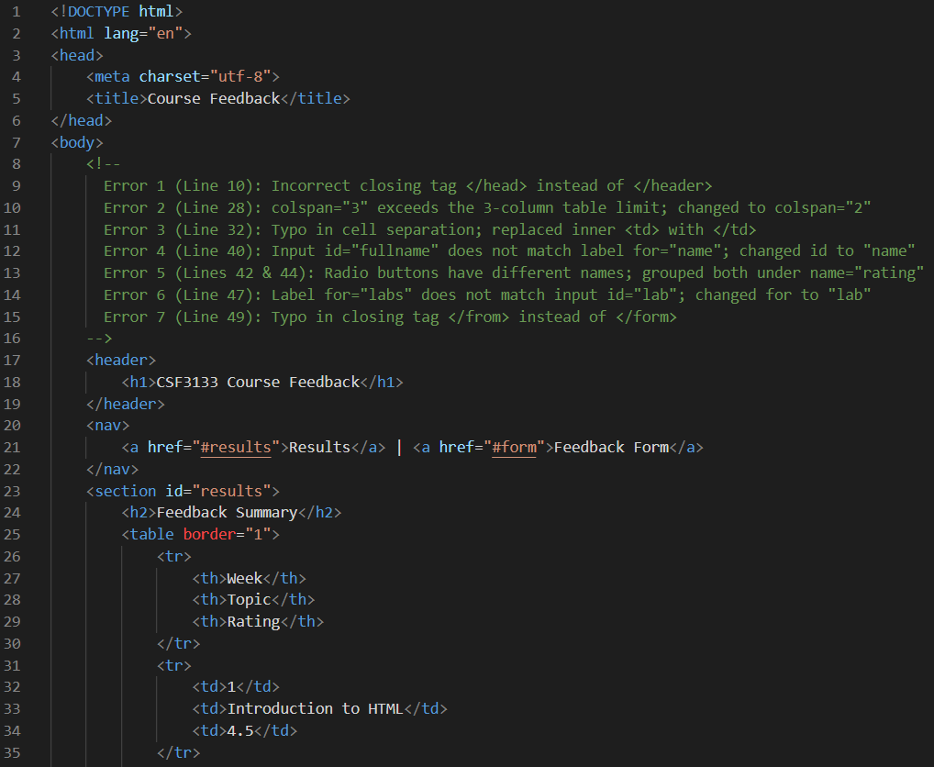

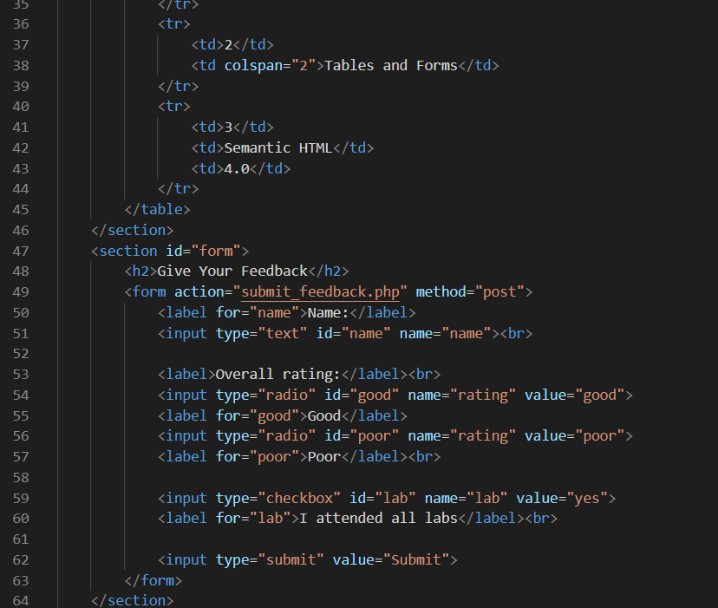

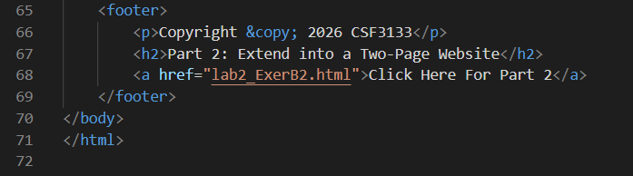

Code (lab2_ExerB2.html) 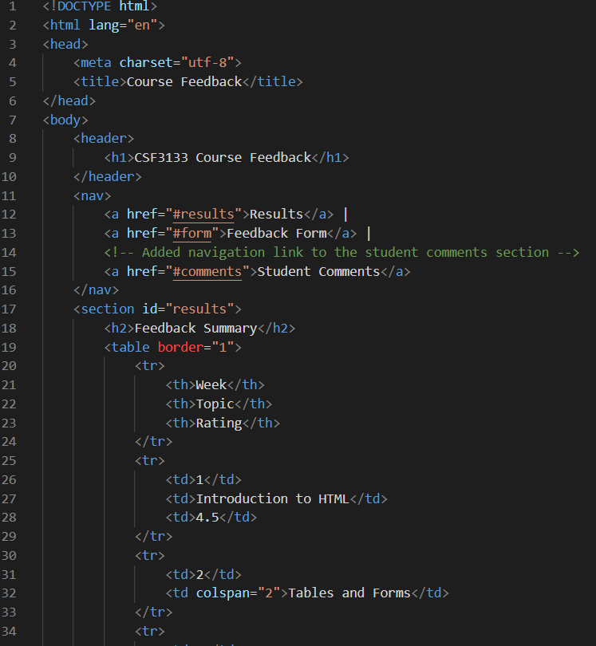
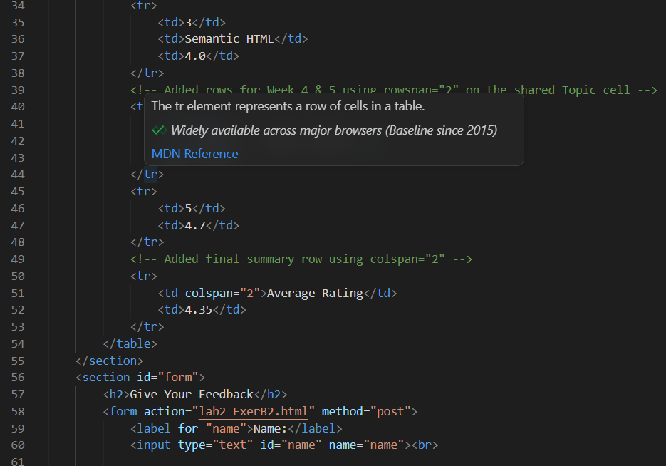
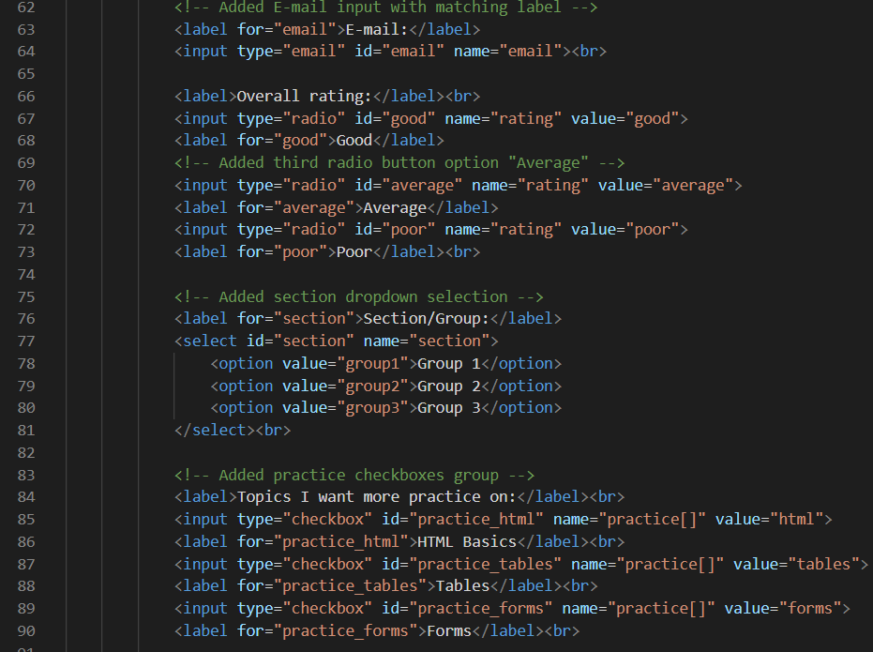

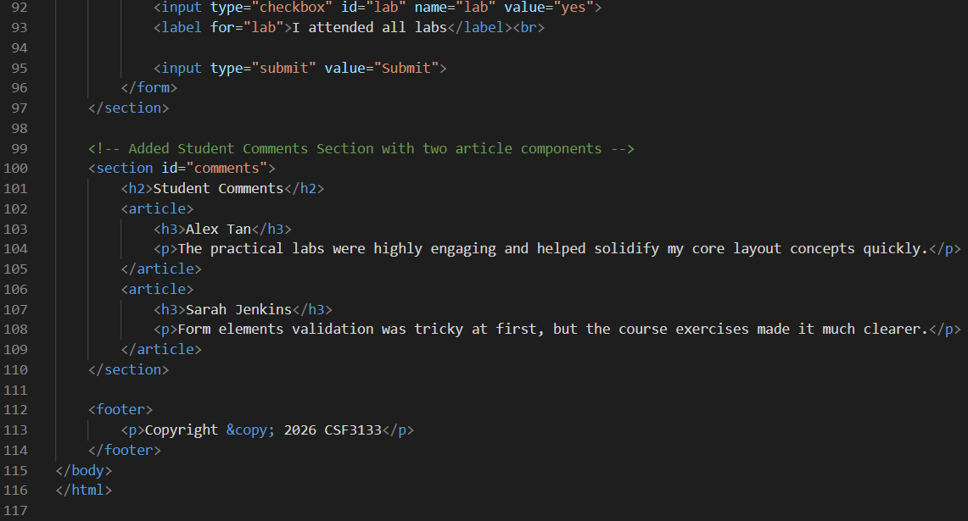

Rubric
Table A: Rubric for Additional Lab Exercise 2 – Problem A

Criteria | Description | Marks
Table Creation | Schedule table has <th> headers, at least 6 rows of meaningful data, and correct use of colspan and rowspan (no extra or missing cells). | 3
Form Structure | Form contains text inputs with matching <label for> and id, a grouped set of radio buttons (same name), at least 3 checkboxes, a <select> with at least 4 options, and a submit button. | 3
Semantic HTML | Proper use of <header>, <nav> with working internal links,  <section> (min. 3), <article> (min. 2) and <footer>. | 2
Code Organization and Readability | Code is well-organized, properly indented and commented. File is named lab2a.html and passes the W3C Validator. | 2
Total |  | 10

Table B: Rubric for Additional Lab Exercise 2 – Problem B

Criteria | Description | Marks
Error Identification | At least 7 errors correctly identified with line numbers and listed in an HTML comment. | 3
Error Correction & Validation | All errors corrected. Radio buttons work as one group, all labels are linked, and the page passes the W3C Validator. | 2
Table Extension | Week 4 and Week 5 rows added with correct rowspan; Average Rating row uses correct colspan. No extra or missing cells. | 2
Form Extension | E-mail input with label, third radio option in the same group, at least 3 checkboxes and a <select> with at least 3 options. | 2
Semantic HTML and Code Organization | New <section> with two <article> elements and a working <nav> link. Code is indented and commented. | 1
Total |  | 10

