RetailCo
Sales Data Platform
From nightly CSV files to a trusted sales data warehouse
Project report for stakeholders
November 2026
Prepared by: Data Engineering

In one sentence: every night's sales file is now loaded, cleaned and organised automatically into a data warehouse, so the business can answer sales questions in seconds and trust the numbers.

Contents
1. Executive summary 4
At a glance 4
What this gives the business 4
2. The business problem 4
3. The data 5
3.1 Where the data came from 5
3.2 What is in each row 5
3.3 What we found in the data 5
4. How we solved it 6
4.1 Guiding principles 6
4.2 The process 6
4.3 Two databases, two jobs 7
4.4 Built-in safety features 7
4.5 Environments: test safely before going live 7
4.6 Keeping history: nothing is ever deleted 7
5. The data warehouse design 8
Naming convention 8
6. What the data tells us 10
6.1 Sales build strongly towards Christmas 10
6.2 Top 10 products last month (November 2011) 10
6.3 The UK is the core market 11
6.4 Orders are large – a wholesale business 11
6.5 Loyal customers drive most of the revenue 11
6.6 Cancellations 11
7. Testing and quality checks 11
8. How we will automate and deploy it 12
8.1 Option A – Quick start on our existing server 12
8.2 Option B – Microsoft Azure cloud (recommended for growth) 12
8.3 How changes are released safely 13
8.4 Suggested rollout plan 13
9. Risks and next steps 14
Appendix A – How to run the platform 15
Appendix B – Project files 15
Appendix C – Glossary 15

1. Executive summary
RetailCo is a UK-based online retailer of home goods and gifts. Every night its sales system exports the previous day's orders, cancellations and adjustments as a CSV file. Until now those files were not organised in one place, so simple questions such as “what were our best products last month?” needed manual work in spreadsheets, and the answers could differ depending on who prepared them.
This project builds a simple, reliable data platform on Microsoft SQL Server. Each file is loaded into a staging database (RETAIL_STG), cleaned with clear rules, and organised into a data warehouse (RETAIL_DWH) designed for reporting. Every run is recorded, problems in the data are counted, and the process is ready to be scheduled so that it runs with no manual steps.

At a glance
Measure | Result
Rows processed | 541,909 sales lines (1 Dec 2010 – 9 Dec 2011)
Duplicate lines removed | 5,268 (1.0%)
Sales lines in the warehouse | 536,641
Net sales captured | £9,771,318 (after £475,901 of cancellations)
Orders / customers / countries | 19,773 orders · 4,372 customers · 38 countries
Time to process the full file | About 30 seconds
Manual steps per day | None once scheduled (drop the file → run)

What this gives the business
- One version of the truth. Everyone reports from the same cleaned tables, so numbers match across teams.
- Answers in seconds. Questions that took hours in Excel are now short queries or dashboard filters.
- Problems are visible, not hidden. Every run records how many duplicates, cancellations and unusual rows it found.
- Safe to run every day. The same data is never loaded twice, and a failed run never leaves half-loaded data.
- Full history, nothing lost. Changes to products and customers are kept as versions, and removed lines are marked, never deleted.
- Ready to automate. It can run unattended on the existing server or in the cloud (section 8).

2. The business problem
The analytics team wants to answer everyday business questions reliably and quickly, for example:
- What were the top 10 products by revenue last month?
- Which countries generated the most orders in the last quarter?
- What is the average order value by month?
- Which customers buy from us repeatedly?
The raw files make this hard because they contain real-world problems:
- the same line recorded more than once;
- about a quarter of lines with no customer number;
- cancellations and returns mixed in with sales;
- non-product lines such as postage, bank charges and Amazon fees;
- warehouse notes such as “damaged” or “?” entered as sales lines with a zero price;
- inconsistent text (extra spaces, upper and lower case) and old country codes such as “EIRE”.
If these issues are not handled consistently, every report can give a different answer.

3. The data

3.1 Where the data came from
The project uses the Online Retail dataset from the UCI Machine Learning Repository (dataset ID 352), a well-known public collection of real business data hosted by the University of California, Irvine.
Item | Detail
Source | UCI Machine Learning Repository – “Online Retail” (ID 352)
Web address | https://archive.ics.uci.edu/dataset/352/online+retail
Business | UK-based, non-store online retailer selling gifts; many customers are wholesalers
Period covered | 1 December 2010 to 9 December 2011
Format | One CSV file, 45 MB, 541,909 rows, 8 columns
Licence | Creative Commons Attribution 4.0 (free to use with credit)
How we get it | Downloaded automatically by the command python main.py extract

3.2 What is in each row
Each row is one line on an invoice: one product, the quantity bought and its price.
Column | Meaning | Example
InvoiceNo | Invoice number. Starts with “C” for a cancellation | 536365 / C536379
StockCode | Product code | 85123A
Description | Product name | WHITE HANGING HEART T-LIGHT HOLDER
Quantity | Units on the line (negative for cancellations) | 6
InvoiceDate | Date and time of the invoice | 12/1/2010 8:26
UnitPrice | Price per unit in pounds sterling | 2.55
CustomerID | Customer number (often blank) | 17850
Country | Customer's country | United Kingdom

3.3 What we found in the data
Before building anything, every column was profiled. The table shows what was found and how each issue is handled. Nothing is silently deleted: removed rows are counted in every run.
Issue found | Rows | How it is handled
Exact duplicate lines | 5,268 | Removed (counted in etl.dataQuality)
Lines with no customer number | 135,037 | Kept as a “guest” customer so sales still count
Cancellations (invoice starts with C) | 9,251 | Kept and shown separately as cancelledAmount
Postage, fees, discounts, manual entries | 2,940 | Kept, but not counted as product sales
Zero price and no customer (“damaged”, “?”) | 2,459 | Marked as stock adjustments, not sales
Very large quantities (10,000+ units) | 5 | Kept and flagged for review (each was cancelled the same day)
Negative prices (bad-debt write-offs) | 2 | Kept and flagged for review
Values that are not valid numbers or dates | 0 | Would be removed and counted
Extra spaces, mixed upper/lower case | ~131,000 | Trimmed and standardised
Old country codes (EIRE, RSA, USA) | ~8,700 | Renamed to Ireland, South Africa, United States

4. How we solved it

4.1 Guiding principles
- Keep it simple. A few clear steps that anyone on the team can follow and maintain.
- Never lose the original. Every file is stored exactly as received, and the file itself is archived.
- Clean in one place. All cleaning rules live in a single, readable SQL view.
- All or nothing. The warehouse is updated in one transaction: it either fully succeeds or nothing changes.
- Record everything. Every run, row count and data problem is written to a log table.

4.2 The process
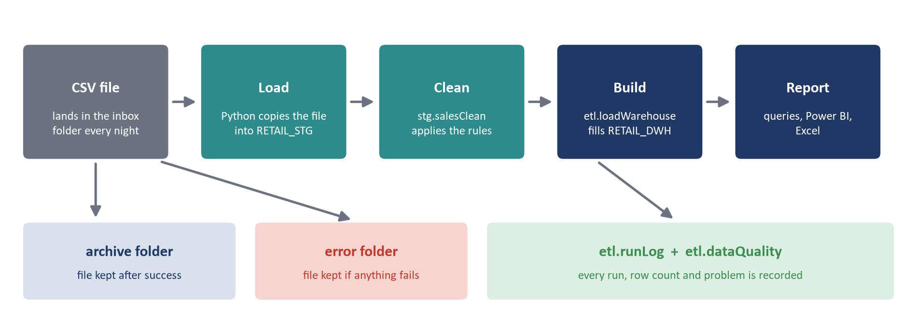
Figure 1 – How one nightly file moves through the platform
1. The nightly CSV file is placed in the inbox folder.
2. Python checks the file has not been loaded before (using a digital fingerprint of the file).
3. The file is copied, unchanged, into the staging database RETAIL_STG (table stg.salesRaw).
4. The view stg.salesClean applies the cleaning rules: removes duplicates, fixes text, converts numbers and dates, and labels each line as a sale, cancellation, fee, postage and so on.
5. The stored procedure etl.loadWarehouse adds the file to RETAIL_DWH: new lines are inserted, lines already loaded are skipped, and changed products or customers get a new version.
6. The run result and data-quality counts are saved in etl.runLog and etl.dataQuality.
7. The file is moved to the archive folder, or to the error folder if anything failed.

4.3 Two databases, two jobs
A simple way to picture it: the staging database is the receiving bay where deliveries arrive and are checked; the data warehouse is the organised shop floor where everything is labelled and easy to find.
Database | Purpose | Contents
RETAIL_STG | Staging: receive and clean | stg.salesRaw (files as received), stg.salesClean (cleaning view)
RETAIL_DWH | Data warehouse: report | dim.calendar, dim.product, dim.customer, fact.sales, etl.runLog, etl.dataQuality, etl.loadWarehouse

4.4 Built-in safety features
Situation | What the platform does
The same file arrives twice | Recognised by its fingerprint and skipped – sales are never double-counted
A file is broken or has missing columns | Nothing is loaded; the file goes to the error folder and the error is logged
A step fails half-way | Everything is rolled back; yesterday's warehouse stays as it was
The same lines arrive again in another file | Each line has a fingerprint; lines already loaded are skipped
A corrected invoice is sent again | Changed or removed lines are marked as deleted (with the time) and the corrected lines are added
Someone asks “where did this number come from?” | Every row links back to the file and run that loaded it

4.5 Environments: test safely before going live
Settings are kept in a small .config folder. A development (dev) environment is used for building and testing; production (prod) is the live system. Switching is one setting (ENVIRONMENT=dev or prod), so new changes are always tried in dev before they reach the business. Passwords are never written in the code: the platform uses Windows sign-in by default.

4.6 Keeping history: nothing is ever deleted
The warehouse is loaded incrementally: each night only the new file is processed, and nothing already in the warehouse is overwritten or removed.
- New data is added once. Every sales line gets a fingerprint. If the same line arrives again, it is skipped.
- Corrections are kept as history. If an invoice is sent again with a changed or missing line, the old line is marked as deleted (isDeleted, deletedAt) and the corrected line is added. Nothing is physically removed.
- Product and customer changes are versioned (Slowly Changing Dimension type 2). When a product is renamed or a customer moves country, the old row is closed and a new version is added. Old sales stay linked to the old version, new sales to the new one.
- Every table has timestamps. loadedAt, createdAt, updatedAt and deletedAt show exactly when each row arrived or changed.
Tested example – a product renamed in a new file:
productKey | stockCode | description | validFrom | validTo | isCurrent
912 | 85123A | WHITE HANGING HEART T-LIGHT HOLDER | 1900-01-01 | 2011-12-10 | 0 (old)
3960 | 85123A | WHITE HANGING HEART T-LIGHT HOLDER LARGE | 2011-12-10 | 9999-12-31 | 1 (current)

Deleted orders. A daily file shows what is new, not what disappeared. Today, cancelled orders arrive as cancellation invoices and are fully handled. If the source system ever deletes an order instead of cancelling it, we recommend (simplest first): agree that orders are always cancelled, never deleted; or receive a small daily list of deleted invoice numbers; or a weekly snapshot to compare against.

5. The data warehouse design
The warehouse uses a star schema, the standard design for reporting. One central fact table holds the sales lines (the numbers), and the dimension tables around it describe them (when, what and who). This makes reports fast and the tables easy to understand.
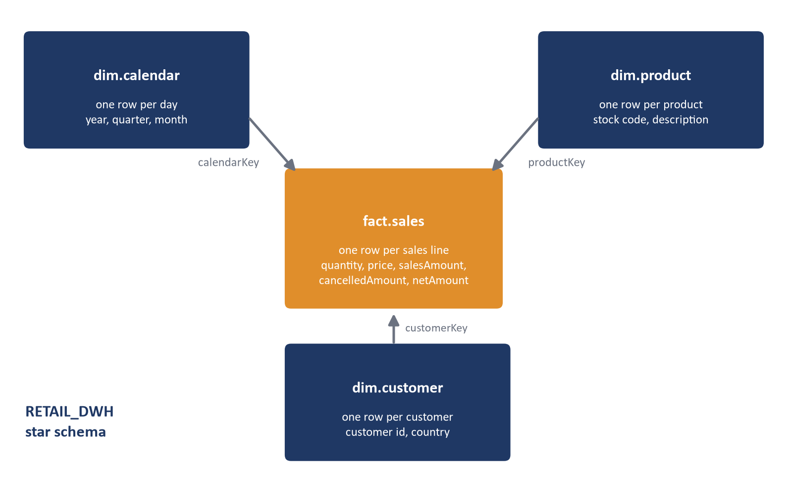
Figure 2 – The star schema in RETAIL_DWH
Table | One row per | What it holds
fact.sales | sales line | quantity, unit price, salesAmount, cancelledAmount, netAmount; insert-only, removed lines soft-deleted
dim.calendar | day | year, quarter, month, month name – for reporting by period
dim.product | product version | stock code, description, product type, validFrom / validTo (history kept)
dim.customer | customer version | customer number, country, validFrom / validTo (key 0 = guest)
etl.runLog | file processed | file name, status, start/finish time, row counts, any error
etl.dataQuality | check per run | how many duplicates, guests, cancellations, etc. were found

Naming convention
Names follow one consistent pattern so that anyone can find things quickly:
- Databases: RETAIL_ + layer, in capitals – RETAIL_STG, RETAIL_DWH.
- Schemas: the role of the table – stg, dim, fact, etl.
- Tables and columns: camelCase – fact.sales, stg.salesRaw, invoiceNo, netAmount.
- Always fully qualified in SQL: DATABASE.schema.table, e.g. RETAIL_DWH.fact.sales.
- Suffixes: keys end in Key, money in Amount, counts in Count; flags start with is.

6. What the data tells us
With the warehouse in place, the business questions become short queries. Key findings:

6.1 Sales build strongly towards Christmas
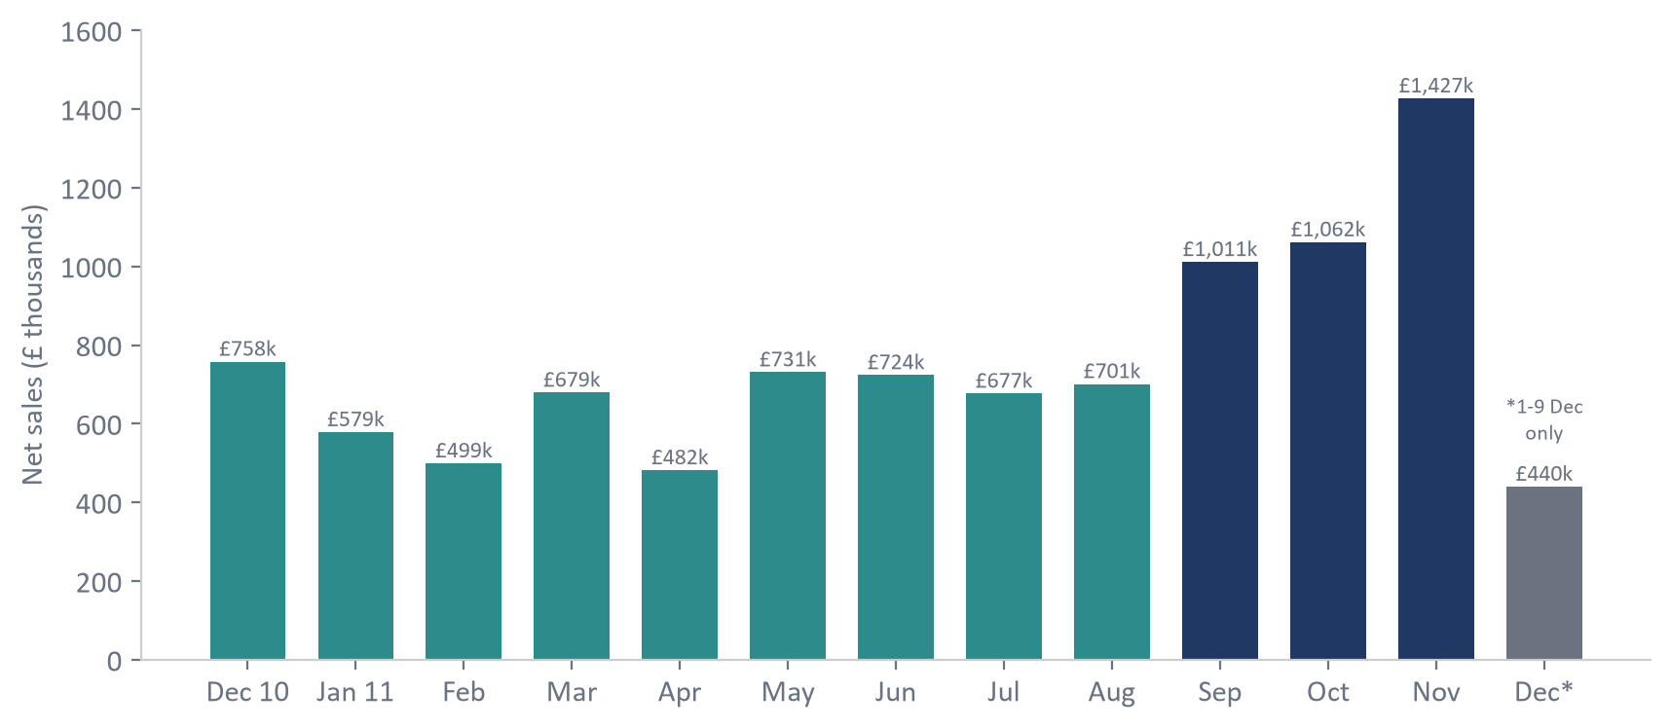
Figure 3 – Net sales by month (£ thousands)
- A typical month brings in £500k–£750k of net sales.
- Sales jump from September; November 2011 is the peak at £1.43m – about twice a normal month.
- December 2011 only covers the first 9 days, so it is not a full month.

6.2 Top 10 products last month (November 2011)
# | Product | Net sales
1 | Rabbit night light | £34,344
2 | Paper chain kit 50's Christmas | £28,854
3 | White hanging heart T-light holder | £14,339
4 | Popcorn holder | £13,962
5 | Paper chain kit vintage Christmas | £12,817
6 | Regency cakestand 3 tier | £12,773
7 | Chilli lights | £11,475
8 | Jumbo bag red retrospot | £11,456
9 | Hot water bottle keep calm | £11,437
10 | Jumbo bag 50's Christmas | £10,882

6.3 The UK is the core market
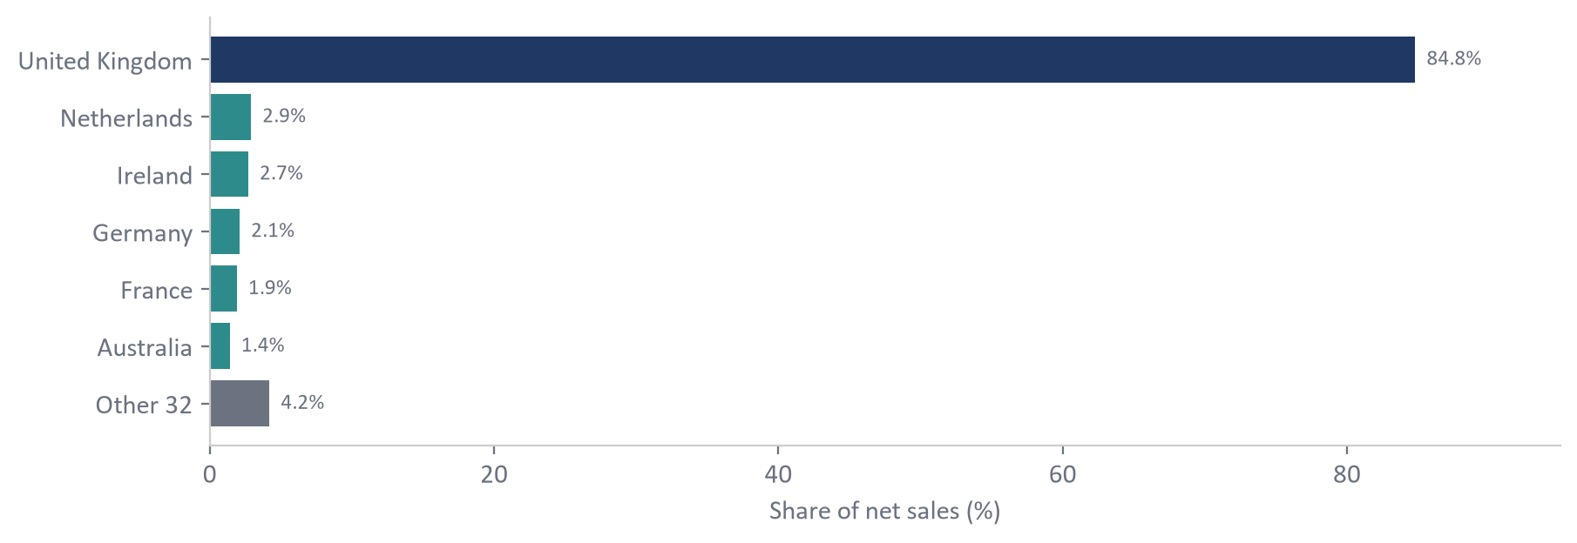
Figure 4 – Share of net sales by country
The United Kingdom brings 84.8% of net sales and 5,014 of the 5,572 orders in Q4 2011 (90%). The Netherlands, Ireland, Germany and France are the largest overseas markets.

6.4 Orders are large – a wholesale business
The average order is worth roughly £430–£640 depending on the month, which confirms that many customers are businesses buying in bulk rather than individual shoppers.

6.5 Loyal customers drive most of the revenue
865 customers (20% of known customers) bought more than five times. Together they generate 66% of sales from known customers. Keeping these customers happy is critical.

6.6 Cancellations
Cancellations are worth 4.6% of product sales (£475,901). The December spike is mainly one order of 80,995 units that was placed and cancelled on the same day – the platform flags such orders for review.

7. Testing and quality checks
Test | Result
Load the full file (541,909 rows) | Passed – 536,641 new lines in about 30 seconds
Run again with an empty inbox | Passed – nothing happens
Drop the same file a second time | Passed – whole file skipped, no double counting
Same invoices again in a different file | Passed – 0 new, 9 already loaded
Drop a broken file (missing columns) | Passed – moved to error folder, logged as failed, warehouse unchanged
Corrected invoice (one quantity changed, one line removed) | Passed – 1 new, 5 skipped, 2 marked as deleted
Customer moves country, product renamed | Passed – new versions; old sales keep the old version
Re-run a file by hand in SSMS | Passed – EXEC RETAIL_DWH.etl.loadWarehouse @runId; nothing duplicated
Totals checked against an independent calculation | Passed – sales, cancellations and net sales match to the penny

8. How we will automate and deploy it
“Automated” means: the file arrives at night, the platform runs on its own, the warehouse is up to date before the working day starts, and someone is told straight away if anything goes wrong. There are two ways to get there.

8.1 Option A – Quick start on our existing server
Lowest cost, can be live within days. Uses tools we already have.
Need | Tool | How it works
Receive the file | Shared network folder | The sales system saves the CSV into the inbox folder each night
Run every night | SQL Server Agent (or Windows Task Scheduler) | Runs python main.py run at 02:30 every day
Store the data | SQL Server (already in place) | RETAIL_STG and RETAIL_DWH
Alert on failure | SQL Server Database Mail | Emails the team if the job fails
Show the results | Power BI or Excel | Connects to RETAIL_DWH and refreshes each morning

8.2 Option B – Microsoft Azure cloud (recommended for growth)
Fully managed services: no servers to maintain, scales as the business grows, and fits naturally with SQL Server and Power BI.
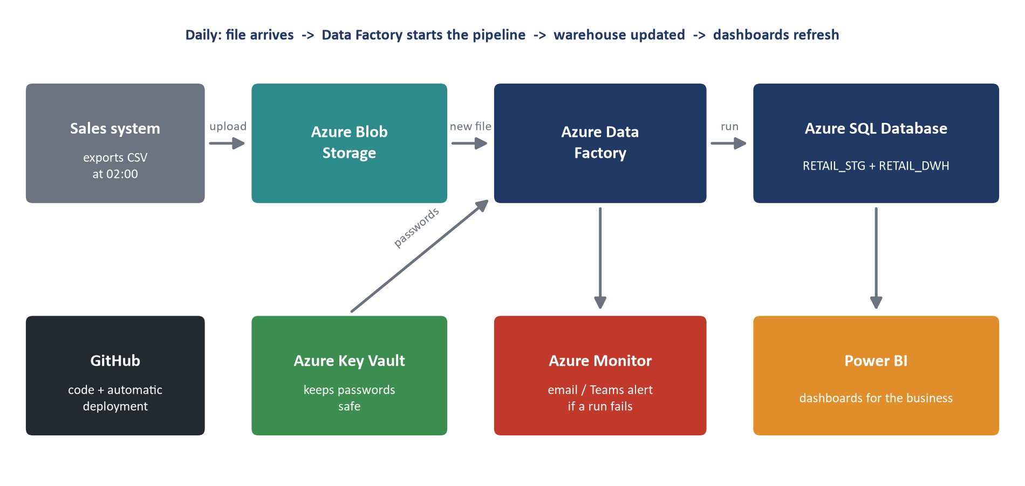
Figure 5 – The automated platform on Microsoft Azure
Service | Its job in plain words
Azure Blob Storage | A secure online folder. The sales system uploads the nightly CSV here (the inbox), and processed files are kept in an archive folder.
Azure Data Factory | The scheduler and conductor. When a new file arrives it loads it into RETAIL_STG and runs etl.loadWarehouse. No one needs to press a button.
Azure SQL Database | Hosts RETAIL_STG and RETAIL_DWH – the same SQL code we built, with backups included.
Azure Key Vault | A safe for passwords and connection details, so they are never stored in code.
Azure Monitor | Watches every run and sends an email or Microsoft Teams alert if one fails or is late.
Power BI | Dashboards for managers, refreshed automatically after each load.
GitHub + GitHub Actions | Stores the code and its history. Approved changes are deployed automatically – first to dev for testing, then to prod.

A normal night on Azure
1. 02:00 – the sales system uploads the day's CSV to Blob Storage.
2. Data Factory notices the new file and starts the pipeline automatically.
3. The file is loaded into RETAIL_STG, cleaned, and only the new data is added to RETAIL_DWH (minutes, not hours).
4. The run result and data-quality counts are written to etl.runLog and etl.dataQuality.
5. The file is moved to the archive folder; Power BI refreshes.
6. If anything fails, Azure Monitor alerts the team before the business day starts.

Equivalent services on other clouds
Job | Microsoft Azure | Amazon Web Services | Google Cloud
File inbox | Blob Storage | S3 | Cloud Storage
Scheduler | Data Factory | Step Functions / Glue | Cloud Composer
Database | Azure SQL Database | RDS for SQL Server | Cloud SQL for SQL Server
Passwords | Key Vault | Secrets Manager | Secret Manager
Alerts | Azure Monitor | CloudWatch | Cloud Monitoring
Dashboards | Power BI | QuickSight | Looker Studio

8.3 How changes are released safely
1. A developer changes the code and saves it to GitHub.
2. GitHub Actions automatically runs the setup and tests on the dev environment.
3. A second person reviews and approves the change.
4. The same scripts are run against prod (python main.py setup --env prod). No manual copying of code.
5. If something goes wrong, the previous version is re-deployed from GitHub.

8.4 Suggested rollout plan
Phase | What happens | Outcome
1. Pilot | Run Option A nightly on the current server for two weeks | Prove the numbers with the finance team
2. Reporting | Connect Power BI to RETAIL_DWH and build the first dashboard | Managers self-serve answers
3. Cloud | Move to Option B (Azure) with alerts and automatic deployment | Fully hands-off, scalable
4. Improve | Add product categories, faster daily loads, more data sources | Richer insight

9. Risks and next steps
Item | Why it matters | Recommendation
No product category in the data | Cannot yet report sales or cancellations by category | Add a category list from the product team
25% of lines have no customer number | Customer analysis covers only known customers | Ask the sales system to always capture the customer
Orders deleted at the source (not cancelled) | A daily file cannot show what disappeared | Agree orders are always cancelled; or receive a deleted-invoices list
A file with only part of an invoice | The missing lines would be marked as deleted | Agree with the source that files always hold complete invoices
Large orders cancelled the same day | Can distort daily figures | Review the flagged rows in etl.dataQuality each week

Decisions needed from stakeholders:
- Approve the pilot (Option A) on the current server.
- Choose the long-term home: existing server or Microsoft Azure.
- Nominate a business owner for the data-quality review and for product categories.

Appendix A – How to run the platform
Command | What it does
python main.py setup | Creates RETAIL_STG and RETAIL_DWH with all tables and the procedure (once)
python main.py extract | Downloads the source CSV into the inbox folder
python main.py run | Loads every file in the inbox, adds new data to the warehouse, archives the file
python main.py report | Runs the business questions and saves the answers to output/report_dev.md
--env prod | Add to any command to use the production settings

Appendix B – Project files
File or folder | Contents
.config/ | Environment settings: settings.env, dev.env, prod.env, example.env
main.py | The four commands
etl/settings.py, etl/pipeline.py | Reads the settings; loads files, runs the procedure, archives files
sql/1_databases.sql … 4_load_warehouse.sql | Creates the databases, tables, cleaning view and procedure
sql/queries/ | The four business questions
docs/ | This report and the original brief (all technical notes are in readme.md)
data/dev/inbox, archive, error | Where files arrive, are kept, or are set aside

Appendix C – Glossary
Term | Meaning
CSV file | A simple text file of rows and columns, like a spreadsheet saved as text
ETL | Extract, Transform, Load – get the data, clean it, store it
Staging database | Where raw data lands and is cleaned before it is used
Data warehouse | A database organised for reporting and analysis
Star schema | A design with one central table of numbers (fact) and tables that describe it (dimensions)
Fact table | Holds the measurable events – here, every sales line
Dimension | Describes the facts – when (calendar), what (product), who (customer)
Stored procedure | A saved set of database steps that can be run with one command
File fingerprint (hash) | A unique code calculated from a file's contents, used to spot repeats
Transaction | A group of steps that either all succeed or all are undone
Incremental load | Only new data is added; existing data is not reloaded
Slowly Changing Dimension type 2 | Keeps every version of a product or customer, with the dates each was valid
Soft delete | A row is marked as deleted (with a time) instead of being removed

Data source credit: Chen, D. (2015). Online Retail [Dataset]. UCI Machine Learning Repository. https://doi.org/10.24432/C5BW33 (CC BY 4.0).

