EduRead Digital
Sales and Customer Analysis Report
Prepared for Executive Leadership

Business | EduRead Digital
Analysis Focus | Sales trends, customer retention, content performance, and payment behavior
Data Source | EduReadDataMart using SQL and Python-based analysis
Reporting Period | 2024-2025

March 09, 2026

Introduction
EduRead Digital operates in a market where affordability, accessibility, and digital convenience shape student purchasing behavior. As the company continues to scale, leadership needs a clear view of what is driving revenue, which customers are returning, and which parts of the catalog are producing the strongest results.
This report presents findings from EduRead Digital's sales and customer data mart. The analysis combines transactional data with student, book, date, and payment information to assess business performance from 2024 through 2025. The goal is not only to summarize results, but to identify patterns that can support stronger planning, better content decisions, and more effective customer strategy.

Executive Summary
Overall performance improved across the period. Total revenue increased from $34,273 in 2024 to $41,704 in 2025, indicating positive year-over-year growth. At the same time, average order value remained almost unchanged at roughly $37 in both years. This suggests that growth came from a higher volume of completed purchases rather than larger orders.
Customer retention is the strongest signal in the data. Repeat customers make up the large majority of buyers and generate substantially more revenue than one-time customers. The analysis also shows that revenue is concentrated in a limited set of genres and authors, with History, Mystery, and Sci-Fi performing especially well. Monthly patterns further suggest that 2025 outperformed 2024 in most periods, especially late in the year.
• Revenue rose by more than $7,400 from 2024 to 2025.
• Average order value stayed stable at approximately $37 in both years.
• Repeat customers account for most customers and most revenue.
• History, Mystery, and Sci-Fi generated the highest genre-level revenue.
• A small set of authors contributed a meaningful share of total sales.
• Monthly order volume was generally stronger in 2025 than in 2024.

Key Performance Snapshot
Metric | 2024 | 2025
Total Revenue | $34,273 | $41,704
Average Order Value | $37.05 | $37.07

Revenue Growth and Sales Performance
EduRead Digital's sales performance improved meaningfully from 2024 to 2025. The increase in total revenue points to stronger overall demand and suggests that the business gained traction across the period. Because average order value stayed nearly flat, the revenue increase appears to reflect more completed transactions rather than a major change in customer spending per order.
From a management perspective, this matters. A business growing through order activity should pay close attention to customer acquisition, repeat purchase behavior, and conversion efficiency. In other words, continued growth will likely depend more on increasing the number of successful purchases than on raising prices.
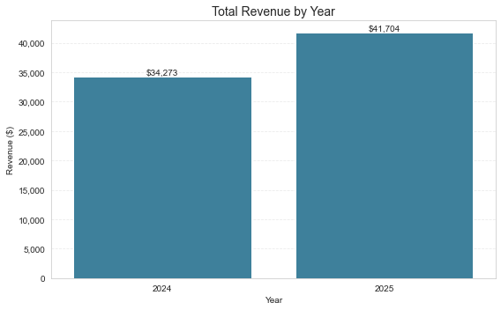
Figure 1. Total revenue increased from $34,273 in 2024 to $41,704 in 2025.
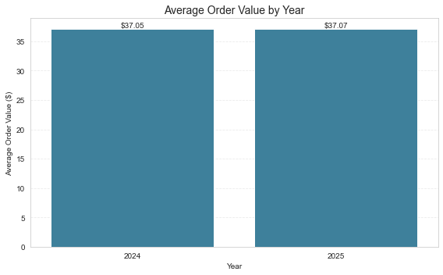
Figure 2. Average order value remained stable at about $37 in both years.

Customer Retention and Revenue Concentration
The retention picture is especially strong. Repeat customers make up the clear majority of EduRead's customer base and contribute far more revenue than one-time buyers. This is important because it suggests the company is not relying only on first-time transactions. Instead, a core group of returning customers appears to sustain the business over time.
This finding points to a practical opportunity. If EduRead continues to strengthen retention through targeted follow-up, personalized recommendations, and customer re-engagement campaigns, it can build on an area that is already performing well. At the same time, converting even a modest share of one-time buyers into repeat purchasers could create measurable revenue gains.
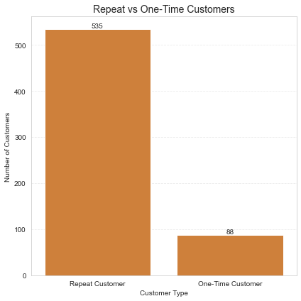
Figure 3. Repeat customers greatly outnumber one-time customers.
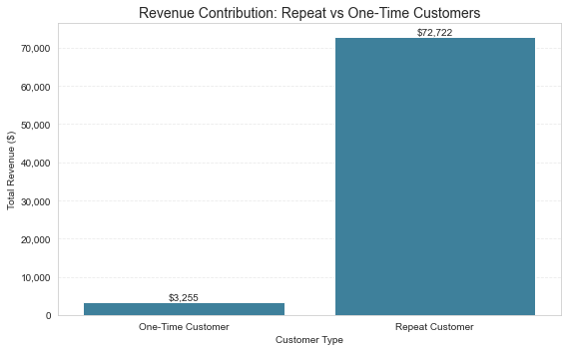
Figure 4. Repeat customers generate the large majority of total revenue.

Content Performance
The data also show that catalog performance is uneven. A small set of genres and authors drives a large portion of total revenue. History, Mystery, and Sci-Fi produced the highest genre-level revenue, while Kids content contributed the least. At the author level, Isabella Garcia ranked first, followed by Noah Garcia and Benjamin Garcia.
For leadership, this means content decisions should be more selective and evidence-based. High-performing genres and authors are strong candidates for featured placement, promotional emphasis, and future partnership activity. Lower-performing categories may still support the company's mission, but they likely require a different pricing or marketing approach if their contribution is to improve.
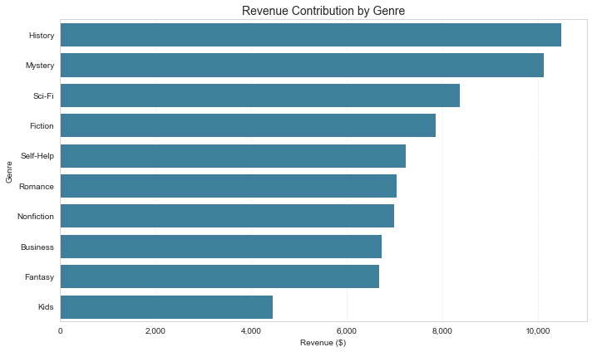
Figure 5. Revenue is concentrated in a limited set of genres, led by History and Mystery.
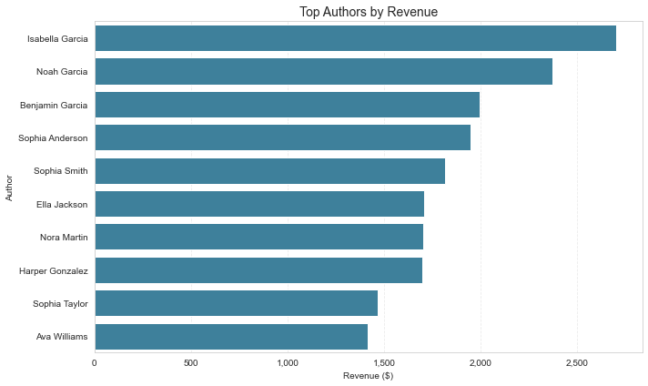
Figure 6. A small group of authors generates a disproportionate share of revenue.

Monthly Trends and Operating Implications
Monthly order and revenue patterns show that demand changes over time rather than remaining constant. While there is some fluctuation from month to month, 2025 generally outperformed 2024, especially in the latter part of the year. The pattern suggests stronger momentum as the business moved forward.
These monthly shifts are useful for planning. High-demand periods are the best candidates for stronger promotional support, platform readiness, and tighter performance monitoring. Lower-demand months, by contrast, may be better suited for targeted discounts, retention efforts, or testing new offers that can stimulate activity.
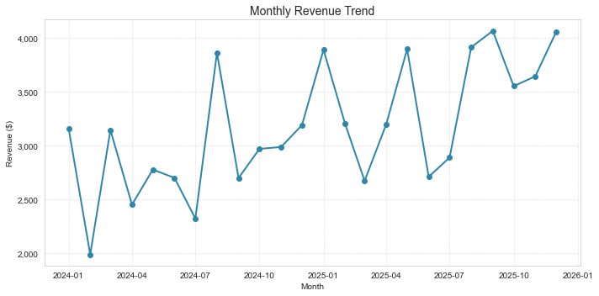
Figure 7. Monthly revenue fluctuated, but the later months of 2025 were generally stronger.
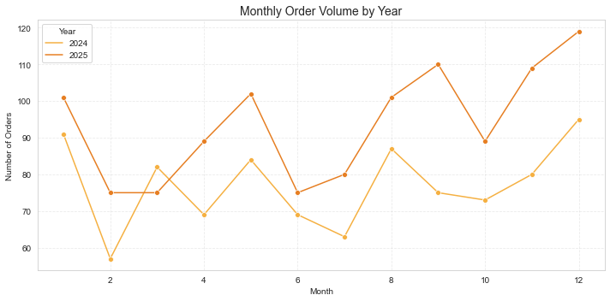
Figure 8. Monthly order counts were generally higher in 2025 than in 2024.

Payment Method Patterns
Payment activity was distributed across several methods, with traditional card-based options appearing most frequently. Discover, Visa, MasterCard, and Debit Card accounted for the largest shares of observed payment activity, while digital wallets such as Apple Pay, PayPal, and Google Pay were used less often.
Although payment behavior is not the main driver of growth in this analysis, checkout convenience still matters. Maintaining a smooth card-based checkout experience should remain a priority, while digital wallet options may deserve continued monitoring as mobile and app-based purchasing evolve.
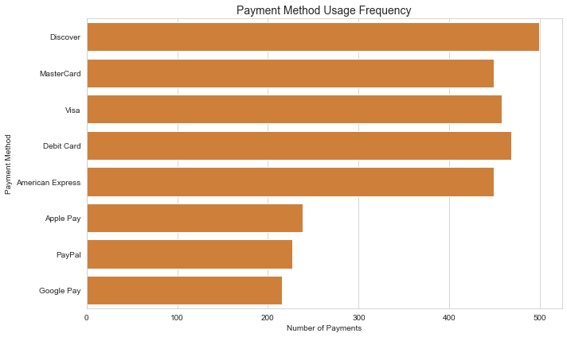
Figure 9. Traditional card-based methods appear most frequently in observed payment activity.

Recommendations
Several actions emerge directly from the analysis. First, EduRead should continue prioritizing customer retention. Repeat buyers are the strongest contributors to revenue, so efforts such as personalized recommendations, reorder reminders, and re-engagement campaigns are likely to produce the greatest return.
Second, leadership should invest more deliberately in high-performing content. Genres such as History, Mystery, and Sci-Fi are already producing strong results, and the same is true for a small set of top authors. These areas are natural candidates for featured placement, curated bundles, and targeted promotional support.
Third, growth strategy should emphasize order frequency rather than price expansion. Since average order value changed very little between years, the clearest path to continued growth is to encourage more completed purchases across the existing customer base.
Finally, monthly performance patterns should inform planning. Promotional timing, demand forecasting, and operational support can be aligned more effectively when the company knows which periods tend to generate stronger order activity.
• Protect and expand repeat-customer behavior through retention-focused outreach.
• Promote high-performing genres and authors more aggressively.
• Increase order frequency through bundles, recommendations, and seasonal offers.
• Use monthly demand patterns to improve campaign timing and resource planning.
• Continue monitoring checkout behavior to maintain a frictionless purchase experience.

Conclusion
The findings show a business that is moving in a positive direction. Revenue increased from 2024 to 2025, monthly order volume strengthened, and repeat customers generated the clear majority of total revenue. At the same time, the analysis revealed that revenue is concentrated among specific genres, authors, and customer groups, which gives leadership a clearer view of where business value is currently being created.
Overall, EduRead's strongest next steps are clear: retain existing customers, support the highest-performing content, and use trend patterns to guide promotion timing and operating decisions. These actions align closely with the company's growth goals and provide a practical basis for decision-making going forward.

