Downloading Microsoft Windows 11

The first step I used was downloading the Rufus windows application

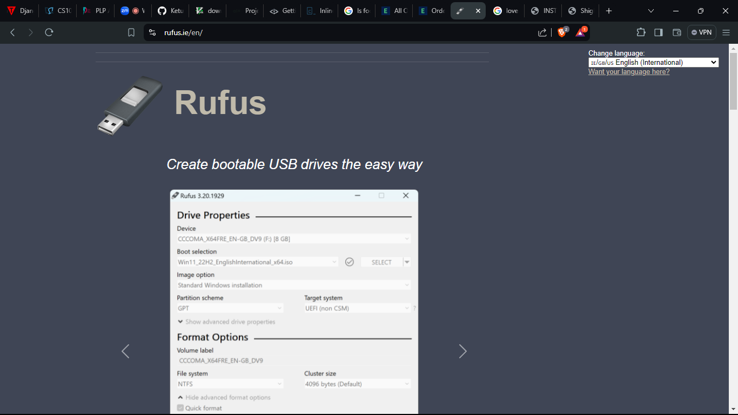

Figure Rufus Download webpage

After a successful download, I installed it to my C drive, then opened it to the following dialog box

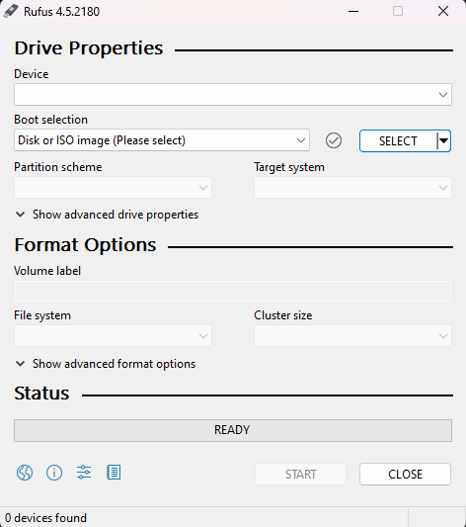

Figure Rufus Dialog box

Step 3:

Selecting the version of Microsoft windows.

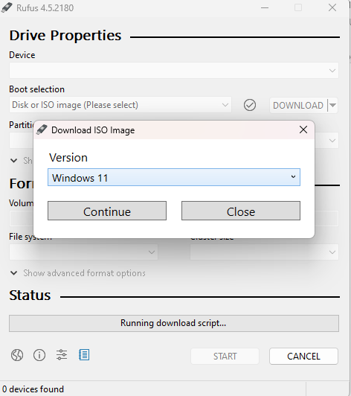

Rufus is more direct on this feature and it will download windows to our pen drive, which can be used to install windows on other machines.

Step 4: Selecting the release version

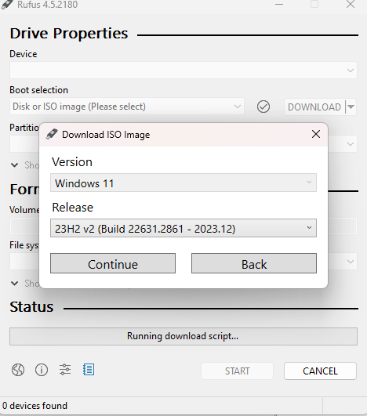

Figure Selecting the most recent release

Step 5: Selecting the windows edition

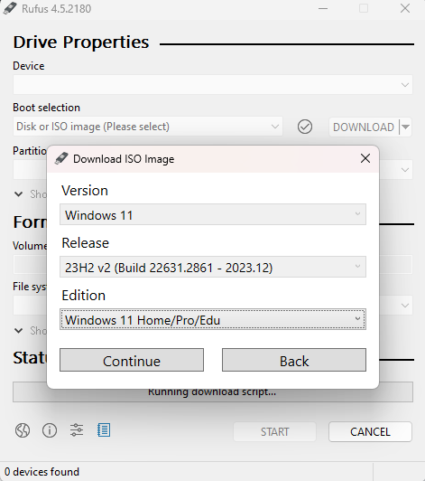

Finally, the language:  
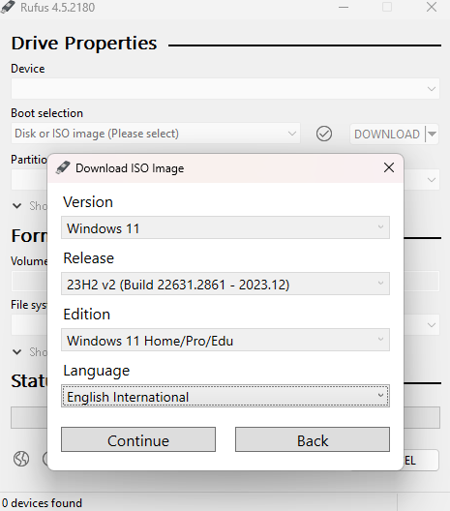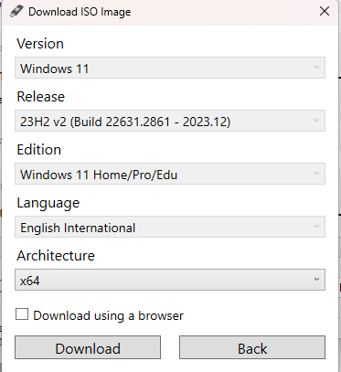

We can wait our download to complete, thereafter we will restart our system.

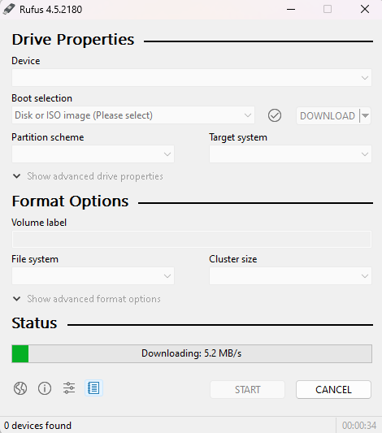

Task 2:

To download Visual Studio Code, I headed over to their website. Thereafter, I selected a version for a 64-bit system, which was for by machine. After a successful download, I installed it on my local disk C. I then added it to PATH in the system environment variables.

Task 3:

Git was downloaded from [www.git-scm.com](http://www.git-scm.com) and installed. After this, a github account was created from github.com. To create my first repository, I did the following:  
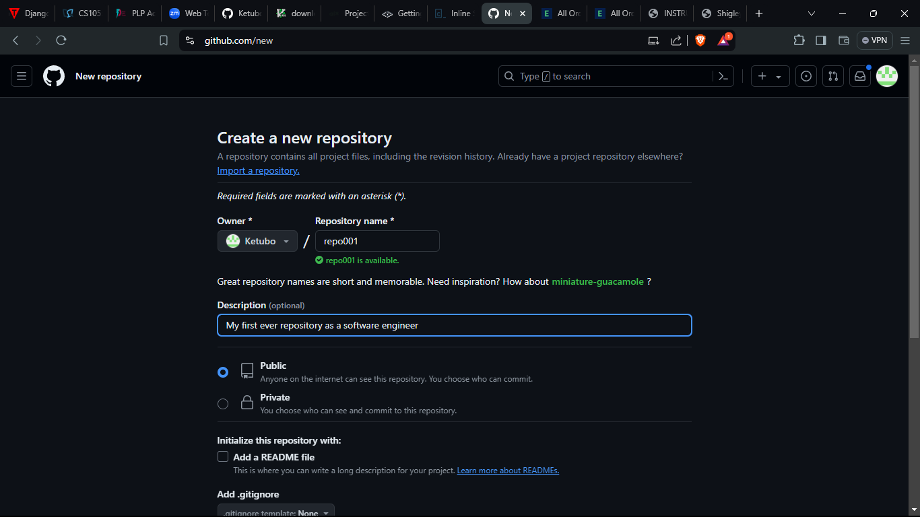

I then followed the following guide to configure git on my local machine:  
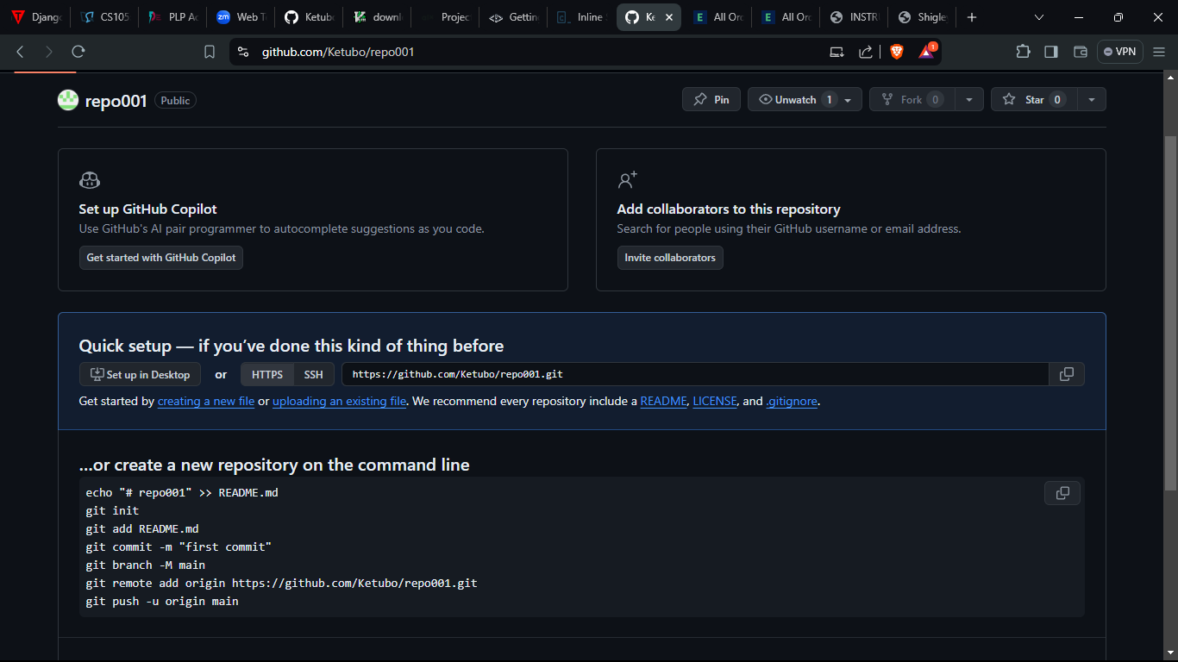

Figure Repo creation

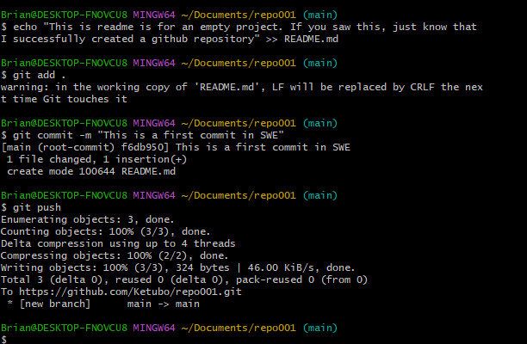

Figure pushing a repo

Having pushed the repo, my github is now finally set.

Next, I installed python3 from python.org website. Since my machine is a windows 64-bit machine, I chose this version. During python installation, the first dialog box prompted for a path addition, which I accepted. This would enable me to run python commands in the terminal without an issue.

After installing python, I then went on and installed pip which is a python intergration. Pip can be used to install other python integrations such as numpy, Django, flask, among others. Finally, IHaving installed pip, I then proceeded with downloading and installing MySQL server on my machine. MySQL is a database markup language used to Create, Read, Update and Delete data. During the installation, I was able to set up a password to protect attacks from unauthorized people. There were several challenges during this installation since I had initially chose to install a full set-up, which gave me several challenges. In addition, having been a previous Linux user, the installation process seemed very different.

Finally, I chose to install WSL which is an integration bvy windows to emulate linux on the terminal. Here, choosing the right version for the wsl was difficult since there are two versions: version 1 and two. Luckily, I windows 11 has version 2 by default. I also had to enable Hyper-v and WSL in the device manager.

From these, I can fully configure a new machine to enable it to be used for development. The challenges encountered are a step to learn from.