**PHYSICS WEBSITE COMPONENTS**

Template link:

<https://www.figma.com/proto/uskZAa9mFd1uIaqOvq60S3/Physics-Conference-Website?node-id=0%3A1&scaling=min-zoom>

Primary color: #22A4A9

1. Typography

Classnames:

* h1, .h1, …, h6, .h6
* small-text
* large-text

Font-family: Verdana, helvetica, sans-serif

1. Hyperlink

classname: hyperlink

Dependency: Typography

1. Buttons

classname: btn

Dependency: Typography

1. Cards:

Dependency: Typography, Buttons

Types:

* Image card
* On the hover of the card, scale the image inside the div.
* Speaker card

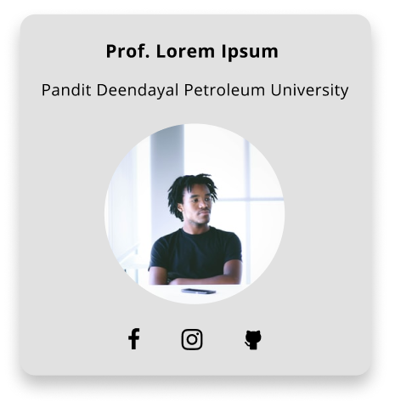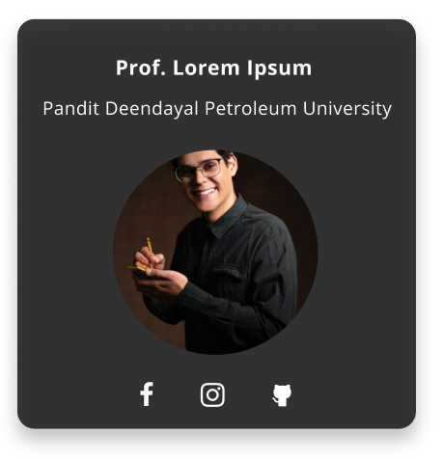

* Above, first image is showing the initial state. Second image is showing the hover state of the whole person card. Add social media handles –Linkedin and their website.
* Person card

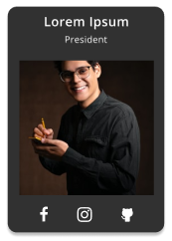

* Above, first image is showing the initial state. Second image is showing the hover state of the whole person card. Add social media handles –Linkedin and Github.

1. Calendar

