Date- 17-Aug-2021

Task:- To Perform Practicals of Javascript & Form with Validation

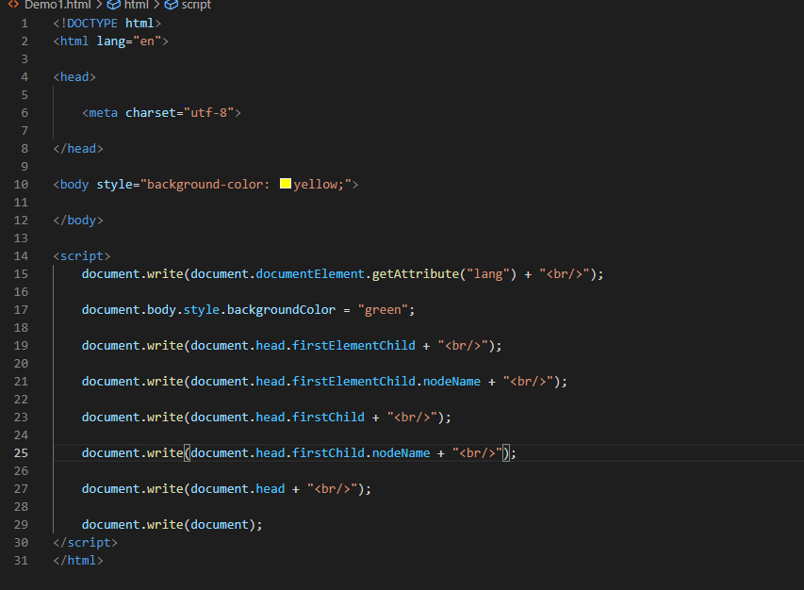

Output:-

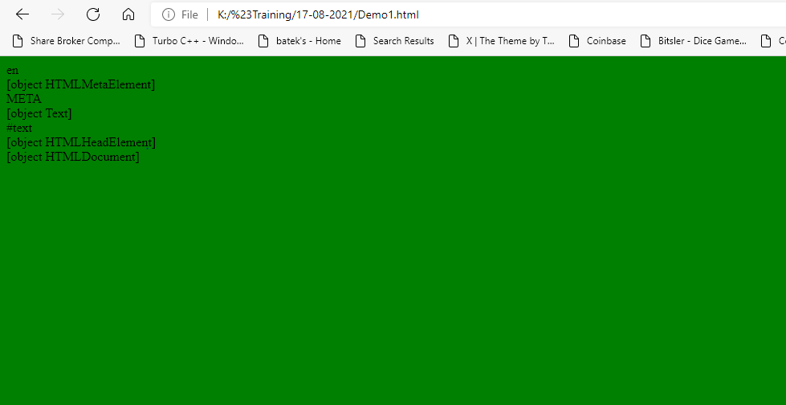

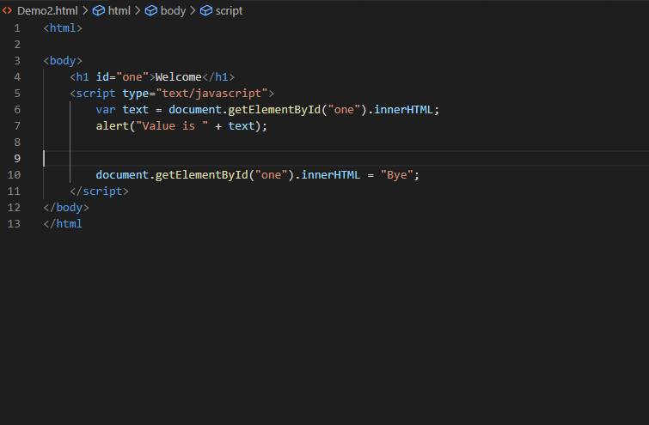

Output:-

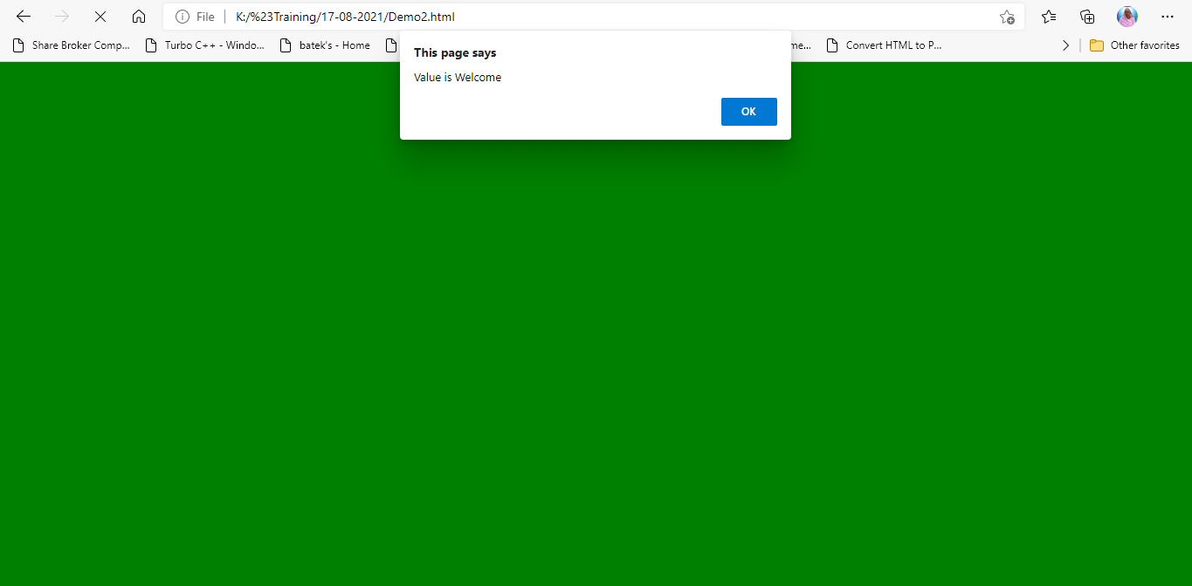

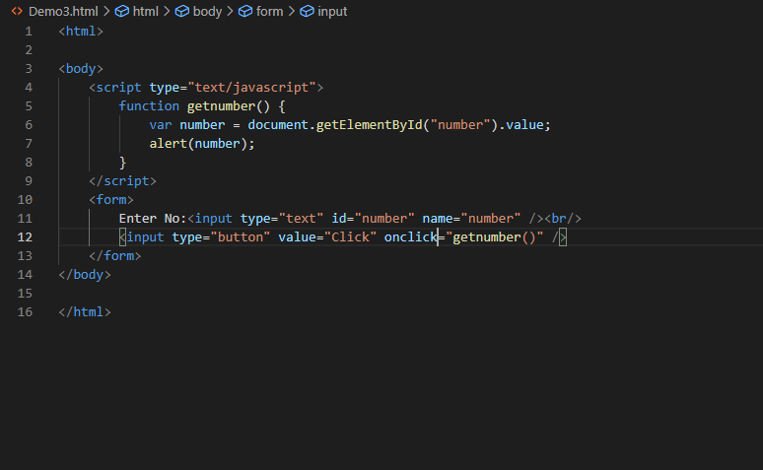

Output:-

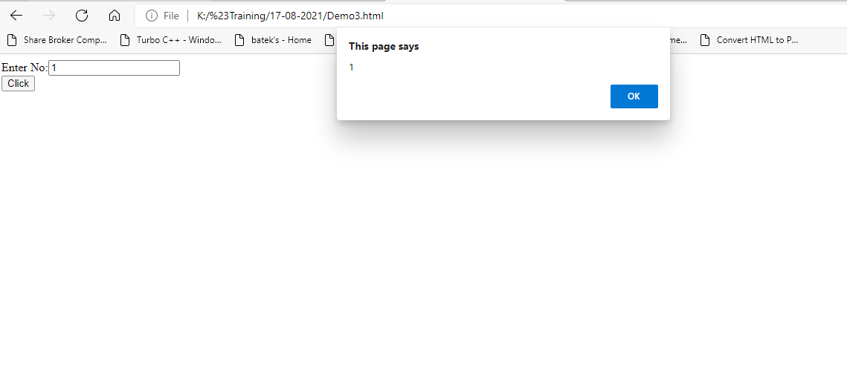

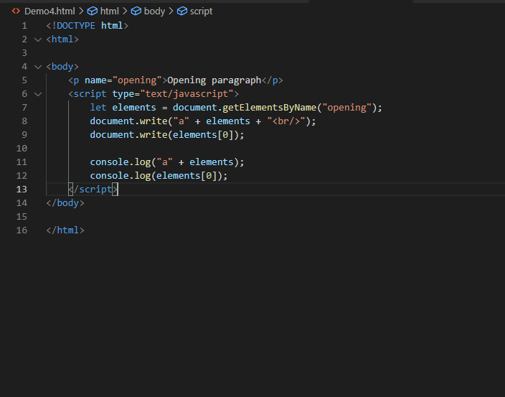

Output:-

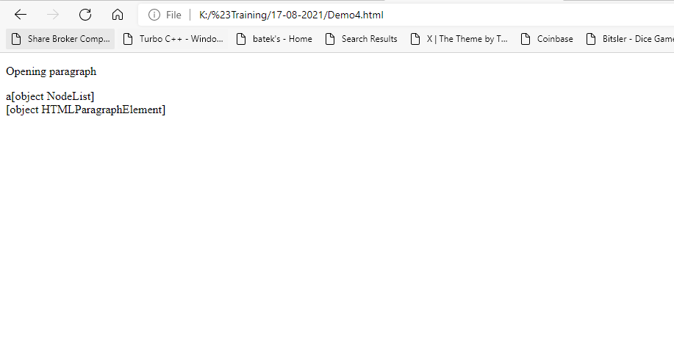

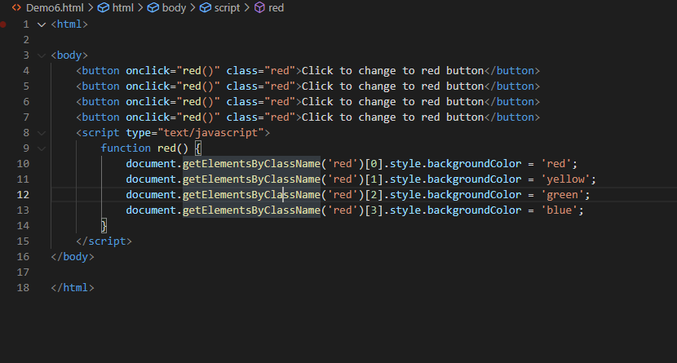

Output:-

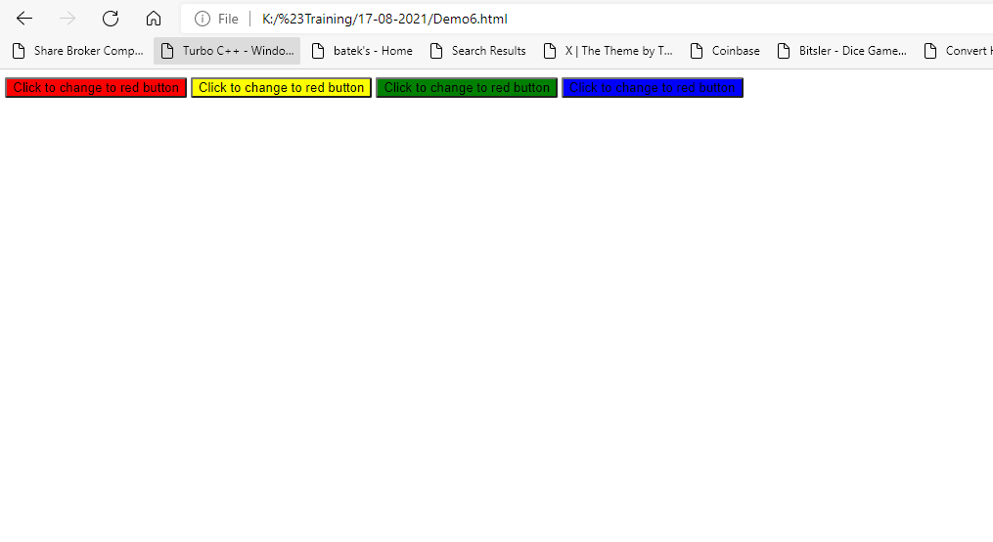

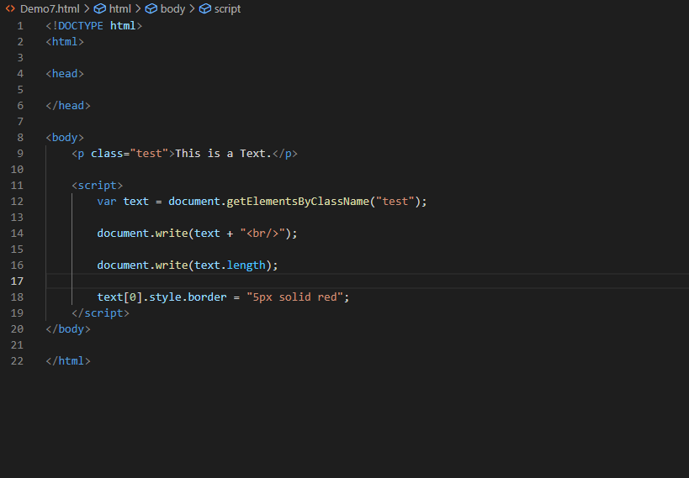

Output:-

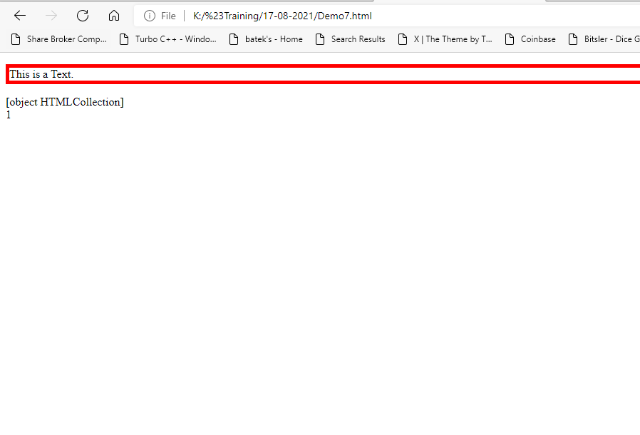

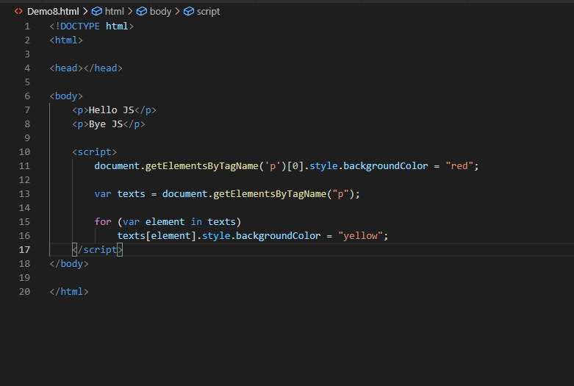

Output

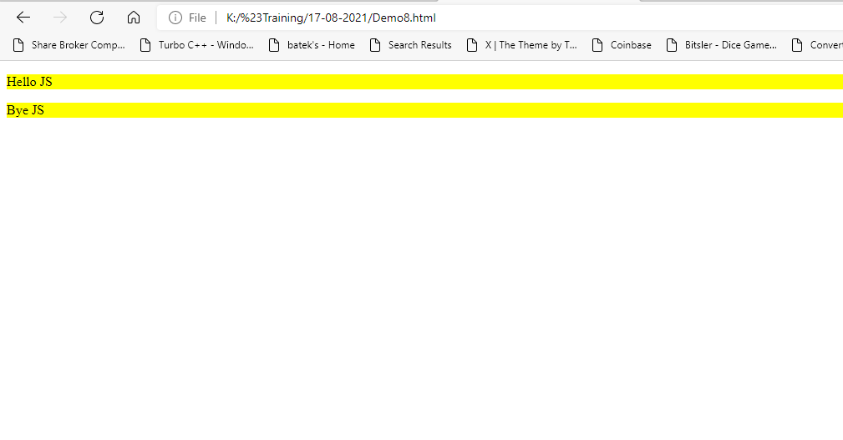

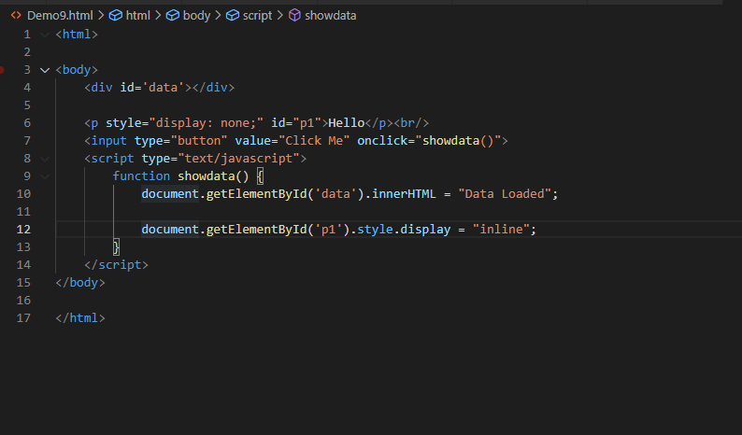

Output:-

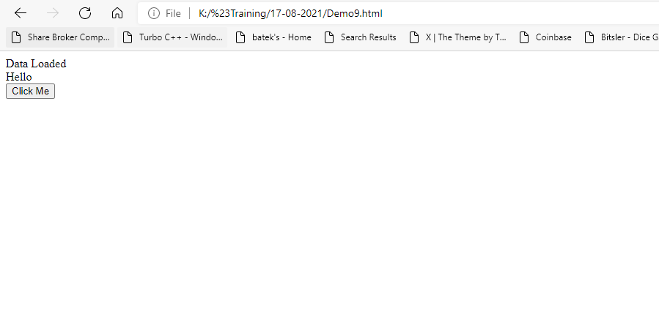

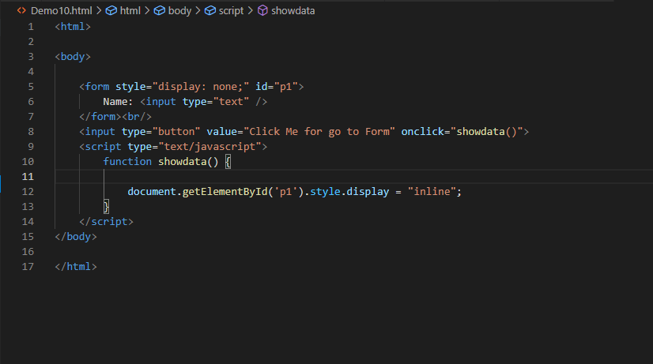

Output:-

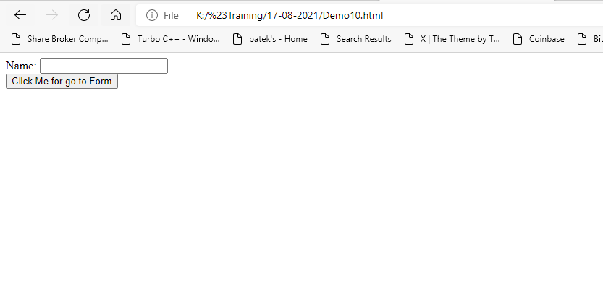

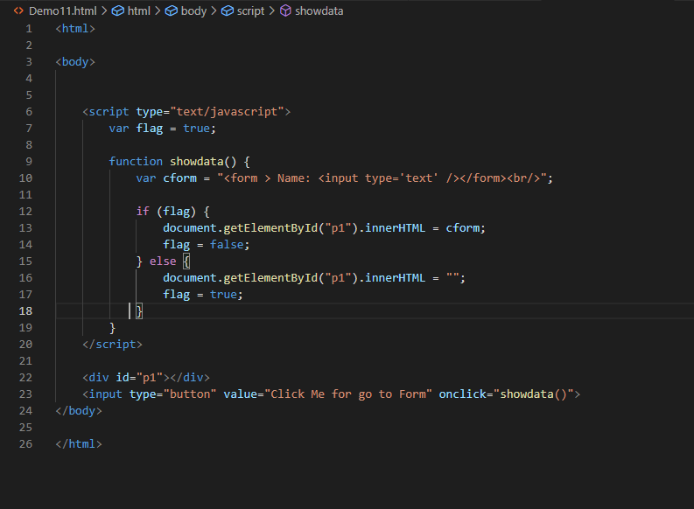

Output:-

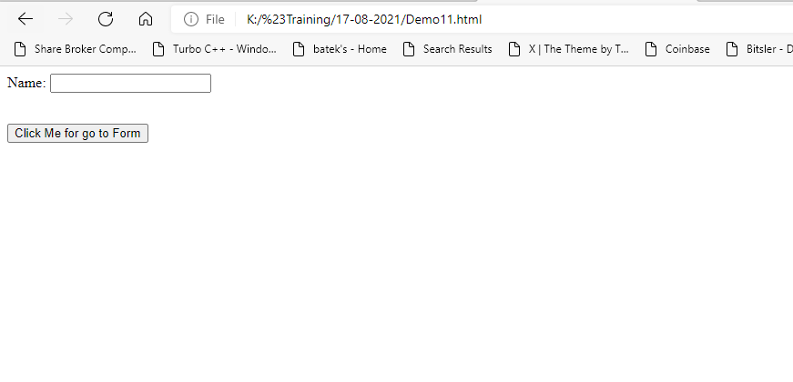

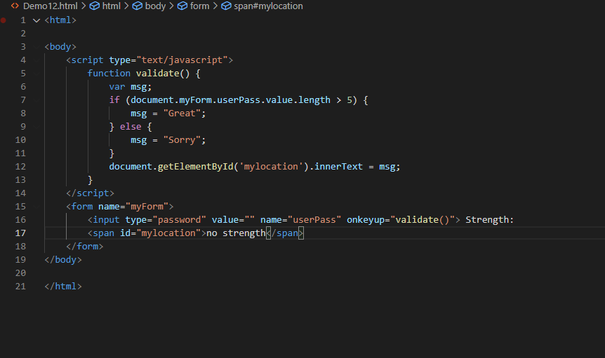

Output:-

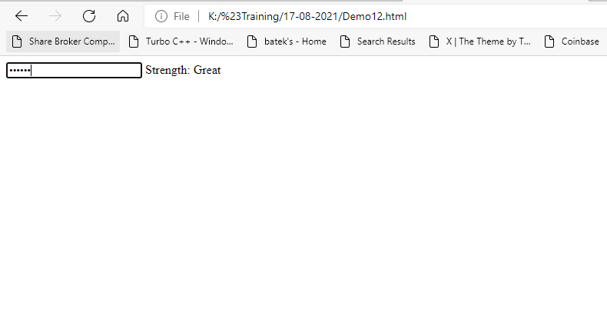

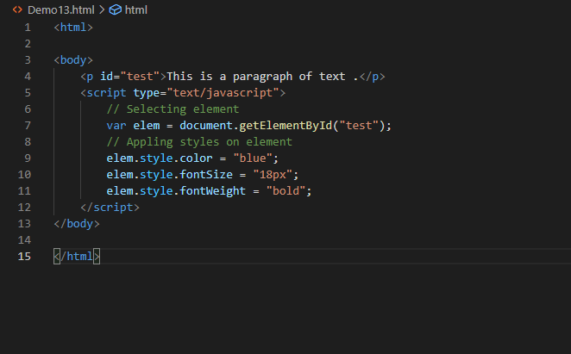

Output:-

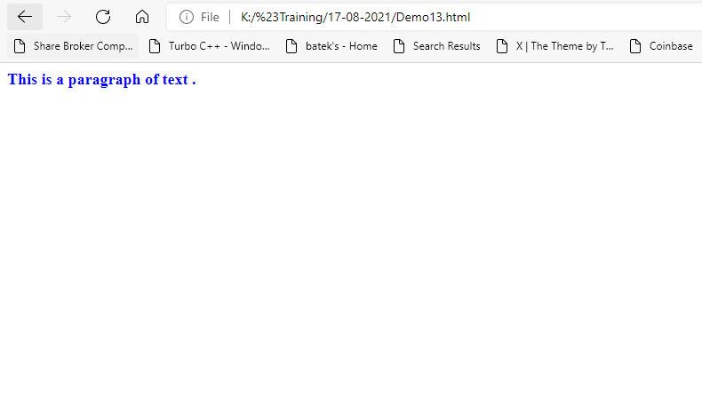

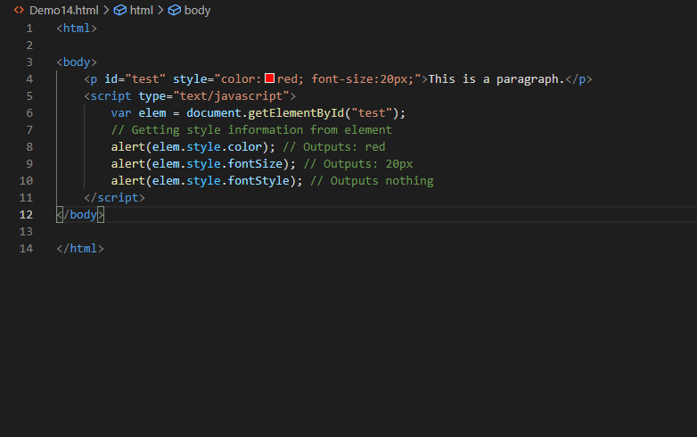

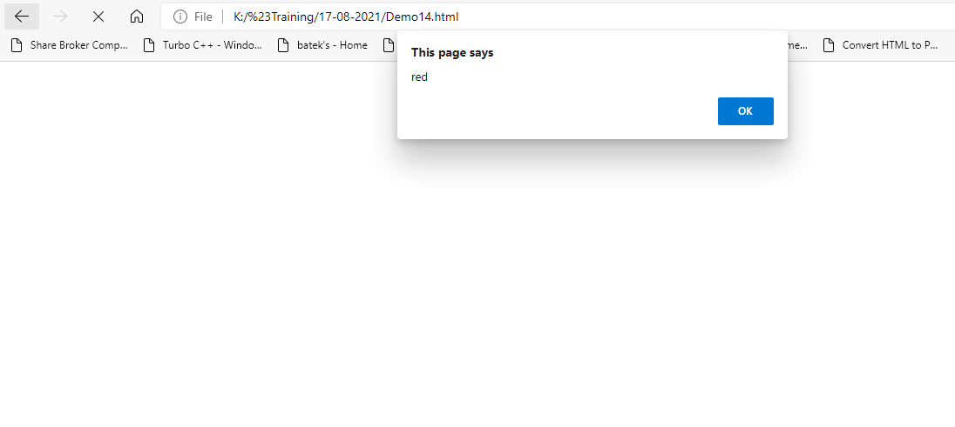

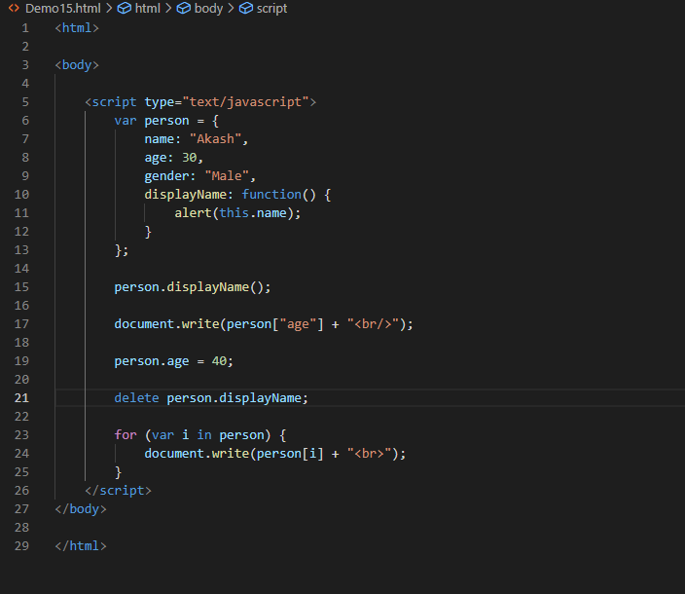

Output:-

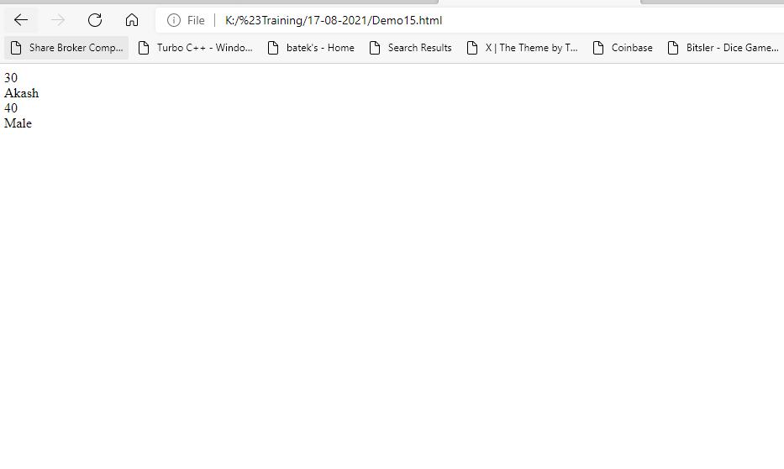

<!DOCTYPE html>

<html>

<head></head>

<body>

    <script>

        // Sample JS array

        var arr = ["Apple", "Banana", "Mango", "Orange",

            "Papaya"

        ];

        // Sample JS object

        var obj = {

            "name": "Akash",

            "age": 30,

            "country": "India"

        };

        // Converting JS array to JSON string

        var jsonArray = JSON.stringify(arr);

        document.write(jsonArray + "<br/>");

        // Converting JS object to JSON string

        var jsonObject = JSON.stringify(obj);

        document.write(jsonObject + "<br/>");

        var obj2 = JSON.parse(jsonArray);

        // Converting JSON-encoded string to JS object

        var obj1 = JSON.parse(jsonObject);

        // Accessing individual value from JS object

        document.write(obj1.name + " ");

        document.write(obj1.age + " ");

        document.write(obj1.country + "<br/>");

        document.write(obj2);

    </script>

</body>

</html>

Output:-

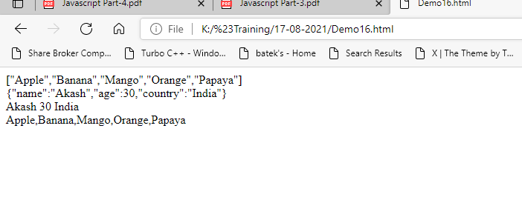

<!DOCTYPE html>

<html>

<head>

    <title>JS Demo Form</title>

    <style>

        form {

            padding-top: 120px;

            padding-left: 80px;

        }

        form fieldset {

            width: 430px;

        }

        form input {

            margin-top: 9px;

            padding-top: 9px;

            width: 207px;

        }

        .lab {

            margin-left: 3px;

        }

        form select {

            width: 200px;

            height: 32px;

            margin-top: 8px;

        }

    </style>

</head>

<body>

    <form action="#" method="POST" name="reg" onsubmit="return checkFocus()">

        <fieldset>

            <legend>Personal Details</legend>

            <table>

                <tr>

                    <td>

                        <label><b>First Name</b></label><br/>

                        <input type="text" name="u_fname" />

                    </td>

                    <td>

                        <label><b style="margin-left: 8px;">Last Name</b></label><br/>

                        <input type="text" name="u_lname" style="margin-left: 8px;" />

                    </td>

                </tr>

            </table><br/>

            <label class="lab"><b>Mobile No.</b></label><br/>

            <input type="number" name="u_number" style="margin-left: 2px;" min="0" />

            <br/><br/>

            <label class="lab"><b>Date Of Birth</b></label><br/>

            <input type="date" name="u_dob" style="margin-left: 2px;" />

            <br/><br/>

            <label class="lab"><b>Enter a State</b></label><br/>

            <select class="lab" name="u_state">

                <option value="">Select a state</option>

                <option value="Gujarat1">Gujarat1</option>

                <option value="Gujarat2">Gujarat2</option>

                <option value="Gujarat3">Gujarat3</option>

                <option value="Gujarat4">Gujarat4</option>

                <option value="Gujarat5">Gujarat5</option>

                <option value="Gujarat6">Gujarat6</option>

                <option value="Gujarat7">Gujarat7</option>

                <option value="Gujarat8">Gujarat8</option>

                <option value="Gujarat9">Gujarat9</option>

                <option value="Gujarat10">Gujarat10</option>

            </select>

            <br/><br/>

        </fieldset>

        <input type="submit" value="Submit" />

    </form>

    <div id="show"></div>

    <script>

        function checkFocus() {

            if (document.reg.u_fname.value.length < 5) {

                // msg += "please enter a first name with a 5 character <br/>";

                document.getElementById("show").innerHTML = "please enter a first name with a 5 character <br/>";

                return false;

            } else if (document.reg.u_lname.value.length < 5) {

                document.getElementById("show").innerHTML = "please enter a last name with a 5 character";

                return false;

            } else if (document.reg.u_lname.value.length < 5) {

                document.getElementById("show").innerHTML = "please enter a last name with a 5 character";

                return false;

            } else if (document.reg.u_number.value.length < 10) {

                document.getElementById("show").innerHTML = "please enter 10 digit number";

                return false;

            } else if (document.reg.u_dob.value.length == "") {

                document.getElementById("show").innerHTML = "please enter a DOB";

                return false;

            } else if (document.reg.u_state.value.length == "") {

                document.getElementById("show").innerHTML = "please enter a state";

                return false;

            }

            // document.getElementById("show").innerHTML = msg;

        }

    </script>

</body>

</html>

Output:-

