Date:18-Aug-2021

Task:- To Perform Task using Local Storage

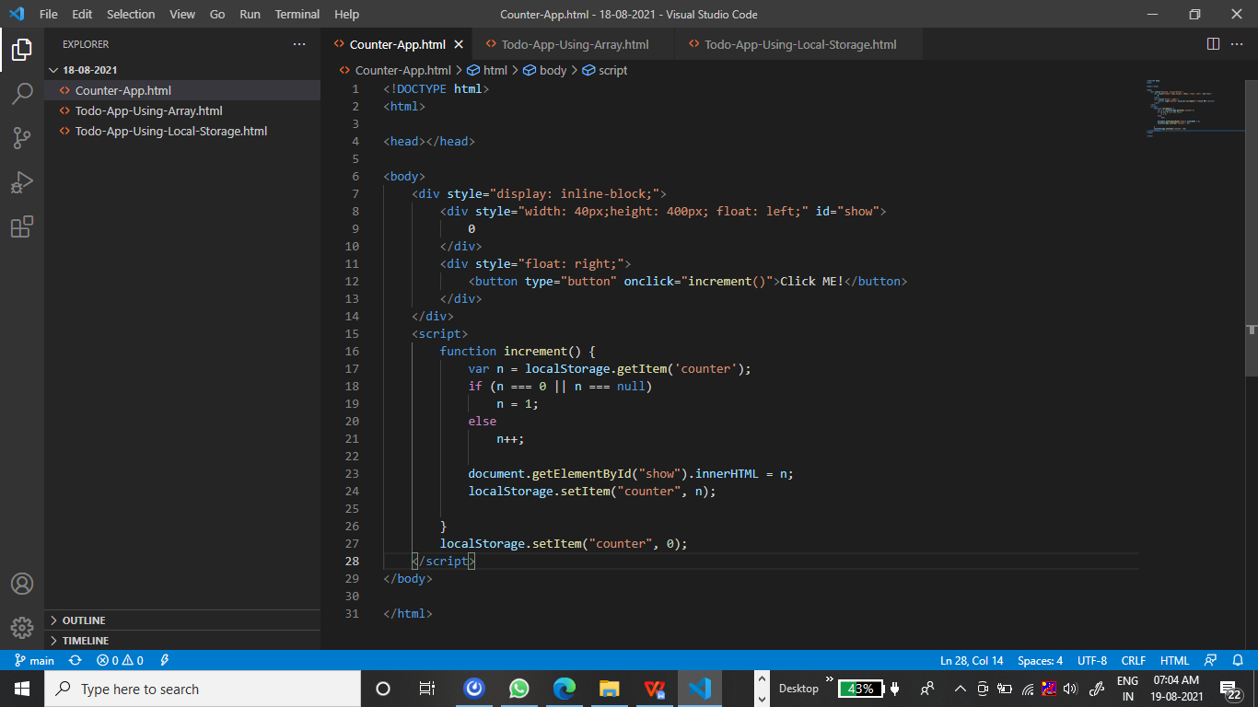

Output:-

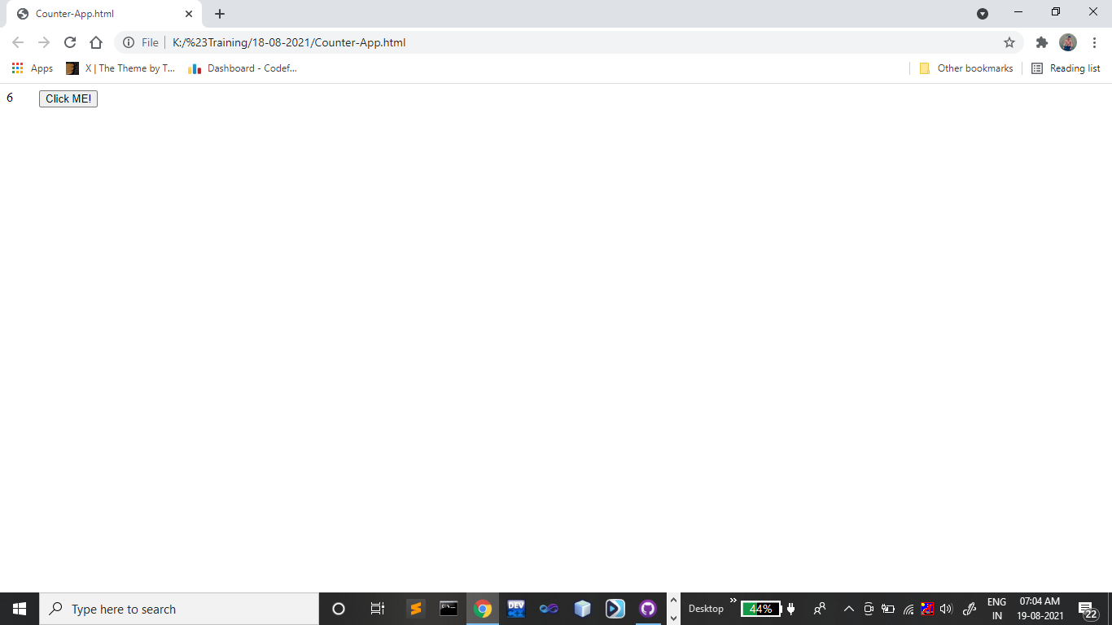

<!DOCTYPE html>

<html>

<head></head>

<body>

    <div style="display: inline-block;">

        <div style="float: left;">

            <input type="text" id="name" /><br/><br/>

            <input type="button" value="submit" onclick="addMoreElements()" /><br/>

            <span id="error"></span>

        </div>

        <div style="float: right;" id="add">

        </div>

    </div>

</body>

<script>

    var array = new Array();

    function addMoreElements() {

        document.getElementById("error").innerHTML = "";

        var add = document.getElementById("name").value;

        if (add == "")

            document.getElementById("error").innerHTML = "Plese enter a number";

        else {

            array.push(add);

            var html = "<ul>";

            for (var i = 0; i < array.length; i++)

                html += "<li>" + array[i] + "</li>";

            html += "</ul>";

            document.getElementById("add").innerHTML = html;

        }

    }

</script>

</html>

Output:-

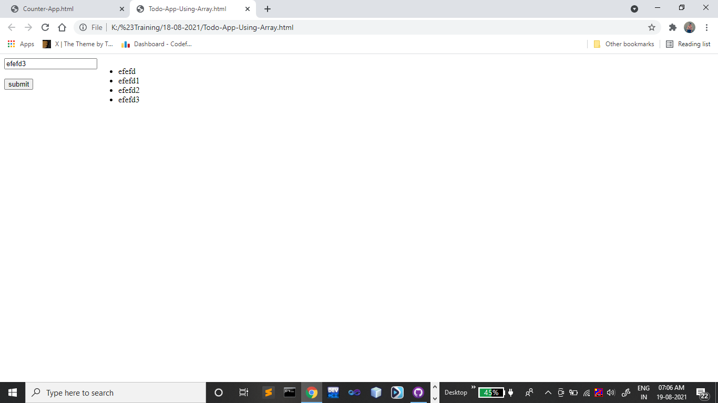

Task 3:-

<!DOCTYPE html>

<html>

<head></head>

<body>

    <div style="display: inline-block;">

        <div style="float: left;">

            <input type="text" id="name" /><br/><br/>

            <input type="button" value="submit" onclick="addMoreElements()" /><br/>

            <span id="error"></span>

        </div>

        <div style="float: right;" id="add">

        </div>

    </div>

</body>

<script>

    localStorage.setItem("array", JSON.stringify(new Array()));

    function addMoreElements() {

        var array = JSON.parse(localStorage.getItem("array"));

        document.getElementById("error").innerHTML = ""

        var add = document.getElementById("name").value;

        if (add == "")

            document.getElementById("error").innerHTML = "Plese enter a number";

        else {

            array.push(add);

            var html = "<ul>";

            for (var i = 0; i < array.length; i++)

                html += "<li>" + array[i] + "</li>";

            html += "</ul>";

            document.getElementById("add").innerHTML = html;

        }

        localStorage.setItem("array", JSON.stringify(array));

    }

</script>

</html>

Output:-

