Date- 19-Aug-2021

Given Task- To Perform All the Task using Event Listener

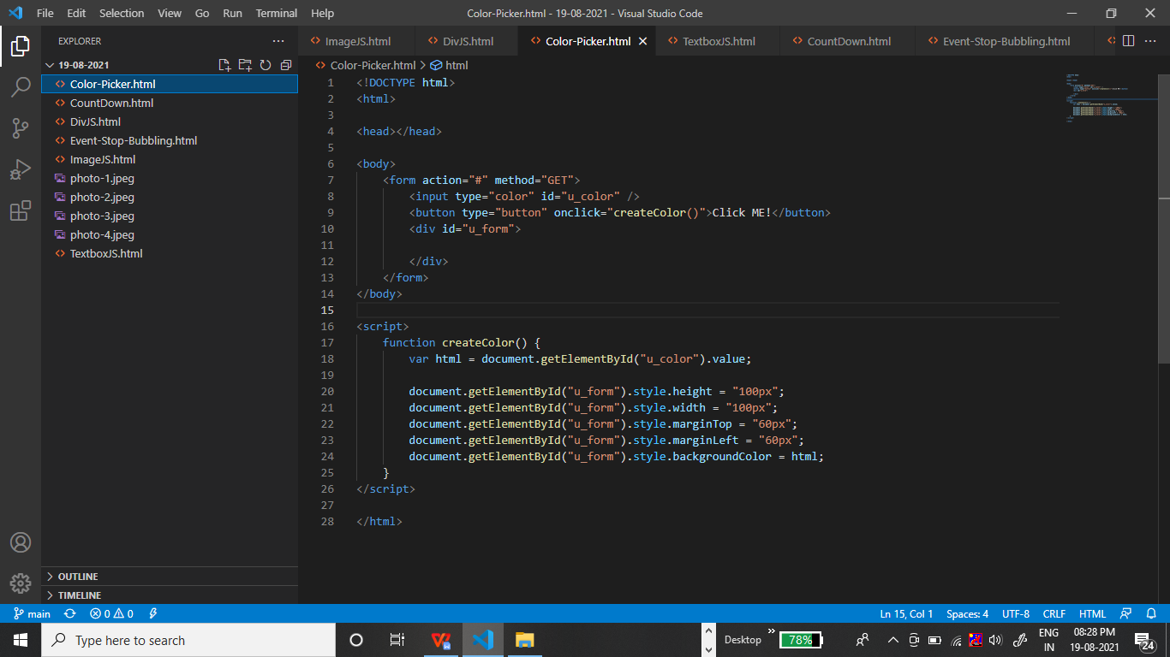

Output:-

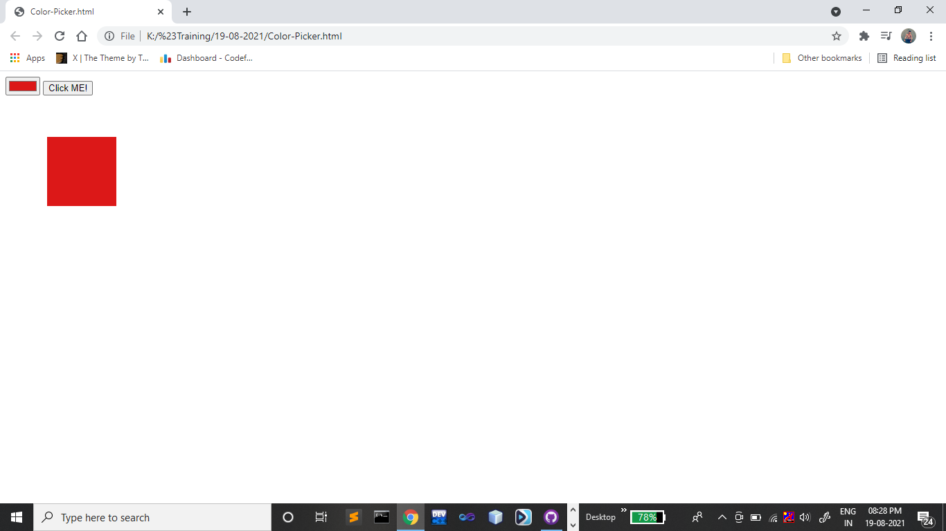

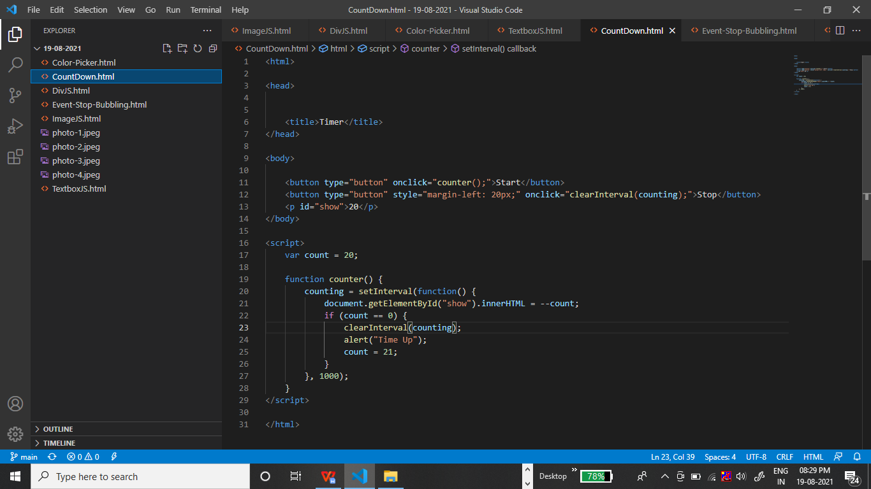

Output:-

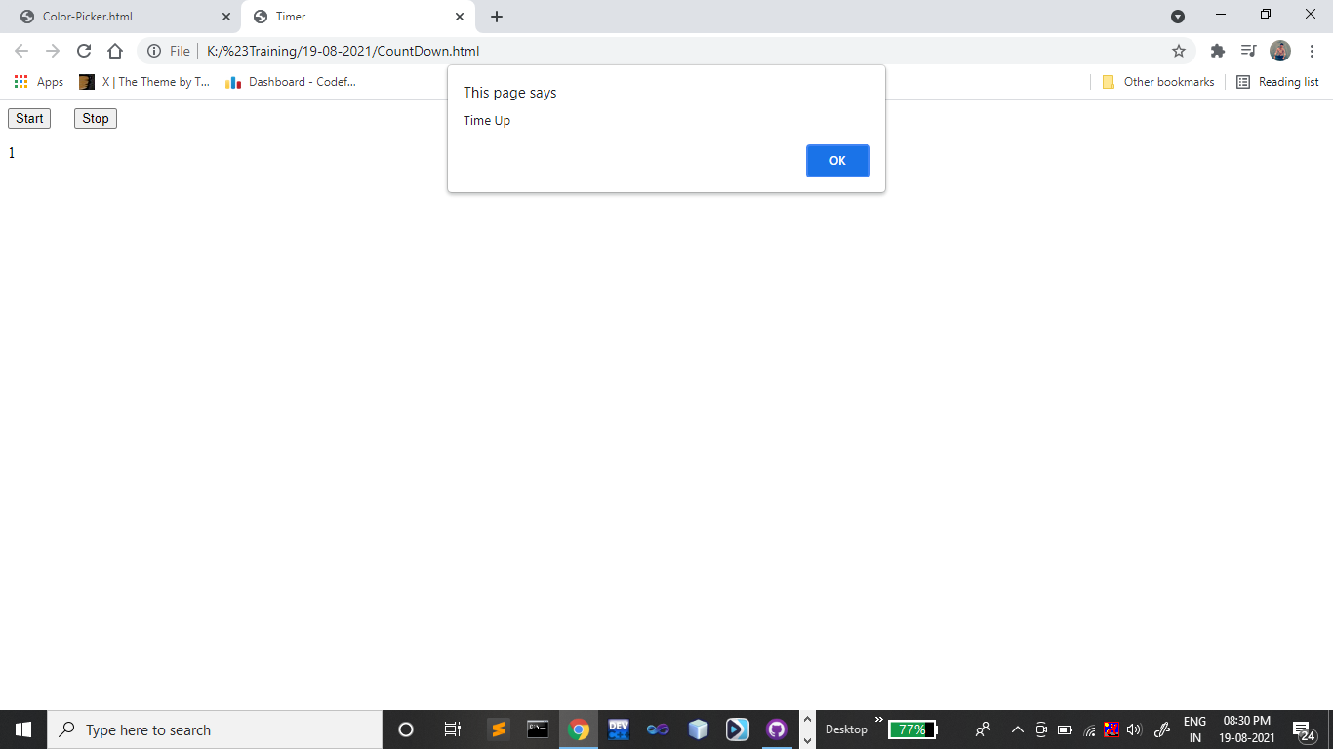

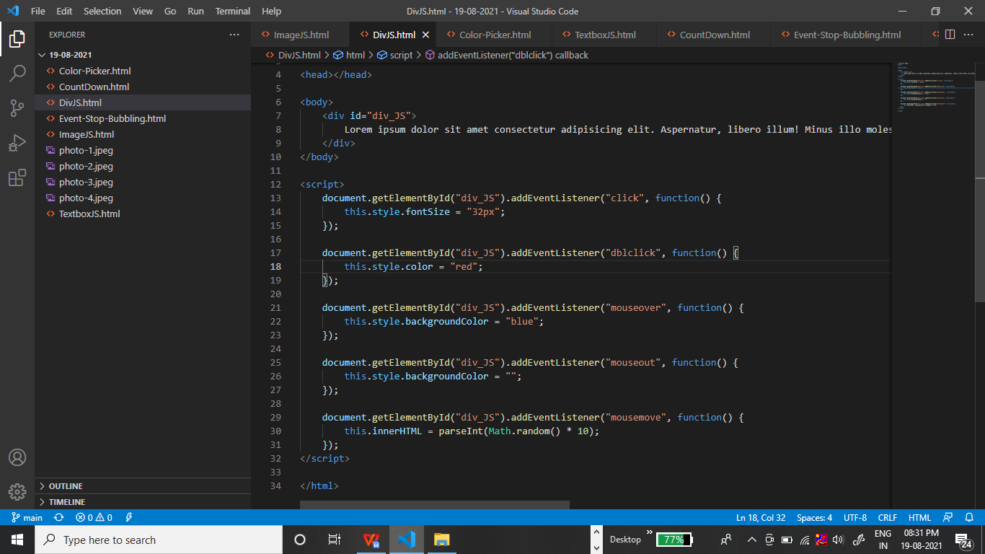

Output:-

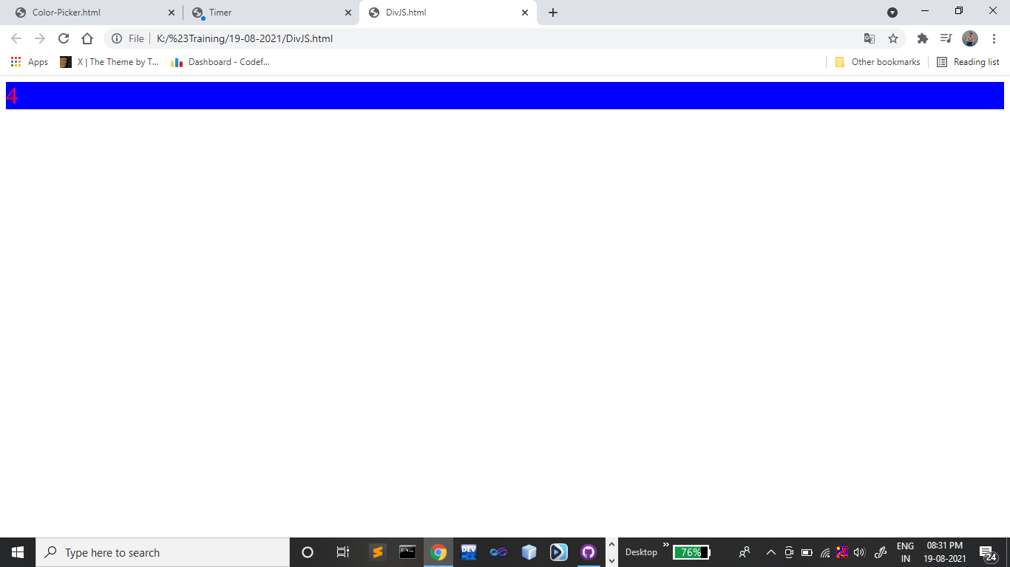

<!DOCTYPE html>

<html>

<head>

    <style>

        #outer {

            height: 200px;

            width: 300px;

            background-color: red;

            padding-top: 50px;

            padding-left: 100px;

        }

        #inner {

            height: 140px;

            width: 190px;

            background-color: yellow;

        }

    </style>

</head>

<body>

    <div id="outer">

        <div id="inner">

        </div>

    </div>

</body>

<script>

    document.getElementById("outer").addEventListener("click", function(event) {

        event.stopPropagation();

        alert("Outer Div");

    });

    document.getElementById("inner").addEventListener("click", function(event) {

        alert("Inner Div 1st time");

        event.stopImmediatePropagation();

    });

    document.getElementById("inner").addEventListener("click", function(event) {

        alert("Inner Div 2nd time");

    });

    document.body.addEventListener("click", function() {

        alert("Body");

    });

</script>

</html>

Output:-

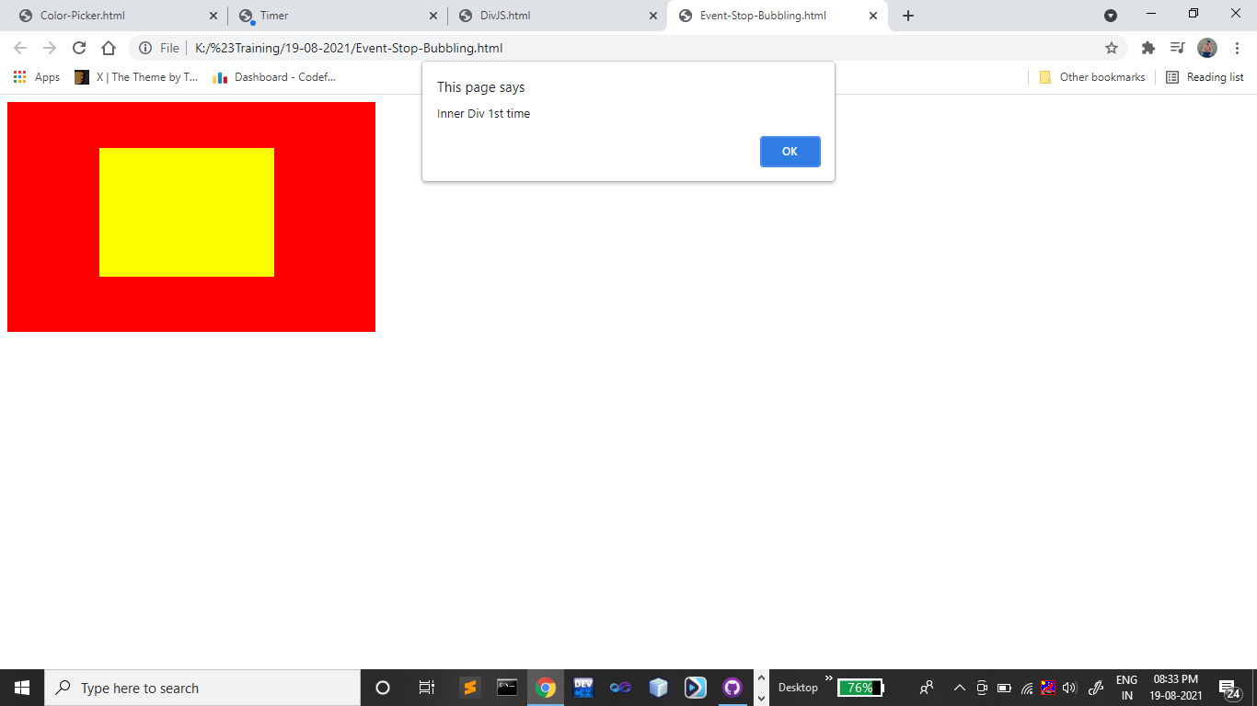

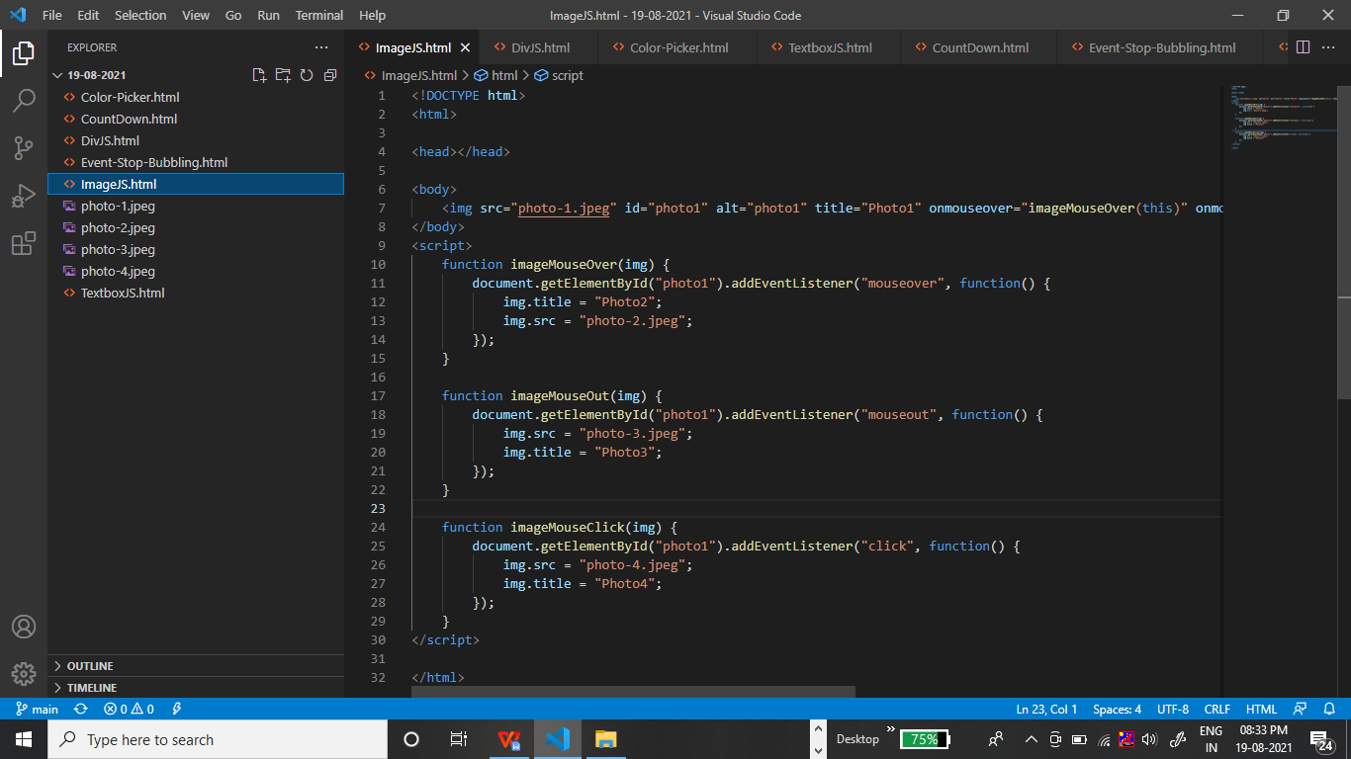

Output:-

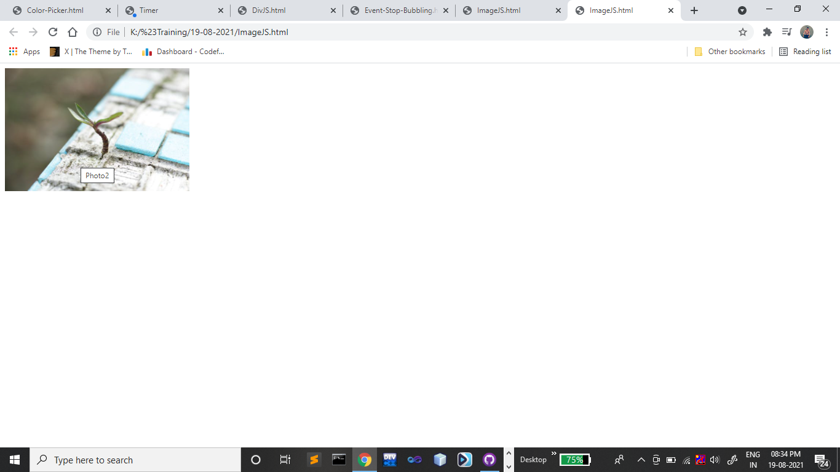

<!DOCTYPE html>

<html>

<head></head>

<body>

    <form name="frm">

        <textarea id="tx1" cols="30" rows="10"></textarea>

        <textarea id="tx2" cols="30" rows="10"></textarea>

        <textarea id="tx3" cols="30" rows="10"></textarea>

        <textarea name="tx4" id="tx4" cols="30" rows="10"></textarea>

        <textarea name="tx5" id="tx5" cols="30" rows="10"></textarea><br/>

        <textarea id="tx6" cols="30" rows="10"></textarea>

        <textarea id="tx7" cols="30" rows="10"></textarea>

        <textarea id="tx8" cols="30" rows="10"></textarea>

        <textarea id="tx9" cols="30" rows="10"></textarea>

        <textarea id="tx10" cols="30" rows="10"></textarea>

    </form>

</body>

<script>

    document.getElementById("tx1").addEventListener("focus", function() {

        this.style.backgroundColor = "black";

    });

    document.getElementById("tx2").addEventListener("mouseover", function() {

        this.style.height = "32px";

        this.style.width = "32px";

    });

    document.getElementById("tx2").addEventListener("mouseout", function() {

        this.style.height = "150px";

        this.style.width = "227px";

    });

    document.getElementById("tx3").addEventListener("mousemove", function() {

        this.innerHTML = "hello";

    });

    document.getElementById("tx4").addEventListener("keyup", function() {

        frm.tx4.value = frm.tx4.value.toUpperCase();

    });

    document.getElementById("tx5").addEventListener("keydown", function() {

        frm.tx5.value = frm.tx5.value.toLowerCase();

    });

    document.getElementById("tx6").addEventListener("click", function() {

        this.style.height = "300px";

        this.style.width = "300px";

    });

    document.getElementById("tx7").addEventListener("mouseup", function() {

        this.style.borderColor = "red";

    });

    document.getElementById("tx8").addEventListener("mousedown", function() {

        this.style.borderStyle = "dotted";

    });

    document.getElementById("tx9").addEventListener("blur", function() {

        this.style.color = "red";

        this.style.backgroundColor = "yellow";

    });

    document.getElementById("tx10").addEventListener("mouseout", function() {

        this.style.borderRadius = "50px";

    });

</script>

</html>

Output:-

