Date- 21-08-2021

Given Task- Jquery Plugins

<!DOCTYPE html>

<html>

<head>

    <link rel="stylesheet" href="https://cdn.datatables.net/1.10.25/css/jquery.dataTables.min.css">

    <style>

        body {

            margin: 20px 0;

            font-family: 'Lato';

            font-weight: 300;

            font-size: 1.25rem;

            width: 300px;

        }

        form,

        p {

            margin: 20px;

        }

        p.note {

            font-size: 1rem;

            color: red;

        }

        input,

        textarea {

            border-radius: 5px;

            border: 1px solid #ccc;

            padding: 4px;

            font-family: 'Lato';

            width: 300px;

            margin-top: 10px;

        }

        label {

            width: 300px;

            font-weight: bold;

            display: inline-block;

            margin-top: 20px;

        }

        label span {

            font-size: 1rem;

        }

        label.error {

            color: red;

            font-size: 1rem;

            display: block;

            margin-top: 5px;

        }

        input.error,

        textarea.error {

            border: 1px dashed red;

            font-weight: 300;

            color: red;

        }

        [type="submit"],

        [type="reset"],

        button,

        html [type="button"] {

            margin-left: 0;

            border-radius: 0;

            background: black;

            color: white;

            border: none;

            font-weight: 300;

            padding: 10px 0;

            line-height: 1;

        }

        #example {

            margin-top: 0px;

        }

    </style>

    <script src="https://cdnjs.cloudflare.com/ajax/libs/jquery/3.4.0/jquery.min.js"></script>

    <script src="https://cdnjs.cloudflare.com/ajax/libs/jquery-validate/1.19.0/jquery.validate.min.js"></script>

    <!-- <script src="https://code.jquery.com/jquery-3.5.1.js"></script> -->

    <script src="https://cdn.datatables.net/1.10.25/js/jquery.dataTables.min.js"></script>

    <script>

        $(document).ready(function() {

            $("#basic-form").validate();

        });

    </script>

    <script>

        $(document).ready(function() {

            $('#example').DataTable();

        });

    </script>

</head>

<body>

    <form id="basic-form" action="" method="post">

        <p>

            <label for="name">Name <span>(required, at least 3 characters)</span></label>

            <input id="name" name="name" minlength="3" type="text" required>

        </p>

        <p>

            <label for="email">E-Mail <span>(required)</span></label>

            <input id="email" type="email" name="email" required>

        </p>

        <p>

            <input class="submit" type="submit" value="SUBMIT">

        </p>

    </form>

    <table id="example" class="display">

        <thead>

            <tr>

                <th>Column 1</th>

                <th>Column 2</th>

            </tr>

        </thead>

        <tbody>

            <tr>

                <td>Row 1 Data 1</td>

                <td>Row 1 Data 2</td>

            </tr>

            <tr>

                <td>Hello</td>

                <td>Row 2 Data 2</td>

            </tr>

            <tr>

                <td>Row 1 Data 1</td>

                <td>Row 1 Data 2</td>

            </tr>

            <tr>

                <td>Row 2 Data 1</td>

                <td>Row 2 Data 2</td>

            </tr>

            <tr>

                <td>Row 1 Data 1</td>

                <td>Row 1 Data 2</td>

            </tr>

            <tr>

                <td>Row 2 Data 1</td>

                <td>Row 2 Data 2</td>

            </tr>

            <tr>

                <td>Row 1 Data 1</td>

                <td>Row 1 Data 2</td>

            </tr>

            <tr>

                <td>Row 2 Data 1</td>

                <td>Row 2 Data 2</td>

            </tr>

            <tr>

                <td>Row 1 Data 1</td>

                <td>Row 1 Data 2</td>

            </tr>

            <tr>

                <td>Row 2 Data 1</td>

                <td>Row 2 Data 2</td>

            </tr>

            <tr>

                <td>Row 1 Data 1</td>

                <td>Row 1 Data 2</td>

            </tr>

            <tr>

                <td>Row 2 Data 1</td>

                <td>Row 2 Data 2</td>

            </tr>

            <tr>

                <td>Row 1 Data 1</td>

                <td>Row 1 Data 2</td>

            </tr>

            <tr>

                <td>Row 2 Data 1</td>

                <td>Row 2 Data 2</td>

            </tr>

            <tr>

                <td>Row 1 Data 1</td>

                <td>Row 1 Data 2</td>

            </tr>

            <tr>

                <td>Row 2 Data 1</td>

                <td>Row 2 Data 2</td>

            </tr>

            <tr>

                <td>Row 1 Data 1</td>

                <td>Row 1 Data 2</td>

            </tr>

            <tr>

                <td>Row 2 Data 1</td>

                <td>Row 2 Data 2</td>

            </tr>

            <tr>

                <td>Row 1 Data 1</td>

                <td>Row 1 Data 2</td>

            </tr>

            <tr>

                <td>Row 2 Data 1</td>

                <td>Row 2 Data 2</td>

            </tr>

            <tr>

                <td>Row 1 Data 1</td>

                <td>Row 1 Data 2</td>

            </tr>

            <tr>

                <td>Row 2 Data 1</td>

                <td>Row 2 Data 2</td>

            </tr>

            <tr>

                <td>Row 1 Data 1</td>

                <td>Row 1 Data 2</td>

            </tr>

            <tr>

                <td>Row 2 Data 1</td>

                <td>Row 2 Data 2</td>

            </tr>

        </tbody>

        <tfoot>

            <tr>

                <th>Column 1</th>

                <th>Column 2</th>

            </tr>

        </tfoot>

    </table>

</body>

</html>

Output:-

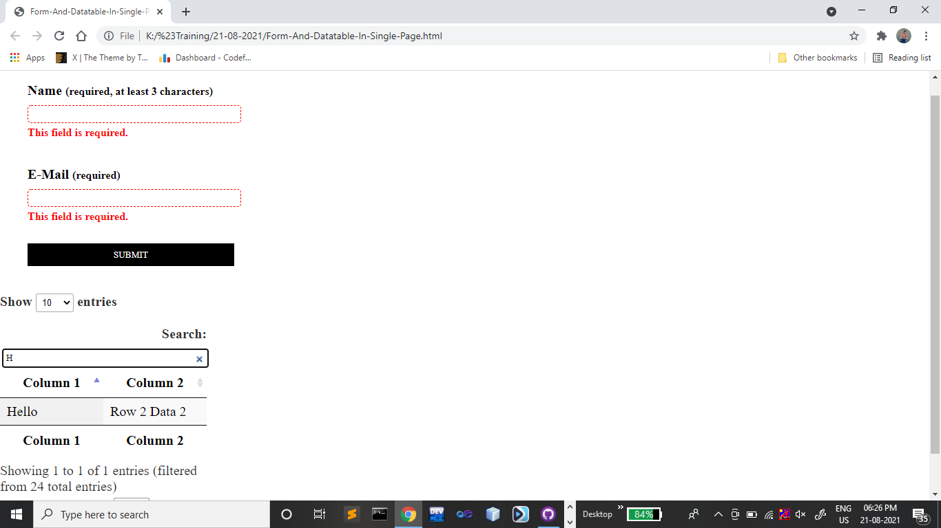

<!DOCTYPE html>

<html lang="en">

<head>

    <meta charset="utf-8">

    <title>jQuery validation plug-in - main demo</title>

    <link rel="stylesheet" href="css/screen.css">

    <script src="https://cdnjs.cloudflare.com/ajax/libs/jquery/3.4.0/jquery.min.js"></script>

    <script src="https://cdnjs.cloudflare.com/ajax/libs/jquery-validate/1.19.3/jquery.validate.js"></script>

    <script src="https://cdnjs.cloudflare.com/ajax/libs/jquery-validate/1.19.2/additional-methods.min.js"></script>

    <script>

        $().ready(function() {

            // validate signup form on keyup and submit

            $("#signupForm").validate({

                rules: {

                    firstname: "required",

                    lastname: "required",

                    username: {

                        required: true,

                        minlength: 2

                    },

                    password: {

                        required: true,

                        minlength: 5

                    },

                    confirm_password: {

                        required: true,

                        minlength: 5,

                        equalTo: "#password"

                    },

                    usernumber: {

                        required: true,

                        minlength: 10,

                        maxlength: 10

                    },

                    userage: {

                        required: true,

                        min: 18

                    },

                    date: {

                        required: true,

                        date: true

                    },

                    email: {

                        required: true,

                        email: true

                    },

                    topic: {

                        required: "#newsletter:checked",

                        minlength: 2

                    },

                    agree: "required"

                },

                messages: {

                    firstname: "Please enter your firstname",

                    lastname: "Please enter your lastname",

                    username: {

                        required: "Please enter a username",

                        minlength: "Your username must consist of at least 2 characters"

                    },

                    usernumber: {

                        required: "Please enter a usernumber",

                        minlength: "Your usernumber must consist of at 10 characters",

                        maxlength: "Your usernumber must consist of at 10 characters"

                    },

                    password: {

                        required: "Please provide a password",

                        minlength: "Your password must be at least 5 characters long"

                    },

                    confirm_password: {

                        required: "Please provide a password",

                        minlength: "Your password must be at least 5 characters long",

                        equalTo: "Please enter the same password as above"

                    },

                    userage: {

                        required: "Please provide a age",

                        minlength: "Your age must be 18"

                    },

                    date: {

                        required: "Date is required",

                        date: "enter date only"

                    },

                    email: "Please enter a valid email address",

                    agree: "Please accept our policy",

                    topic: "Please select at least 2 topics"

                }

            });

            // propose username by combining first- and lastname

            $("#username").focus(function() {

                var firstname = $("#firstname").val();

                var lastname = $("#lastname").val();

                if (firstname && lastname && !this.value) {

                    this.value = firstname + "." + lastname;

                }

            });

            //code to hide topic selection, disable for demo

            var newsletter = $("#newsletter");

            // newsletter topics are optional, hide at first

            var inital = newsletter.is(":checked");

            var topics = $("#newsletter_topics")[inital ? "removeClass" : "addClass"]("gray");

            var topicInputs = topics.find("input").attr("disabled", !inital);

            // show when newsletter is checked

            newsletter.click(function() {

                topics[this.checked ? "removeClass" : "addClass"]("gray");

                topicInputs.attr("disabled", !this.checked);

            });

        });

    </script>

    <style>

        #commentForm {

            width: 500px;

        }

        #commentForm label {

            width: 250px;

        }

        #commentForm label.error,

        #commentForm input.submit {

            margin-left: 253px;

        }

        #signupForm {

            width: 670px;

        }

        #signupForm label.error {

            margin-left: 10px;

            width: auto;

            display: inline;

        }

        #newsletter_topics label.error {

            display: none;

            margin-left: 103px;

        }

        .error {

            color: red;

        }

    </style>

</head>

<body>

    <form class="cmxform" id="signupForm" method="get" action="">

        <fieldset>

            <legend>Validating a complete form</legend>

            <p>

                <label for="firstname">Firstname</label>

                <input id="firstname" name="firstname" type="text">

            </p>

            <p>

                <label for="lastname">Lastname</label>

                <input id="lastname" name="lastname" type="text">

            </p>

            <p>

                <label for="username">Username</label>

                <input id="username" name="username" type="text">

            </p>

            <p>

                <label for="usernumber">Usernumber</label>

                <input id="usernumber" name="usernumber" type="number" min="0">

            </p>

            <p>

                <label for="password">Password</label>

                <input id="password" name="password" type="password">

            </p>

            <p>

                <label for="confirm_password">Confirm password</label>

                <input id="confirm_password" name="confirm_password" type="password">

            </p>

            <p>

                <label for="date">date</label>

                <input id="date" name="date" type="date">

            </p>

            <p>

                <label for="userage">userage</label>

                <input id="userage" name="userage" type="number" min="18">

            </p>

            <p>

                <label for="email">Email</label>

                <input id="email" name="email" type="email">

            </p>

            <p>

                <label for="agree">Please agree to our policy</label>

                <input type="checkbox" class="checkbox" id="agree" name="agree">

            </p>

            <p>

                <label for="file2">Select any image file</label>

                <input type="file" id="file2" name="file2" class="required" accept="image/*">

            </p>

            <p>

                <input class="submit" type="submit" value="Submit">

            </p>

        </fieldset>

    </form>

</body>

</html>

Output:-

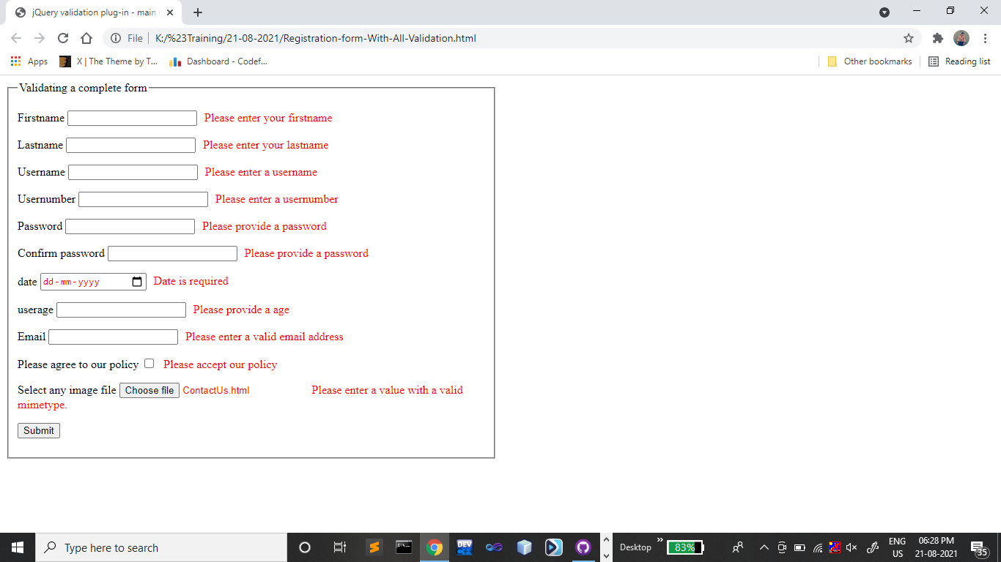

<!DOCTYPE html>

<html>

<head>

    <link rel="stylesheet" href="https://cdn.datatables.net/1.10.25/css/jquery.dataTables.min.css">

    <style>

        body {

            margin: 20px 0;

            font-family: 'Lato';

            font-weight: 300;

            font-size: 1.25rem;

            width: 300px;

        }

        form,

        p {

            margin: 20px;

        }

        p.note {

            font-size: 1rem;

            color: red;

        }

        input,

        textarea {

            border-radius: 5px;

            border: 1px solid #ccc;

            padding: 4px;

            font-family: 'Lato';

            width: 300px;

            margin-top: 10px;

        }

        label {

            width: 300px;

            font-weight: bold;

            display: inline-block;

            margin-top: 20px;

        }

        label span {

            font-size: 1rem;

        }

        label.error {

            color: red;

            font-size: 1rem;

            display: block;

            margin-top: 5px;

        }

        input.error,

        textarea.error {

            border: 1px dashed red;

            font-weight: 300;

            color: red;

        }

        [type="submit"],

        [type="reset"],

        button,

        html [type="button"] {

            margin-left: 0;

            border-radius: 0;

            background: black;

            color: white;

            border: none;

            font-weight: 300;

            padding: 10px 0;

            line-height: 1;

        }

        #example {

            margin-top: 0px;

        }

    </style>

    <script src="https://cdnjs.cloudflare.com/ajax/libs/jquery/3.4.0/jquery.min.js"></script>

    <script src="https://cdnjs.cloudflare.com/ajax/libs/jquery-validate/1.19.0/jquery.validate.min.js"></script>

    <script>

        $(document).ready(function() {

            $("#basic-form").validate();

        });

    </script>

</head>

<body>

    <form id="basic-form" action="" method="post">

        <p>

            <label for="name">Name <span>(required, at least 3 characters)</span></label>

            <input id="name" name="name" minlength="3" type="text" required>

        </p>

        <p>

            <label for="email">E-Mail <span>(required)</span></label>

            <input id="email" type="email" name="email" required>

        </p>

        <p>

            <input class="submit" type="submit" value="SUBMIT">

        </p>

    </form>

</body>

</html>

Output:-

