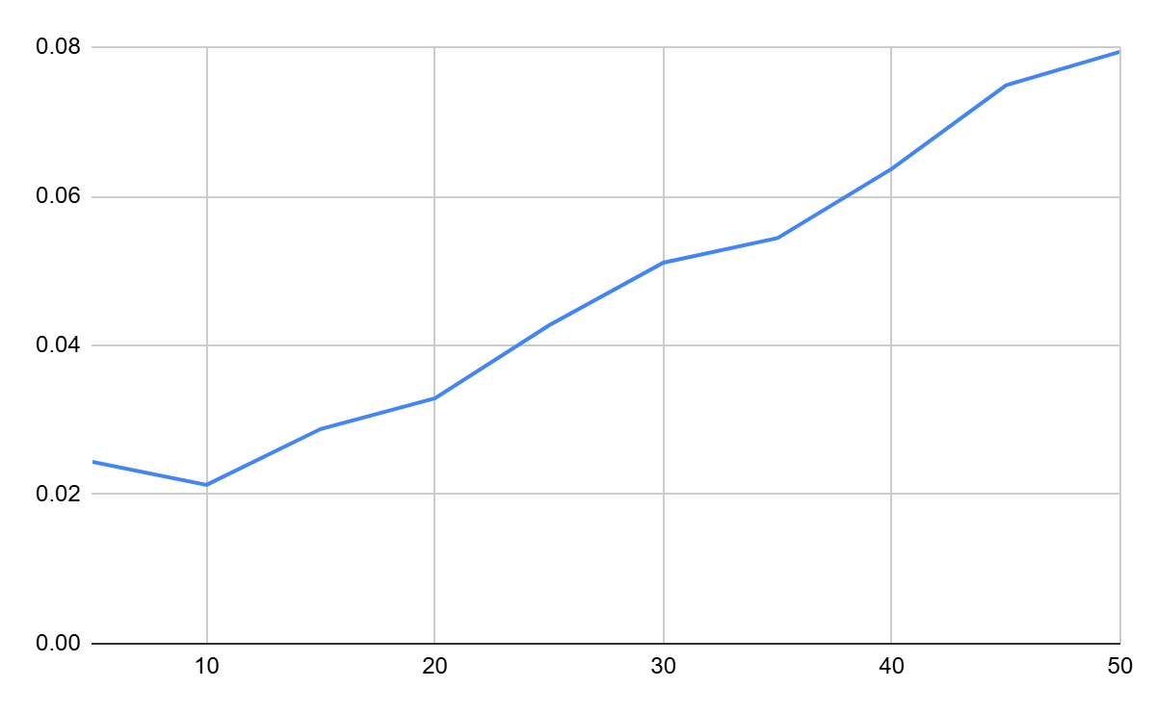

The main bottleneck when dealing with file transfer is the file size as the input. As the file size increases, the runtime to transfer all the items increases in a linear behavior.